For Immediate Release: November 2026

RC12R8 Factory Team Kit #4023
1:12 Scale 2WD Electric On Road Competition Race Car

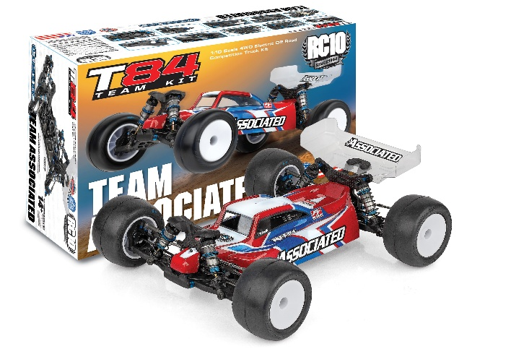
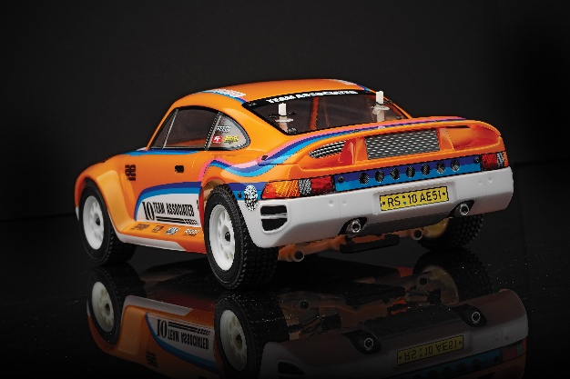
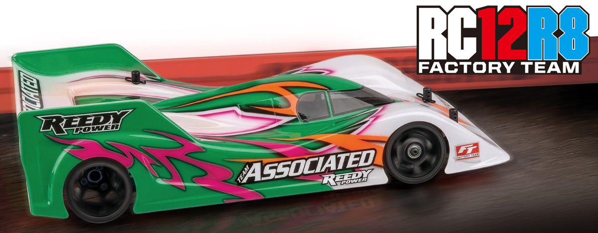

ELECTRIC ■ 1:12 SCALE ■ 2 WHEEL DRIVE ■ ON ROAD ■ KIT

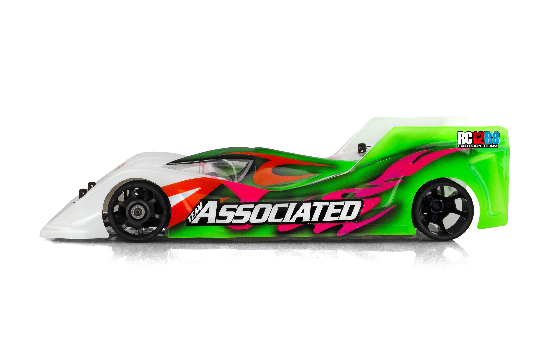
Team Associated introduces the RC12R8, an all-new 1:12 scale electric on-road racing platform developed by Area 51 for top-level competition. Built around an ultra-low center of gravity, exceptional rigidity, and fast, precise adjustability, the RC12R8 features a dual chassis design combining hybrid steel and carbon fiber center chassis with a 2mm 7075-T6 aluminum lower spring chassis. Its all-new triple central pivot design eliminates tweak while maximizing cornering rigidity, providing consistent handling and precise chassis feel without the complexity of traditional rear pod designs.

The RC12R8 also features a dual rotary damper rear suspension with four spring configurations for precise heave and pitch control, while the Advanced Front End offers extensive adjustment for droop, Ackerman, ride height, and camber. An ultra-lightweight hybrid aluminum and steel spool axle reduces rotating mass for improved acceleration and responsiveness, and a stiff TPU bumper provides protection while supporting increased front aerodynamic load. Designed as a complete, integrated system, the RC12R8 delivers the precision, consistency, durability, and low-center-of-gravity performance needed to compete at the highest levels of 1:12 racing.


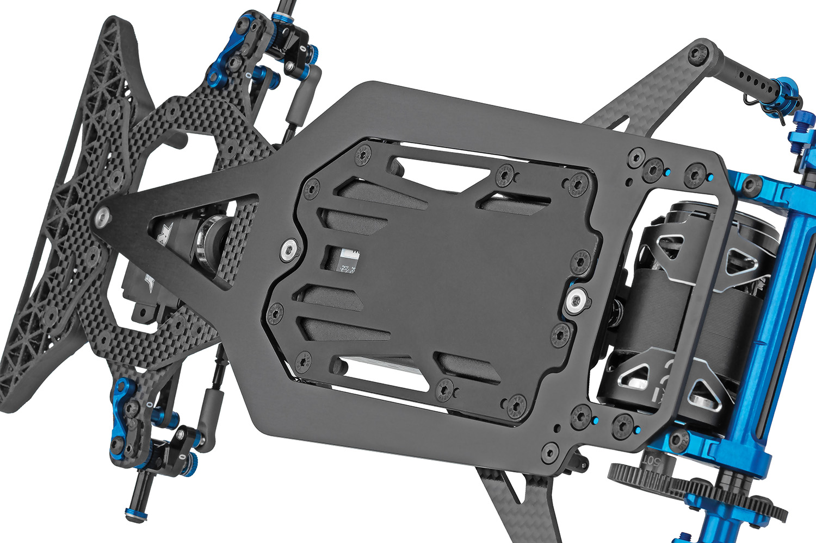
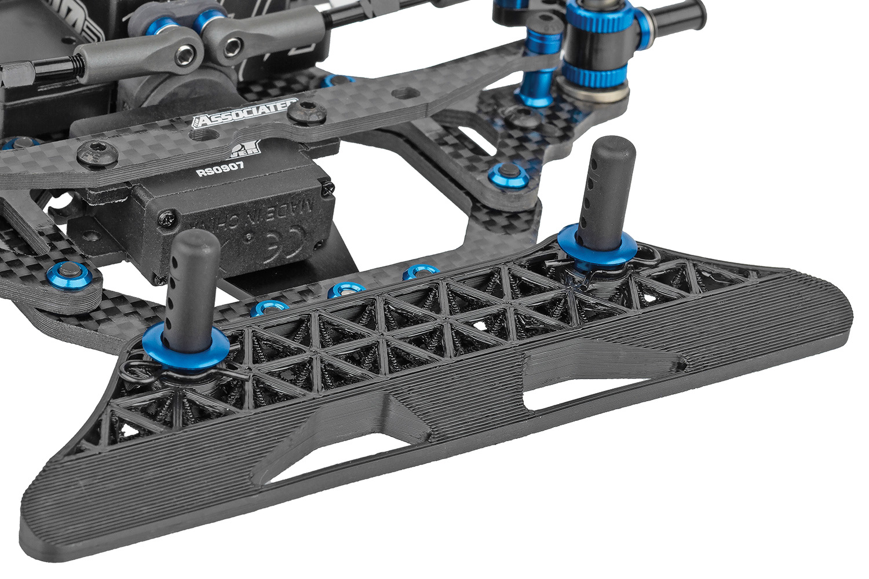

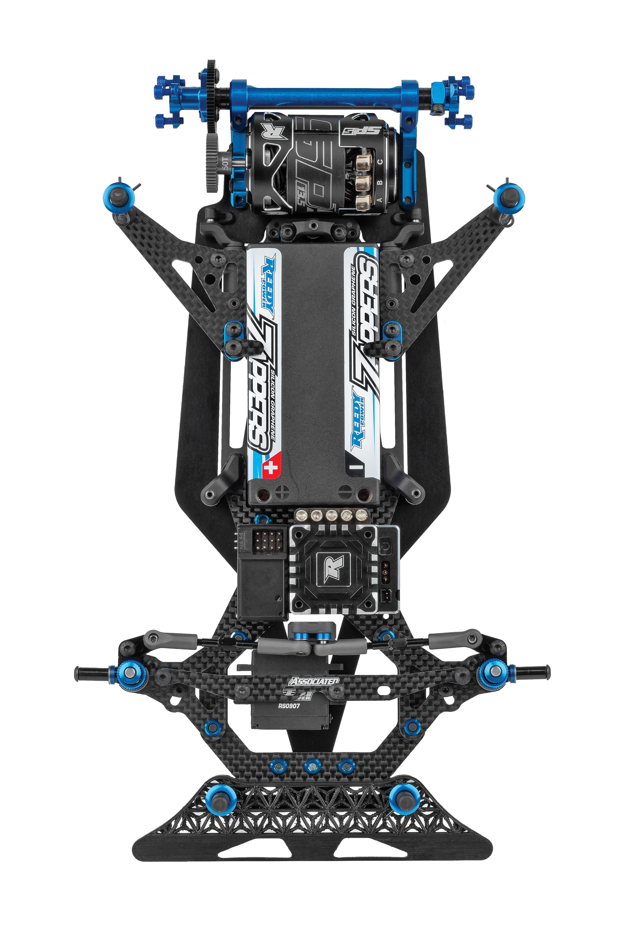

Aerodynamic TPU
Front Bumper
Hybrid Steel and Carbon-Fiber Center Chassis

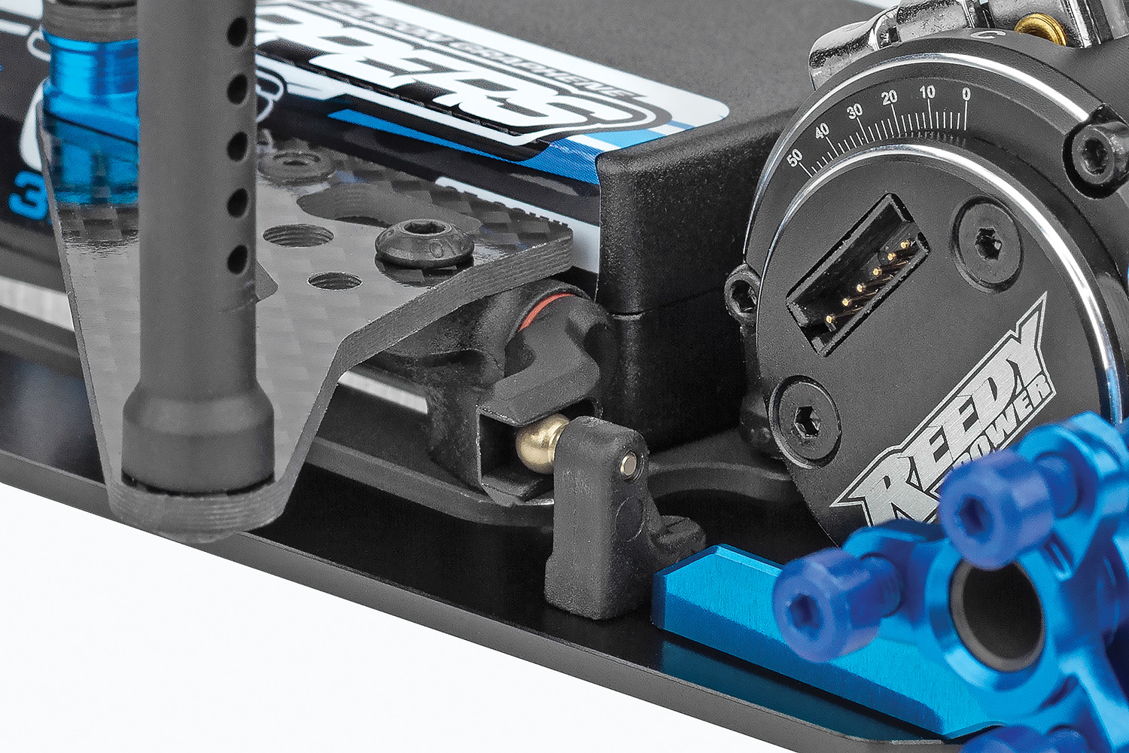
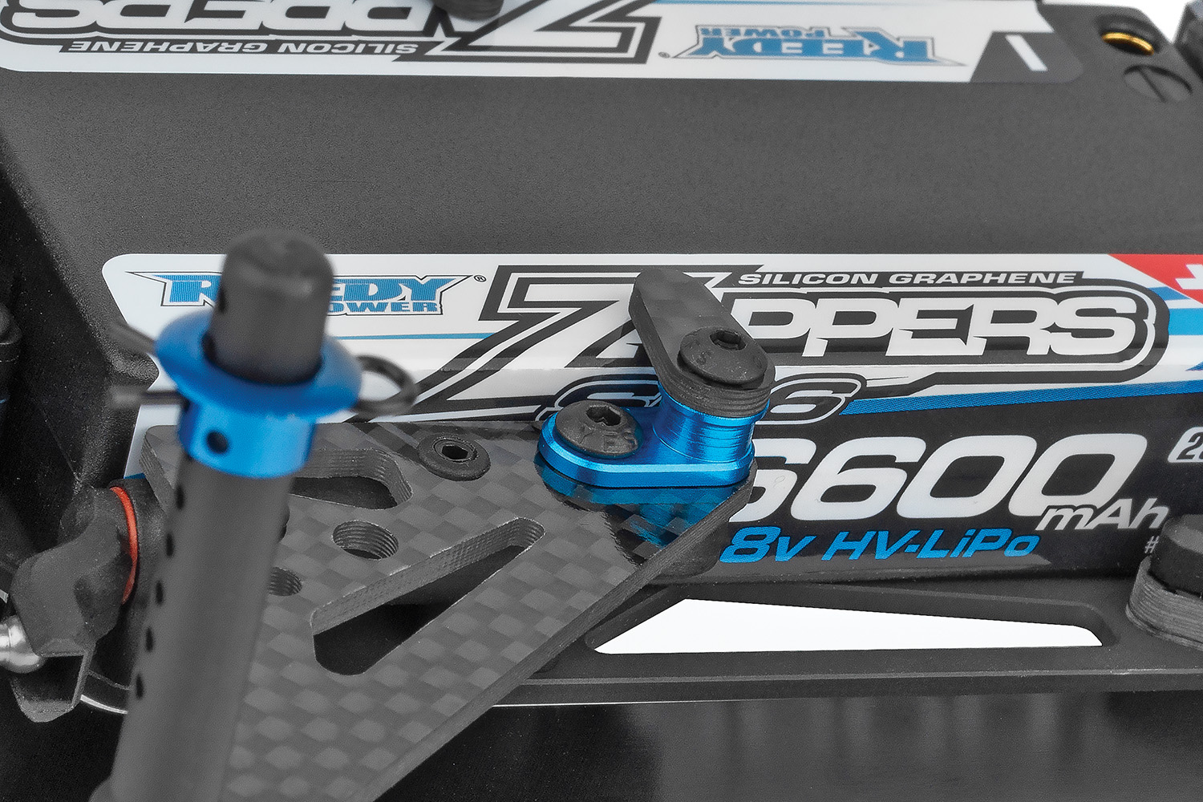

Dual Rotary
Rear Dampers
Quick Access Battery
Holder Design

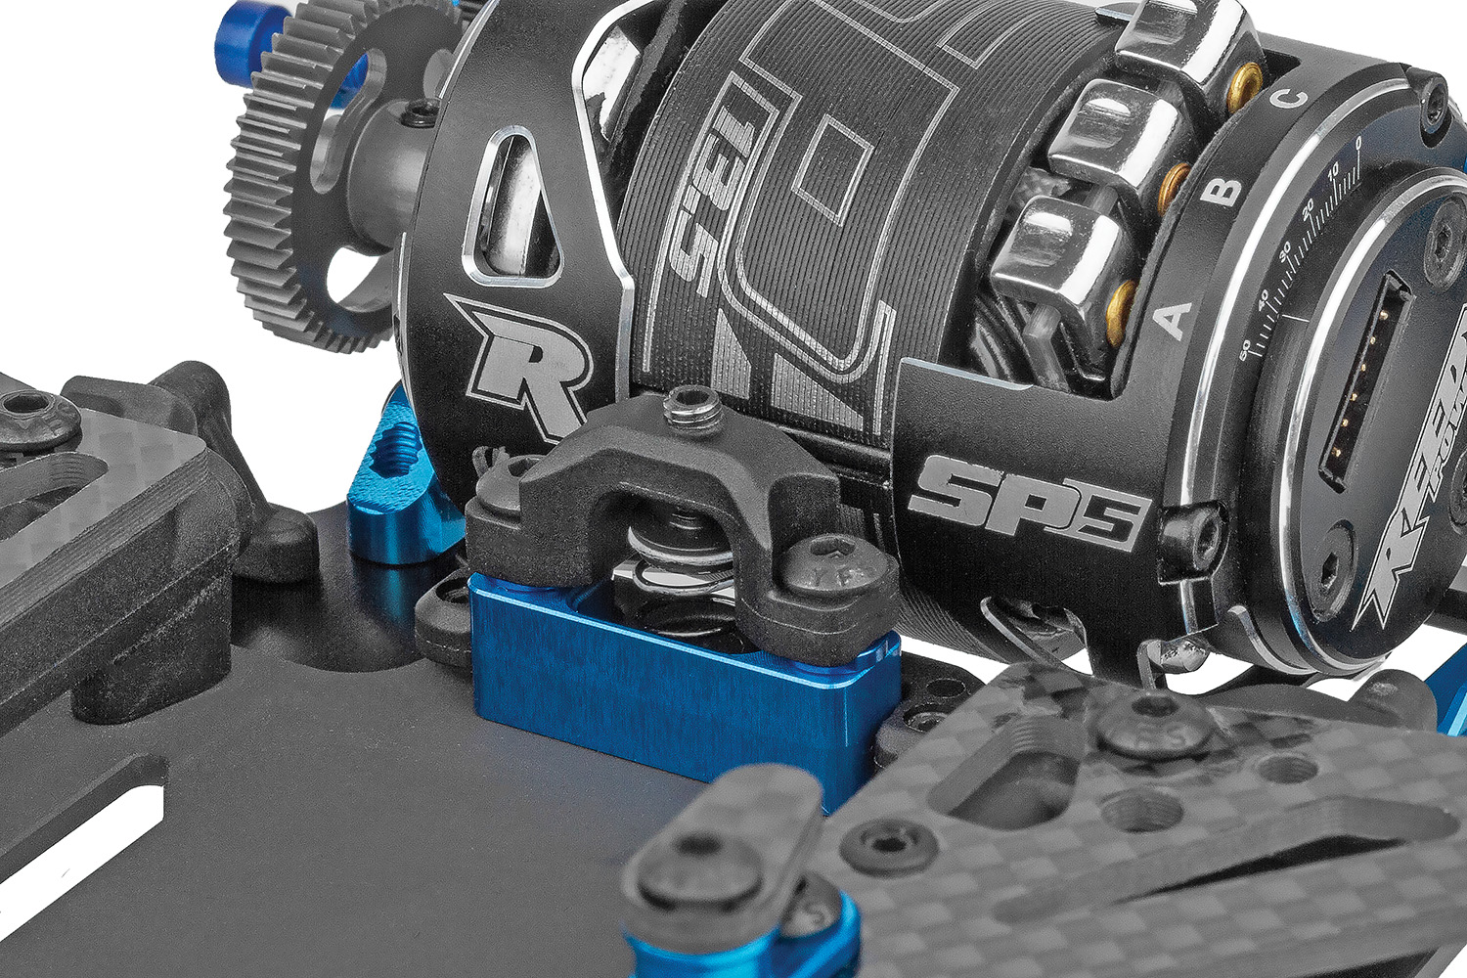
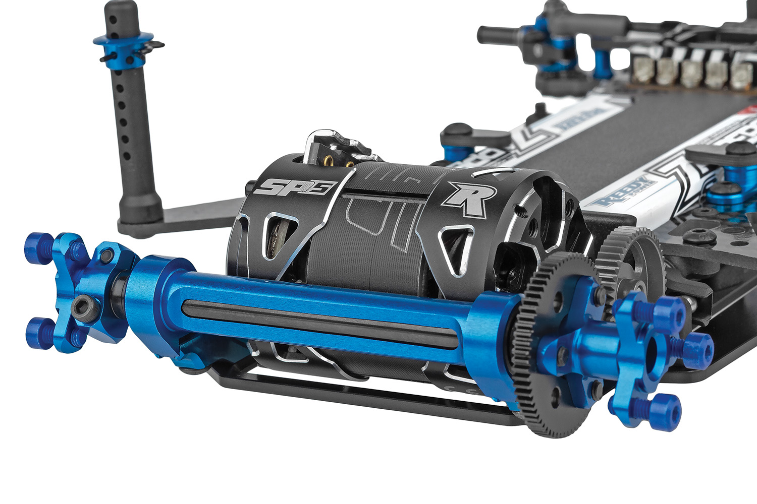

Ultra-Lightweight Hybrid
Spool Axle
Easy Rear Up Stop and Down Stop Adjustment



RC12R8 Associated Electrics Genuine Parts Available
FEATURES
  SPECS
Scale | 1:12
Power | Electric
Length | 260mm
Width | Varies*
Weight | Varies*
Wheelbase | Varies*
Gear Pitch | 64
Drive  *Final width, length and weight will vary based on electronics, tire configuration, wing position and vehicle setup. | 2WD

Motor, Battery, ESC, Servo, Receiver, Radio, Wheels, Tires and Body. Assembly and painting required.
- Hybrid Steel and Carbon-Fiber Center Chassis: Centralizes weight for an ultra-low center of gravity and optimized handling balance.
- 2mm 7075-T6 Aluminum Lower Spring Chassis: Provides a rigid, precise foundation for consistent suspension performance.
- Triple Central Pivot “No-Tweak” Design: Eliminates traditional pod tweak while maximizing cornering rigidity and chassis consistency.
- Dual Rotary Rear Dampers: Delivers smooth, controlled damping while maintaining the lowest possible center of gravity.
- Four Rear Spring Configurations: Provides an extensive range of heave and pitch-control adjustments for varying track conditions.
- Easy Rear Up Stop and Down Stop Adjustment: Allows quick and precise tuning of rear up stop and down stop settings.
- 7075-T6 Aluminum Front Spring Damper Hubs: Provides high rigidity, precise suspension movement, and exceptional durability.
- Comprehensive Front-End Adjustment System: Integrates easy screw-based droop adjustment, adjustable Ackermann geometry with plates, threaded ride-height collars, and a camber lever system to provide fast, precise, and fully accessible tuning of the car’s front suspension.
- All-New Factory Team Adjustable Servo Saver: Provides adjustable servo saver stiffness while maintaining the steering precision and servo holding power required to compete at the highest level.
- Ultra-Lightweight Hybrid Spool Axle: Combines aluminum and steel construction to reduce rotating mass while maintaining strength and durability.
- Aerodynamic TPU Front Bumper: Supports the outer corners of the body to increase front aerodynamic load while providing effective impact protection.

- Motors (#27481 Sonic 540-SP5 13.5T Brushless Motor)
(#27480 Sonic 540-SP5 17.5T Brushless Motor)
- Servo (#27177 Reedy Power RS0907 1:12 Hi-Speed Servo)
- Battery (#27614 Reedy Power STOCKSTAR 8300mAh 3.7V 160C 1:12)
- Charger (#27203 Reedy 1416-C2L Dual AC/DC Competition Balance Charger

Other Helpful Items:

- Silicone Shock Fluid (Refer to catalog for complete listings)
- Silicone Diff Fluid (Refer to catalog for complete listings)
- Body Scissors (AE Part # 1737)
- Reamer (AE Part #1499) / Hole Punch
- FT Wrench Set (AE Part #1519)
- Hobby Knife
- Needle Nose Pliers
- Wire Cutters
- Soldering Iron
- Calipers or a Precision Ruler

Recommended Electronics:

Items required for operation:

UPC | Part No. | Description | MSRP | MAP | Pieces Per Case | Origin | Available
784695040236 | 4023 | RC12R8 Kit | $599.99 | $399.99 | 12 | TW | Nov 2026
Download all zipped photos here: https://www.RC10.com/RC12R8_Images/(11.1MB) Link is active for 30 days.
Please refer to our MAP Policy here: https://img2c.associatedelectrics.com/pdf/map-policy.pdf

