For Immediate Release: June

New! Reedy Sonic 540-M4 10.5 Drift Edition Motor

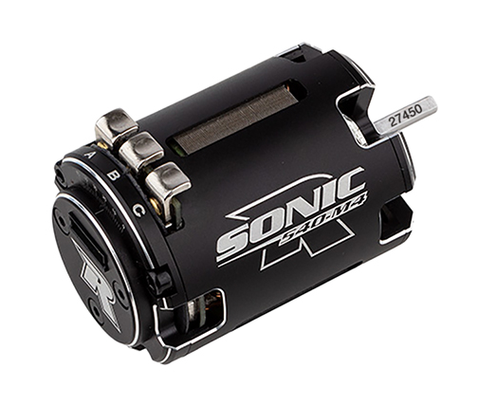
(Pictured: Reedy Sonic 540-M4 10.5 Drift Edition Motor #27502)

Reedy Power, a leader in high-performance R/C electronics, is thrilled to announce the launch of the Sonic 540-M4 10.5 Drift Edition motor. Meticulously engineered for the demands of R/C drifting enthusiasts and building on the legacy of the acclaimed Sonic 540-M4 series, this motor incorporates drift-specific tuning to deliver unmatched control and style on the track.

Developed in collaboration with top R/C drifters, the Sonic 540-M4 10.5 Drift Edition motor is optimized for the precise throttle response and consistent power delivery critical for flawless drift execution. The motor retains the proven linear powerband and exceptional feel of the Sonic 540-M4 but comes equipped with Reedy Power’s #27450 12mm rotor which further enhances control throughout the motor’s RPM range.

“Drifting demands precision and finesse, and the Sonic 540-M4 10.5 Drift motor is engineered to give drivers the edge they need to push their skills to the limit,” said Reedy Power Manager Rick Hohwart. “Our team worked closely with the drifting community to create a motor that delivers the perfect balance of control and power, letting drivers focus on style and execution.”

The Sonic 540-M4 10.5 Drift Edition motor is now available through authorized Reedy Power retailers and online at www.reedypower.com.

Features Specifications
Cells | 1-2S LiPo
Diameter (mm) | 35.9
Length (mm) | 50.3
Shaft Diameter (mm) | 3.15
Weight (g) | 164
Rotor | #27450 12.0mm
Bearings | 1/8 x 3/8 x 5/32 (x1), 1/8 x 5/16 x 9/64 (x1)
- CNC machined lightweight can
- Drift specific stator
- Low-resistance, silver plated solder tabs
- Optimized air cooling
- Dual precision ball bearings
- #27450 Balanced rotor
- Adjustable timing
- Completely rebuildable
- Track proven

UPC | Part No. | Description | MSRP | MAP | COO | Available
784695275027 | 27502 | Reedy Sonic 540-M4 10.5 Drift | $199.99 | $119.99 | CN | 

