For Immediate Release: February 2026

#8083 RC10DS w/Rally Body Kit
1:10 Scale RC10 Dual Sport Competition 2WD Kit

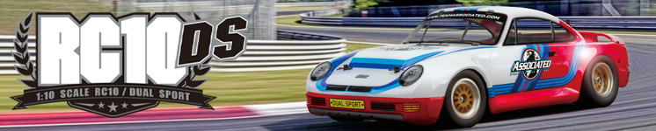

ELECTRIC ■ ON ROAD ■ 1:10 SCALE ■ 2 WHEEL DRIVE ■ KIT

DUAL SPORT FUN HAS JUST BEGUN
At Team Associated we don’t think that parking lot racing means a car that handles like a shopping cart.

Our RC10 Dual Sport was engineered to deliver real racing action and performance to the type of less-than-ideal track conditions RC drivers frequently encounter.

Totally new, fully independent suspension and the World Champion Stealth® transmission have been brilliantly mated to the classic RC10 aluminum alloy tub to produce an RC race car of stunning performance.

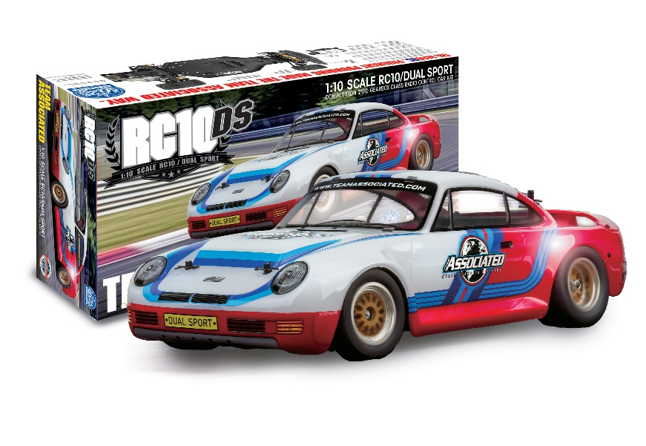

That’s why the RC10DS was built around the most enduring chassis ever, the RC10 alloy tub.

Computer-designed, race-tuned suspension, semi-pneumatic tires that hook up on almost any hard surface and the World Championship Stealth® gearbox let the RC10DS race on surfaces that most pan cars can’t even run on.

The Dual Sport formula lets you convert an RC10, build a full-race version, or start with a complete kit with body. Put the fun back into RC racing. Build a real racing machine for the parking lot, the RC10DS from Team Associated.

RACE YOUR RC10DS ANYWHERE YOU WANT.

Turn a cul-de-sac into a speedway, a parking lot into a road course. The new DS runs on semi-pneumatic tires that hook up on almost any hard surface. In fact, the RC10DS can race on surfaces that most pan cars can’t even run on with its fully tunable, 4-wheel independent suspension. With handling and durability superior to expensive 4WDs!

RALLY RACING.

The RC10DS RALLY body is vacuum-formed clear polycarbonate and ready to paint and detail.

The DS kit gives you everything you need to go fast on asphalt: the classic and near indestructible aircraft alloy chassis, scale road racing wheels with mesh inserts, molded racing tires, suspension arms, our alloy bodies, custom racing oil-filled shocks, shock towers, anti-roll bars, plus all the necessary high-quality hardware. Step-by-step instructions make assembly easy for the beginner and race-tuning tips are provided for the advanced racer.

GO DIRECTLY TO THE HEAD OF THE CLASS.

With Team Associated’s RC10DS you’re entering a new and highly competitive class of RC racing with the chassis based on one of the most successful RC cars ever, our RC10. Twelve times a World Champion in off road racing, the original RC10 provides the backbone of the new DS and ensures its racing heritage in the 2WD gearbox class.

The Dual Sport puts the fun back into RC racing. Build a real racing machine for the parking lot, the RC10DS
from Team Associated!

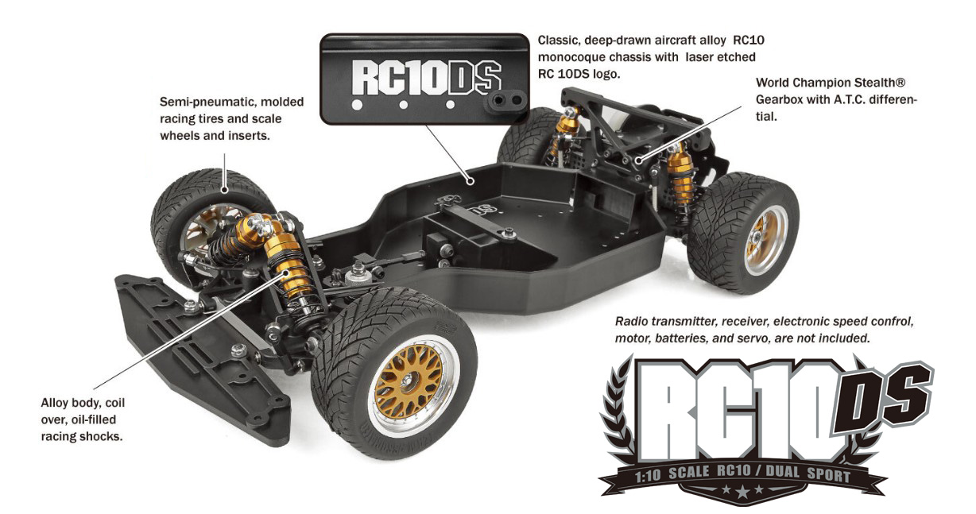

FEATURES |  | SPECIFICATIONS

- Molded composite rear shock tower
Scale | 1:10
Power | Electric
Length | 480.1mm (18.9")
Width | 223.5mm (8.8")
Weight | Varies*
Wheelbase | 261.1mm (10.28")
Transmission Ratio | 2.25:1

*Weight varies depending on electronics added.

ITEMS NEEDED TO COMPLETE

- 1:10 scale electric motor and electronic speed control
- 7.4V-7.6V 2S LiPo with “shorty” battery dimensions (standard or low-profile height)
- Battery charger suited for one of the batteries mentioned above
- 2-channel surface transmitter
- 2-channel receiver
- Steering servo
- Spray paint for Lexan™ body

- Stealth transmission with A.T.C. slipper
- Molded ultra-stiff composite suspension arm, front
and rear
- Adjustable rear toe in
- Black anodized aluminum tub chassis
- Scale mesh style chrome wheels
- Adjustable front and rear anti-roll bars
- Adjustable servo saver bellcrank steering
- Low kick-up angle for superior steering response
- High-impact front bumper
- Adjustable height body mounts

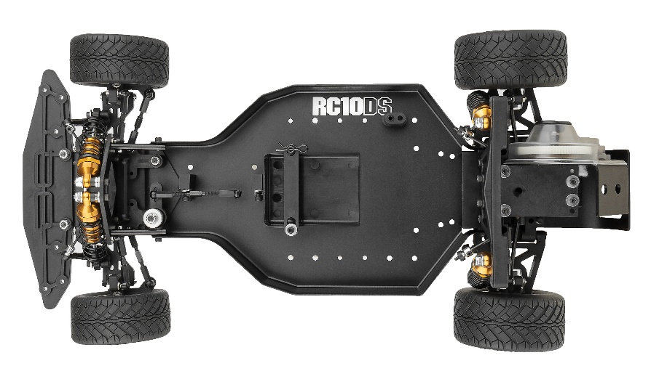

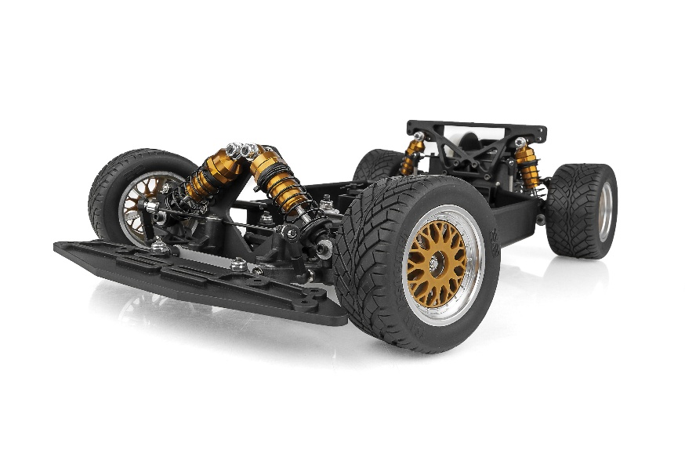

CATALOG INFORMATION

UPC | Part No. | Description | Pieces Per Case | Origin | MSRP | MAP | Available
784695080836 | 8083 | RC10 DS Rally | 4 | TW | $524.99 | $349.99 | March 26

Download all zipped photos here: https://rc10.com/RC10DSRallyImages/ (5.19MB). Link is active for 30 days.
Please refer to our MAP Policy here: https://img2c.associatedelectrics.com/pdf/map-policy.pdf

