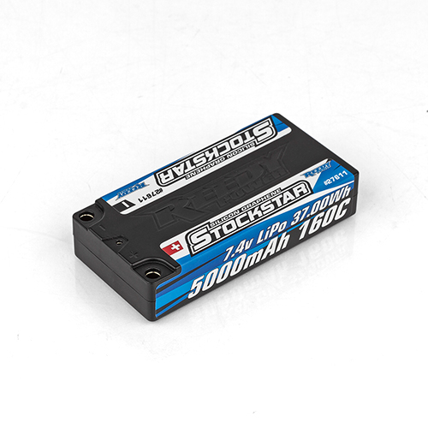
For Immediate Release: December 2025
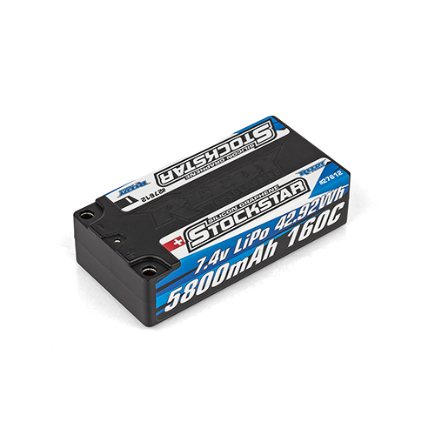
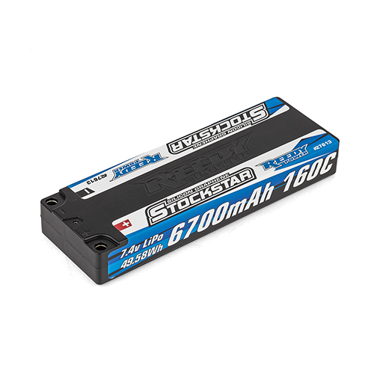
NEW! Reedy Stockstar Competition LiPo Batteries

(Pictured: #27611, #27612, #27613 Reedy Stockstar Competition LiPo Batteries)

Reedy Power, a leading innovator in high-performance electronics for R/C cars, is proud to announce the launch of its all-new Stockstar battery line. Specifically designed to meet the demanding power requirements of stock class RC car racing, Stockstar batteries deliver unmatched power output and efficiency for racers competing under strict stock class rules.

Reedy’s Stockstar LiPo batteries incorporate new advancements in cell formulation, manufacturing and construction to reduce internal resistance, improve average discharge voltage, and increase 8.0V discharge times.

Three configurations, which cover the needs of most stock class 1:10 on-road and off-road applications while also remaining a high-power alternative for modified class racers, are available with more to come! A durable hard case features embedded low-resistance 5mm sockets to reduce power-robbing resistance. Male ESC connectors are included!

"Stock class racing is all about producing maximum power with minimum fade," said Rick Hohwart, Reedy Power manager. "Stockstar batteries were developed in close collaboration with experienced stock class racers to push the boundaries of what's possible within class regulations. We're excited to give competitors the edge they need to win, whether at local club events or national and international competitions."

LiPo battery technology continues to evolve and Reedy is committed to bringing improved performance to the masses.

Key features include:

- State-of-the-Art Formulation and Construction: New advancements reduce internal resistance, improve average discharge voltage, and increase 8.0V discharge times.
- Low IR with Elevated Average Voltage: Unmatched power output and efficiency for racers competing under strict stock class rules.
- Durable hard case with low-resistance connectors: Embedded low-resistance 5mm sockets reduce power-robbing resistance.
- Stick and Shorty Configurations: Three configurations cover the needs of most 1:10 stock class racers, with more to come!
- Built to ROAR/EFRA/BRCA/IFMAR specifications: Approvals pending.

Specifications
Model Number | 27611 | 27612 | 27613
Capacity | 5000mAh | 5800mAh | 6700mAh
Voltage | 7.4 | 7.4 | 7.4
Dimensions | 96x47x20mm | 96x47x25mm | 139x47x19.5mm
Max. Charge Rate | 3C | 3C | 3C
Discharge Current | 160C | 160C | 160C
Weight | 178g | 235g | 250g
Socket | 5mm | 5mm | 5mm

UPC | Part No. | Description | MSRP | MAP/Web | Available
784695 276116 | 27611 | Stockstar 5000mah 7.4V 160C LP Shorty | $137.99 | $85.99 | Dec. 2025
784695 276123 | 27612 | Stockstar 5800mah 7.4V 160C Shorty | $158,99 | $99.99 | Dec. 2025
784695 276130 | 27613 | Stockstar 6700mah 7.4V 160C LP Stick | $171.99 | $113.99 | Dec. 2025

