For Immediate Release: June 2026

New! Reedy Power 480mAh 65C 7.4V 1:28 LiPo Battery
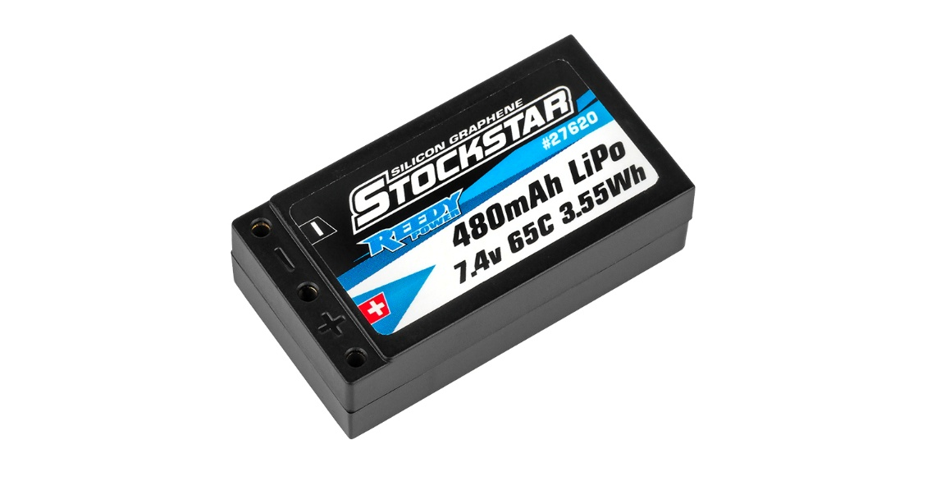

Reedy Power, a leading name in RC performance electronics, is proud to announce the launch of its latest battery, a 480mAH 65C 7.4V LiPo designed specifically for 1:28 micro racing enthusiasts. Engineered for maximum power, durability, and efficiency, this cutting-edge battery is set to redefine performance standards in the increasing competitive world of 1:28 micro racing.

An impressive 65C rating and 480mAh capacity provides explosive power and run time across all 1:28 racing classes. Weighing just 18g, this lightweight battery ensures optimal vehicle handling, making it ideal for racers seeking a competitive edge over an entire lap.

A high quality, durable hard case helps prevent damage while embedded 2mm socket connectors keep power robbing resistance to a minimum.

LiPo battery technology continues to evolve, and Reedy Power is committed to bringing improved performance to the masses.

Not compatible with #20168
.
Features
- State-of-the-art LiPo chemistry
- Updated formulation and construction
- Heavy-duty internal construction
- High capacity
- Reduced IR with elevated average voltage
- Proven reliability and cycle-life
- Durable hard case with low-resistance connectors

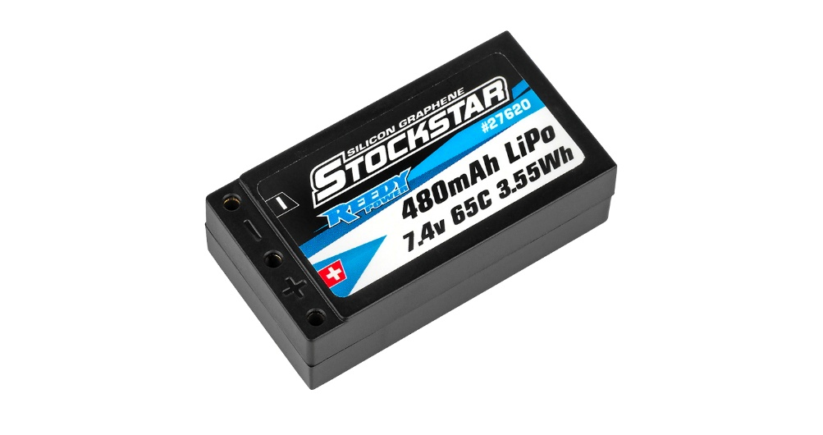

Specifications
Model Number | 27620
Capacity | 480mAh
Voltage | 7.4V (2S)
Dimensions (mm) | 44.45x25.4x12.7
Max. Charge Rate | 1.2A
Discharge Current | 65C
Weight (g) | 23
Socket | 2mm/2mm (included)

UPC | Part No. | Description | MSRP | MAP/Web | Available
784695276208 | #27620 | Reedy Stockstar 480mah 65c 7.4v 1:28 Stick | $39.99 | $24.99 | Now

