For Immediate Release: June 2026

RC10 Sprint Edition Kit #6057
1:10 Scale 2WD Electric Off-Road Sprint Car Kit

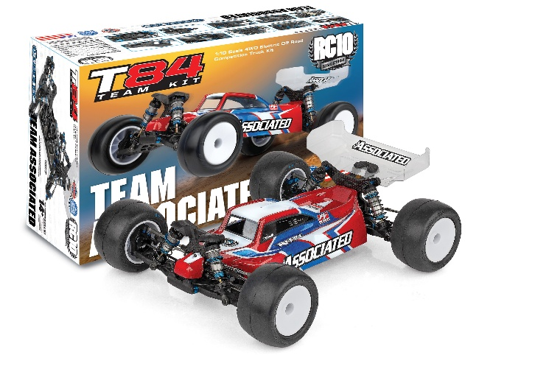
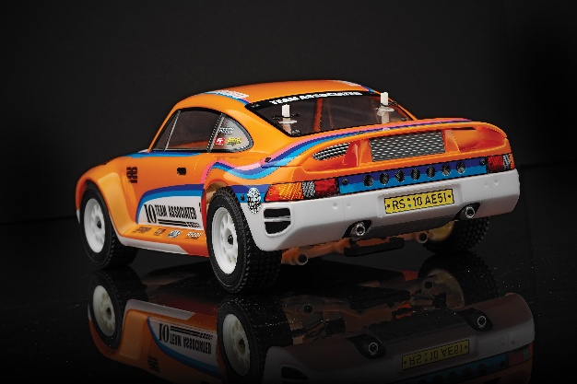
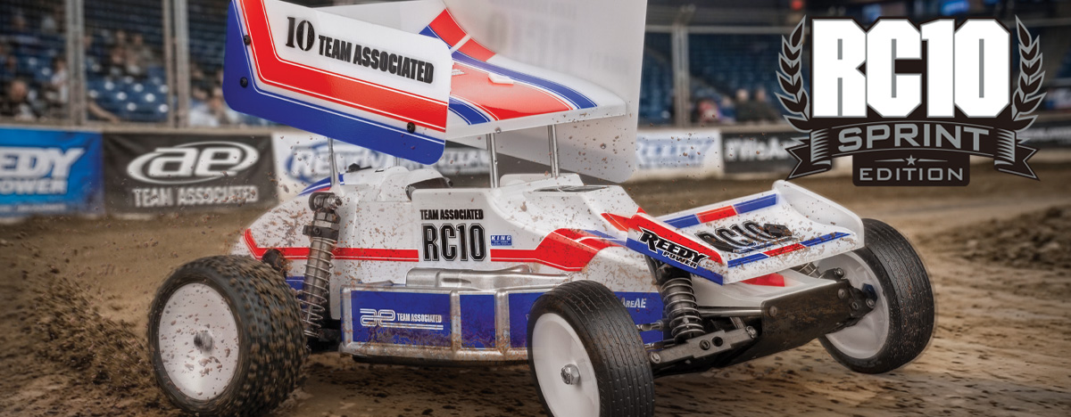

ELECTRIC ■ 1:10 SCALE ■ 2 WHEEL DRIVE ■ OFF ROAD ■ KIT
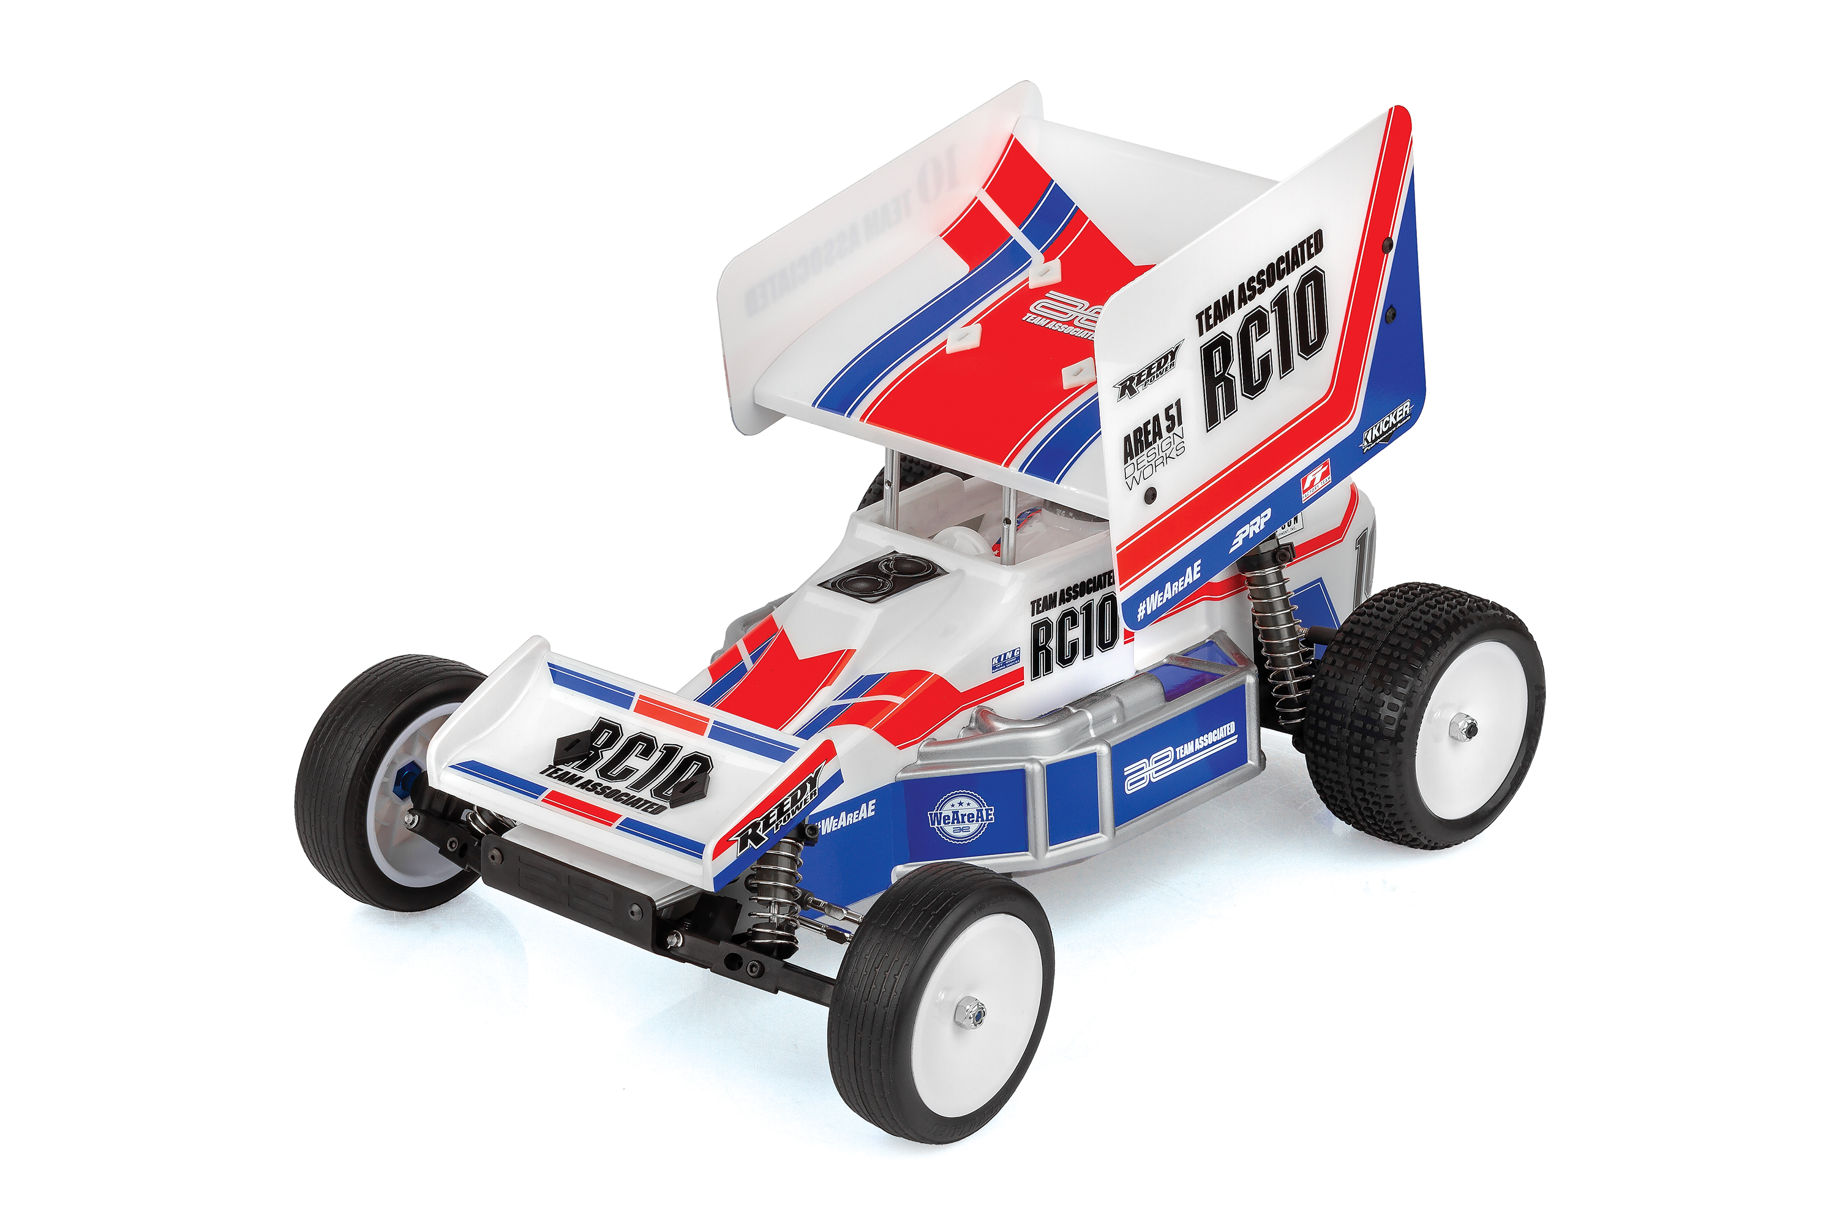
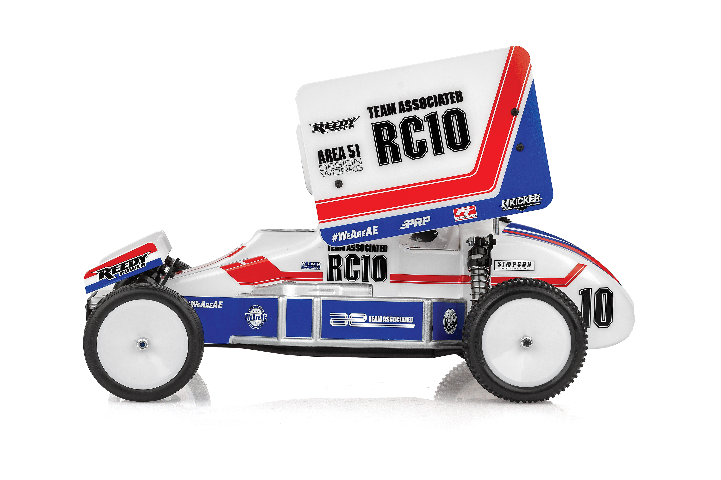
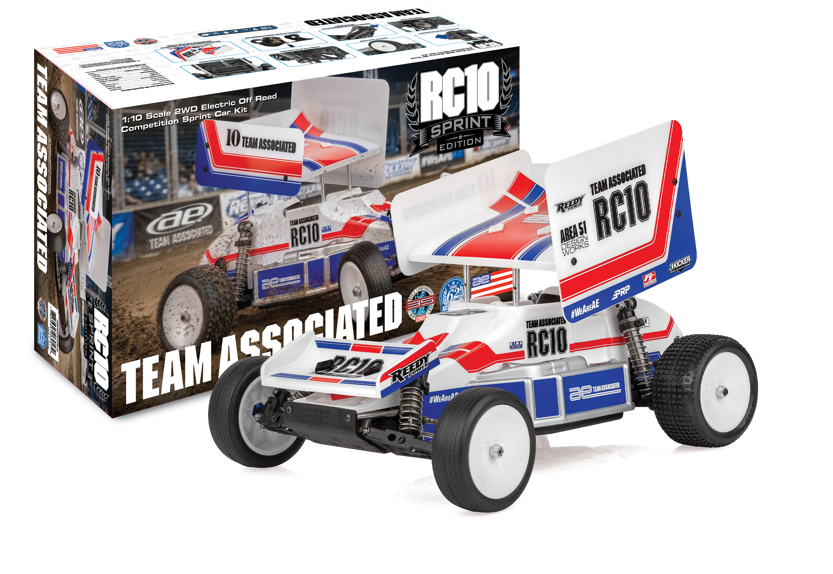
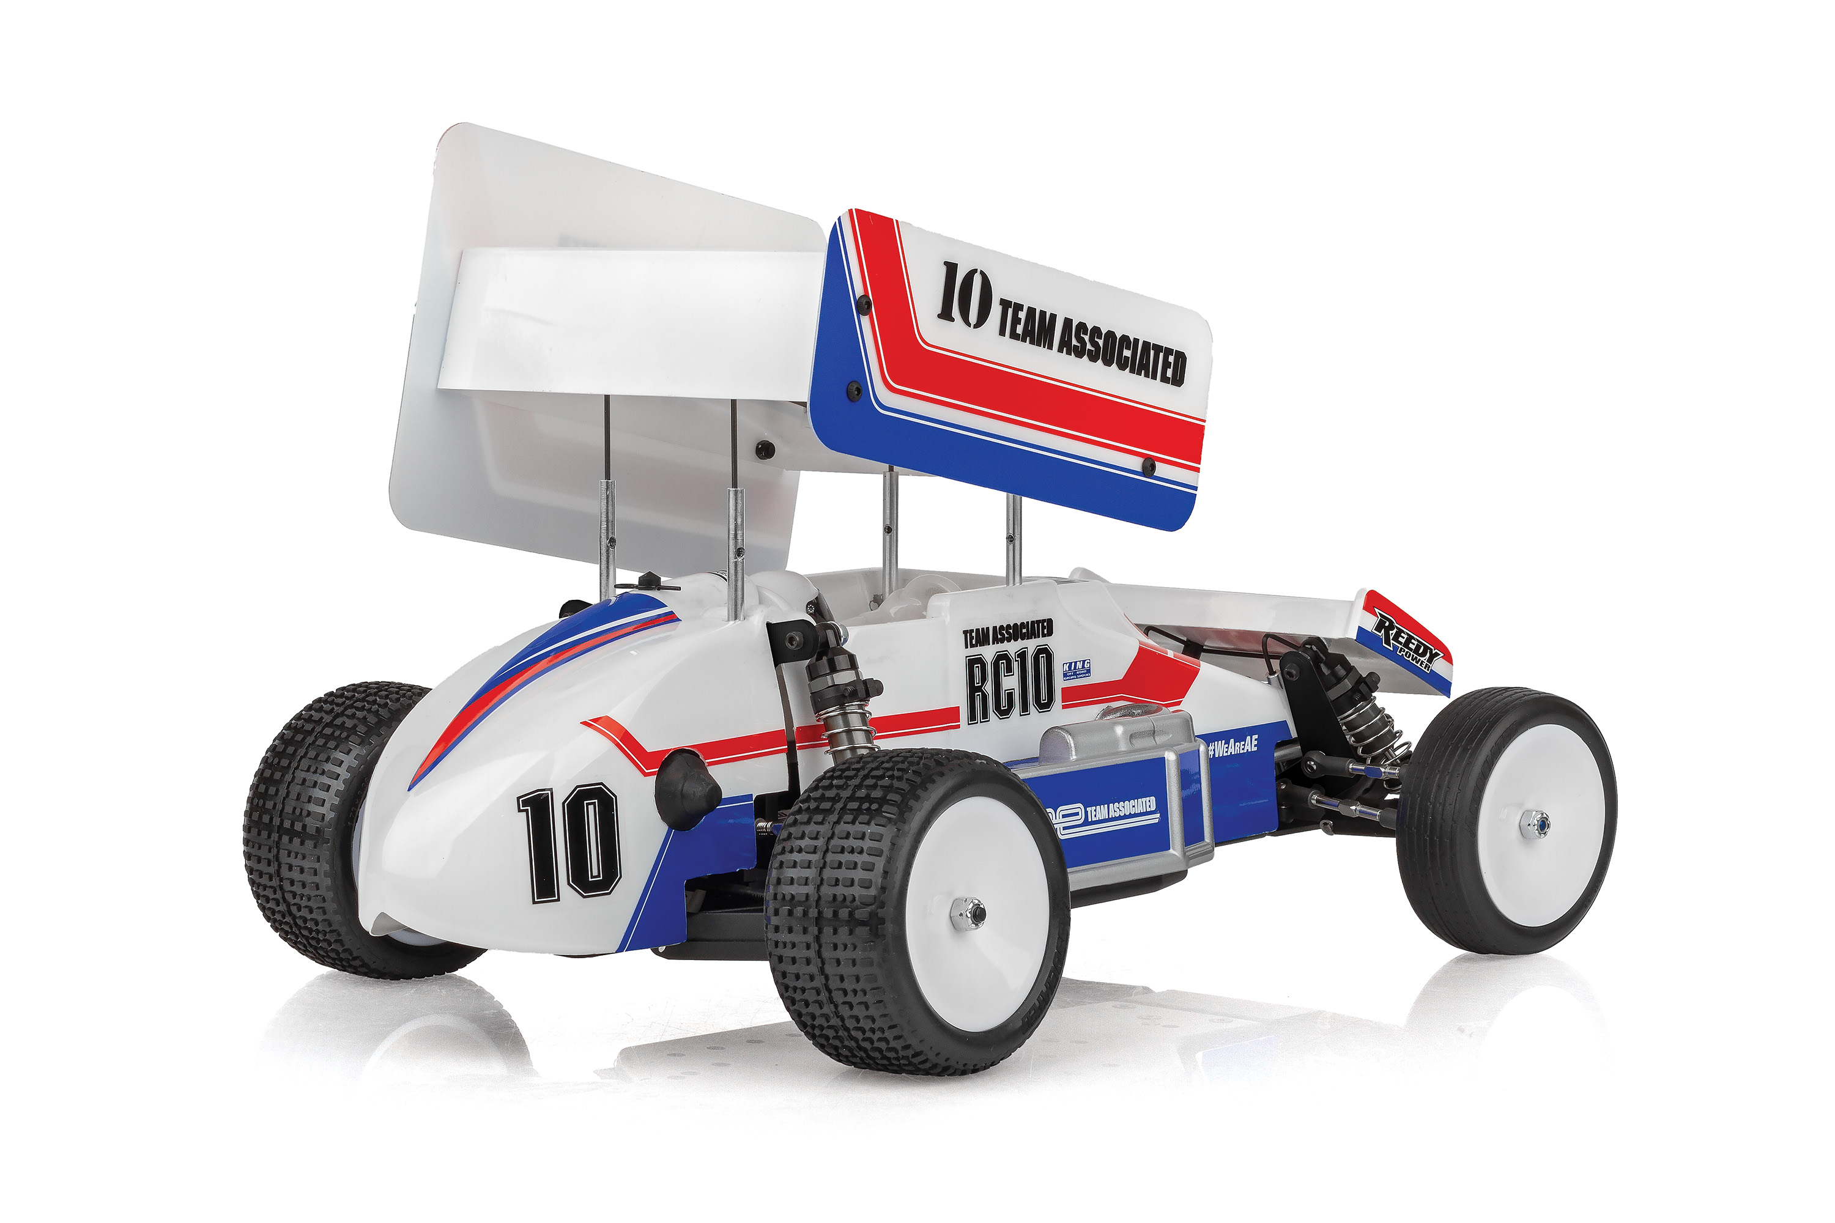
The RC10 isn’t just a car; it’s the foundation of championship racing. Now, Team Associated takes that winning soul to the oval. The all-new RC10 Sprint Car combines classic pedigree with modern, heavy-duty precision, designed to slide sideways and stay pinned to the cushion.
The Icon, Re-Engineered.
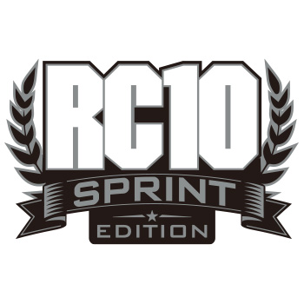
Built for the Big Show.

At its core sits a rugged Black Anodized 6061 Aluminum chassis, nose plate, and motor plates—providing the rigid backbone needed for high-torque oval combat.

We’ve paired the legendary World’s Car bellcrank steering with an all-new Stealth Retro Transmission and the V2 slipper system, ensuring every ounce of power is delivered smoothly to the clay.

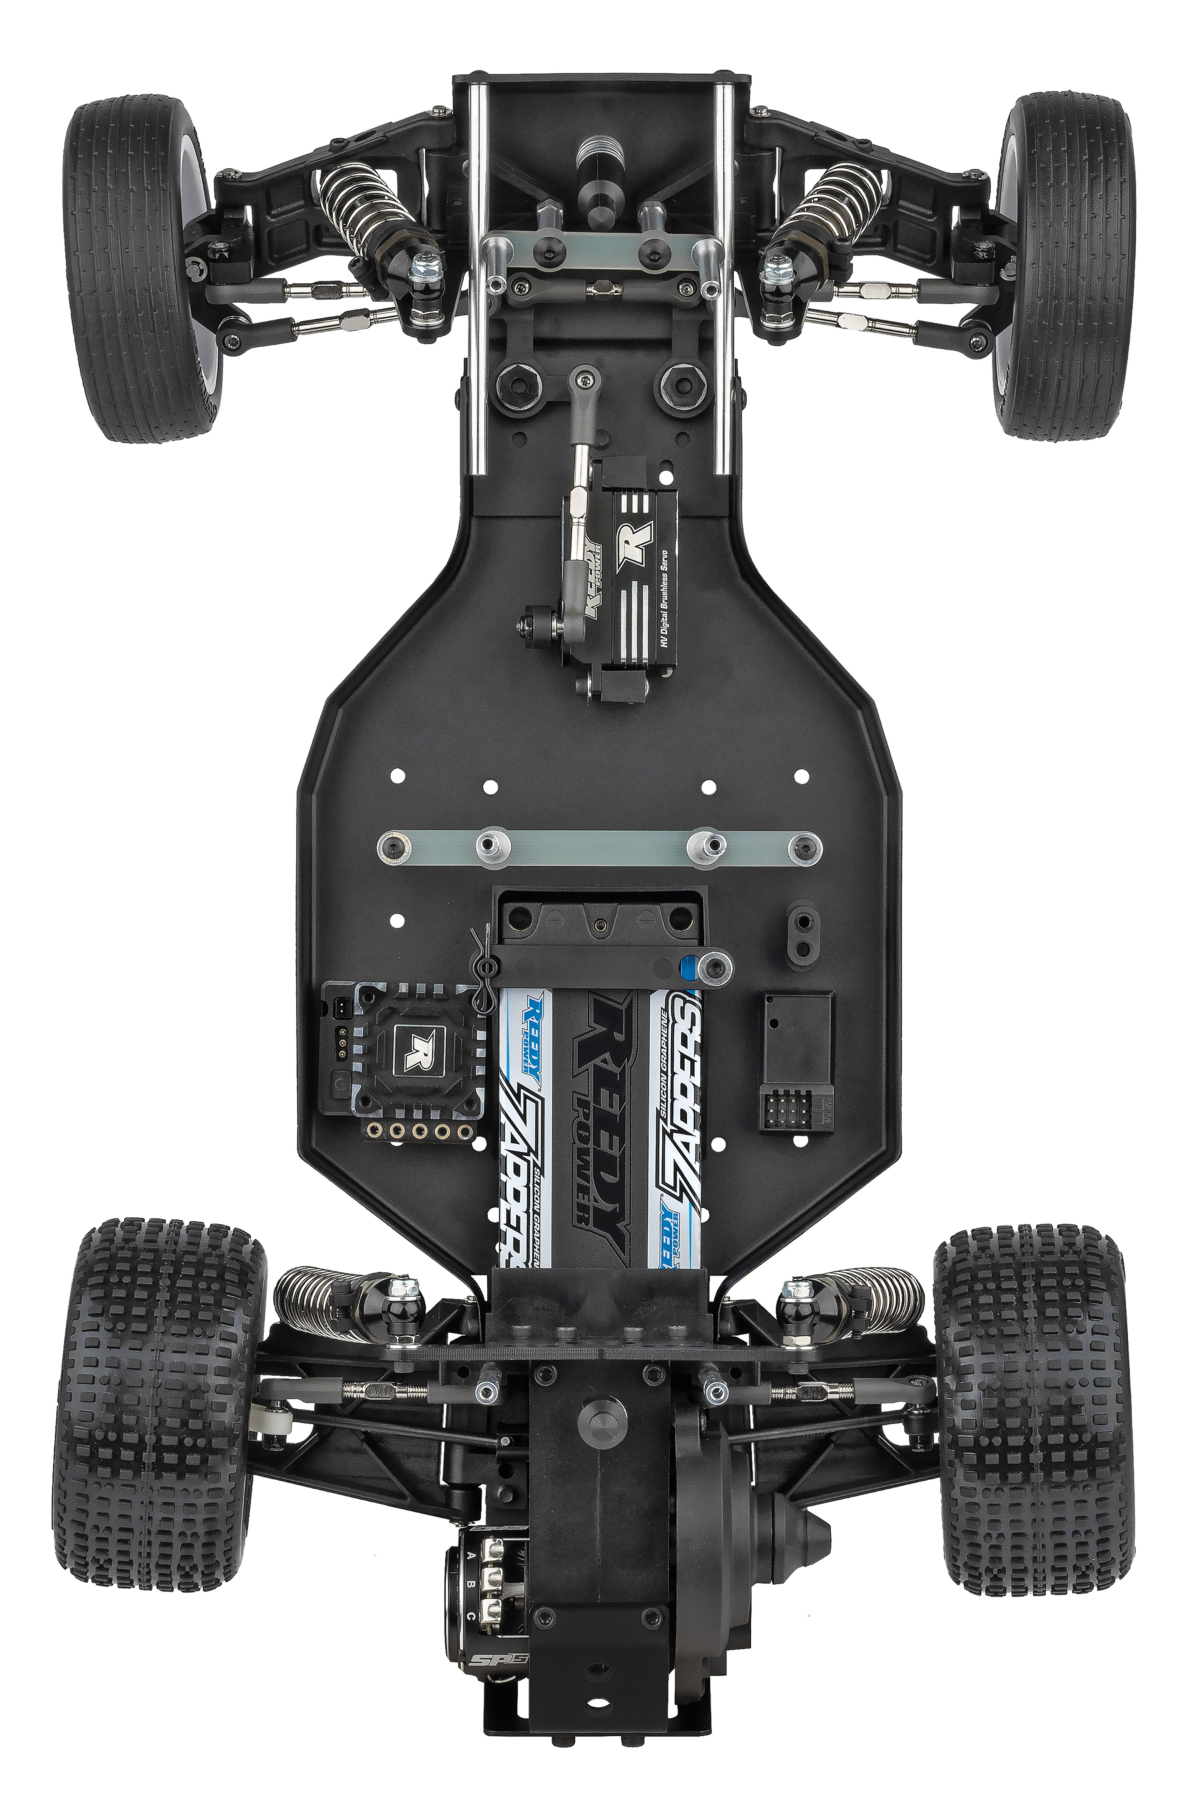

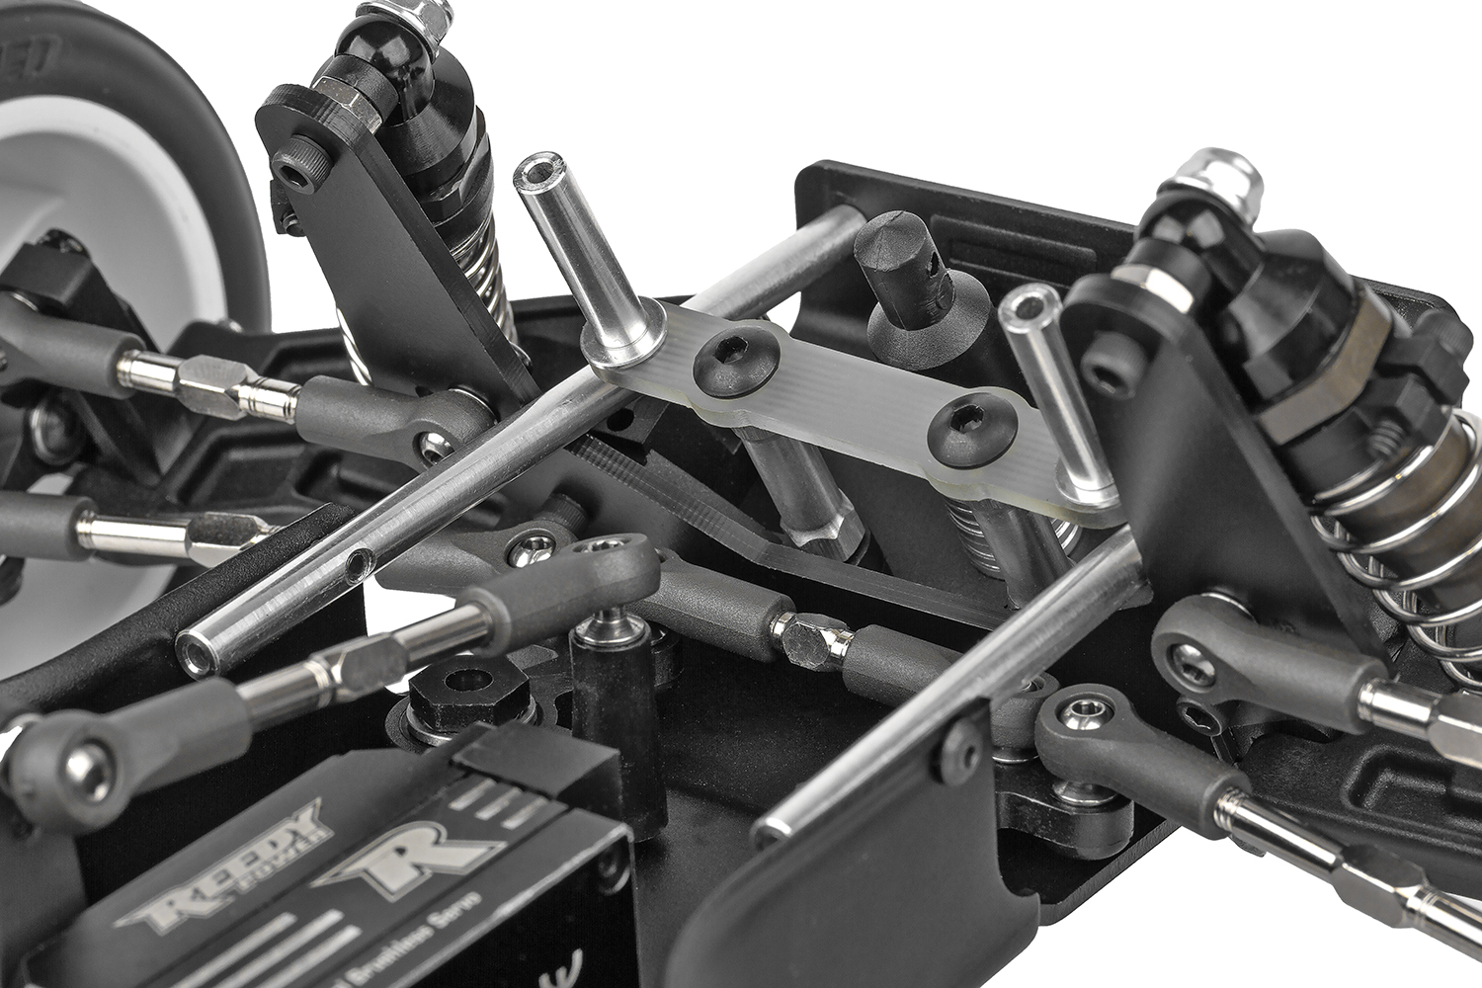
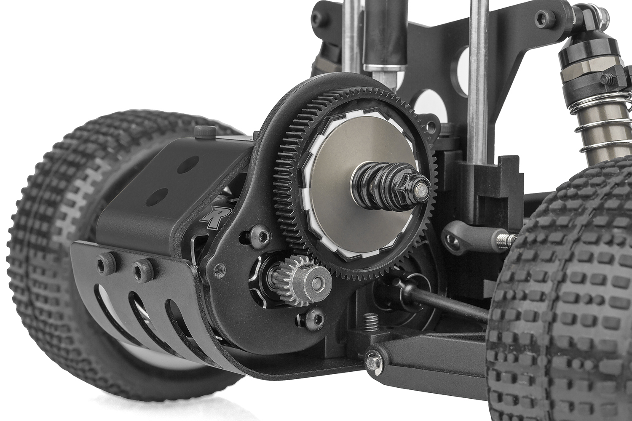

Precision in the Dirt.

Dominate the groove with a refined suspension geometry featuring durable long front arms, fiberglass shock towers, and Hard Anodized shock bodies. The all-new Factory Team 12mm hex system—from the steering blocks to the B7 wheels—offers a modern, rock-solid interface for maximum traction.

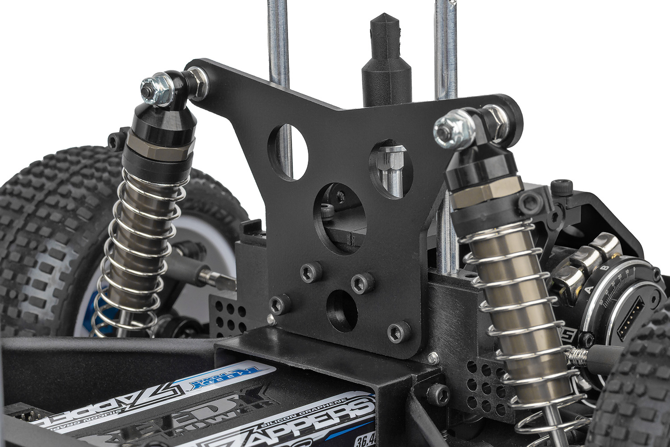
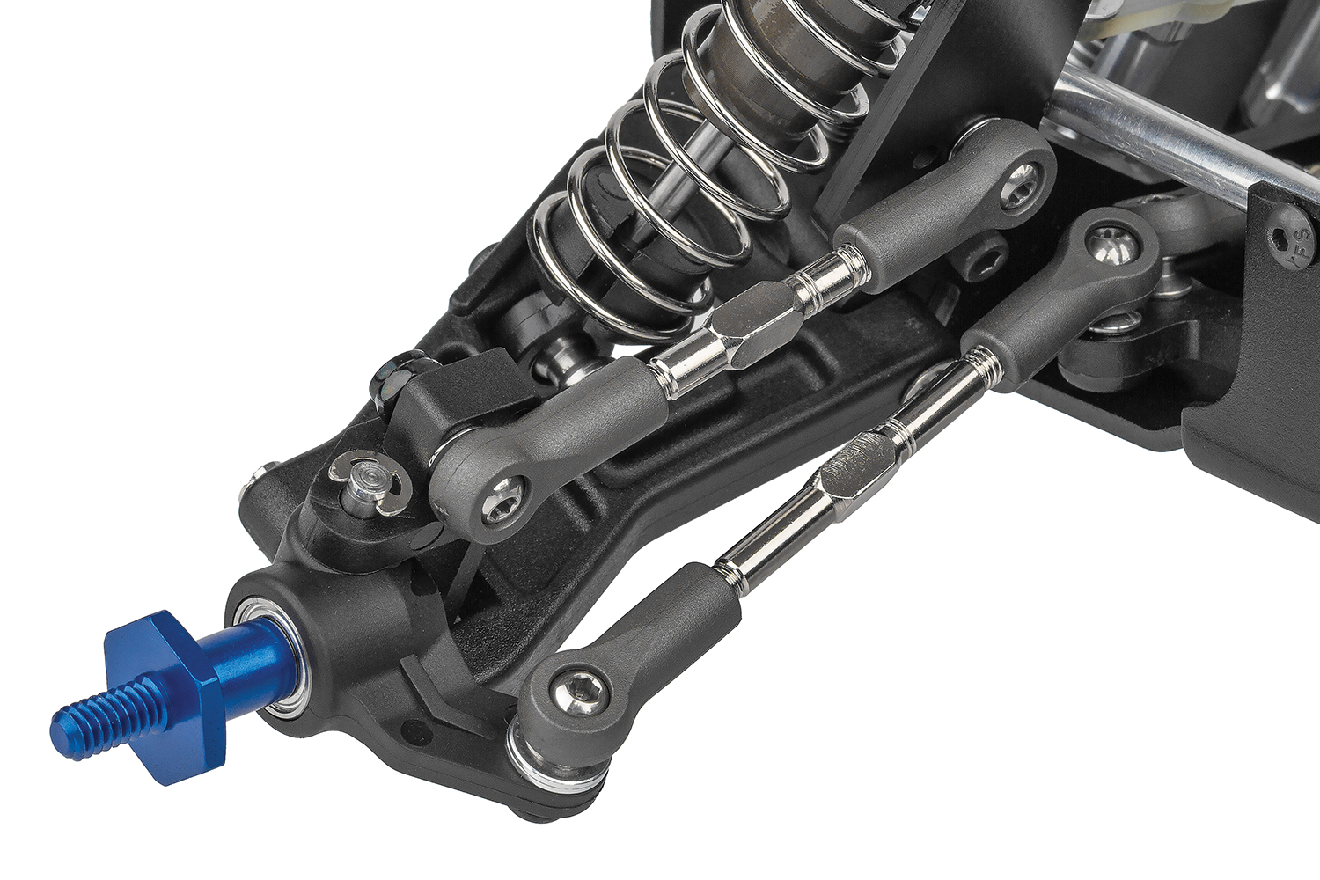

Aerodynamic Dominance.
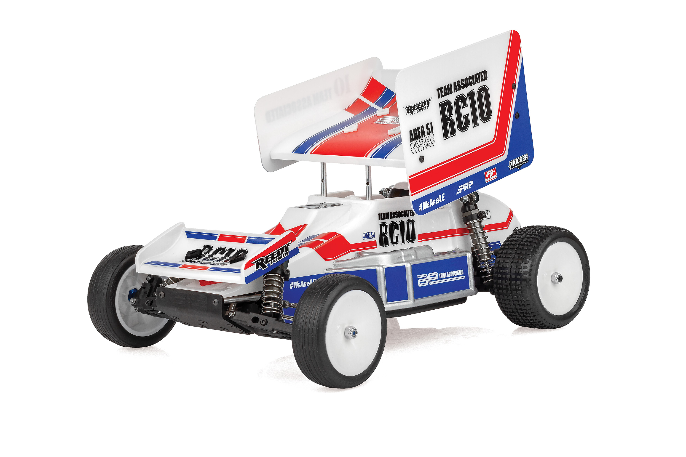

Cut through the air and plant the rear with the all-new sprint car wing mounting system and signature clear body.

Whether you’re tuning with the multiple rear arm mounts or the included 0° and 1.5° hubs, this machine is fully adjustable and
race-ready with heavy-duty metric hardware and full ball bearings throughout. World Champion meets the grit of the oval track.
This is the RC10 Sprint Car. Own the Oval.

Due to ongoing R&D, photos may not match final kit. Vehicle shown on these pages equipped with items NOT included in kit: Motor, transponder, servos, receiver, wheels, tires. Assembly and painting required.
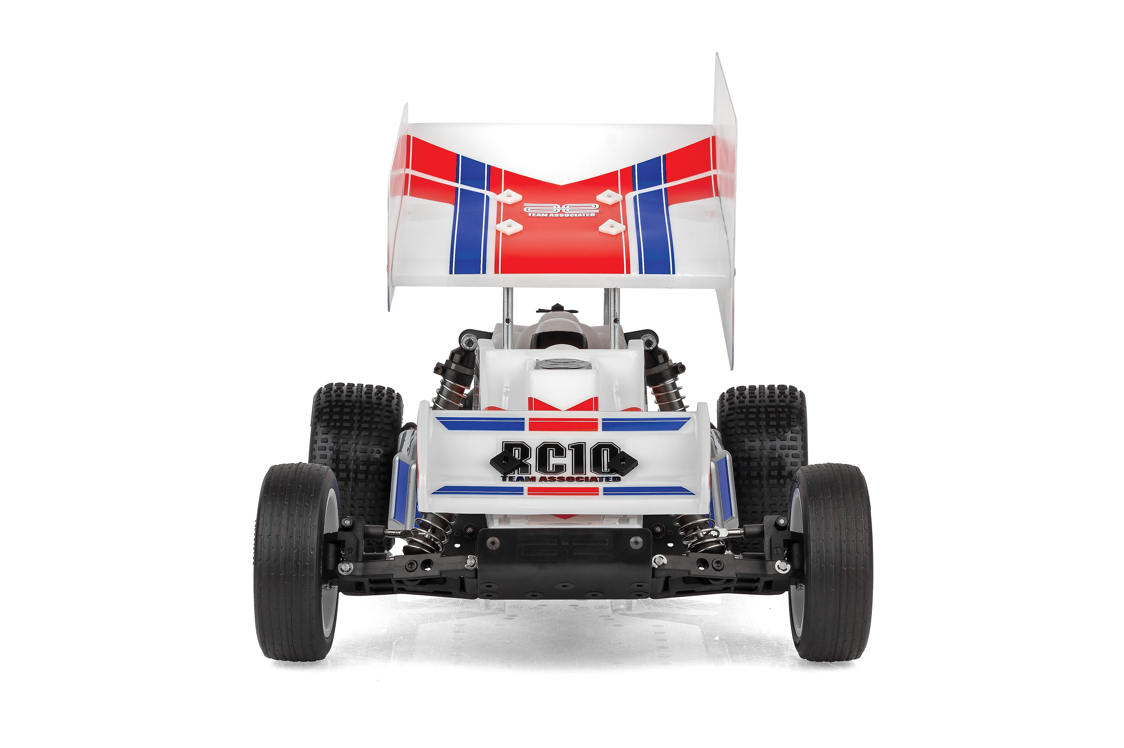
* Final width, length and weight will vary based on engine, electronics, tire configuration, wing position and vehicle setup.
FEATURES
  SPECS
Scale Size | 1:10 Scale
Terrain | Off-Road
Power | Electric
Length | 380mm (15in)
Width ​ | 226.8mm (8.93in)
Weight | Varies*
Wheelbase | 266.7(10.54in)
Internal Gear Ratio: | 2.25:1
Drive | 2WD
Body Style | Sprint Car
Assembly Level | Kit
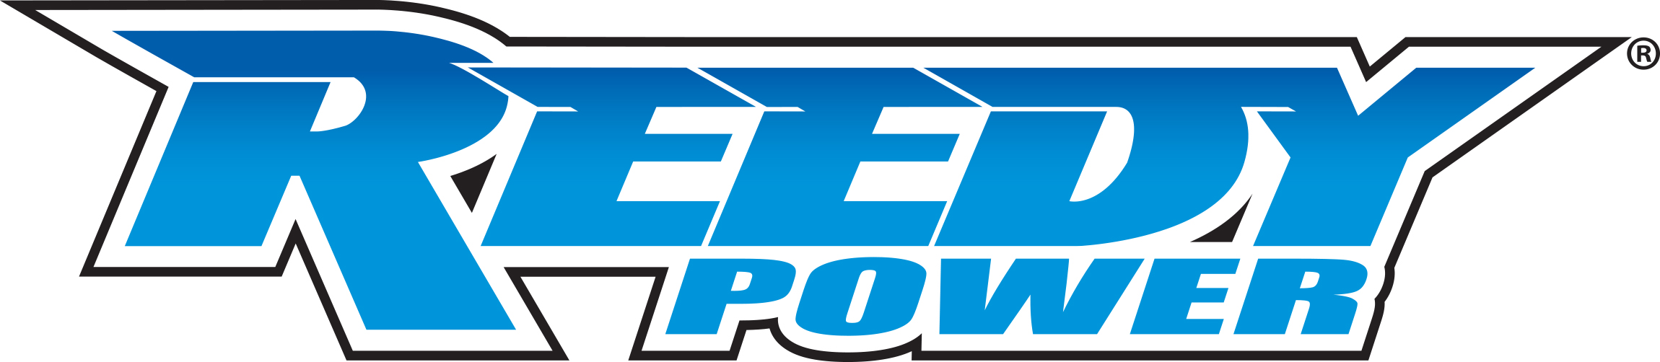
- New Stealth Retro transmission and motor plates
- B6 Gear Differential and locker included
- New Factory Team 12mm hex front axle
- New Factory Team 12mm hex front steering block
- New front wing and mounting system
- New Team Associated clear sprint car body and
wing included
- New Team Associated livery decals included
- All new sprint car wing mounting system
- All Black plastics + white 1.5-degree rear hubs
- 1.5-degree rear hub and 0-degree rear hubs included
- 12mm Hex B7 wheels included
- Black anodized 6061 aluminum chassis, nose plate and motor plates
- Factory Team 12mm Hex rear CVA’s included
- Fiberglass front and rear shock towers
- Full ball bearings included
- Hard Anodized shock bodies
- Heavy Duty Ball Cups and 3.5mm adjustable turnbuckles
- Heavy Duty Metric Ball Studs
- Independent suspension with durable long front arms and refined geometry
- Multiple rear arm mount degrees included
- Spring Car dirt tires included
- V2 slipper system included
- World’s Car bellcrank steering

Recommended Electronics:

- Battery (#27604 ZAPPERS SG6 4800mAh 135C 7.6V SHORTY)
- Motor (#27481 REEDY SONIC 540-SP5 13.5T BRUSHLESS MOTOR)
- ESC (#27016 BLACKBOX 610R COMPETITION ESC)
- Servo (#27171 REEDY RS1606HD LOW-PROFILE BRUSHLESS HI-SPEED SERVO
- Charger (#27203 REEDY 1416-C2L DUAL AC/DC COMPETITION BALANCE CHARGER)

Other Helpful Items:
- Body Scissors (AE Part # 1737)
- FT Wrench Set (AE Part #1519)
- Hobby Knife
- Needle Nose Pliers
- Wire Cutters
- Soldering Iron
- Calipers or a Precision Ruler

Items required for operation:
Motor, Servo, Receiver, Radio, Battery, and Paint. Assembly and painting required.

CATALOG INFORMATION
Motor, battery, ESC, servo, receiver, paint, tires and radio. Assembly and painting required

CATALOG INFORMATION
UPC | Part No. | Description | MSRP | MAP | Pieces Per Case | Origin | Available
784695060579 | 6057 | RC10 Sprint Edition Kit | $599.99 | $399.99 | 6 | TW | July
Download all zipped photos here: https://www.RC10.com/RC10SprintCarImages/ (17.3MB) Link is active for 30 days.
Please refer to our MAP Policy here: https://img2c.associatedelectrics.com/pdf/map-policy.pdf

