For Immediate Release: February 2026

RC10 Model 24 Classic #20200
1:24 SCALE ELECTRIC COMPETITION OFF-ROAD CAR KIT

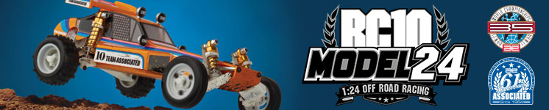
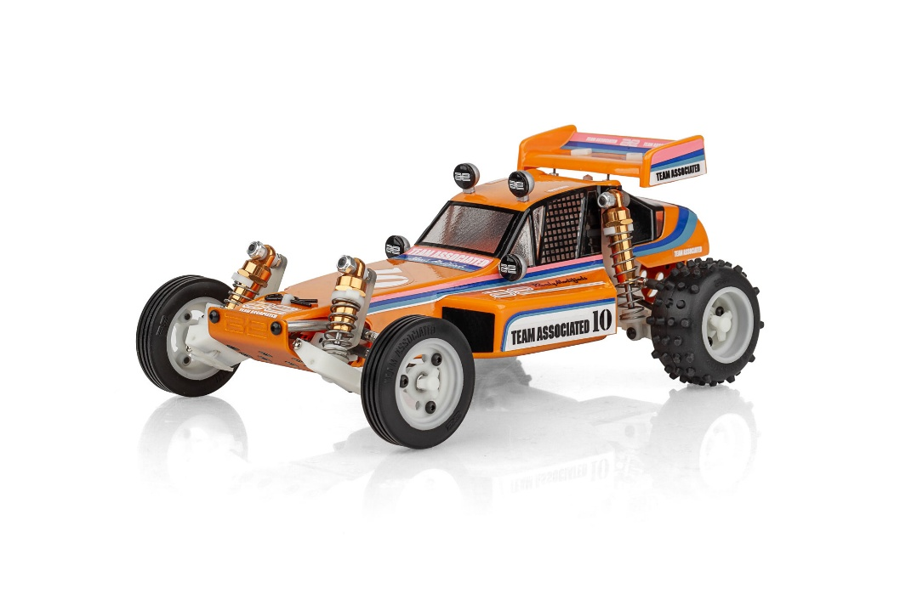
ELECTRIC ■ OFF ROAD ■ 1:24 SCALE ■ 2 WHEEL DRIVE ■ KIT
THE TEAM DOES IT IN THE DIRT
A RACE CAR, NOT A TOY — NOW IN 1:24 SCALE

You’ve heard it before, and it still rings true. Team Associated doesn’t build toys—we design and engineer true RACE cars, now expertly scaled down to an authentic 1:24 version of the legendary RC10. The RC10 Model 24 captures the look, feel, and performance DNA of the original in a compact, precision-built package.

The RC10 Model 24 features fully independent suspension, a scaled aluminum monocoque tub chassis, and race-inspired hardware throughout. Strength, durability, and attention to detail come standard.

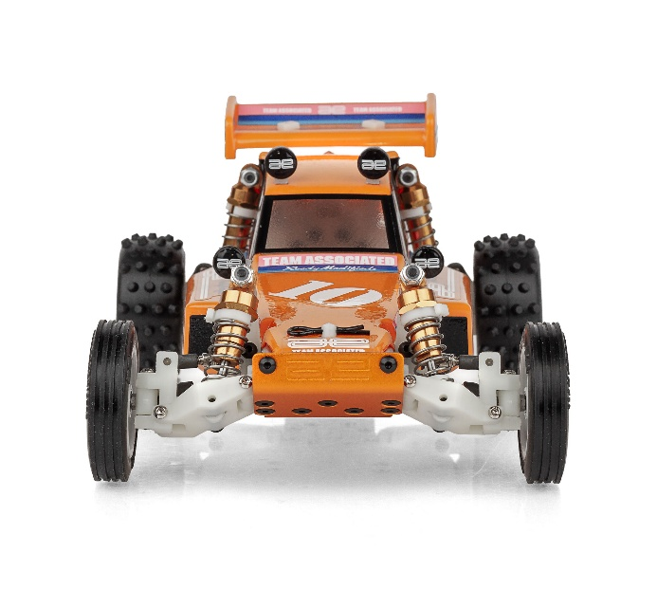
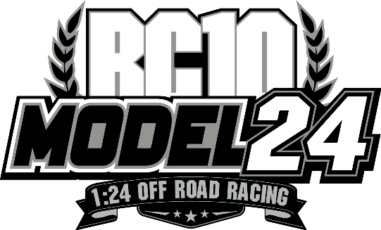

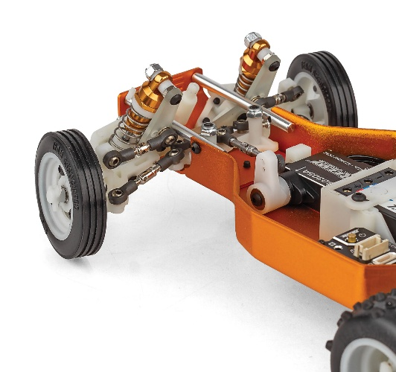
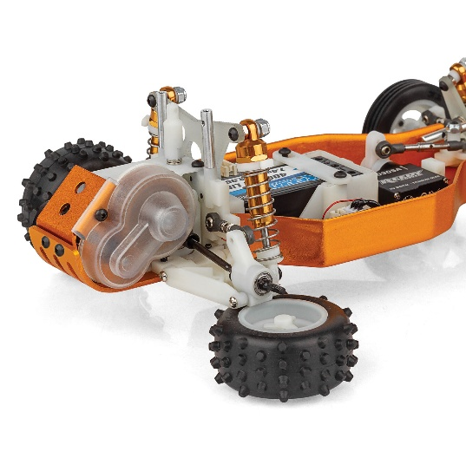

RACE-WINNING ENGINEERING, PERFECTLY SCALED

Long-throw, fluid-filled racing shocks deliver smooth, controlled damping, while the lightweight yet rugged suspension provides real adjustability just like larger counterpart race buggies. The A-arm design allows precise tuning of camber, ride height, and spring rates, and an adjustable gear differential ensures balanced power delivery.

With excellent ground clearance and a low center of gravity, the RC10 Model 24 delivers impressive balance and performance across a variety of surfaces.

GET THE JUMP ON THE COMPETITION
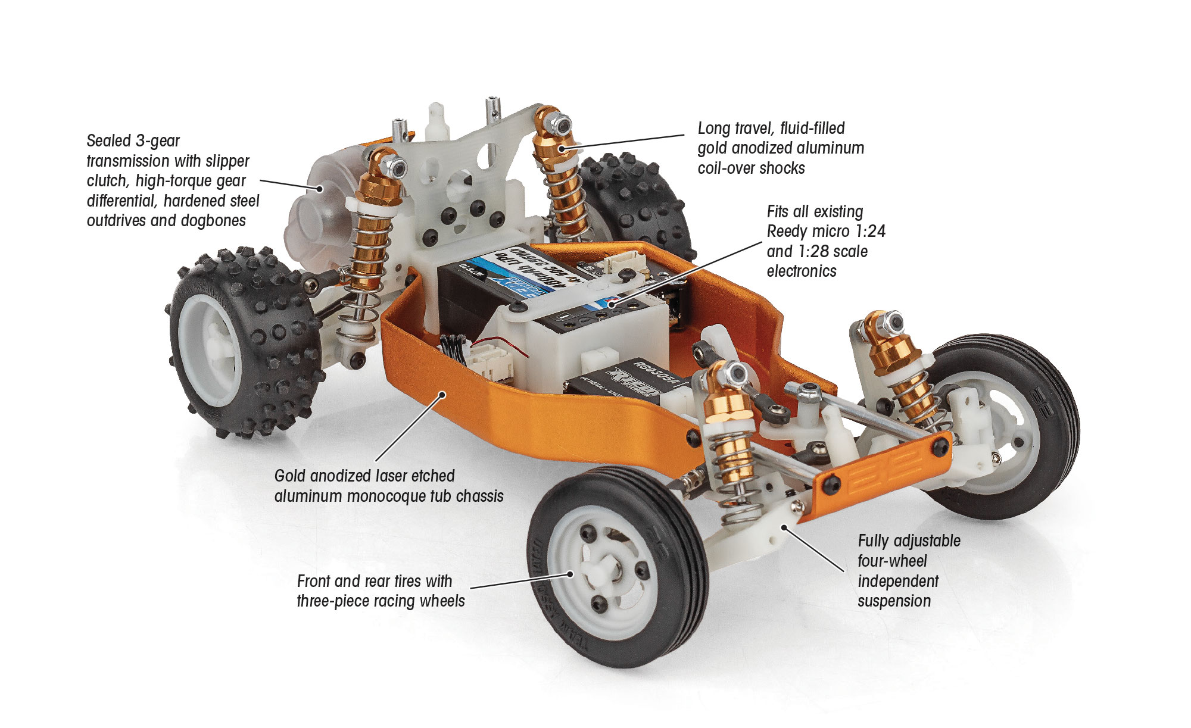

Experience off-road RC racing heritage in a compact form. The iconic RC10—reborn in 1:24 scale—is ready to race, display, and impress. Take the challenge and build yourself a winner. Team Associated RC10 Model 24.

A 1:24 Tribute to an RC Legend
The RC10 Model 24 is a faithful, downsized tribute to one of the most iconic radio control buggies ever created. Designed as an exact replica of the legendary 1:10 scale RC10, this 1:24 scale version captures the same unmistakable silhouette, proportions, and design details that defined a generation of RC racing. From the classic white wheels and gold-anodized aluminum tub, to the unmistakable suspension layout, every element reflects the heritage of the original championship-winning buggy.

Despite its compact size, the RC10 Model 24 delivers an authentic RC experience. This model is perfect for collectors, longtime RC enthusiasts, and newcomers alike who want to experience RC10 history in a smaller, more accessible format. The RC10 Model 24 isn’t just a mini RC car—it’s a celebration of innovation, performance, and timeless design that helped shape the world of radio control racing.

FEATURES
- Front and rear tires with three-piece racing wheels
- Clear micro Protech body, wing, and driver with classic livery decal sheet
- Fiberglass shock towers
- Full metal ball bearings
- All metric hardware
- Compatible with all existing Reedy micro 1:24 and 1:28 scale electronics
- Full parts support
- Exceptional ground clearance with low center of gravity

- Authentic precision hobby-grade 1:24 scale replica of the original RC10 Classic buggy
- Gold anodized laser etched aluminum monocoque tub chassis
- Hardened steel outdrives and dogbones
- Fully adjustable four-wheel independent suspension
- Long travel, fluid-filled gold anodized aluminum coil-over shocks
- Sealed 3-gear transmission with fully adjustable slipper system
- High-torque gear differential

ITEMS NEEDED TO COMPLETE |  | SPECIFICATIONS
Scale | 1:24 Scale
Power | Electric
Length | 175mm (6.89in)
Width | 107mm (4.21in)
Weight | Varies
Wheelbase | 117mm (4.61in)
Internal Ratio | 3.3:1
Power Source | Electric
Terrain: | Off-Road
Assembly Level | Kit
Drive | 2WD
Body Style | Buggy
- R/C two channel surface frequency radio system
- Batteries for transmitter
- Micro Electronic Speed Control (“ESC”) (Reedy #20175)
- Micro Steering servo (#27175)
- Micro R/C electric motor (Reedy #27503, #27504, #27505, #27506.)
- Battery charger (a peak detection charger, or LiPo compatible charger)
- 2 cell LiPo battery pack (Reedy # 27610)
- Polycarbonate specific spray paint for Lexan body
- Cyanoacrylate glue (“CA”) (#1697)
- Thread locking compound (#1596)

Other Helpful Items / Tools:
Silicone Shock Fluid (Refer to AssociatedElectrics.com for complete listings), 4.5mm Nut Wrench,.050”, 0.9mm, 1.3mm, 1.5mm Hex Wrenches, FT Body Scissors (#1737), FT Body Reamer (#1499), Small Needle Nose Pliers, Calipers or a Precision Ruler, Soldering Iron, Hobby Knife

UPC | Part No. | Description | MSRP | MAP | Pieces Per Case | Origin | Available
784695202009 | 20200 | RC10 Model 24 Classic | $359.99 | $239.99 | 20 | TW | Early March
Download all zipped photos here: https://www.RC10.com/RC10Model24ClassicImages/ (8.3MB). Link is active for 30 days.Please refer to our MAP Policy here: https://img2c.associatedelectrics.com/pdf/map-policy.pdf


SONIC 1525 Micro Brushless Motors
The Sonic 1525 is designed specifically for 1:28 and other micro vehicles intended for competition use. Thanks to input from our racing team and customers, the Reedy development team has created reliable, yet powerful design featuring the latest brushless motor technology along with the engineering experience that is responsible for 30 World Championship titles.

REEDY BLACKBOX 300R Competition Micro ESC
Reedy Power, a legendary name in the RC racing industry with 30 IFMAR World Championship titles, is proud to expand its lineup of competition level products with the launch of the Blackbox 300R Competition Micro ESC.

Reedy RS0305A Micro Hi-Speed Competition Servo
Reedy Power, a trusted name in RC performance electronics with 30 IFMAR World Championship titles, is excited to announce the launch of its all-new RS0305A High-Speed Micro Servo, engineered specifically for the fast-paced world of micro 1:28 scale R/C car racing. This cutting-edge servo delivers unmatched speed, precision, and durability, to claim gold-standard status for micro racing enthusiasts and competitive racers alike

REEDY POWER 400mAh 60C 7.4V 1:28 Stick Battery
Reedy Power, a leading name in RC performance electronics, is proud to announce the launch of its latest battery, a 400mAH 60C 7.4V LiPo designed specifically for 1:28 micro racing enthusiasts. Engineered for maximum power, durability, and efficiency, this cutting-edge battery is set to redefine performance standards in the increasing competitive world of 1:28 micro racing.

UPC | Part No. | Description | MSRP | MAP | Origin | Available
784695275034 | 27503 | SONIC 1525 2500kV Micro Brushless Motor | $82.99 | $49.99 | CN | Pre-order
784695275041 | 27504 | SONIC 1525 3500kV Micro Brushless Motor | $82.99 | $49.99 | CN | Pre-order
784695275058 | 27505 | SONIC 1525 4500kV Micro Brushless Motor | $82.99 | $49.99 | CN | Pre-order
784695275065 | 27506 | SONIC 1525 5500kV Micro Brushless Motor | $82.99 | $49.99 | CN | Pre-order
784695270459 | 27045 | REEDY BLACKBOX 300R Competition Micro ESC | $105.99 | $59.99 | CN | Pre-order
784695271753 | 27175 | REEDY RS0305A Micro Hi-Speed Servo | $121.99 | $72.99 | CN | Buy Now
784695276109 | 27610 | REEDY POWER 400mAh 60C 7.4V 1:28 Stick Battery | $36.99 | $22.99 | CN | Buy Now

