**For Immediate Release:** **August 2025**

**#6560 Stealth Transmission Kit**

|  |  |
| --- | --- |
|  |  |

(Pictured: #6560 Stealth Transmission Kit)

**Stealth® Transmission Revolutionizes RC Racing**

The Team Associated Stealth® A.T.C. (Associated Torque Control) Transmission was a revolutionary advancement in RC racing, developed by Cliff Lett to give the new RC10 “Team Car” a competitive edge. Released in 1990, the Stealth® featured a compact, low-friction, and fully enclosed 3-gear design that significantly improved efficiency and durability over the original 6-gear transmission.

Its debut took place at the 1990 ROAR Off-Road Nationals held at Hobby Haven Raceway in Des Moines, Iowa. At the event, the transmission proved its worth as Team Associated drivers dominated the field, showcasing its superior performance. Lett’s engineering focused on optimizing power transfer, reducing rotating mass, and simplifying maintenance—all of which contributed to the Team Car’s immediate success.

The Stealth® quickly became the gold standard in competitive off-road RC, influencing future transmission designs across the industry and solidifying Associated’s dominance throughout the early ‘90s. Its legacy continues as a defining innovation in RC racing history.



Everything you need to convert, replace, or refresh the transmission of your favorite RC10 buggy is included in this Stealth® Transmission kit. In addition to the Stealth® gearbox you get the updated V2 Octalock slipper system, plastic transmission brace, case-to-motor plate seal, 75-tooth 48-pitch Octalock spur gear, molded gear cover, steel ball bearings, and ball differential.

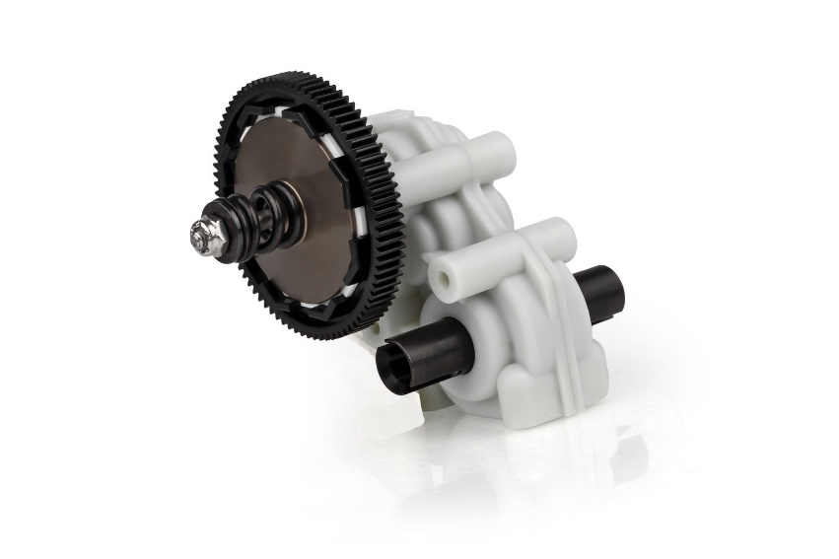

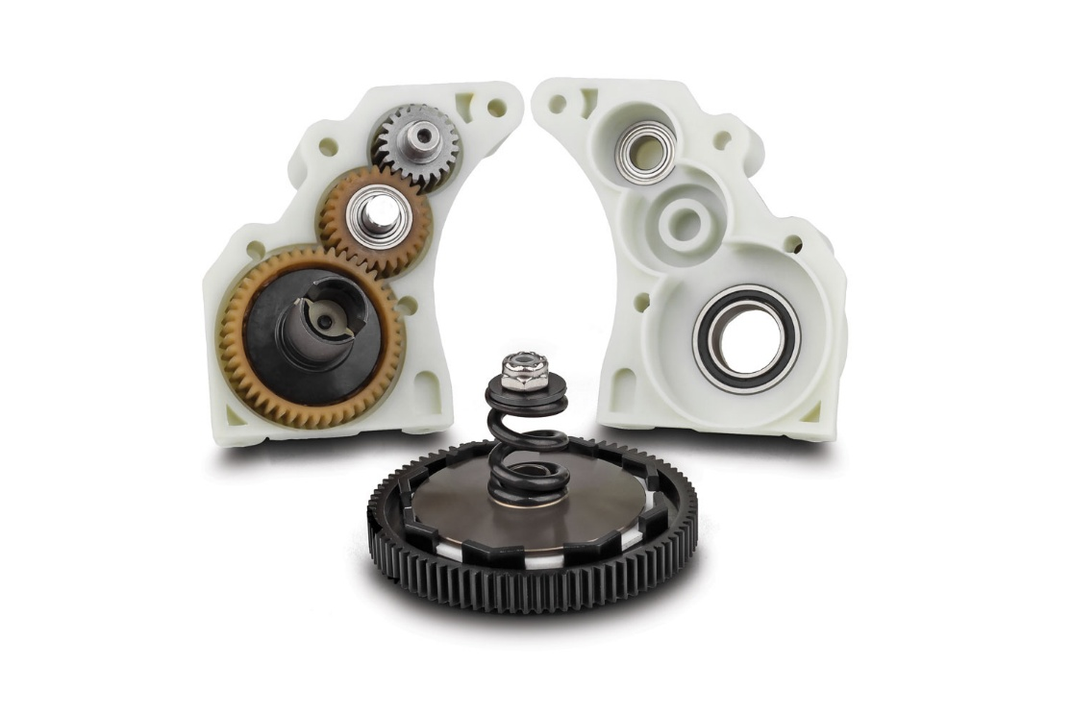

* Associated Torque Control (A.T.C.) lets you setup for every track
* Updated World’s Car idler gear and gearbox
* High efficiency design for extended run time and motor life
* Steel ball bearings and ball differential
* V2 Octalock slipper system lets you setup for any track condition

|  |  |  |  |  |  |  |
| --- | --- | --- | --- | --- | --- | --- |
| **UPC** | **Part No.** | **Description** | **MAP** | **MSRP** | **Origin** | **Available** |
| 784695065604 | 6560 | Stealth Transmission Kit | $139.39 | $163.99 | TW | Now |