For Immediate Release: September

NEW! Reedy RS0305A Micro Hi-Speed Competition Servo
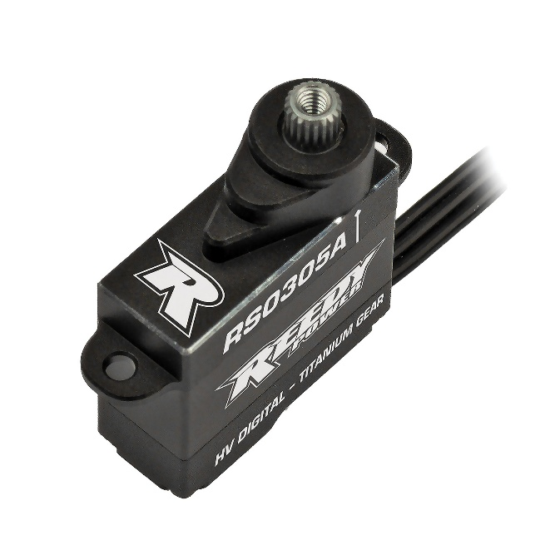

Reedy Power, a trusted name in RC performance electronics with 30 IFMAR World Championship titles, is excited to announce the launch of its all-new RS0305A High-Speed Micro Servo, engineered specifically for the fast-paced world of micro 1:28 scale R/C car racing. This cutting-edge servo delivers unmatched speed, precision, and durability, to claim gold-standard status for micro racing enthusiasts and competitive racers alike.

Key features include:

Blazing-Fast Speed: Powered by a high-efficiency coreless motor, the RS0305A achieves an ultra-fast speed of 0.058 sec/60° at 7.4V, ensuring lightning-quick steering response to meet the intense demands of competition, while not sacrificing torque.

Precision Engineering: An advanced microprocessor provides pinpoint accuracy, delivering smooth and consistent control to maximize lap times in competitive 1:28 racing environments.

Compact Durability: Featuring a robust CNC-machined aluminum case, the RS0305A is built to withstand the rigors of micro racing while maintaining a lightweight profile at just 7g.

High-Voltage Compatibility: Because this servo is compatible with up to 8.4V, maximum performance is achieved without compromising reliability.

Full Metal Gears: The servo’s high-strength titanium and steel gear set ensures long-lasting durability and precision control.

Engineered for Victory
Developed with input from Team Associated’s skilled engineers and Reedy’s championship-winning racing team, the RS0305A Micro High-Speed Competition Servo is tailored to meet the needs of 1:28 scale R/C car racing, where every advantage counts. Its compact design is optimized for seamless integration into micro chassis like the Team Associated RC28, delivering the precision and power needed to dominate.

“The RS0305A is a must-have for 1:28 racers,” said Rick Hohwart, Reedy Electric Department Manager. “We’ve relied on decades of competition experience to offer a servo that offers unrivaled speed and control, giving drivers the edge they need to compete at the highest levels.”

For more information, visit www.ReedyPower.com or contact your local hobby retailer.

Specifications
Feature |  | Specification
Input (V) |  | 4.8 - 8.4
Motor |  | Coreless
Speed (sec/60°) | 6.0V | .066
 | 7.4V | .058
 | 8.4V | .052
Torque (kg-cm/oz-in) | 6.0V | 2.2/30.6
 | 7.4V | 2.6/36.1
 | 8.4V | 3.0/41.7
Dimensions (mm) |  | 20x8x17.8
Weight (g) |  | 7
Spline |  | 20/4mm
Wire |  | JST1.5/50mm

UPC | Part No. | Description | MSRP | MAP | COO | Available
784695 271753 | 27175 | Reedy RS0305 Micro Hi-Speed Servo | $121.99 | $72.99 | CN | Oct. ‘25
784695 271760 | 27176 | Reedy RS0305A Gear Set | $43.99 | $36.99 | CN | Oct. ‘25

