For Immediate Release: December

1991 RC10 Stealth Car Masami Edition #6044

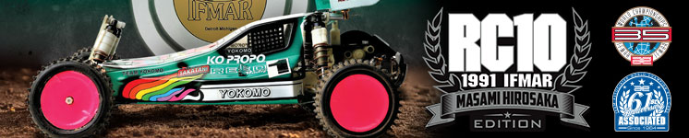

ELECTRIC ■ OFF ROAD ■ 1:10 SCALE ■ 2 WHEEL DRIVE ■ KIT
Masami’s RC10 Stealth Car
A RACE CAR, NOT A TOY.

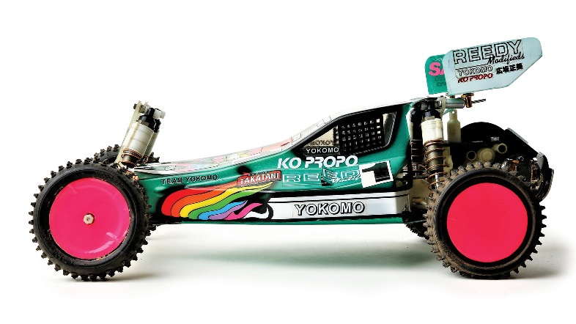

The Team Associated RC10 Stealth car that captured the 1991 IFMAR 1/10 Scale Off-Road World Championship in Detroit, Michigan has become one of the most iconic race-winning platforms in RC history.

Driven by Masami Hirosaka, this legendary car showcased
cutting-edge engineering, precision handling, and a forward-thinking chassis layout that pushed the limits of performance at the time. The RC10 Stealth Car featured a double deck chassis paired with the now-famous Stealth transmission, which offered smoother power delivery, improved efficiency, and enhanced durability on the demanding track surface. Its carefully tuned suspension geometry, adjustable camber links, and race-optimized shock package allowed Masami to dial in exceptional grip and stability throughout the event.

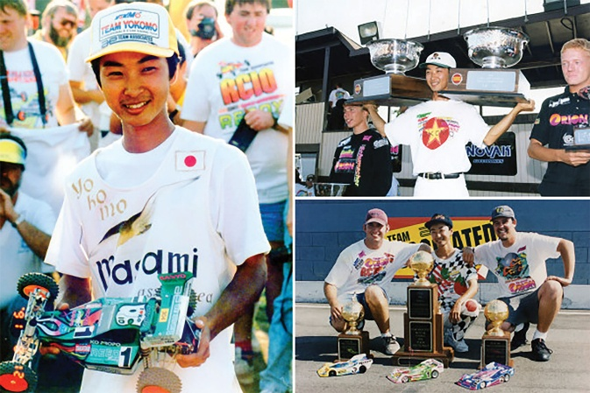

Masami’s driving skill combined with meticulous setup work made this RC10 stand out among competitors, securing a historic victory that further solidified Team Associated’s dominance in the racing world.

The win not only demonstrated the evolution of competitive RC car design but also influenced future generations of off-road racing platforms. Today, the 1991 RC10 Stealth is celebrated by collectors, racers, and enthusiasts alike as a true milestone in RC racing heritage, representing both technical innovation and championship-winning legacy.



Bring home a piece of RC racing history and celebrate the legend of Masami Hirosaka’s unforgettable 1991 Worlds victory. This is more than a car — it’s a tribute to skill, speed, and championship heritage.

A Full race-tuned suspension with long-arm independent suspension and hard anodized coil-over shocks help smooth out the bumps. Low profile Stealth® transmission and slipper is protected by an integrated motor/heat sink.

A-Arm/Ball joint design permits static camber, camber rise, caster, ride height and spring rate tuning to suit every type of track.

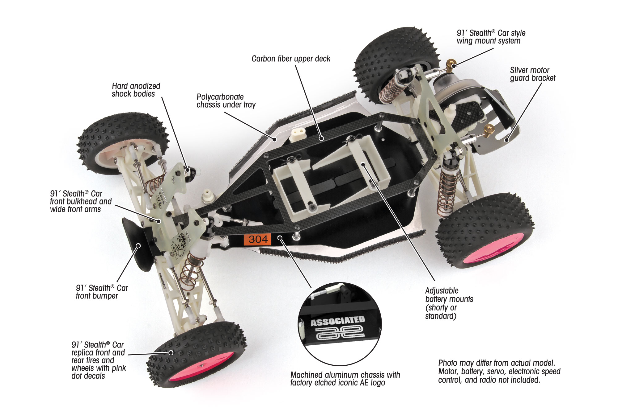

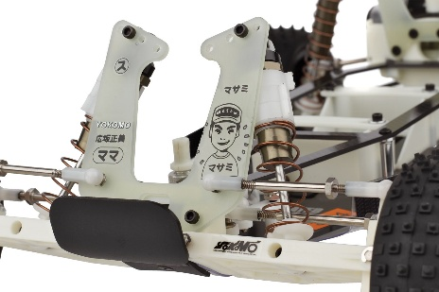
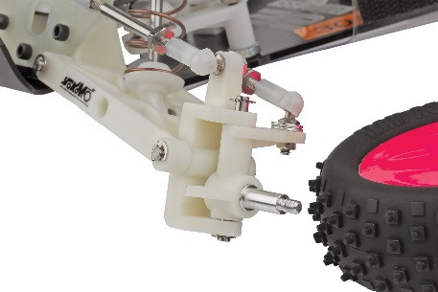
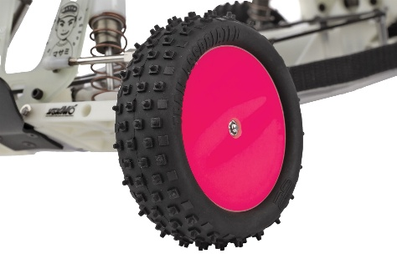

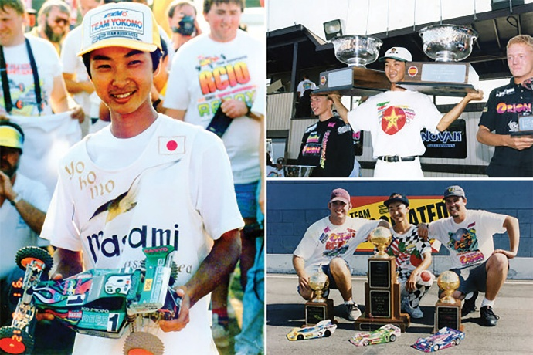
Masami Hirosaka’s 1991 IFMAR Worlds Victory – Detroit, Michigan

Experience the legendary 1991 IFMAR 1:10 Electric Off-Road World Championship triumph with Masami Hirosaka behind the wheel! Racing at Sterling Heights’ iconic Freedom Hill Park, Hirosaka showcased why he was already a multiple world champion, dominating the competition with precision, consistency, and unmatched skill.

Pictured here is Masami’s actual RC10 Stealth Car he drove to victory in the 1991 IFMAR World Championships.

Piloting the iconic Team Associated RC10 Stealth Car, Masami mastered the challenging clay track, navigating rhythm sections, berms, and jumps with flawless control. His strategic driving, smooth lines, and expert management of tires, battery, and motor set him apart from the field and secured a commanding victory in both qualifying and the A-main finals.

This win not only cemented Hirosaka’s legacy as one of the greatest off-road racers of all time but also highlighted the unbeatable performance of the RC10 platform. Collectors, racers, and enthusiasts alike recognize the 1991 Detroit Worlds as a defining moment in RC racing history — a performance that inspired car development, racing techniques, and the passion of RC drivers around the world.

The Most Successful and Legendary RC Racer of All Time
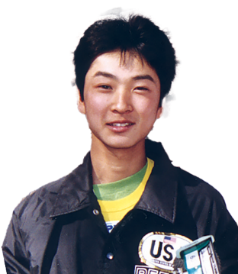



Masami Hirosaka is considered the most successful RC car racer of all time, with a record that still stands unmatched today. Born in Japan in 1970, Masami dominated the RC racing world for more than two decades, earning an incredible 14 IFMAR World Championship titles across multiple classes. His world titles include victories in 1:10th scale electric off-road (2WD and 4WD), 1:12th scale electric on-road, and touring car categories, showcasing his remarkable versatility and technical skill.

In addition to his many IFMAR world championships, Masami claimed over 50 Japanese National Championships, another record that highlights his dominance on both the national and international stages. His ability to consistently perform at the highest levels across so many different disciplines helped cement his reputation as a true legend in the RC community.

Masami first captured global attention when he won the 1987 IFMAR 4WD Off-Road World Championship at just 17 years old. Throughout his career, he was known not only for his smooth, precise driving style but also for his deep technical understanding of RC car setup and design. Working closely with brands like Yokomo and Team Associated, he helped advance RC technology and vehicle performance, leaving a lasting impact on the industry.

Masami Hirosaka’s fame extended far beyond Japan — he became a global icon for RC racers everywhere. His races were featured in magazines around the world, and many aspiring drivers studied his techniques in hopes of replicating even a fraction of his success. Even after stepping away from top-level competition in the late 2000s, Masami remains active in the RC scene as a mentor, team manager, and ambassador for the sport.

Today, Masami Hirosaka is remembered as the gold standard in competitive radio-control car racing — a true legend whose achievements may never be equaled.

FEATURES
- CNC machined aluminum chassis
- Laser etched chassis logo
- Carbon fiber top plate
- Hard anodized shock bodies
- Black anodized shock caps
- Ball bearings
- 91’ Stealth® car front bulkhead
- 91’ Stealth® car rear arm mounts
- Stealth® car wide front suspension arms
- CNC chassis standoffs
- Stealth® transmission
- Titanium turnbuckles
- 91’ Stealth® car world championship replica tires
- 91’ Stealth® car rear suspension arms

- Replica Masami battery strap and ESC mount
- 91’ Stealth® car long stroke shock springs
- Rear Dogbones included
- 91’ Stealth car pink wheel dot decals (rear wheels are black)
- 91’ Stealth car clear lexan under tray
- 91’ Stealth car front bumper
- 91’ Stealth car copper shock springs
- 91’ Stealth car silver motor bracket
- Replica Masami battery strap and ESC mount
- 91’ Stealth car legendary front shock tower geometry

ITEMS NEEDED TO COMPLETE |  | SPECIFICATIONS
- 6-cell NiMH or 2S LiPo for radio-controlled car
- Radio control battery charger
- 1:10 scale radio control electronic speed control
- 1:10 scale 540-size electric RC car motor
- 2-channel RC surface transmitter and its batteries
- 2-channel receiver
- Pinion gear
- Steering servo
- Lexan paint for body
- Glue for tires.
- Tools

Scale | 1:10
Power | Electric
Length | 381mm (15in)
Width | 226.8mm (8.93in)
Weight | Varies
Wheelbase | 267.7mm (10.54in) Adjustable
Internal Ratio | 2.25:1
Power Source | Electric
Terrain: | Off-Road
Assembly Level | Kit
Drive | 2WD
Body Style | Buggy

UPC | Part No. | Description | MSRP | MAP | Pieces Per Case | Origin | Available
784695060449 | 6044 | RC10 1991 Stealth Car | $631.99 | $429.99 | 6 | TW | Early Jan

Download all zipped photos here: https://www.rc10.com/RC10StealthMasamiCar/ (7.85MB). Link is active for 30 days.
Please refer to our MAP Policy here: https://img2c.associatedelectrics.com/pdf/map-policy.pdf

