FOR IMMEDIATE RELEASE

February 12, 2026

National Champion Doug Lariviere Joins Reedy

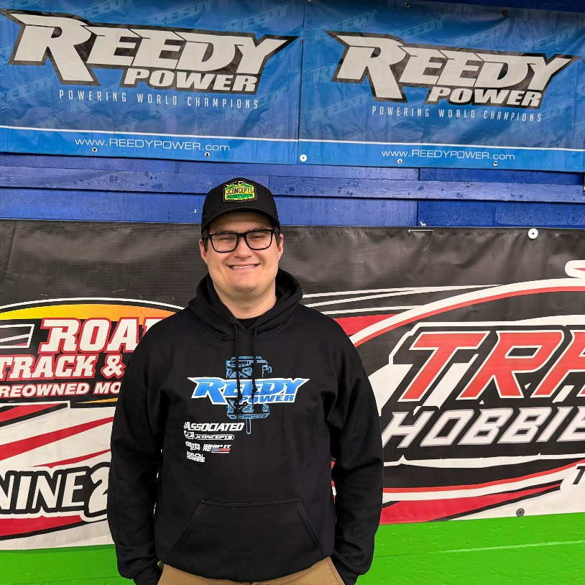
Reedy is excited to announce multi time ROAR Spec National Champion Doug Lariviere has joined the Reedy team for 2026 and beyond. Doug will bring years of experience and expertise to the Reedy brand where his skills will be used for both product development and event support. While Doug will continue to mostly compete in the modified classes, he will develop spec specific products between events and assist all Reedy drivers at major events with technical support.

When asked about this opportunity, Doug said, “I’m excited to partner with the Reedy brand for 2026 and beyond. Huge thanks to Brent, Rick, Billy, Kyle and everyone else at AE for giving me an opportunity and making me feel at home right away. I can’t wait to hit the track and grow with the brand.”

#WeAreAE

