For Immediate Release: September 2026

RC28R.1 Team Kit #20194
1:28 Scale 2WD Electric On-Road Competition Kit
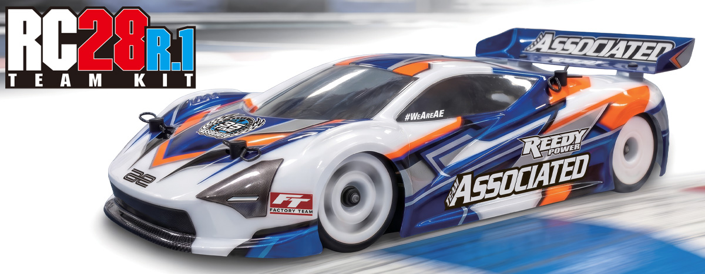

ELECTRIC ■ 1:28 SCALE ■ 2 WHEEL DRIVE ■ ON-ROAD ■ KIT
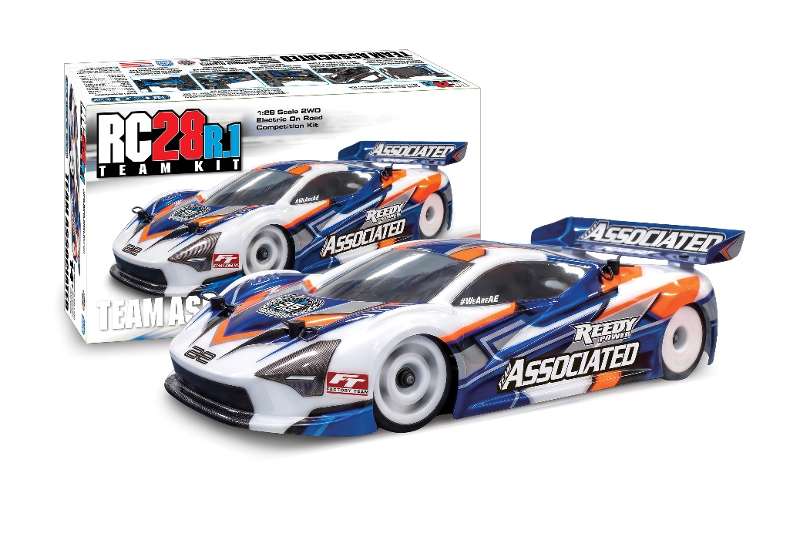

A newly updated steel chassis plate allows wider battery packs and electronic mounting space while keeping its low center of gravity. The pitch, roll and droop can further be tuned/Adjusted with the threaded aluminum center shock, spring collars and side damper tubes. The two-piece rear pod allows quick axle height adjustment utilizing Factory Team carbon fiber shims. This RC28R.1 is compatible with all 28th scale Reedy Electronics. Compact, tunable, and designed to race, the RC28R.1 is built for high performance and fun—even in tight spaces.
This compact on-road race car is designed with the same engineering precision found in every AREA 51-developed product. Though small in scale, the RC28R.1 delivers big performance in an easy to set up package. Featuring a new FT carbon fiber upper arm brace, front bulkhead shim and upper arm options, offered in .5 and 1 degree of camber with 2 and 4 decrees of caster. The torsion side links (soft, medium, and hard included) replace the need for a side spring making setup easy while adding performance in areas a conventional spring does not.

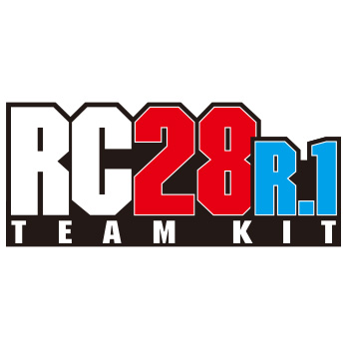

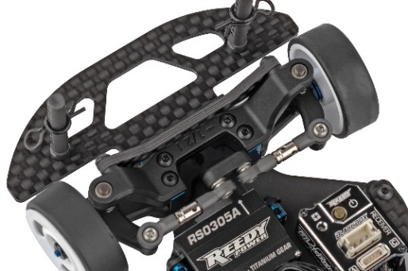

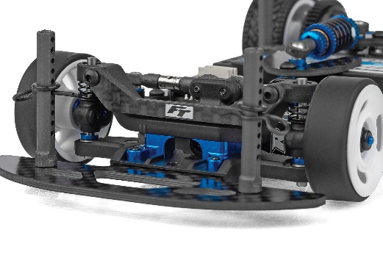
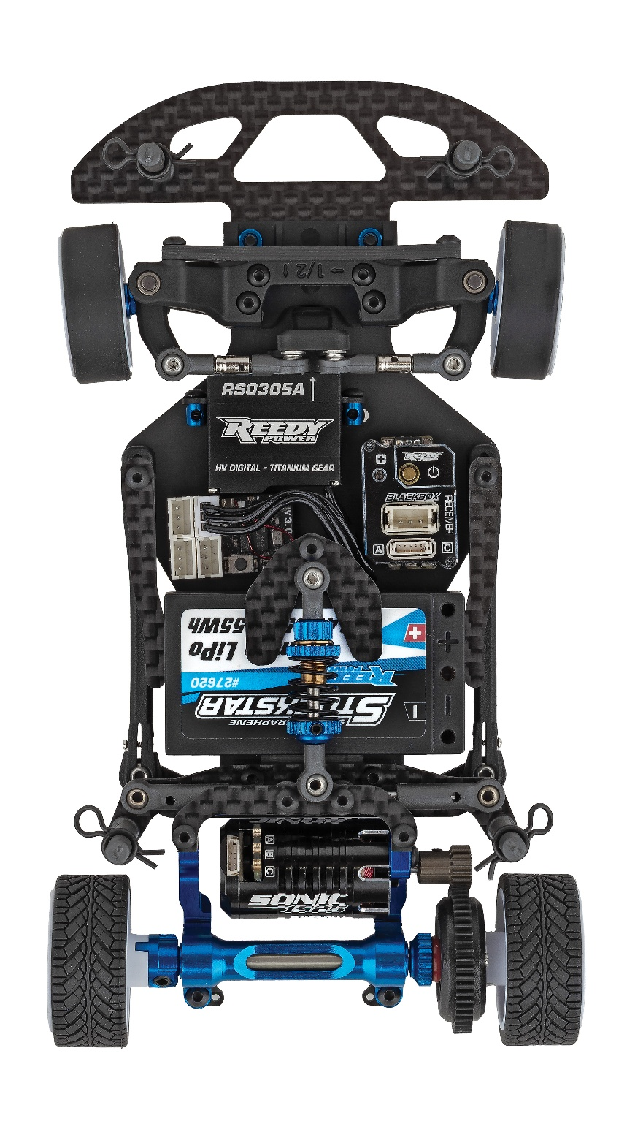

New upper arm options included offer .5 and 1 degree of camber with 2 and 4 degrees of caster
Includes FT carbon fiber upper arm brace and front bulkhead shim

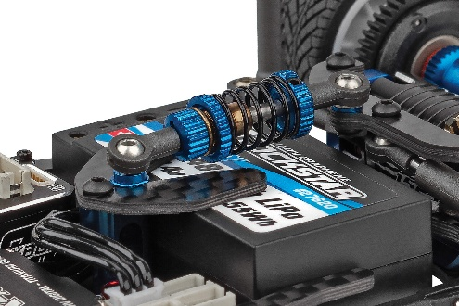
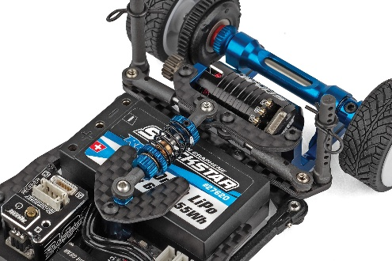

Hard plastic and polycarbonate body mounting options included
Threaded aluminum center shock with adjustable droop and spring collar

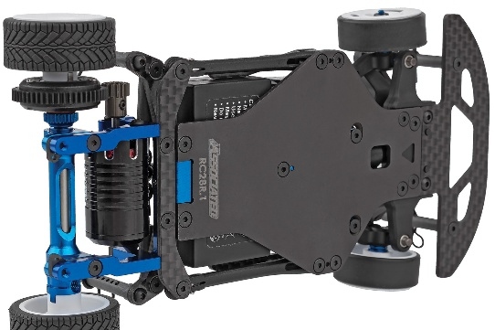
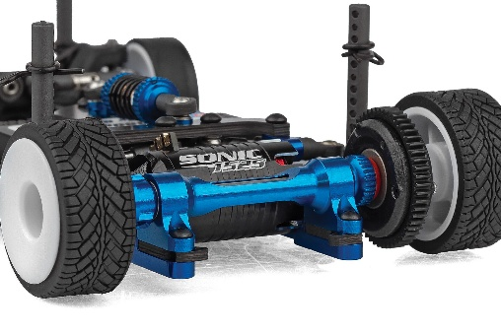

Adjustable axle heights for different tire diameters and ride heights utilizing Factory Team carbon fiber shims
Updated steel chassis and center bulkhead design

FEATURES
  SPECS
Scale | 1:28
Type | On-road
Motor: | 16mm Dia. Motors
Power | Electric
Length | 160mm/6.3in
Width | 83mm/3.27in
Weight | Varies*
Wheelbase | 98mm
Chassis Material | Machined Steel
Gear Pitch | 64p
Drivetrain | 2WD
• Updated steel chassis and center bulkhead design allows for 24mm wide battery packs and more space for mounting electronics while also reducing chassis scrub
• New upper arm options included offer .5 and 1 degree of camber with 2 and 4 degrees of caster
• Includes FT carbon fiber upper arm brace and front bulkhead shim
• Radbody Mako X2 included
• Torsion style side links act as side spring with soft, medium, and hard options included
• Adjustable rear pod roll center inserts to tune roll characteristics to grip level
• Optimized roll geometry with side damper tubes

• Threaded aluminum center shock with adjustable droop and spring collar
• Two-piece rear pod with adjustable axle heights for different tire diameters and ride heights utilizing Factory Team carbon fiber shims
• Gear differential included but can fit other aftermarket options currently available
• Hard plastic and polycarbonate body mounting options included
• V2 White wheels included that fit optional front wheel flanges to tune steering feel
• Universal front bumper included
• Team Associated’s quality, distribution, support, and customer service

*Final width, length and weight will vary based on electronics, tire configuration, wing position and vehicle setup.


Recommended Electronics:

- Motors (#27503 SONIC 1525 2500kV Micro Brushless Motor) (#27504 SONIC 1525 3500kV Micro Brushless Motor)
(#27505 SONIC 1525 4500kV Micro Brushless Motor)
- Battery (#27620 REEDY Stockstar 480mah 65c 7.4v 1:28 Stick)
(#27610 REEDY POWER 400mAh 60C 7.4V 1:28 Stick Battery)
- Servo (#27175 REEDY RS0305A Micro Hi-Speed Servo)
- ESC (#27045 REEDY BLACKBOX 300R Competition
Micro ESC)
- Charger (#27203 Reedy 1416-C2L Dual AC/DC Competition Balance Charger)

Other Helpful Items:

• Body Scissors (AE Part # 1737)
• Reamer / Hole Punch
• Hobby Knife
• Needle Nose Pliers
• Wire Cutters
• Soldering Iron
• FT 4.5mm Short Nut Driver (AE Part #21694)
• FT 28th Scale Ride Height Gauge (AE Part #21693)
• Calipers or a Precision Ruler

CATALOG INFORMATION

UPC | Part No. | Description | MSRP | MAP | Pieces Per Case | Origin | Available
784695201941 | 20194 | RC28R.1 Team Kit | $419.99 | $279.99 | 20 | TW | October
Download all zipped photos here: https://RC10.com/RC28R1KitImages/ (7.9MB) Link is active for 30 days.
Please refer to our MAP Policy here: https://img2c.associatedelectrics.com/pdf/map-policy.pdf

