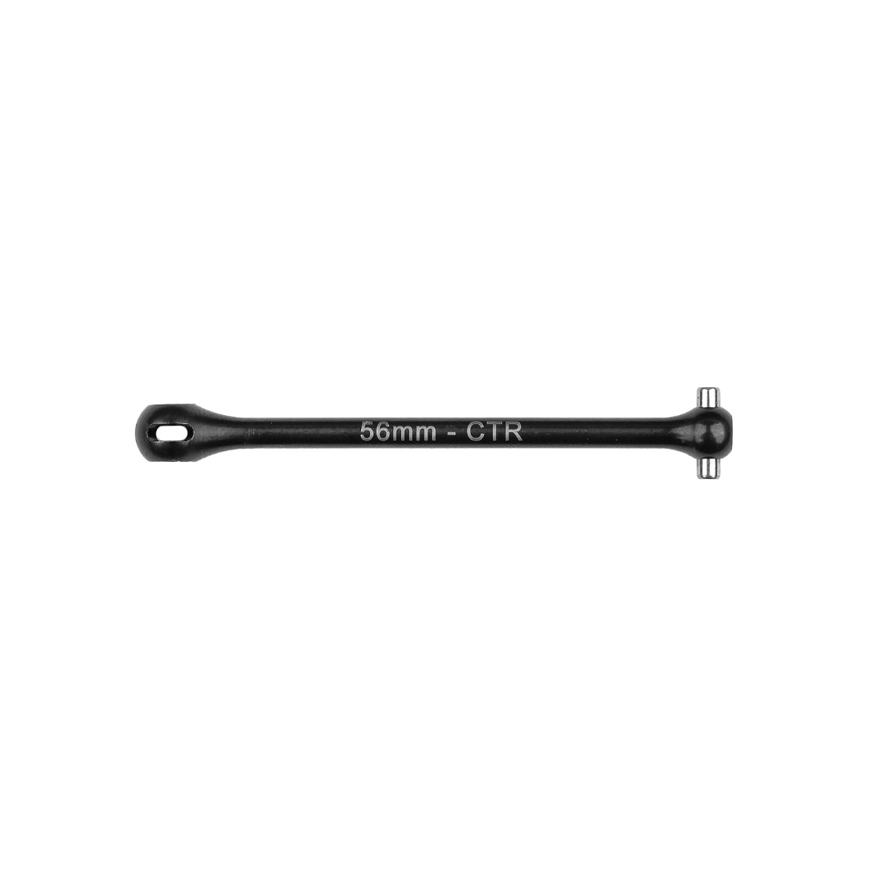
For Immediate Release: March 2026

RC10B84 FT CENTER CVA BONE, 56mm, FWB DIFF #92572

(Pictured: RC10B84 FT Center CVA Bone, 56mm, FWD DIFF #92572)

Introducing the new RC10B84 FT center CVA bone, 56mm! This part is a must have for those who want to use the center diff in the forward position. The bone is laser etched along the shaft for easy part recognition. The forward differential position means this front bone needs to be paired with #92551 for the rear center bone to reach the differential.

Compatible with:
90050/90051
UPC | Part No. | Description | MAP | MSRP | Origin | Available
784695925724 | 92572 | RC10B84 FT Center CVA Bone, 56mm, FWD DIFF | $10.99 | $10.99 | TW | 

