For Immediate Release: February 2026

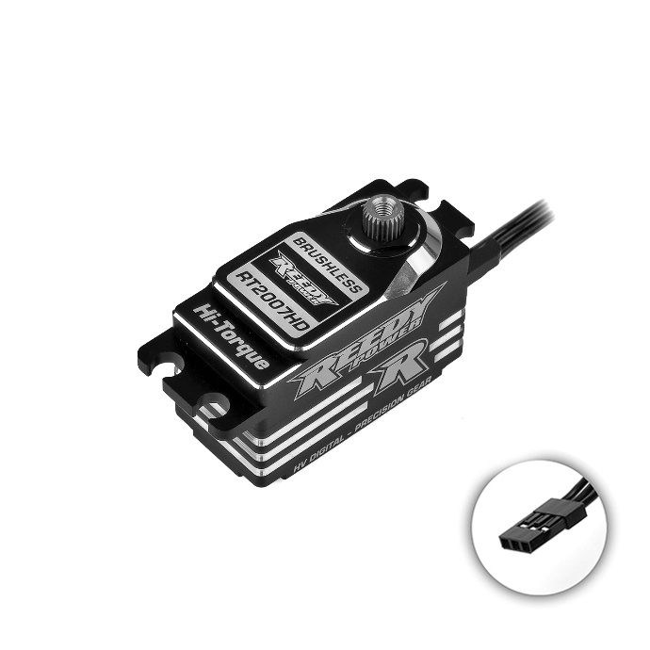
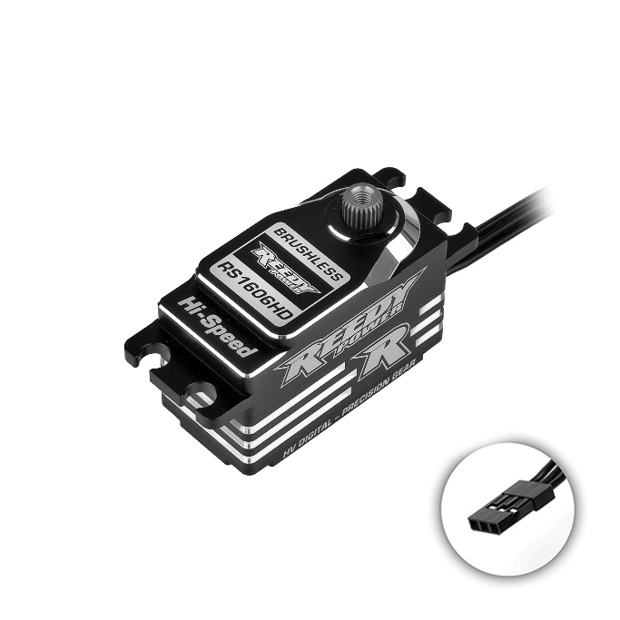
New! Reedy Low-Profile Competition HD Brushless Servos

(Pictured: #27171 RS1606HD & #27172 RT2007HD Reedy Servos)

Reedy is proud to introduce heavy-duty steel gear variants of its popular RT2007A and RS1606A low-profile competition servos.
Building on the success of the current titanium gear lineup, new RT2007HD and RS1606HD steel gear versions maintain the servos' core attributes while addressing demands for even greater durability in high-stress applications. The precision-machined steel gears offer improved resistance to impact and fatigue, reducing the risk of gear stripping and ensuring consistent performance lap after lap.
A powerful brushless motor produces a combination of lightning quick speeds and maximum torque while an advanced microprocessor improves vehicle control and enhances driver feel. A CNC-machined aluminum case with integrated fins increases rigidity to ensure consistent driving feel while lowering operating temperatures for fade-free operation. Two options, high speed or high torque, are available to suit a variety of on and off-road applications and driver preferences.
"By introducing steel gears to our flagship low-profile servos, we're giving racers a robust improvement that excels in durability without compromising the speed and torque they've come to expect", said Rick Hohwart, Reedy Power Manager. "These upgrades are a direct response to feedback from Team drivers and valued customers, ensuring our products stand up to the rigors of competition while minimizing wear over time."
For more information, visit www.reedypower.com or contact your local hobby shop.

- CNC Machined Full Aluminum Case: Increases rigidity to ensure consistent driving feel with heatsink fins to reduce operating temperatures.
- Powerful Brushless Motor: Provides maximum speed and torque for the most demanding applications.
- Waterproof Construction: Eliminates moisture penetration to maximize reliability when driving in wet conditions.
- Ultra-precise Steel Gears: Improved resistance to impact and fatigue, reducing the risk of gear stripping and ensuring consistent performance.
- Dual Ball Bearings: Eliminate slop that can result in poor driving feel while reducing gear lash for improved reliability.
- High-Voltage Compatible: Input voltage of up to 8.4V results in reliable operation in a variety of racing classes.

For more information and a complete list of Reedy motors, batteries, electronic speed controls, servos, and accessories, visit www.reedypower.com or contact your local hobby shop.
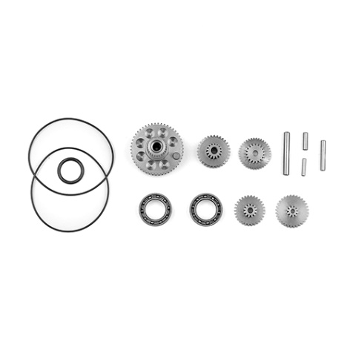
Specifications
(Pictured: #27173 RS1606HD Gear Set)
Model |  | RS1606HD | RT2007HD
Part # |  | 27171 | 27172
Input (V) |  | 4.8 – 8.4 | 4.8 – 8.4
Motor |  | Brushless | Brushless
Speed  (sec/60°) | 6.0V | .070 | .090
Speed  (sec/60°) | 7.4V | .065 | .085
Speed  (sec/60°) | 8.4V | .058 | .070
Torque  (kg-cm/in-oz) | 6.0V | 13/180 | 17/236
Torque  (kg-cm/in-oz) | 7.4V | 14.5/201 | 19.5/271
Torque  (kg-cm/in-oz) | 8.4V | 16/222 | 20/278
Dimensions (mm) |  | 40.8x20.2x26.5 | 40.8x20.2x26.5
Weight (g) |  | 58.2 | 58.2
Gear Type |  | Steel | Steel
Spline |  | 25 | 25

UPC | Part No. | Description | MSRP | MAP | Available
784695271715 | 27171 | Reedy RS1606HD Low-Profile Steel Gear Brushless Hi-Speed HV Servo | $227.99 | $135.99 | 
784695271722 | 27172 | Reedy RT2007HD Low-Profile Steel Gear Brushless Hi-Torque HV Servo | $227.99 | $135.99
784695271739 | 27173 | RS1606HD Gear Set | $55.99 | $46.99
784695271746 | 27174 | RT2007HD Gear Set | $55.99 | $46.99

