For Immediate Release: March 2026

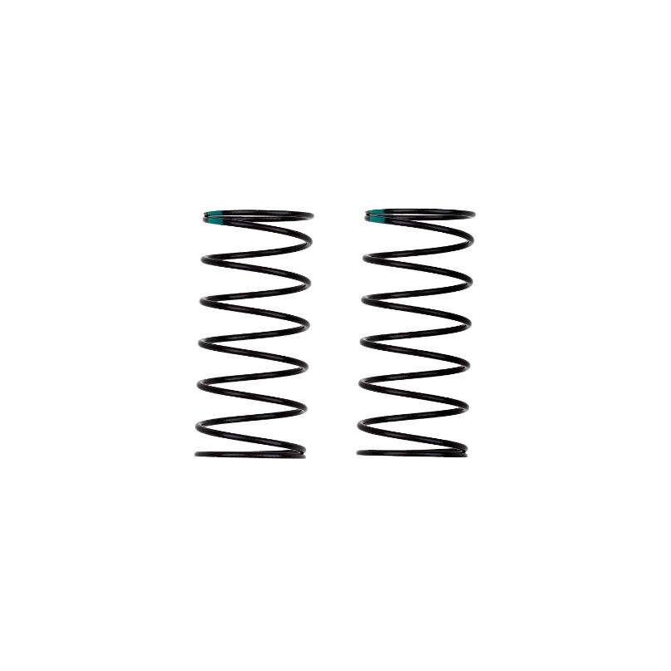
13mm FRONT SHOCK SPRINGS, GREEN #91939
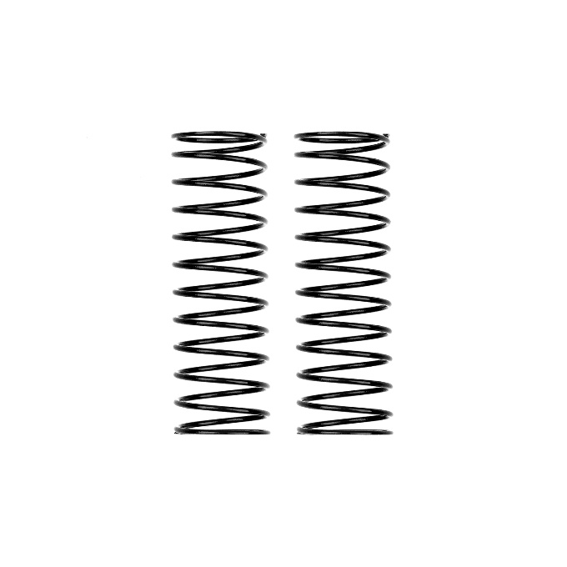
13mm REAR SHOCK SPRINGS, BLACK #91961

(Pictured left to right: #91939 13mm FRONT SHOCK SPRINGS, GREEN & #91961 13mm REAR SHOCK SPRINGS, BLACK)

Team Associated introduces two new, soft spring additions to the 13mm shock spring lineup. The front lineup now includes a Green spring option, while the rear lineup now has a Black spring option. These springs allow for a greater range of adjustability for various conditions, allowing you to fine tune your car for every situation.

Compatible with:
90041, 90042, 90046, 90047, 90050, 90051, 90055, 90056, 6049

UPC | Part No. | Description | MAP | MSRP | Origin | Available
784695919396 | 91939 | 13mm Front Shock Springs, Green 3.1 lb/in, L44, 7.5T, 1.2D | $9.99 | $9.99 | TW | 
784695919617 | 91961 | 13mm Rear Shock Springs, Black 1.7 lb/in, L61, 12.5T, 1.2D | $9.99 | $9.99 | TW

