For Immediate Release: April 2026

RC10T84 Team Kit #90057
1:10 Scale 4WD Electric Off Road Competition Truck Kit

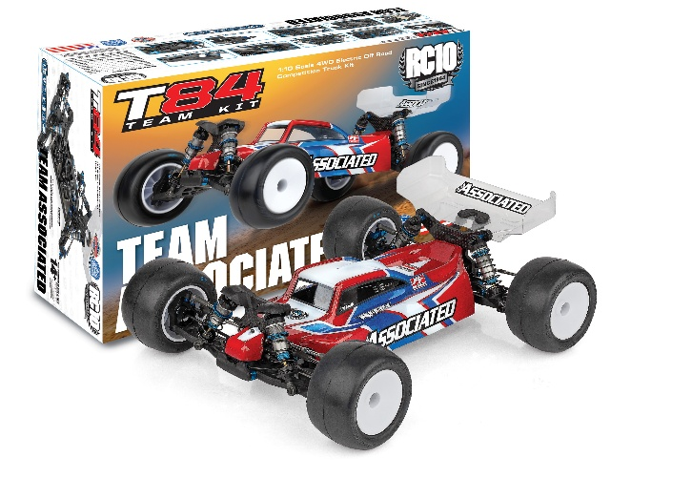
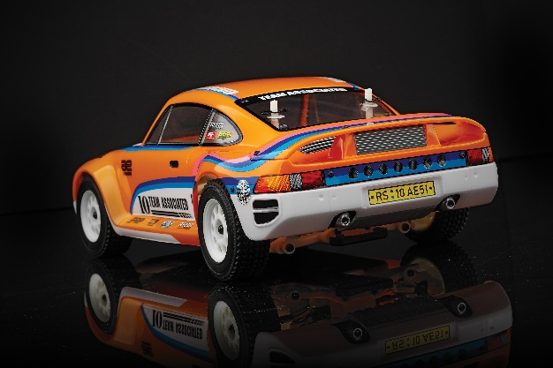
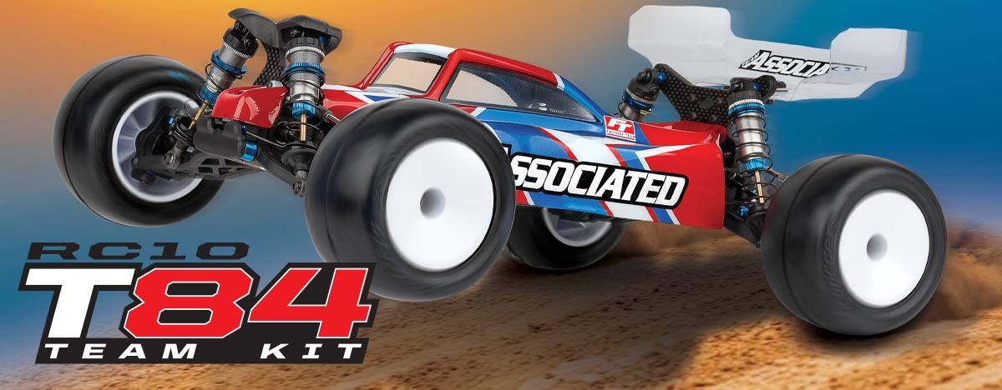

ELECTRIC ■ 1:10 SCALE ■ 4 WHEEL DRIVE ■ OFF ROAD ■ KIT
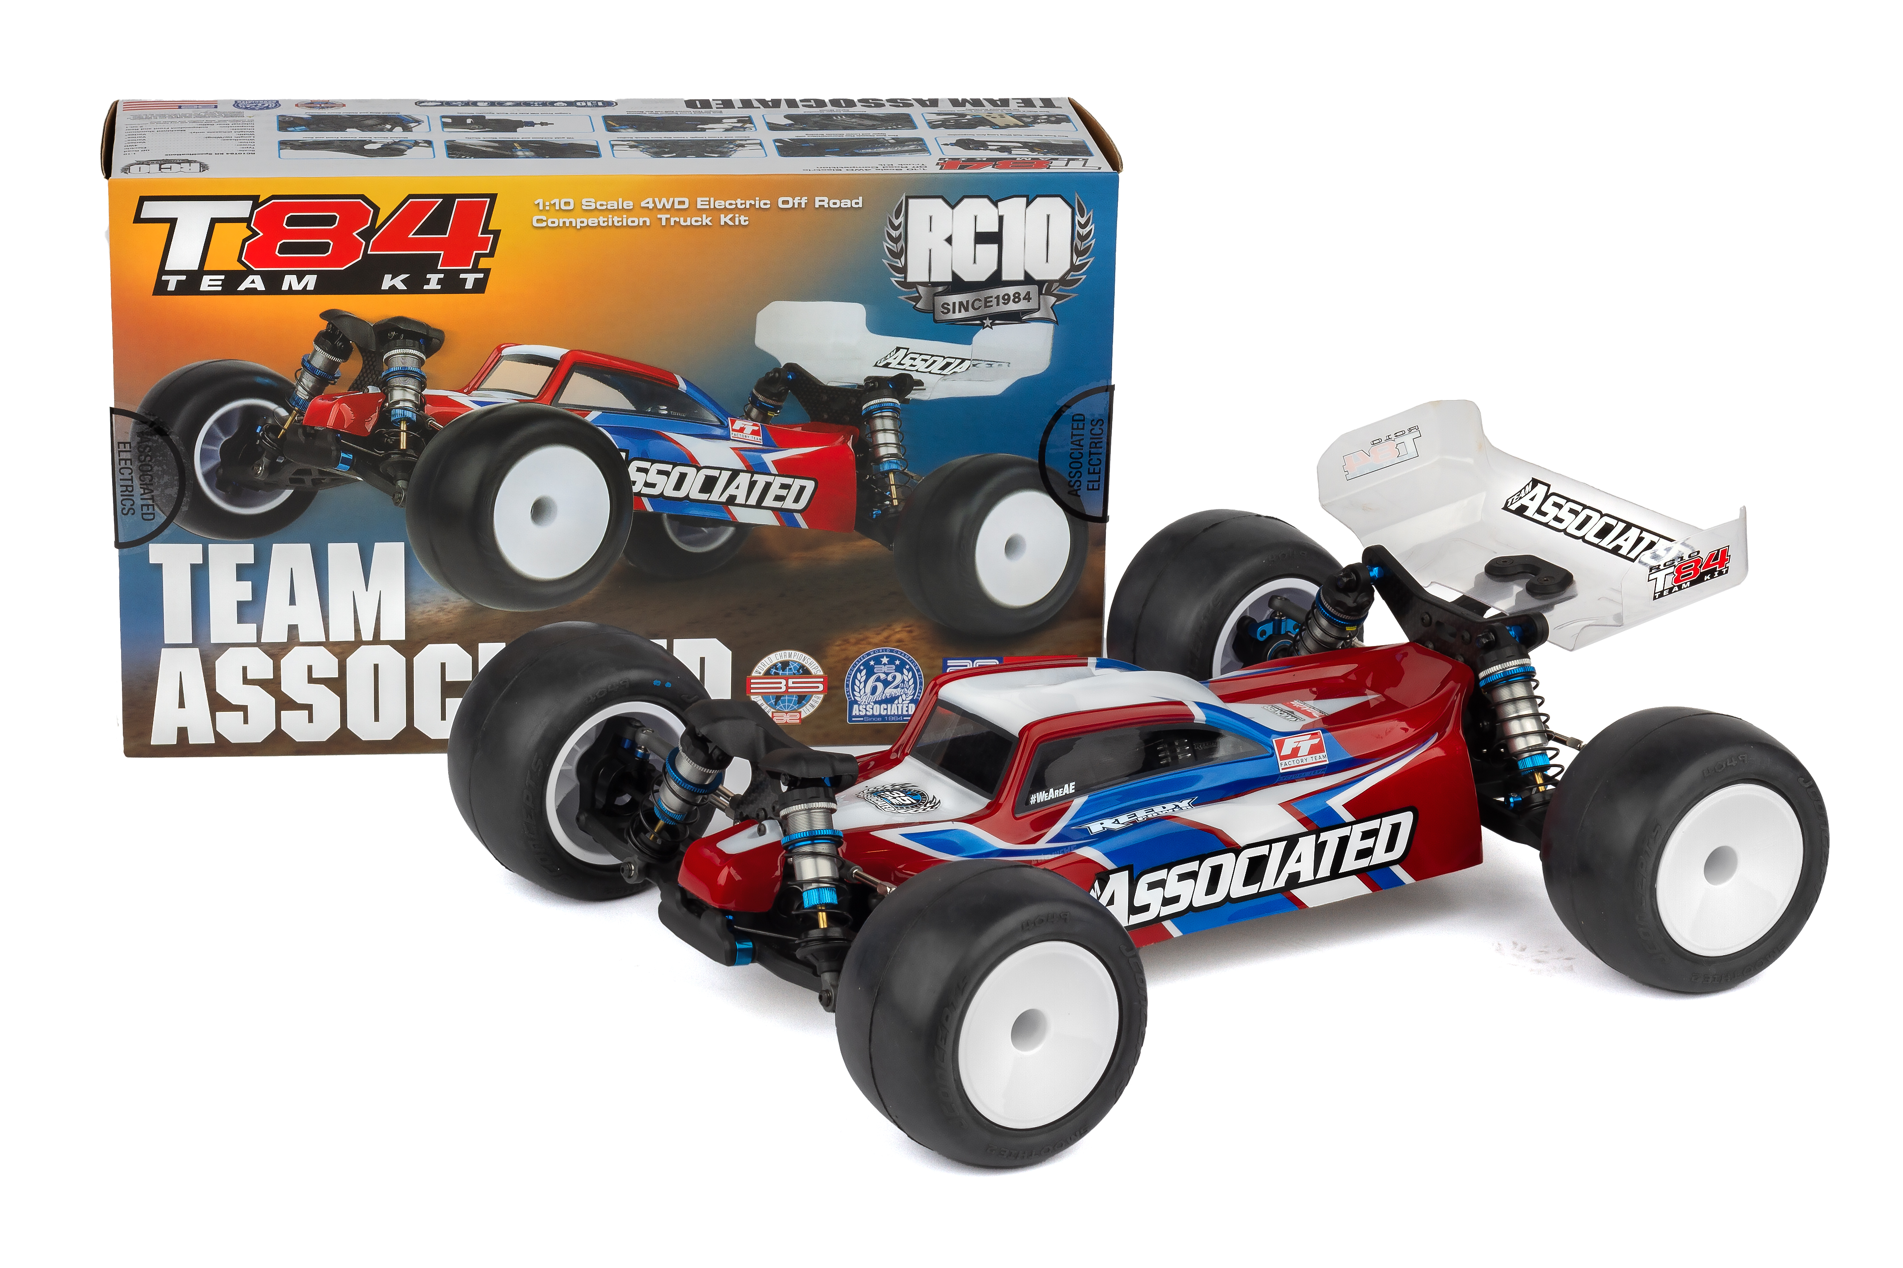
Enhanced aerodynamics come standard with an all new truck specific low-profile body paired with adjustable rear wing mount heights. The RC10T84 Team Kit is finished with shock tower covers, 3.5mm turnbuckles and ballcups, and 13mm big-bore shocks, providing the ultimate blend of strength, precision, and performance.

The RC10T84 Team Kit is your key to placing on top of the podium!

Unleash unparalleled performance with the RC10T84 Team Kit, a 1/10-scale 4WD truck engineered for precision, speed, and racetrack victories. Designed with cutting-edge features, this competition machine delivers superior handling and control.

Its molded height-adjustable gearboxes ensure optimized drivetrain efficiency. The truck specific gull wing long-arm suspension geometry enhances grip and predictability, while
the optimized steering bellcranks and rack provide exceptional bump steer control, keeping your lines tight at every corner.

Fine-tune your setup with chassis bracing adjustments, giving you the flexibility to adapt to each track you race on. The RC10T84 Team Kit allows for precise weight distribution and chassis balance, letting you push the limits with confidence.

The Team Associated RC10T84 Team Kit is Engineered for Victory!
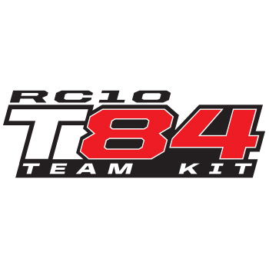

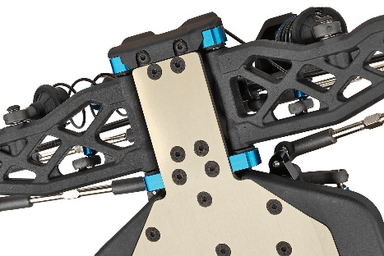
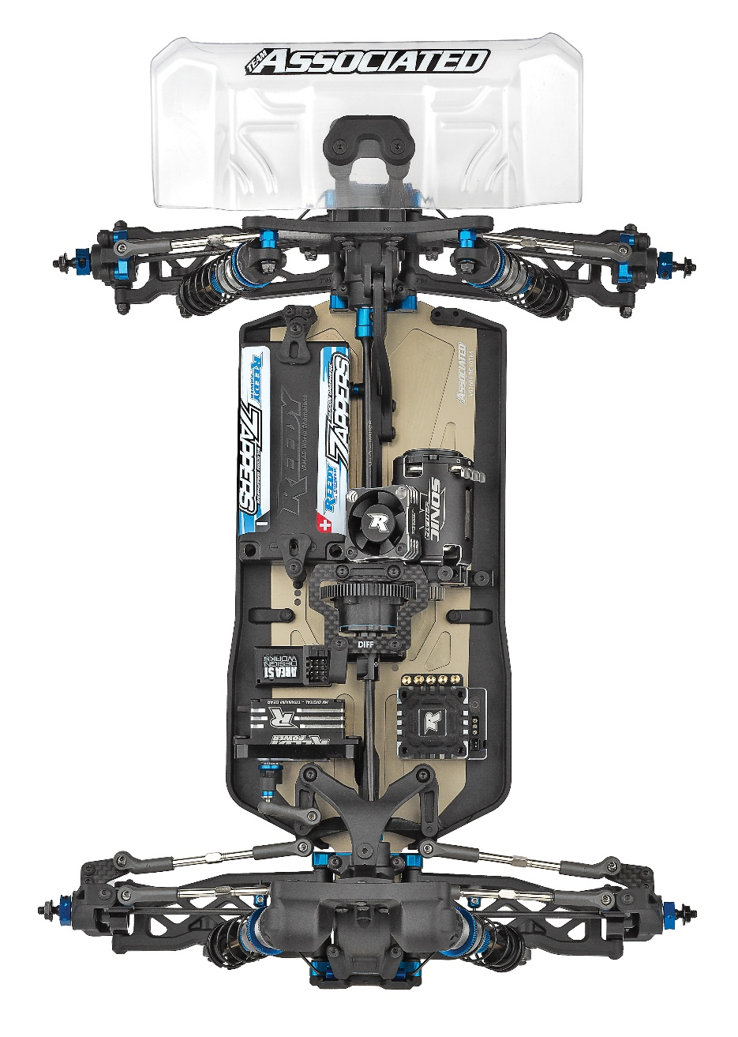
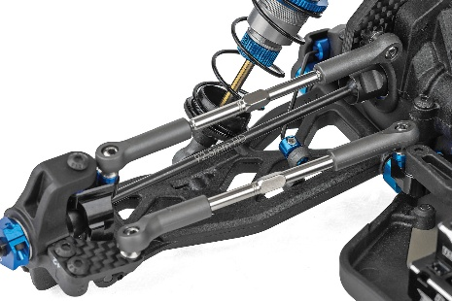

Wide Tongue Chassis for Improved Durability
Truck Specific Gull Wing Long Arm Suspension

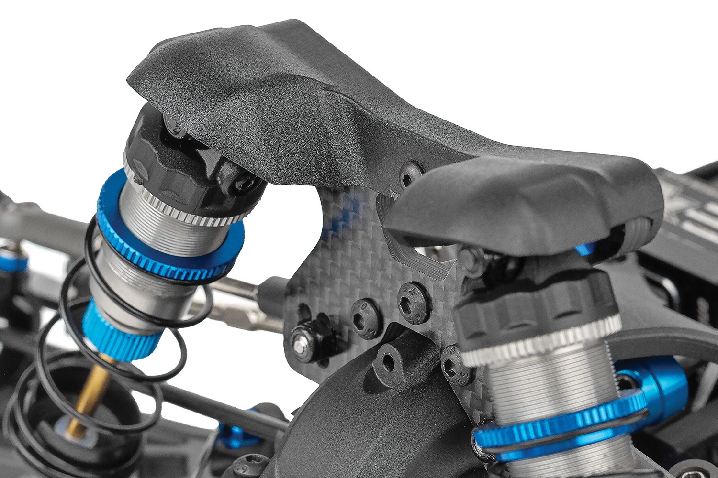
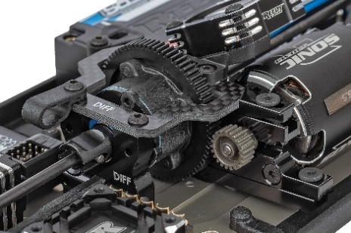

Molded Shock
Tower Covers
Center
Differential

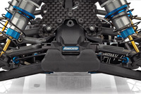
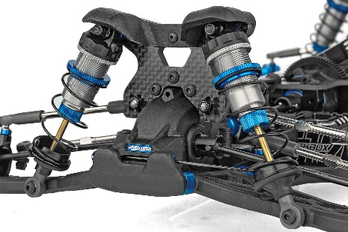

Molded
Front Bumper
25mm and 31mm Length 13mm Big-bore Shock Bodies


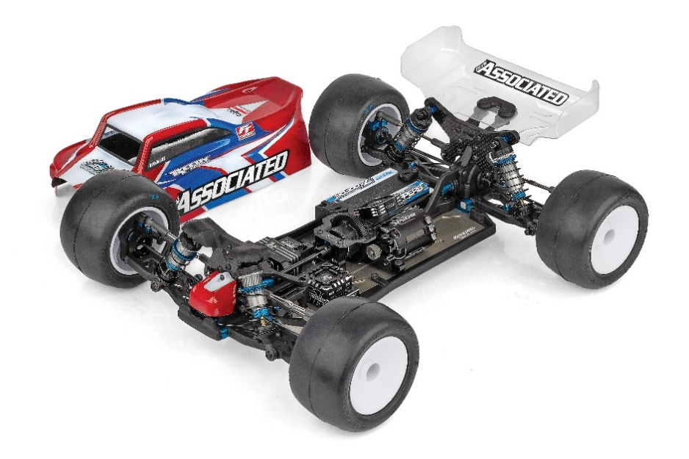
Recommended Electronics:

*Final width, length and weight will vary based on electronics, tire configuration, wing position and vehicle setup.

- New Truck Specific Gull Wing Long Arm Suspension
- New Truck Specific Body
- 25mm and 31mm Length 13mm Big-bore Shock Bodies
- TiN gold 3x24mm and 3x29mm Shock Shafts
- Molded Shock Tower Covers Front and Rear
- New Wide Tongue Chassis for Improved Durability
- New Wide A and B Mounts
- New Molded Front Bumper with Optional Bumper That Covers Anti-roll Bar Mounts
- Longer Front CVA Axle For Truck Specific Wheels
- Center Differential Included

FEATURES
  SPECS
Scale | 1:10
Type | Off Road
Power | Electric
Length | Varies*
Width | Varies*
Weight | Varies*
Wheelbase | Varies*
Internal Gear Ratio | 2.50:1
Drive: | 4WD
Chassis: | Varies*
Suspension: | Independent Front and Rear

- Battery (#27617 Zappers SG7 6600mAh 100C 7.6V Shorty)
- Motor (#27444 Reedy Sonic 540-M4 Motor 6.5)
- ESC (#27016 Blackbox 610R Competition ESC)
- Servo (#27172 Reedy RT2007HD Low-Profile Brushless Hi-Torque Servo)

Other Helpful Items:

- Silicone Shock Fluid (Refer to catalog for complete listings)
- Silicone Diff Fluid (Refer to catalog for complete listings)
- Body Scissors (AE Part # 1737)
- Reamer (AE Part #1499) / Hole Punch
- FT Wrench Set (AE Part #1519)
- Hobby Knife
- Needle Nose Pliers
- FT Shock Shaft Multi-Tool Pliers (AE Part #1681)
- Wire Cutters
- Soldering Iron
- Calipers or a Precision Ruler

Items required for operation:
Motor, battery, ESC, servo, receiver, paint, tires and radio. Assembly and painting required

UPC | Part No. | Description | MSRP | MAP | Pieces Per Case | Origin | Available
784695900578 | 90057 | RC10T84 Team Kit | $970.99 | $659.99 | 6 | TW | April
CATALOG INFORMATION
Download all zipped photos here: https://rc10.com/RC10T84Images/ (15.2MB) Link is active for 30 days.
Please refer to our MAP Policy here: https://img2c.associatedelectrics.com/pdf/map-policy.pdf

