For Immediate Release: May

NEW! Reedy RS4008A Hi-Speed HV Digital Competition 1:8 Servo
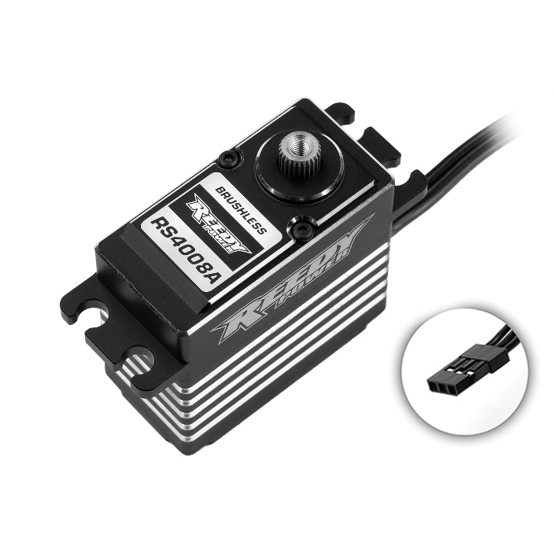
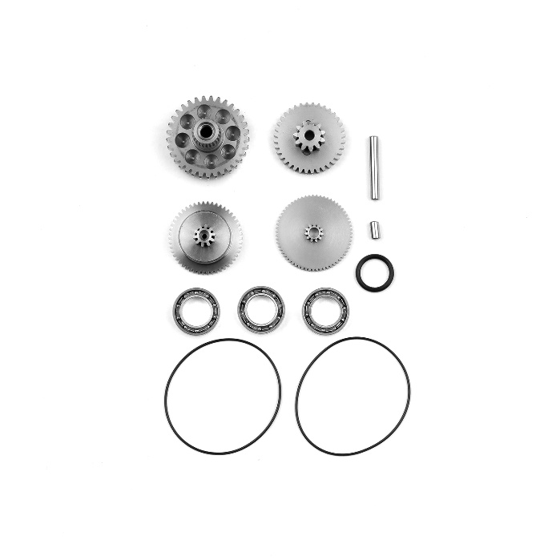

Reedy is thrilled to announce the launch of the RS4008A Hi-Speed HV Digital Competition Servo, designed specifically for the demanding world of 1:8 buggy and truggy racing, but also suitable for 1:10 off-road buggies and trucks as well as rock crawlers.

The RS4008A Hi-Speed HV Servo represents the pinnacle of servo technology, combining unparalleled performance with durability to cater to both professional racers and casual enthusiasts. Here are the key features that make this servo a game-changer:

Powerful Brushless Motor: Engineered with input from the Reedy racing team, the RS4008A features a high-efficiency brushless motor that offers exceptional torque and speed, tailored for both steering and throttle control in 1:8 scale vehicles. The RS4008A serves as a high-speed alternative to the popular RT5012A hi-torque option.

Advanced Microprocessor: This servo boasts an advanced microprocessor that ensures precision in steering and throttle response, leading to more consistent and faster lap times on the track.

High-Strength Steel Gear Set: Constructed for maximum strength and durability, the steel gear steel set is designed to withstand the rigors of off-road racing, providing racers with reliability race after race.

CNC-Machined Full-Aluminum Case: The servo's aluminum case not only adds to its robustness but also aids in reducing operating temperatures, ensuring fade-free performance even in the most demanding conditions.

High Voltage Compatibility: With HV compatibility, the RS4008A can leverage the power of LiPo RX batteries, offering racers the ability to maximize the servo's capabilities without the risk of damaging internal components.

Reedy’s commitment to quality and performance shines with the RS4008A, providing racers with the same equipment and specifications trusted by pros. Whether you're competing in local club events or international championships, this servo is engineered to give you an edge on the track.

"We've listened to our customers and factory team drivers, and developed a servo that not only meets but exceeds the expectations of what a competition servo should be. The RS4008A is the result of our dedication to innovation, performance, and durability," said Rick Hohwart, Reedy Electric Department Manager.

The RS4008A Hi-Speed HV Servo is now available for purchase at hobby shops, online retailers, and at www.ReedyPower.com.

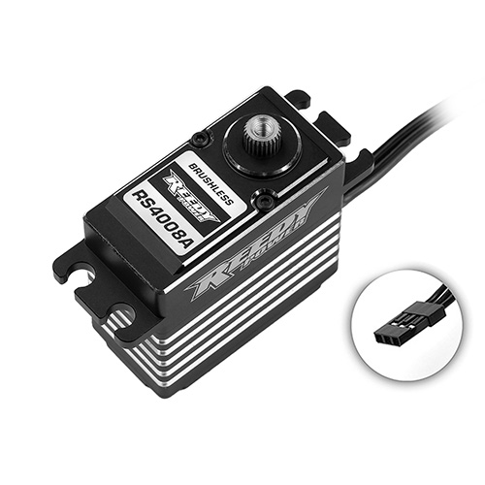

Specifications
Feature |  | Specification
Input (V) |  | 4.8 - 8.6
Motor |  | Brushless
Speed (sec/60°) | 6.0V | .115
 | 7.4V | .100
 | 8.4V | .085
Torque (kg-cm/oz-in) | 6.0V | 34/472
 | 7.4V | 39/542
 | 8.4V | 45/625
Dimensions (mm) |  | 40x20x37.5
Weight (g) |  | 83
Spline |  | 25

UPC | Part No. | Description | MSRP | MAP | COO | Available
784695271685 | 27168 | Reedy RS4008A Hi-Speed HV 1:8 Servo | $269.99 | $160.99 | CN | 
784695271692 | 27169 | Reedy RS4008A Gear Set | $56.99 | $47.99 | CN

