

**For Immediate Release:** Sept 2025

**RC10 4x4 Rally Kit #30138**

1:10 Scale Electric 4x4 Electric Off Road Rally Kit

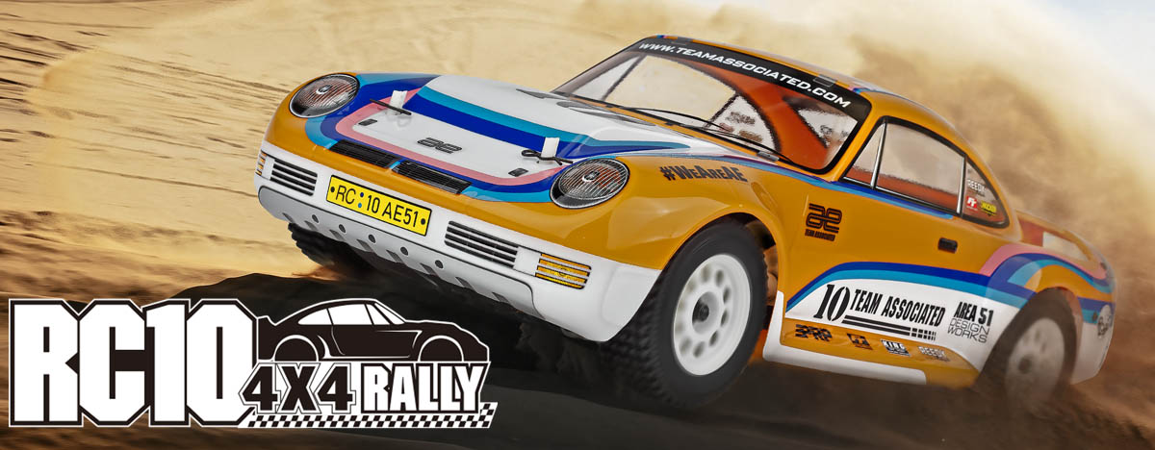

|  |
| --- |
| **ELECTRIC ■ 1:10 SCALE ■ 4 WHEEL DRIVE ■ OFF ROAD ■ KIT** |

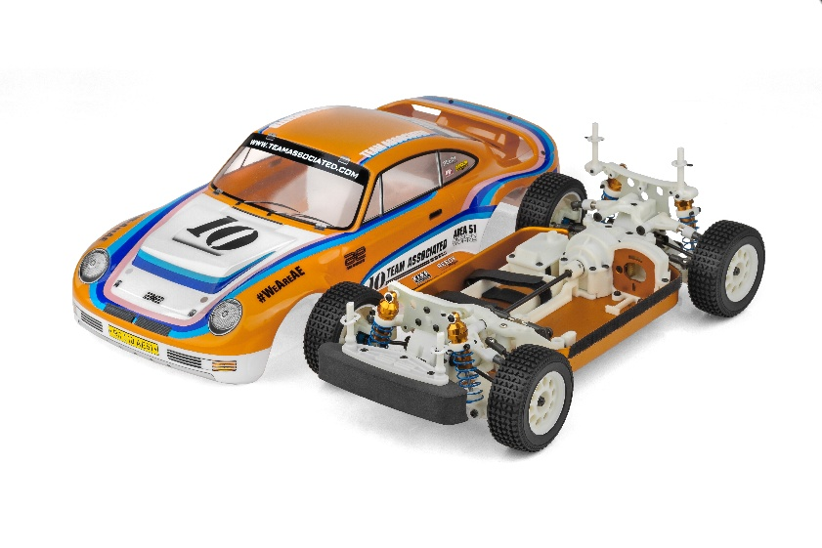

The Team Associated RC10 4x4 Rally is Engineered

for Victory!

Built for performance and protection, this RC machine includes a water-resistant enclosed receiver box, sealed gear differentials, and a dust-protective chassis cover with an optional filter screen to keep debris at bay. Hardened steel driveshafts and axles, full metal ball bearings, and an aluminum motor plate ensure long-lasting durability. This rally car is ready for anything—from backyard bashing to competition racing.

Bring the golden era of RC racing into the modern age with this rally-bred powerhouse, outfitted with a new aluminum gold tub chassis plate and iconic RC10 livery decal sheet. The clear 3-piece rally body set, complete with rear bumper and wing, delivers aggressive styling and aerodynamic performance, while injection-molded brake calipers and rotors add realistic scale detail. New rally shock towers, gold anodized aluminum shocks, and a fully adjustable front suspension with upgraded upper arms and turnbuckle set give you the precision handling needed to dominate any surface.

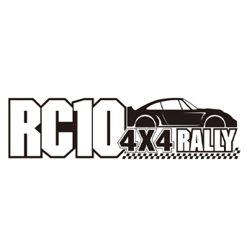

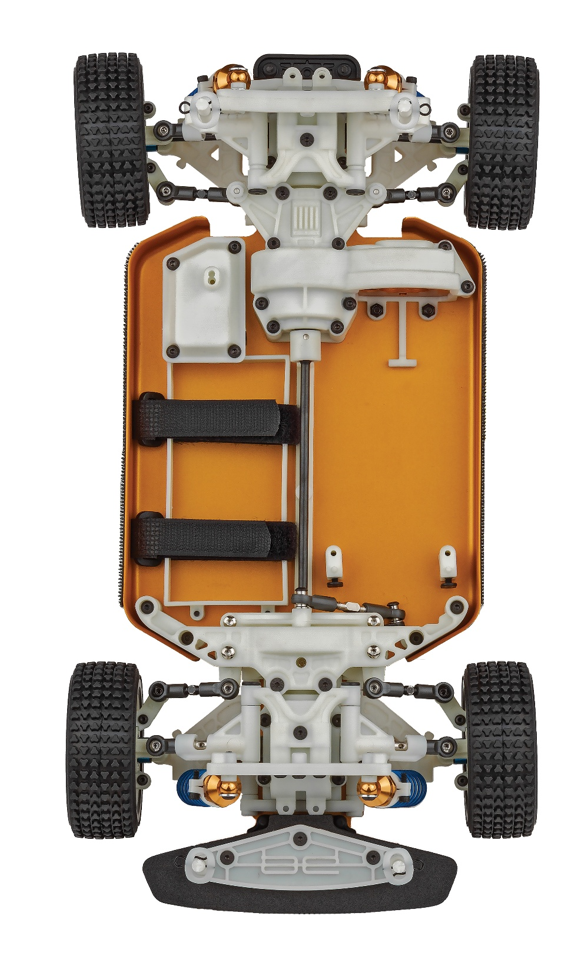

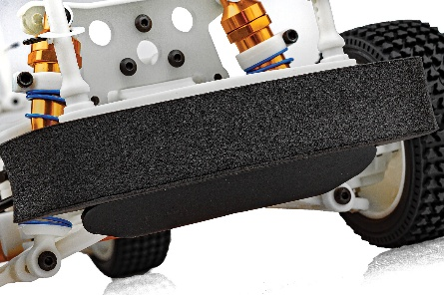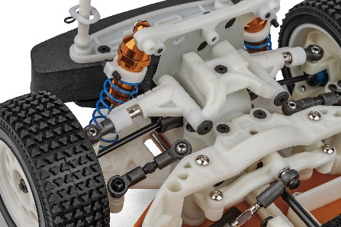

New front rally bumper

New fully adjustable front upper arms

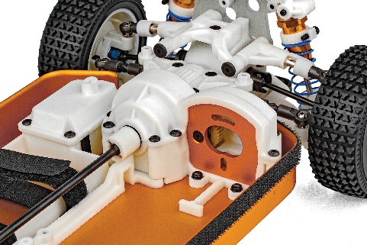

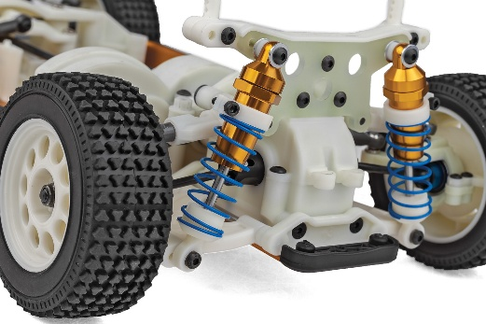

Hardened steel driveshafts and axles

Gold anodized aluminum shocks

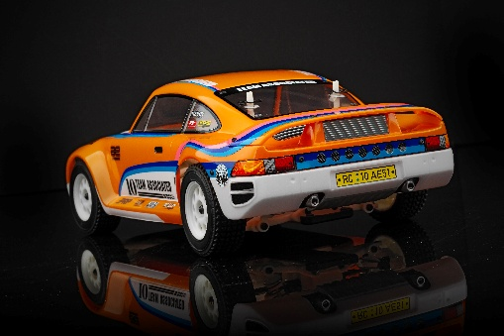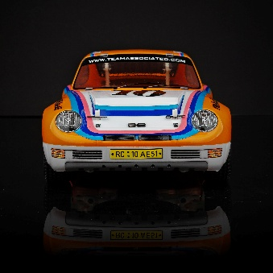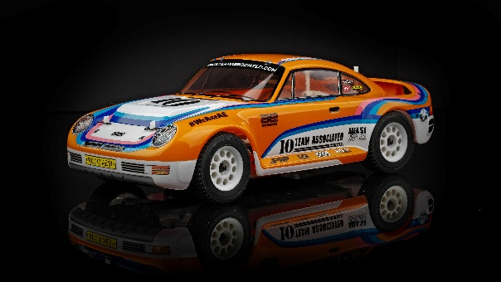

|  |  |  |  |  |
| --- | --- | --- | --- | --- |
| **FEATURES** | |  |  | | --- | --- | | **SPECS** |  | |  |

* Injection molded brake calipers and rotors
* New fully adjustable front upper Arms
* New front rally bumper
* Adjustable turnbuckle set
* Classic RC10 livery decal sheet included
* New aluminum gold tub chassis plate
* New rally shock towers
* New clear 3pc rally body set with rear bumper and wing
* New rally chassis dust protective cover
* Optional dust filter screen included
* New rally wheels and tires
* Gold anodized aluminum shocks
* Water-resistant, enclosed receiver box
* Hardened Steel driveshafts and axles
* Sealed front, center and rear gear differentials
* Adjustable hook and loop battery straps
* Full metal ball bearings
* Aluminum motor plate
* Adjustable shock mounting locations
* Bolt-on steering plates
* Adjustable body post height locations
* “Shorty” battery box

|  |  |
| --- | --- |
| **Scale** | 1:10 |
| Type | Off Road |
| **Power** | Electric |
| **Length** | 458mm (18.0 in.) |
| **Width** | 190mm (7.48 in.) |
| **Weight** | Varies* |
| **Wheelbase** | 259mm (10.2 in.) |
| **Internal Gear Ratio** | 2.6:1 |
| **Drive:** | 4WD |
| **Chassis:** | Aluminum Tub |
| **Suspension:** | Independent Front and Rear |

*Final width, length and weight will vary based on electronics, tire configuration, wing position and vehicle setup.

|  |  |
| --- | --- |
| **OTHER HELPFUL ITEMS** |  |

* Silicone Shock Fluid (Refer to catalog for complete listings)
* Silicone Diff Fluid (Refer to catalog for complete listings)
* Body Scissors (AE Part # 1737)
* Reamer / Hole Punch
* FT Wrench Set (AE Part #1519)
* Hobby Knife
* Needle Nose Pliers
* Wire Cutters
* Soldering Iron
* Calipers or a Precision Ruler

**Items required for operation:**

Motor, battery, ESC, servo, receiver, paint, and radio. Assembly and painting required.

|  |  |  |  |  |  |  |  |
| --- | --- | --- | --- | --- | --- | --- | --- |
| **UPC** | **Part No.** | **Description** | **MSRP** | **MAP** | **Pieces Per Case** | **Origin** | **Available** |
| 784695301382 | 30138 | RC10 4x4 RALLY KIT | $573.99 | $389.99 | 2 | TW | Sept |

|  |
| --- |
| **CATALOG INFORMATION** |

Download all zipped photos here: <https://rc10.com/4x4RallyImages/> (26MB) Link is active for 30 days.

Please refer to our MAP Policy here: <https://img2c.associatedelectrics.com/pdf/map-policy.pdf>

