For Immediate Release: August 2025

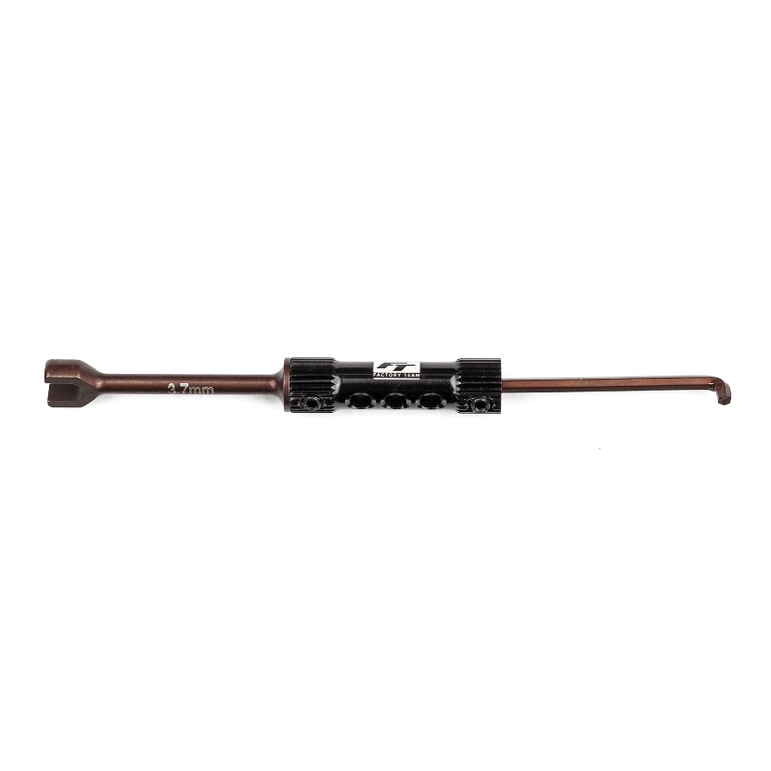
#1529 FT turnbuckle and hex wrench, 3.7mm and 2mm

(Pictured: FT Turnbuckle and Hex Wrench, 3.7mm and 2mm)

Factory Team is proud to introduce the new combination FT turnbuckle and hex diff wrench! This two in one wrench allows you to adjust your ball differential without having to take off the tires or conveniently flip around the tool to adjust 3.7mm turnbuckle like those from Factory Team.

Compatible with:

RC10B7, RC10B7D

UPC | Part No. | Description | MAP | MSRP | Origin | Available
784695015296 | 1529 | FT Turnbuckle and Hex Diff Wrench, 3.7mm | $18.69 | $21.99 | TW | 

