For Immediate Release: December 2025

#21657, #21658 RC28R FT Sidewall Flange Sets

Now available from Factory Team are sidewall wheel flanges for the RC28R front wheels. These flanges come in diameters of 22.4, 22.6, 22.8, and 23.0mm to fine tune the sensitivity of front grip depending on tire diameter. Also included in the package are molded tools for removing the flanges from wheels which makes changing from one size to the next easy.
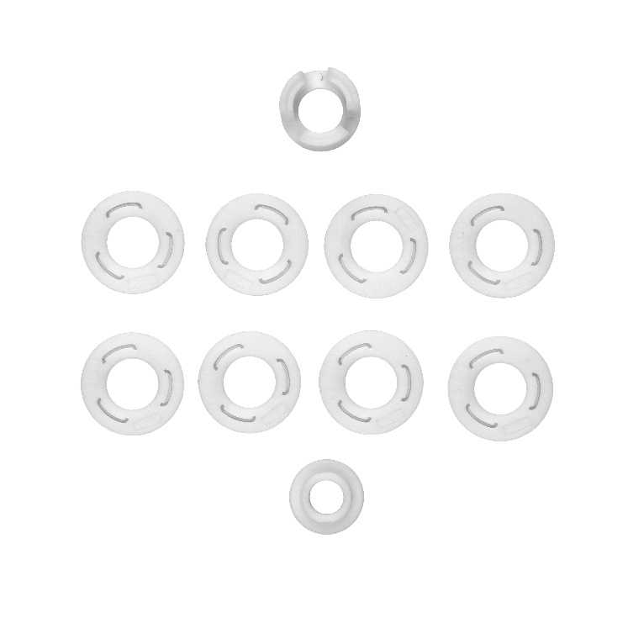
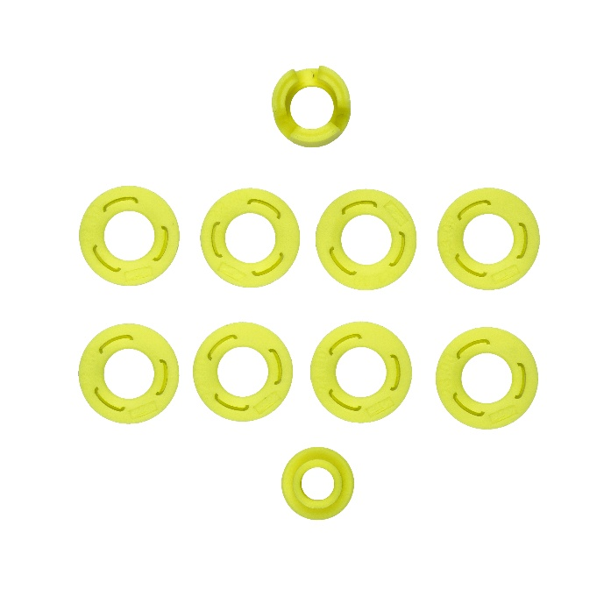

Compatible with:
20165 , 20168

UPC | Part No. | Description | MAP | MSRP | Origin | Available
784695216570 | 21657 | FT Sidewall Flange Set, White | $12.99 | $12.99 | TW | 
784695216587 | 21658 | FT Sidewall Flange Set, Yellow | $12.99 | $12.99 | TW

