For Immediate Release: February 2026

RC10 Factory Team Captured Hinge Pins
Whether you are racing or bashing, these all new RC10 Factory Team Captured Hinge pins provide added durability and peace of mind when driving your favorite RC10 Vintage car. Never lose an e-clip again!

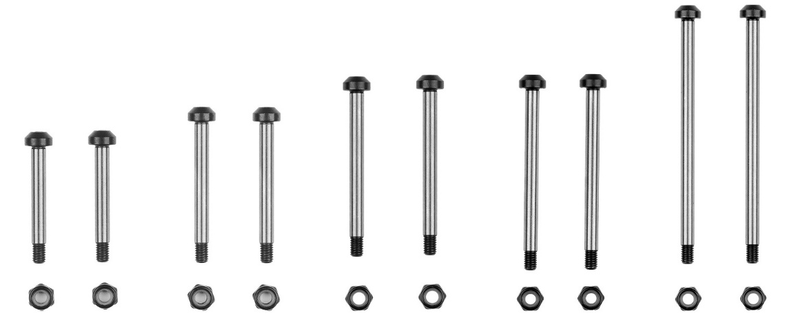
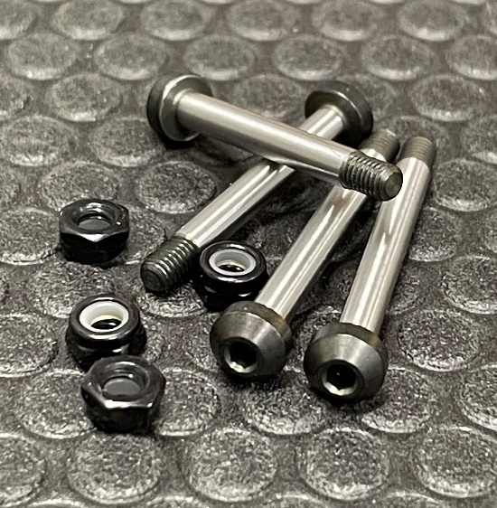

(Pictured left to right: 6970, 6971,6972, 6973, 6974)

Now in stock!
Compatible with:
All RC10 2wd and 4wd Tub Chassis vehicles.
*More sizes coming soon! Stay tuned.

UPC | Part No. | Description | MAP | MSRP | Origin | Available
784695069701 | 6970 | FT Captured King Pin, 28.2mm | $11.99 | $11.99 | TW | 
784695069718 | 6971 | FT Captured Front Outer Hinge Pin, 33.2mm | $11.99 | $11.99 | TW
784695069725 | 6972 | FT Captured Rear Outer Hinge Pin, 38.8mm | $11.99 | $11.99 | TW
784695069732 | 6973 | RC10 FT Captured Front Inner Hinge Pin, 43.5mm | $12.99 | $12.99 | TW
784695069749 | 6974 | RC10 FT Captured Rear Inner Hinge Pin, 58.7mm | $13.99 | $13.99 | TW

