For Immediate Release: January 2026

FT Aluminum 1:28 Scale Pinion Sets #21690, #21691, #21692
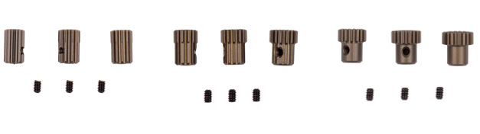

(Pictured left to right: #21690, #21691, #21692)

A new line of aluminum pinion gears are now available from Factory Team! These pinion gear sets all come with three pinion gears, and are offered in three different ranges, depending on which motor is being used. These are precision cut gears designed to mesh with 64P spur gears.

Compatible with:
20165, 20168
UPC | Part No. | Description | MAP | MSRP | Origin | Available
784695216907 | 21690 | RC28R FT Aluminum 1:28 Pinion Gear Set, 9-11 Tooth – 64P | $26.34 | $30.99 | TW | Now
784695216914 | 21691 | RC28R FT Aluminum 1:28 Scale Pinion Gear Set, 12-14 Tooth – 64P | $26.34 | $30.99 | TW | Now
784695216921 | 21692 | RC28R FT Aluminum 1:28 Scale Pinion Gear Set, 15-17 Tooth – 64P | 26.34 | 30.99 | TW | Now

