**For Immediate Release:** **July 2025**

**#42387 Enduro FT steel weighted portal covers, 67g**

Factory Team presents the FT weighted portal covers. Get the weight low where you need it most. These covers have a nice snug fit to the portals to ensure correct placement every time. Pair this with the black oxide coating for that stealthy performance. Pick yours up today!

Features:

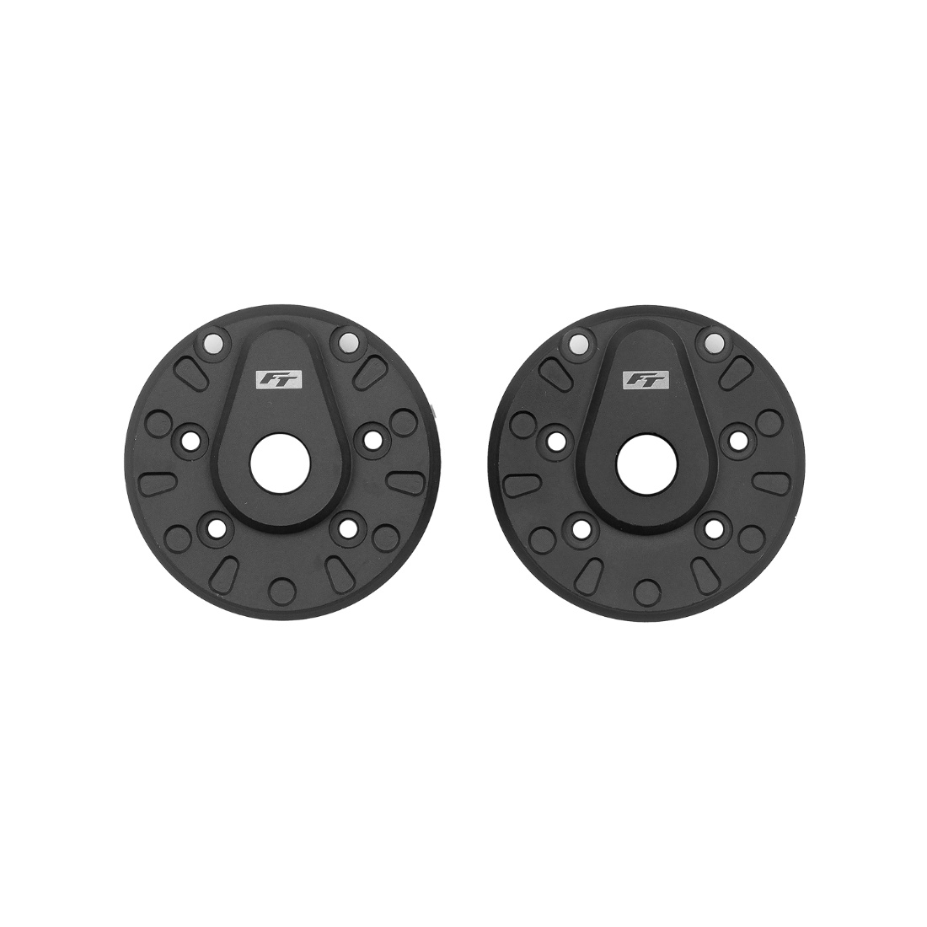• 67 grams each

• Low center of gravity

Compatible with:

Element RC Enduro Portal Axles

|  |  |  |  |  |  |  |
| --- | --- | --- | --- | --- | --- | --- |
| **UPC** | **Part No.** | **Description** | **MAP** | **MSRP** | **Origin** | **Available** |
| 784695423879 | 42387 | Enduro FT steel weighted portal covers, 67g | $54.39 | $63.99 | CN | Now |