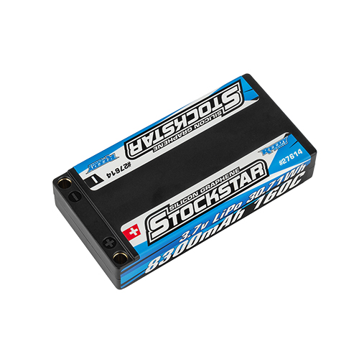
For Immediate Release: November 2026

New! Reedy Power STOCKSTAR 8300mAh 3.7V 160C 1:12

Continuing Reedy Power’s pioneering legacy in 1:12 racing, the new STOCKSTAR 8300mAh 3.7V 160C LiPo battery brings updated chemistry and construction to the demands of the class. Its high-capacity formulation combines reduced internal resistance with elevated average voltage, while heavy-duty internal construction delivers proven reliability and cycle life. A durable hard case with 5mm low-resistance sockets houses the 8300mAh pack in a compact 93 x 47 x 18.3mm footprint weighing 165g. With a 160C discharge rating, the STOCKSTAR carries Reedy Power’s commitment to racing performance into the next generation of 1:12 competition.

.
Specifications
Features
Model Number | 27614
Capacity | 8300mAh
Voltage | 3.7v
Dimensions (mm) | 93x47x18.3
Max. Charge Rate | 16.6a
Discharge Current | 160c
Weight (g) | 165g
Socket | 5mm
- State-of-the-art LiPo chemistry
- Updated formulation and construction
- Heavy-duty internal construction
- High capacity
- Reduced IR with elevated average voltage
- Proven reliability and cycle-life
- Durable hard case with low-resistance connector

UPC | Part No. | Description | MSRP | MAP/Web | COO | Available
784695276147 | #27614 | Reedy Power STOCKSTAR 8300mAh 3.7V 160C 1:12 | $121.99 | $75.99 | HK | Now

