For Immediate Release: March 2026

RB10 Retro Kit #90054

1:10 Scale 2WD Electric Off Road Competition Buggy Kit


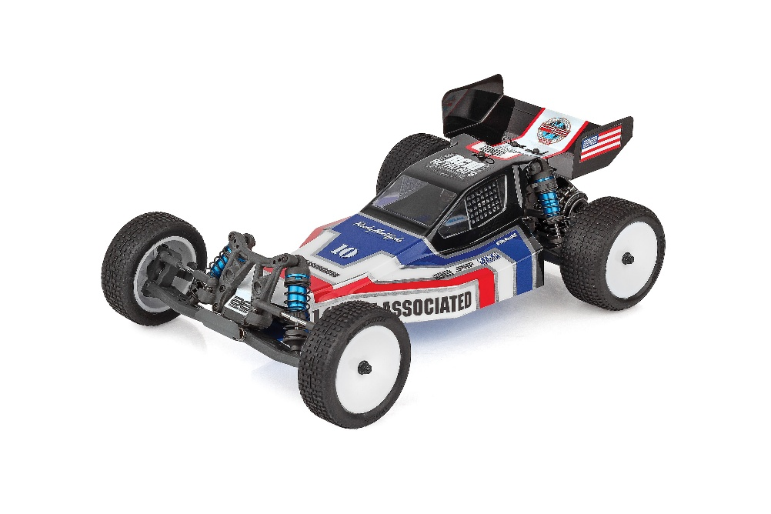
ELECTRIC ■ OFF ROAD ■ 1:10 SCALE ■ 2 WHEEL DRIVE ■ KIT
Retro style. Modern performance.

The Team Associated RB10 Retro Kit blends classic off-road buggy styling with proven B5 engineering for a true old-school look backed by modern durability and adjustability. Featuring a rear-motor layout, the RB10 delivers familiar handling characteristics with updated materials and race-ready components.

At its core is a Retro Blue anodized aluminum B5 tub chassis, paired with a matching Retro Blue aluminum front nose plate and exclusive grey molded plastics throughout for an unmistakable vintage appearance. An authentic retro Viper body and high-downforce 5.5” retro wing complete the classic silhouette, while 12mm hex dish wheels and high-grip off-road tires ensure confident performance on today’s tracks.

Under the body, the RB10 is all business. Blue anodized 12mm big bore coil-over shocks, a B5 rear-motor Stealth transmission, rear CVA driveshafts, and a 2.6:1 sealed gear differential provide smooth, reliable power delivery. Fully adjustable suspension geometry, steel turnbuckles, vertical ball ends, and an adjustable V2 slipper system give drivers the tuning range they expect from a modern Team Associated platform.

The RB10 Retro Kit captures the look, feel, and attitude of
classic RC racing—without giving up the performance to match.

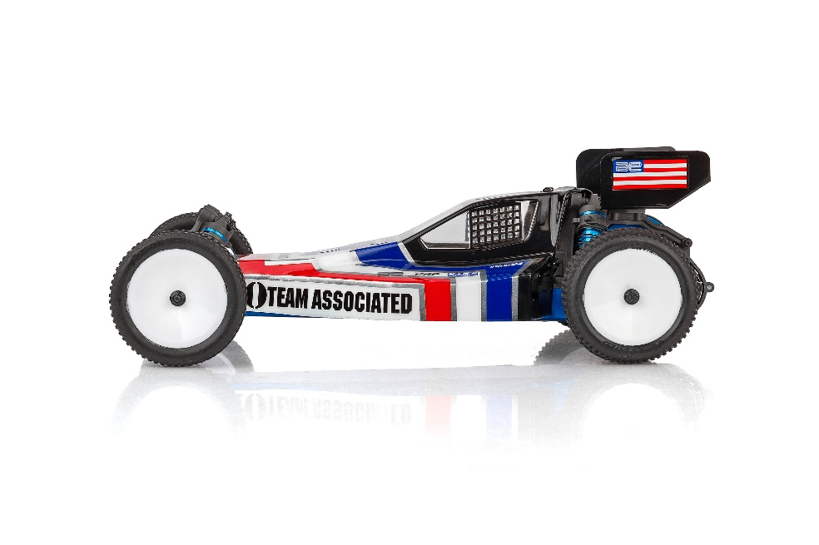

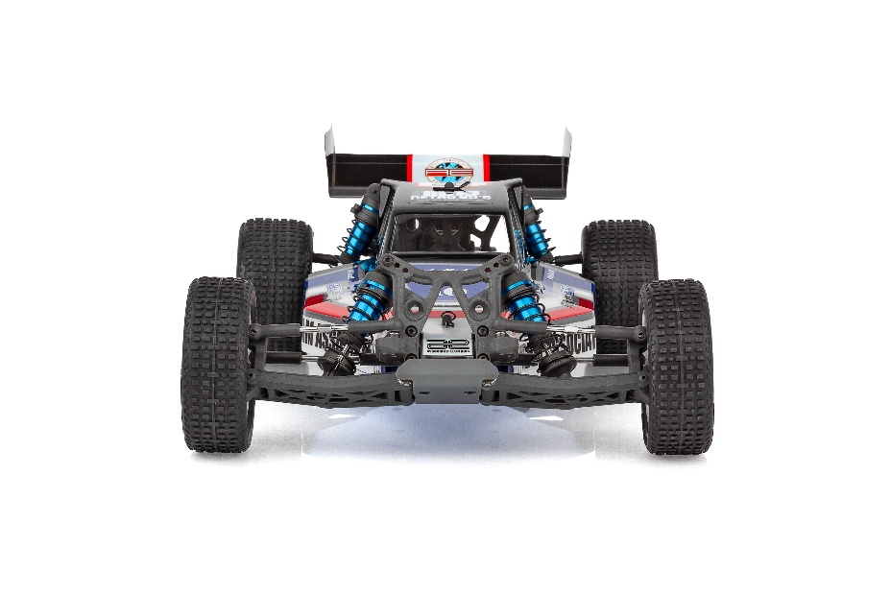

FEATURES
SPECIFICATIONS

- New Retro Blue aluminum B5 tub chassis (rear motor)
- New Retro Blue aluminum front nose plate
- New front and rear molded bulkhead parts
- Exclusive grey plastics throughout
- High downforce 5.5” retro wing included
- 12mm Hex Dish Wheels
- Authentic retro Viper body included
- High Grip Offroad tires included
- Aluminum Blue anodized 12mm big bore coil-over shock absorbers
- B5 Rear motor stealth transmission
- Rear CVA driveshafts for more durability
- 2.6:1 ratio gearbox with heavy-duty sealed gear differential
- Adjustable V2 slipper system
- Rugged steel turnbuckles for adjustable camber and front toe-in
- Fully adjustable suspension geometry
- Vertical ball ends for roll center adjustments, front and rear
- Metric hardware throughout
- Full ball bearings included

Power | Electric
Terrain | Off-Road
Body Style | Buggy
Scale Size | 1:10 Scale
Length | 400mm (15.75in)
Width | 248mm (9.76in)
Weight | Varies*
Wheelbase | 277.8mm (10.94in)
Internal Ratio | 2.6:1
Assembly Level | Kit
Drive | 2WD

*Final width, length and weight will vary based on electronics, tire configuration, wing position and vehicle setup.

Recommended Electronics:

- Battery (#27318 Wolfpack HV-LiPo 2S 7.4v 4200mAh - bullet connectors)
- Battery (#758 Wolfpack LiPo 2S 7.4v 3000mAh - with T-plug)
- Motor (#293 Sonic 540-FT 17.5 Spec FT)
- ESC (#27012 Blackbox 600z-G2)
- Servo (#27154 RS1606A Low Profile Hi-Speed HV)

Other Helpful Items:

- Body Scissors (AE Part # 1737)
- FT Wrench Set (AE Part #1519)
- Hobby Knife
- Needle Nose Pliers
- Wire Cutters
- Soldering Iron
- Calipers or a Precision Ruler

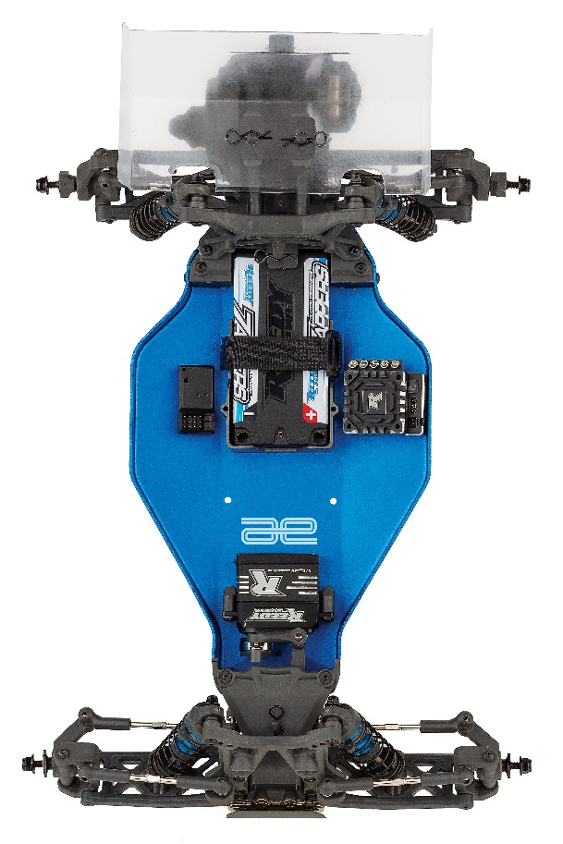

UPC | Part No. | Description | MSRP | MAP | Pieces Per Case | Origin | Available
784695900547 | 90054 | RB10 Retro Kit | $440.99 | $299.99 | 6 | TW | Early April
Download all zipped photos here: https://rc10.com/RB10RetroImages/ (12.3MB). Link is active for 30 days. Please refer to our MAP Policy here: https://img2c.associatedelectrics.com/pdf/map-policy.pdf

