For Immediate Release: September 2026

RB10 Factory Team Retro Kit #90060

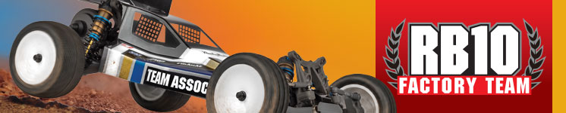

ELECTRIC ■ OFF ROAD ■ 1:10 SCALE ■ 2 WHEEL DRIVE ■ KIT

Retro style. Modern performance.

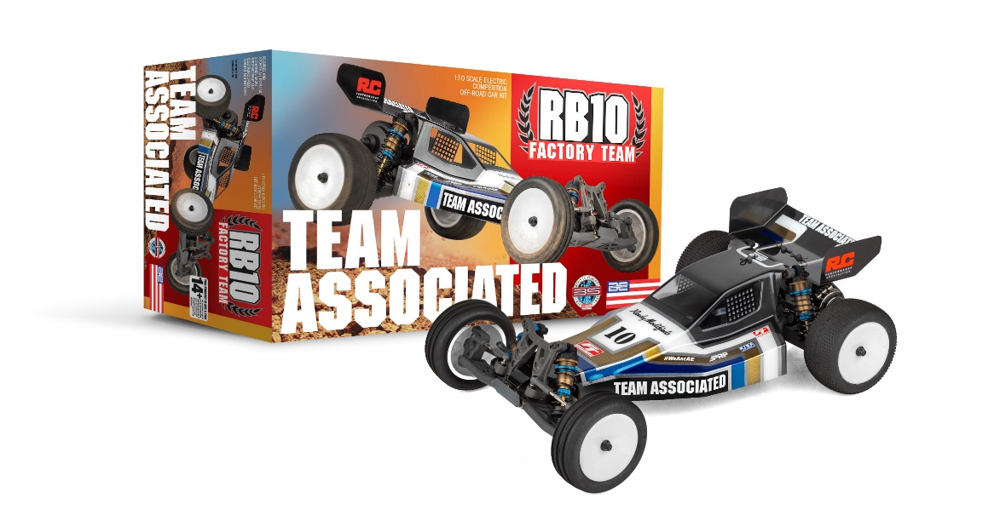

The Team Associated RB10 Factory Team Retro Kit blends classic off-road buggy styling with proven B5 engineering for a true old-school look backed by modern durability and adjustability. Featuring a rear-motor layout, the RB10 Factory Team Retro delivers familiar handling characteristics with updated materials, race-ready components, and some Factory Team upgrades.

At its core is a Retro Bronze anodized aluminum B5 tub chassis, paired with a matching Retro Bronze aluminum front nose plate and exclusive grey molded plastics throughout for an unmistakable vintage appearance. An authentic retro Viper body and high-downforce 5.5” retro wing complete the classic silhouette, while 12mm hex dish wheels and your choice of tires (not included) ensure confident performance on today’s tracks.

Under the body, the RB10 Factory Team Retro Kit is all business. Kashima coated 13mm big bore coil-over shocks, a B5 rear-motor Stealth transmission, rear CVA driveshafts, and a 2.6:1 sealed B5 Ball differential provides smooth, reliable power delivery. Fully adjustable suspension geometry, steel turnbuckles, vertical ball ends, and an adjustable V2 slipper system give drivers the tuning range they expect from a modern Team Associated platform.

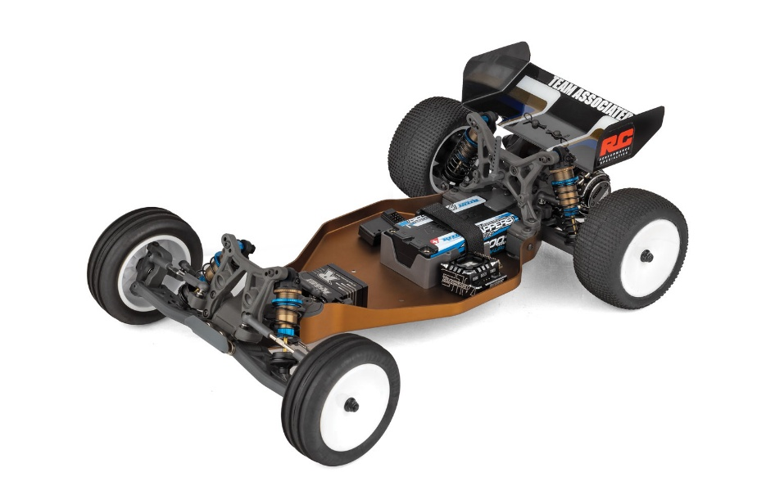



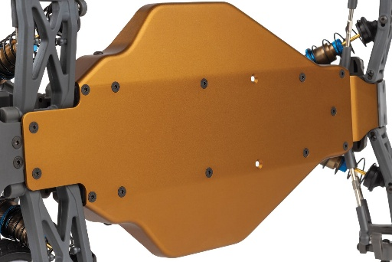
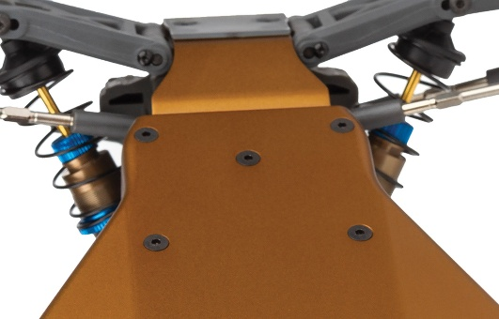

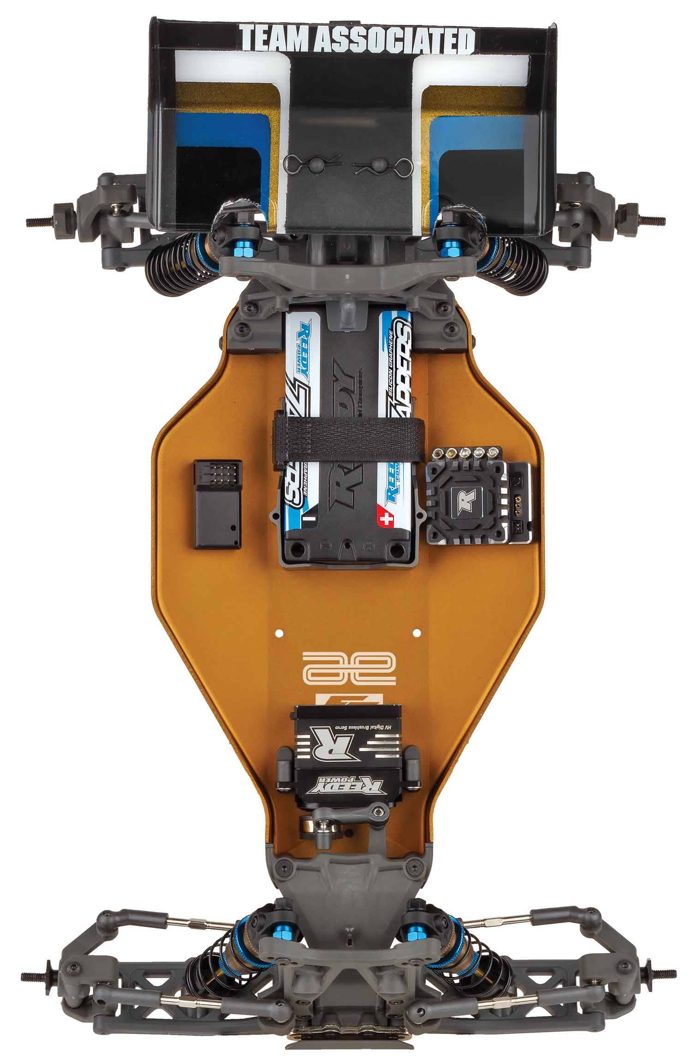
New Retro Bronze aluminum front nose plate
New Retro Bronze aluminum
B5 tub chassis

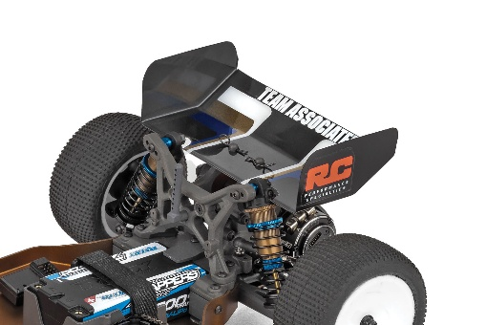
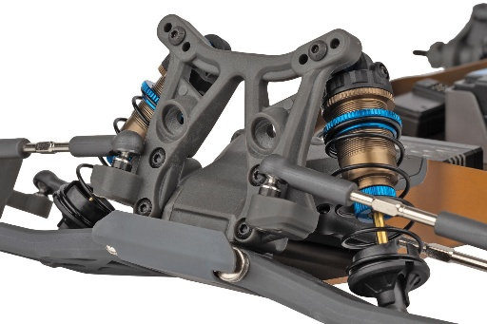

New front and rear molded
bulkhead parts
High downforce 5.5” retro wing included

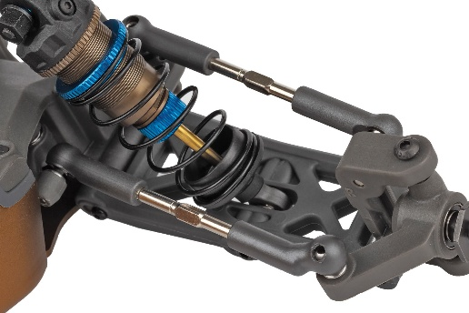
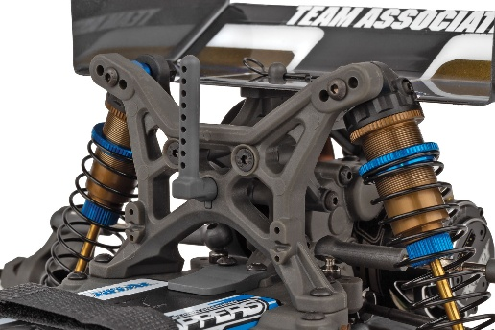

Exclusive grey plastics throughout
13mm Kashima big bore coil-over shock absorbers

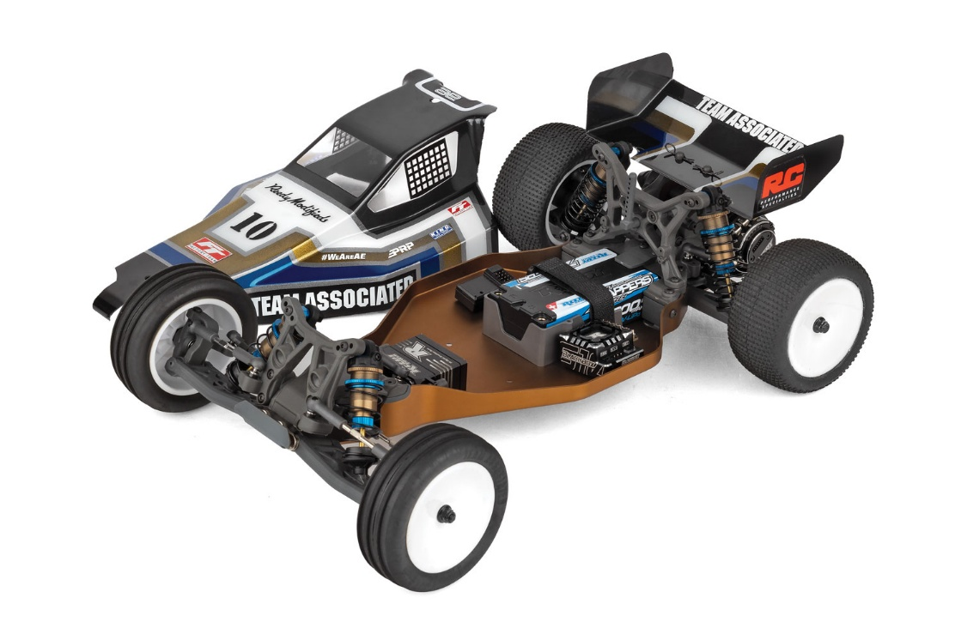

The RB10 Factory Team Retro Kit captures the look, feel, and attitude of classic RC racing—without giving up the performance to match.

FEATURES
SPECIFICATIONS

- New Retro Bronze aluminum B5 tub chassis (rear motor)
- New Retro Bronze aluminum front nose plate
- New Bronze aluminum motor plate
- New front and rear molded bulkhead parts
- Exclusive grey plastics throughout
- High downforce 5.5” retro wing included
- 12mm Hex Dish Wheels
- Authentic retro Viper body included
- 13mm Kashima big bore coil-over shock absorbers
- B5 Rear motor stealth transmission
- Rear CVA driveshafts for more durability
- 2.6:1 ratio gearbox with B5 Ball differential
- Adjustable V2 slipper system
- Rugged steel turnbuckles for adjustable camber and front toe-in
- Fully adjustable suspension geometry
- Vertical ball ends for roll center adjustments, front and rear
- Metric hardware throughout
- Full ball bearings included

Power | Electric
Length | 400mm (15.75in)
Width | 248mm (9.76in)
Weight (Chassis only) | Varies*
Wheelbase | 266.7mm (10.54in)
Internal Ratio | 2.6:1
Terrain | Off-Road
Assembly Level | Kit
Drive | 2WD
Scale Size | 1:10 Scale
Body Style | Buggy

*Final width, length and weight will vary based on electronics, tire configuration, wing position and vehicle setup.


Recommended Electronics:

- Battery (#27318 Wolfpack HV-LiPo 2S 7.4v 4200mAh - bullet connectors)
- Battery (#758 Wolfpack LiPo 2S 7.4v 3000mAh - with T-plug)
- Motor (#293 Sonic 540-FT 17.5 Spec FT)
- ESC (#27012 Blackbox 600z-G2)
- Servo (#27154 RS1606A Low Profile Hi-Speed HV)

Other Helpful Items:

- Body Scissors (AE Part # 1737)
- FT Wrench Set (AE Part #1519)
- Hobby Knife
- Needle Nose Pliers
- Wire Cutters
- Soldering Iron
- Calipers or a Precision Ruler

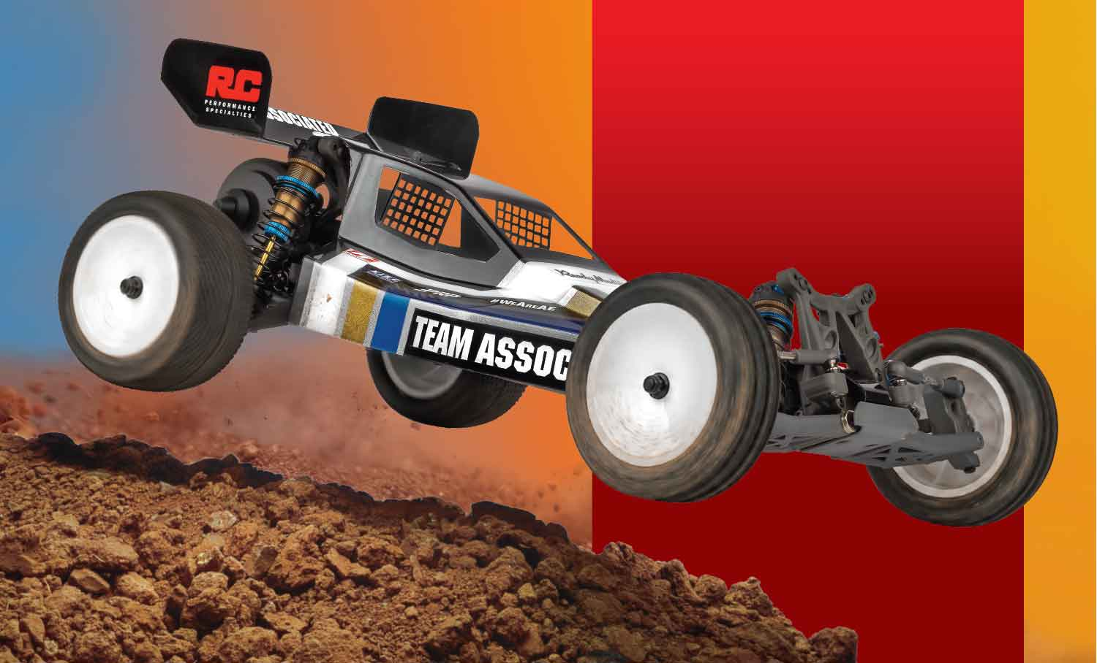

UPC | Part No. | Description | MSRP | MAP | Pieces Per Case | Origin | Available
784695900608 | 90060 | RB10 Factory Team Retro Kit | $499.99 | $329.99 | 6 | TW | September
Download all zipped photos here: https://www.rc10.com/RB10FTImages/(2.37 MB). Link is active for 30 days. Please refer to our MAP Policy here: https://img2c.associatedelectrics.com/pdf/map-policy.pdf

