For Immediate Release: July 2025

New 1.4mm Diameter Shock Spring Sets
for the RC8 Line
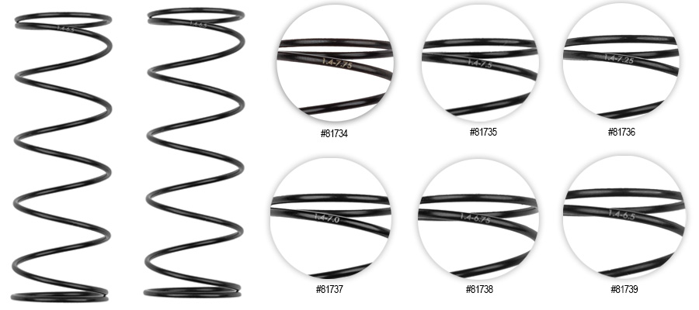

Team Associated would like to introduce the optional 1.4mm diameter wire springs for the RC8 line of cars! These springs come in 66mm length and can be used on the front and rear of your vehicle. Running two shock collars may be necessary on the rear of the vehicle in order to get your desired ride height. These springs boast a change in performance that cannot be replicated with springs that have the same spring rate with a different wire diameter.

Compatible with:
80946/80949/80950/80951/80952/80953/80954/80955/80956/80957/80958

UPC | Part No. | Description | MAP | MSRP | Origin | Available
784695817340 | 81734 | 16mm SHOCK SPRINGS, GREEN 3.70 lb/in, L66, 7.75T, 1.4D | $13.59 | $15.99 | TW | 
784695817357 | 81735 | 16mm SHOCK SPRINGS, WHITE 3.90 lb/in, L66, 7.50T, 1.4D | $13.59 | $15.99 | TW
784695817364 | 81736 | 16mm SHOCK SPRINGS, GRAY 4.10 lb/in, L66, 7.25T, 1.4D | $13.59 | $15.99 | TW
784695817371 | 81737 | 16mm SHOCK SPRINGS, BLUE 4.25 lb/in, L66, 7.00T, 1.4D | $13.59 | $15.99 | TW
784695817388 | 81738 | 16mm SHOCK SPRINGS, YELLOW 4.40 lb/in, L66, 6.75T, 1.4D | $13.59 | $15.99 | TW
784695817395 | 81739 | 16mm SHOCK SPRINGS, RED 4.55 lb/in, L66, 6.50T, 1.4D | $13.59 | $15.99 | TW

