

**For Immediate Release: May**

**#6030 RC10 Graphite Kit**

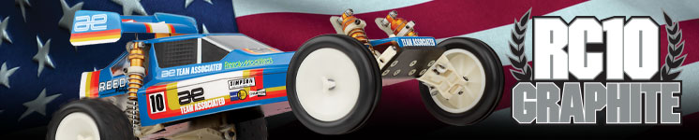

|  |
| --- |
| **ELECTRIC ■ OFF ROAD ■ 1:10 SCALE ■ 2 WHEEL DRIVE ■ KIT** |

Team Associated’s RC10 has won more National and World Championships than any other RC car. Our new **RC10 GRAPHITE** was engineered to give that serious racer all the latest team-developed components. Without altering any of the RC10’s legendary competition features, like our custom, coil-over shocks and high-torque gearbox; the RC10 GRAPHITE incorporates a wealth of subtle changes designed specifically for championship caliber drivers. This eliminates the need to purchase aftermarket components of questionable reliability and availability to modify an RC10.

The chassis of the RC10 GRAPHITE is carbon fiber graphite, which reduces weight without sacrificing rigidity. Team Associated’s graphite is the lightest and strongest available, specially laminated using 100% woven graphite cloth. All mounting holes have been drilled and countersunk using precision, CNC equipment to ensure perfect alignment.

The redesigned front suspension of the RC10 GRAPHITE features a wider front track, made possible with the development of longer lower arms. Combined with zero-offset steering blocks, the RC10 GRAPHITE is more stable at speed and offers improved turn-in for faster cornering. Also up front, new shock towers give you a wider selection of shock mounting positions to adjust spring rate to individual tracks and driving styles. In addition, turnbuckles are used throughout to make suspension changes easier and more precise.

Competition-proven wheels are also part of the

RC10 GRAPHITE package. With low mass and minimal flex, these wheels provide stable predictable handling and reduce unsprung weight. Low profile, special compound racing rubber is another important addition. Team Associated high-traction TQ tires are used on all four corners for balanced handling and grip that hooks up on any track. The rear suspension mounts also allow you to setup rear toe-in at 0 or 3 degrees. And to get every bit of power to the wheels, the RC10 GRAPHITE uses hardened universal drive shafts.

**Included in the RC10 kit is a low-profile clear polycarbonate Viper body and wing kit.**

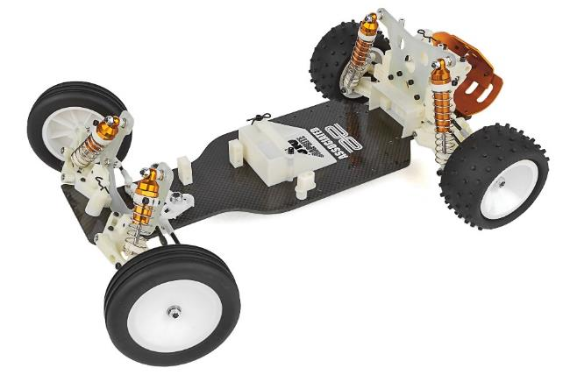

*

**Factory drivers, like Cliff Lett, Jay Halsey, and Masami Hirosaka have continued in Team Associated’s tradition of developing our race cars in world class competition. The result of their most recent efforts in winning numerous National and International events is the RC10 GRAPHITE.**

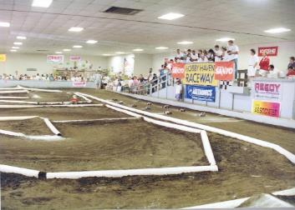

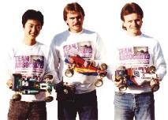

**WE HAVE**

**THE TECHNOLOGY**

In the late 80s, the introduction of graphite materials helped set a new standard for high-end competitive RC models. Team Associated first used carbon fiber a few years prior to the release of the RC10 Graphite on the RC12L, so it was a natural progression that the RC10 would adopt the use of a carbon fiber chassis.

The first example of a carbon fiber chassis used on the RC10

buggy was the TQ10, an RC10 kit made exclusively and distributed

by Horizon Hobby. Eventually, Team Associated decided to produce

and sell an updated version and called it the RC10 Graphite. Later,

an RC10 Graphite Team Car would be released.

During this era, prototypes of the next evolution of the RC10 were being designed and built. These cars were known as RC10 Stealth cars, but they never made it to production. The first was raced at the 1989 IFMAR Worlds in St. Ives New South Wales, Australia and the second at the 1991 IFMAR Worlds in Sterling Heights, Michigan. Both prototypes claimed victory with Team driver Masami Hirosaka at the wheel. The somewhat enigmatic RC10 Graphite, and its variants, have been pursued by racers and collectors ever since this small window of product.

**THE CHASSIS**

Our first graphite off-road chassis is unique, specially fabricated to our specifications to perfectly suit the RC10 GRAPHITE’s fully independent suspension. 100% carbon fiber, the RC10 GRAPHITE chassis is laminated with unidirectional graphite cloth and then precision drilled on CNC equipment.

The RC10 GRAPHITE’s carbon fiber is even lighter and stiffer than the more common fiberglass/graphite composites, and it won’t tweak and is perfectly flat as well.

**

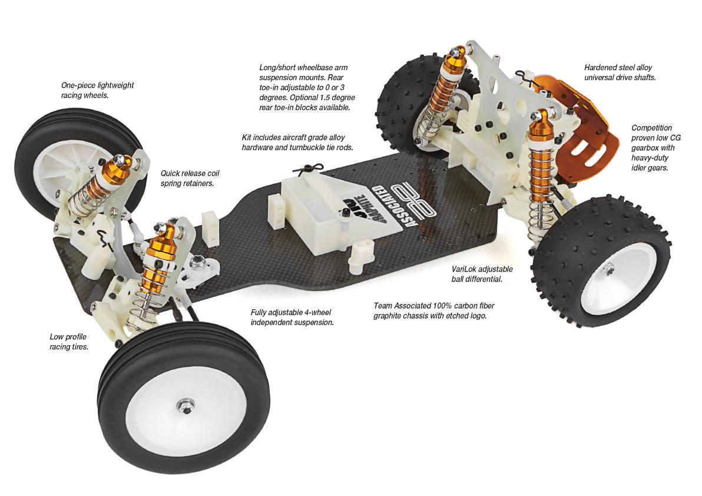

**THE FRONT SUSPENSION**

Many of the RC10’s racing refinements can be found up front. A wider, more aggressive stance is made possible with longer front suspension arms. The wider track, combined with zero offset steering blocks give the RC10 more high-speed stability and better tracking. Other advantages are quicker steering response and faster turn-in to cut tighter lines through sharp corners.

Because no two drivers or tracks are alike, the RC10 front suspension uses front shock towers with additional mounting points for extended travel and progressive spring rate adjustment, quick release spring retainers and turnbuckles to make dialing-in the right settings a simple and rapid process.

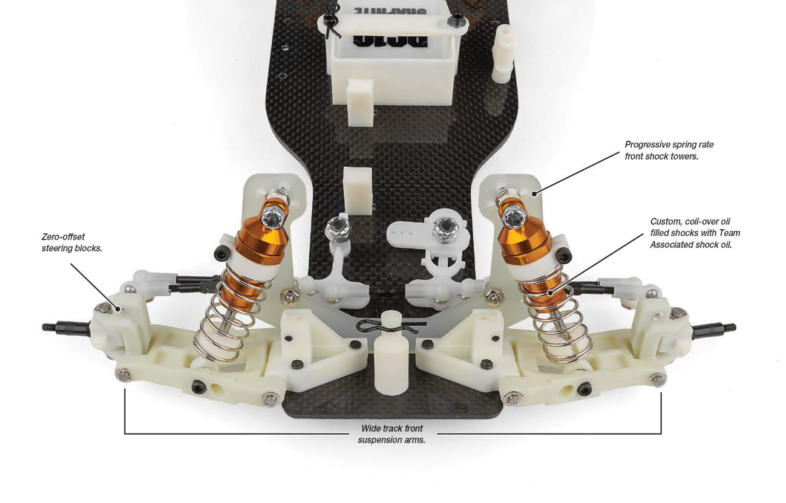

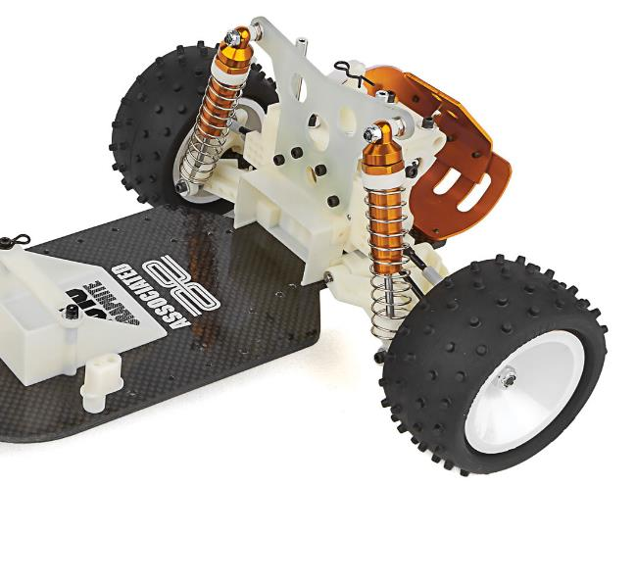

**THE WHEELS**

**AND TIRES**

Lighter, stronger wheels were made possible by using a webbed, one-piece design. The RC10 GRAPHITE’s racing wheels are larger diameter (2 1/8” front, 2” rear) to reduce sidewall flex and are precision molded in virgin nylon for optimum strength and concentricity. The deep-dish styling of the wheels is also functional in reducing dirt build-up. Low profile Team Associated racing tires were specially developed for our new wheels. Soft ribbed compound fronts and the medium compound knobby rears keep the RC10 GRAPHITE hooked up to most offroad racing surfaces. Team Associated tires are molded from special long-wear, high-traction formulas in to suit varying track conditions and surfaces.

**REAR SUSPENSION AND GEARBOX**

We’ve even improved the World and National Championship-winning low CG gearbox of the RC10. The transmission has been strengthened with heavy duty idler gears developed to handle the additional loads of RC10 truck conversions.

For that extra added stability under power, the RC10 GRAPHITE also incorporates adjustable rear toe-in. Using rugged suspension mount blocks, you can select 0- or 3.0-degree toe-in. Optional 1.5-degree blocks are available. Universal drive shafts, another very popular item with team drivers, are standard with the RC10 GRAPHITE. Heat treated steel alloy, these universals reduce power loss and eliminate lost dog bones.

**Features:**

* Authentic replica of the RC10 Buggy Kit originally released in 1989
* 3.4mm Carbon fiber graphite chassis
* Fully adjustable four-wheel independent suspension
* Long travel, fluid-filled silver anodized aluminum coil-over shocks
* Low profile sealed six-gear transmission
* VariLok adjustable ball differential
* Exceptional ground clearance with low center of gravity
* Front and rear tires with modular racing wheels
* Clear ProTech II body and wing
* Fiberglass shock towers
* Full metal ball bearings
* Fits 6-cell NiMH and 2S LiPo battery packs

|  |  |  |
| --- | --- | --- |
| **ITEMS NEEDED TO COMPLETE** |  | **SPECIFICATIONS** |

|  |  |
| --- | --- |
| **Scale** | 1:10 |
| **Power** | Electric |
| **Length** | 381mm (15”) |
| **Width** | 226.8mm (8.93”) |
| **Weight** | Varies |
| **Wheelbase** | 267.7mm (10.54”) |
| **Internal Ratio** | 1.83:1 |

* 6-cell NiMH or 2S LiPo for radio-controlled car
* Radio control battery charger
* 1:10 scale radio control electronic speed control
* 1:10 scale 540-size electric RC car motor
* 2-channel RC surface transmitter and its batteries
* 2-channel receiver
* Pinion gear
* Steering servo
* Lexan paint for body
* Glue for tires.

|  |
| --- |
| **CATALOG INFORMATION** |

|  |  |  |  |  |  |  |  |
| --- | --- | --- | --- | --- | --- | --- | --- |
| **UPC** | **Part No.** | **Description** | **MSRP** | **MAP** | **Pieces Per Case** | **Origin** | **Available** |
| 784695060302 | 6030 | RC10 Graphite | $679.99 | $459.99 | 6 | TW | Late May |

Download all zipped photos here: <https://www.rc10.com/rc10graphiteimages/> (14MB). Link is active for 30 days.

