For Immediate Release: February 2026

#9066 YZ-10 Classic Kit
1:10 Scale 4WD Electric Off Road Competition Buggy Kit

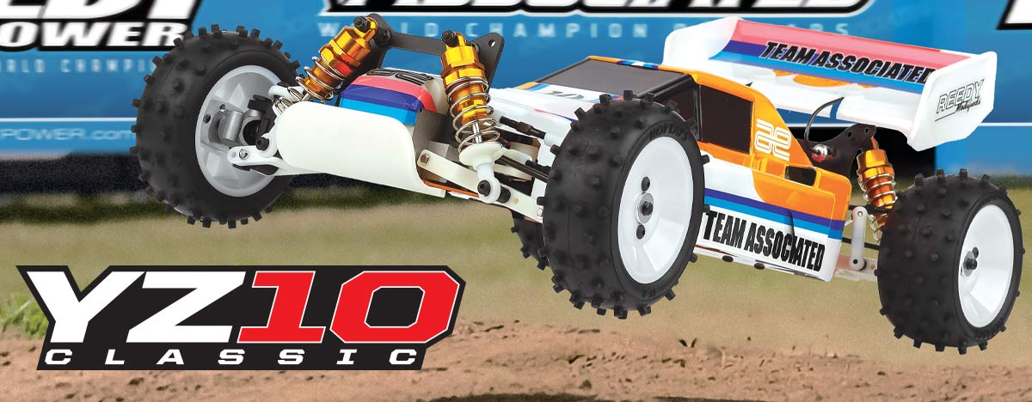

ELECTRIC ■ OFF ROAD ■ 1:10 SCALE ■ 4 WHEEL DRIVE ■ KIT

Competition 4WD 1/10 Scale Electric Race Buggy

When the serious racers on Team Associated wanted to go 4WD racing, they chose the best car they could find:The Yokomo YZ-10. This car is state of the art. It’s not only designed to be the best 4WD car in the world, it’s also designed so that it’s easy to work on. If you’re really serious about 4WD racing, race the best - the YZ-10.

The front end includes a gear differential, universal drive shafts and an adjustable track width. Plus fully adjustable coil over, oil-dampened shocks, front and rear.

High traction, low profile tires and wheels, front and rear, for super handling. Realistic-looking Protect IV body has separate under pan to keep your car clean. Body includes functional air scoop for the motor cooling.

With a very efficient 2-belt drive system, the YZ-10 includes a gear differential, slipper clutch, and universal drive shaft. Saddle mount battery pack for better weight distribution.
HIGHLIGHTS

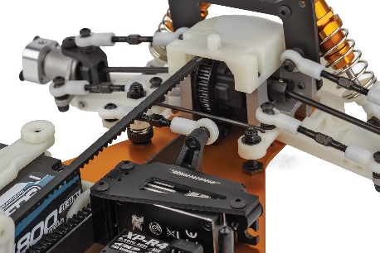

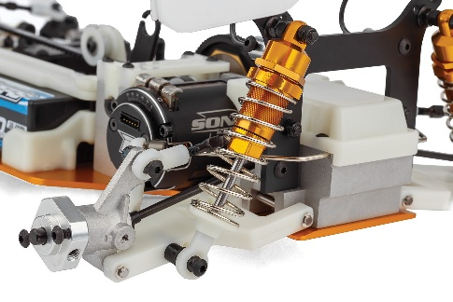
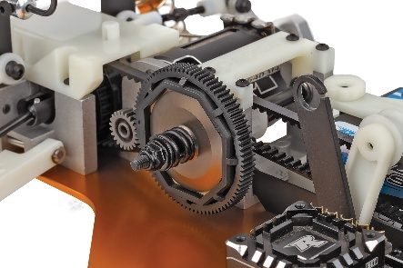

Floating Servo Mount
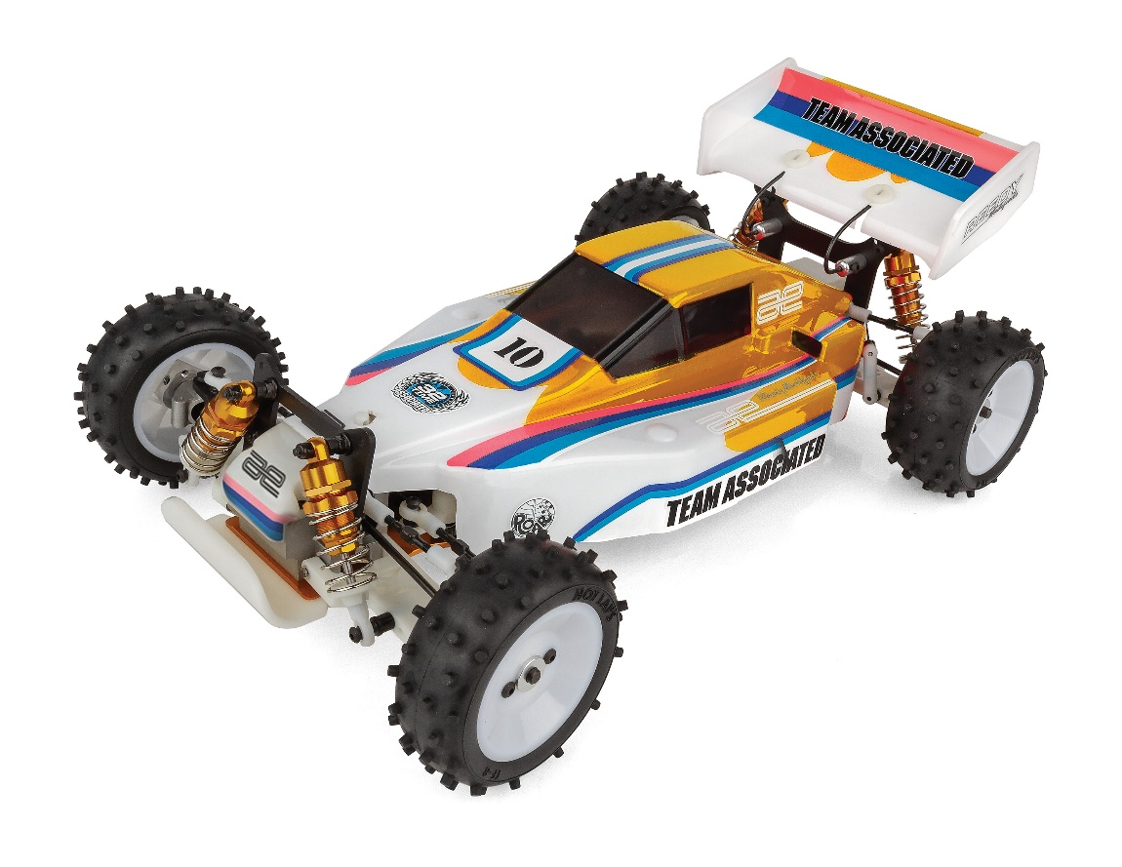
Anti-Roll Bar
Slipper Clutch

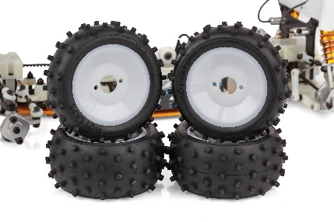
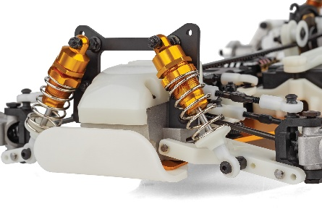

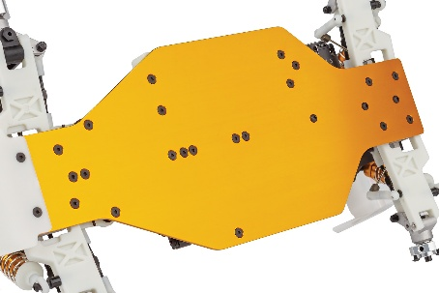

Vintage Stubbed Tires
Gold Threaded Shocks

Gold Aluminum Chassis

Due to ongoing R&D, photos may not match the final kit. Vehicle shown on these pages equipped with items NOT included in kit:
Reedy motor, battery, ESC, servo, and receiver. Assembly and painting required.

FEATURES |  | SPECIFICATIONS

- 4WD belt drive
Scale | 1:10
Power | Electric
Length | 395mm (15.55")
Width | 235mm (9.25")
Height | 190mm (7.48")
Wheelbase | 273.5mm (10.77")

ITEMS NEEDED TO COMPLETE

- 2S Shorty LiPo battery for radio-controlled car
- Radio control battery charger
- 1:10 scale radio control electronic speed control
- 1:10 scale 540-size electric RC car motor
- 2-channel RC surface transmitter and its batteries
- Steering servo
- 2-channel receiver
- Paint for the body
- Other helpful items: Body Scissors (#1737), FT Wrench Set (#1519), Hobby Knife, Needle Nose Pliers, Wire Cutters, Soldering Iron, Calipers or a Precision Ruler

- Adjustable servo saver
- 3 servo horns included
- 21T pinion gear included
- Chassis protector
- Metric hardware throughout
- Fluid-filled gear differentials
- Ball bearings
- Gold Aluminum chassis
- Aluminum bulkhead, motor mount, rear hubs, and steering knuckles
- Spring loaded servo saver
- Floating servo mount
- Gold Threaded shocks
- Anti-roll bar
- Original studded tires
- Slipper clutch
- Battery box for shorty battery
- White Dyeable Plastics
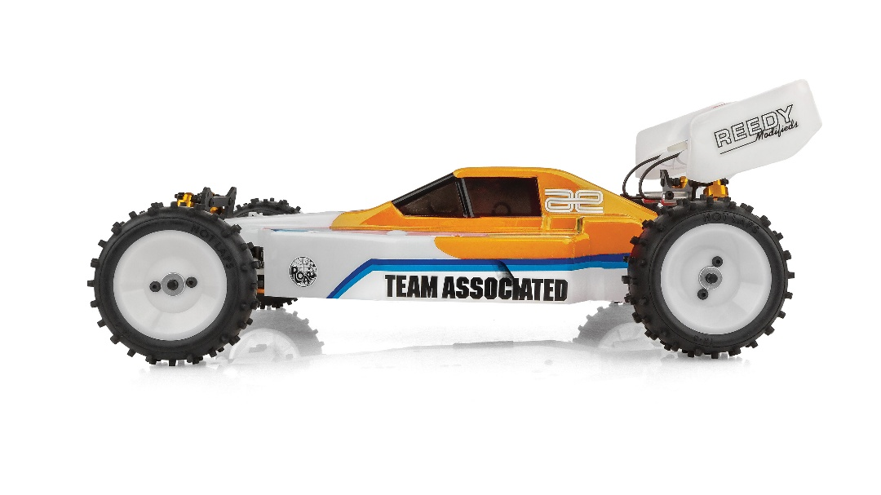

CATALOG INFORMATION
UPC | Part No. | Description | Pieces Per Case | Origin | MSRP | MAP | Available
784695090651 | 9066 | YZ-10 CLASSIC KIT | 6 | TW | $630.99 | $429.99 | Feb 26
Download all zipped photos here: https://www.rc10.com/YZ10ClassicImages/ (5.9MB). Link is active for 30 days.
* Starting on 4/1/26, pricing will change--MSRP: $675.99 and MAP: $459.99
Please refer to our MAP Policy here: https://img2c.associatedelectrics.com/pdf/map-policy.pdf

