For Immediate Release: June 2026

RC10 Retro 80’s Ultra Fox Kit #6051
1:10 Scale 2WD Electric Off Road Buggy Kit

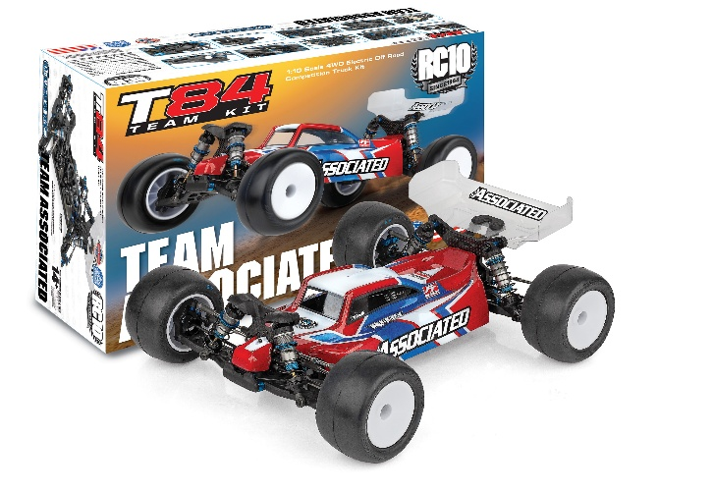
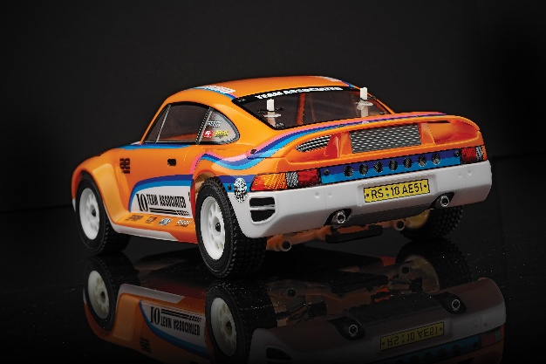
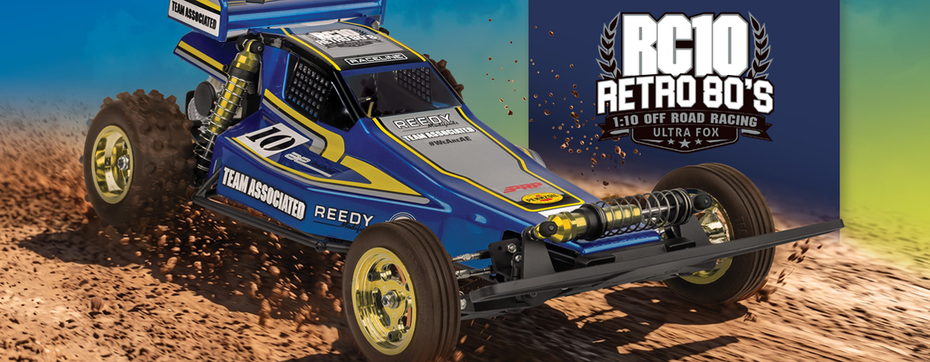

ELECTRIC ■ 1:10 SCALE ■ 2 WHEEL DRIVE ■ OFF ROAD ■ KIT
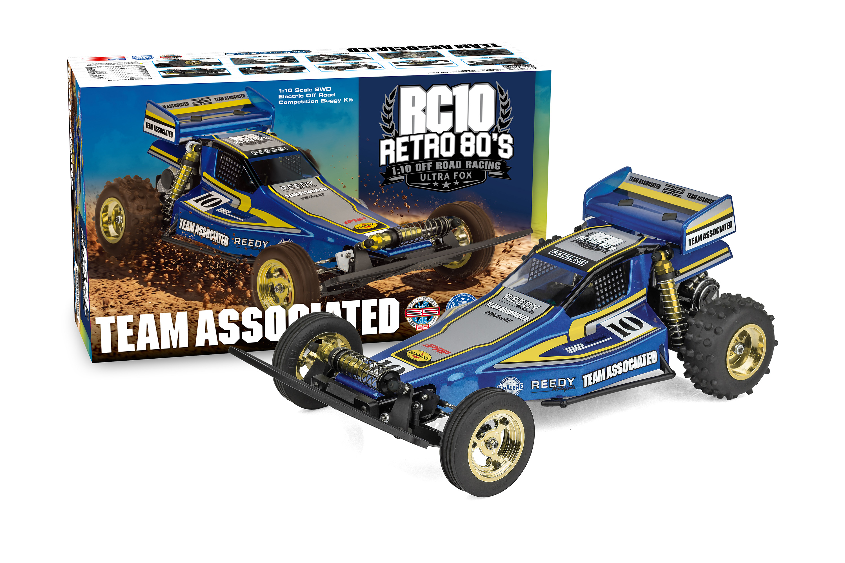
VINTAGE SOUL. MODERN STRENGTH.
The RC10 Ultra Fox isn’t just a tribute; it’s a high-performance celebration of engineering that defined a decade.

Combining the iconic aesthetics of the 1980s with modern Team Associated precision, the RC10 Ultra Fox is built for those who remember the thrill of the first dirt jump and those ready to experience it for the first time.

Iconic Mono-Shock Front End:

At the heart of the RC10 Ultra Fox is the legendary front mono-shock suspension. This unique design captures the authentic look and feel of the era’s most innovative race cars and provides a nostalgic driving experience.

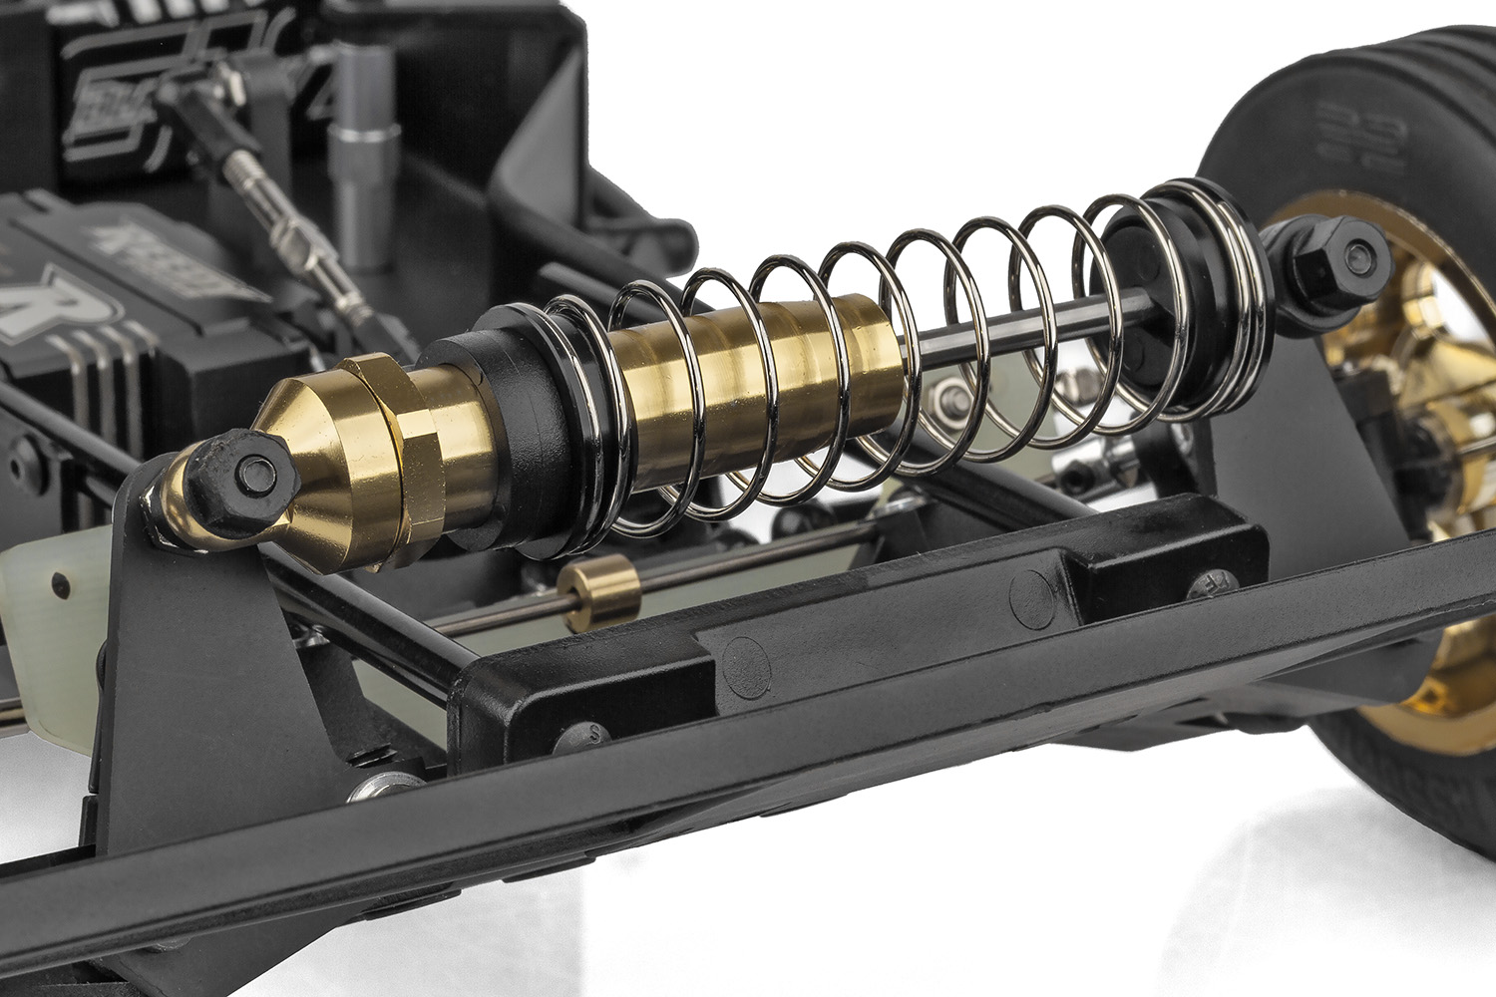
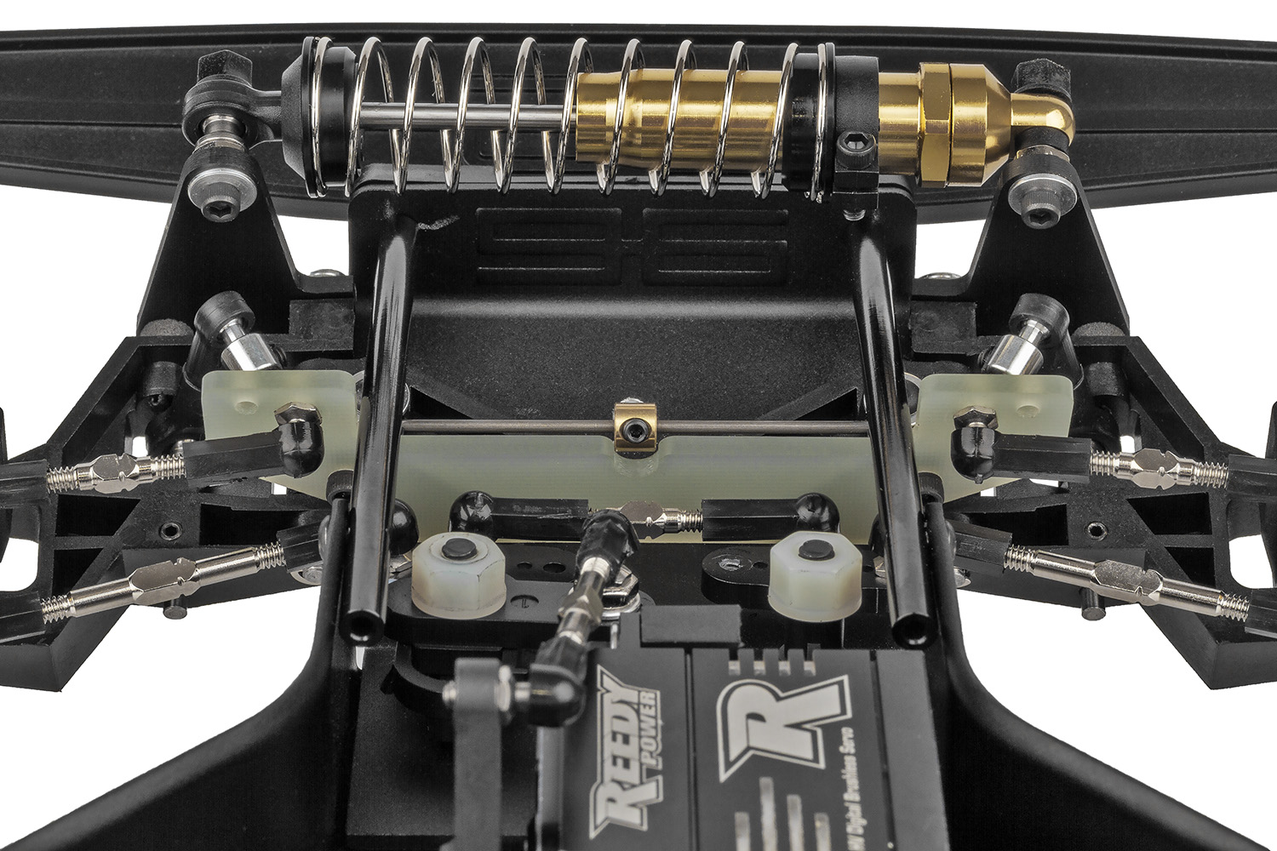

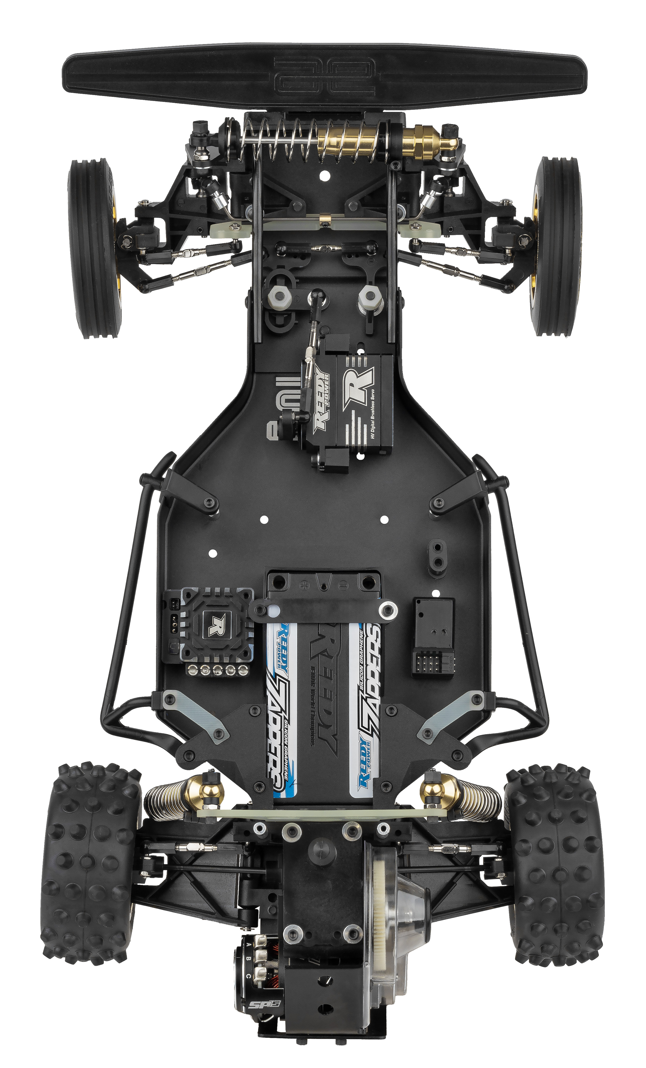

Signature Gold Aluminum Shocks:

It wouldn’t be a classic without the bling. Our race-proven, oil-filled gold anodized shocks offer buttery-smooth damping and that unmistakable “Team Associated” factory look.

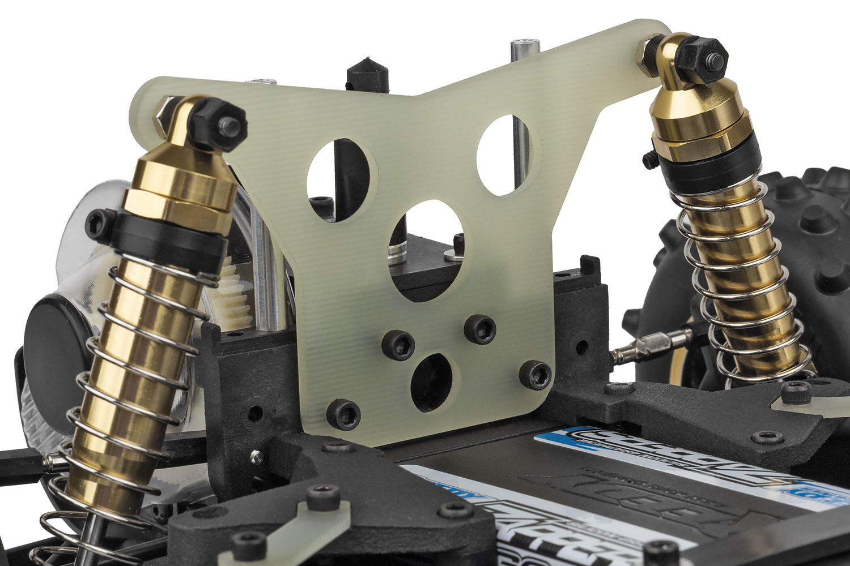
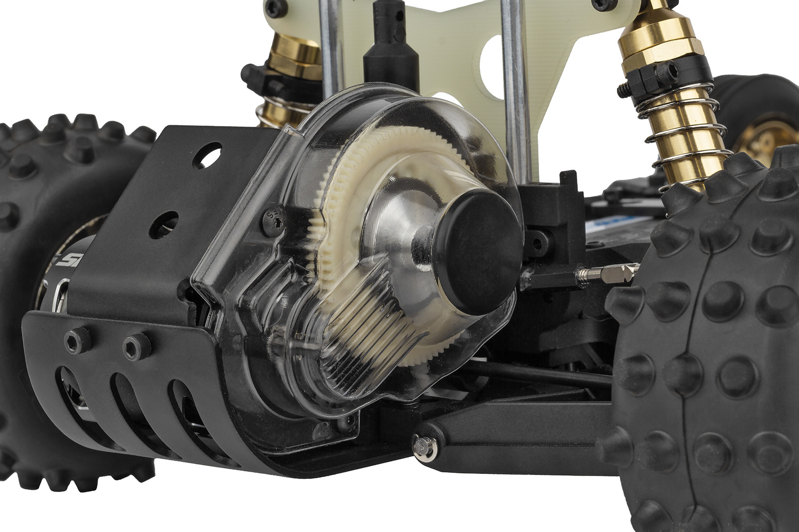

Full Independent Suspension:

Don’t let the vintage vibes fool you. With fully independent front and rear suspension geometry, the RC10 Ultra Fox soaks up bumps and sticks the landings with the poise of a modern champion.

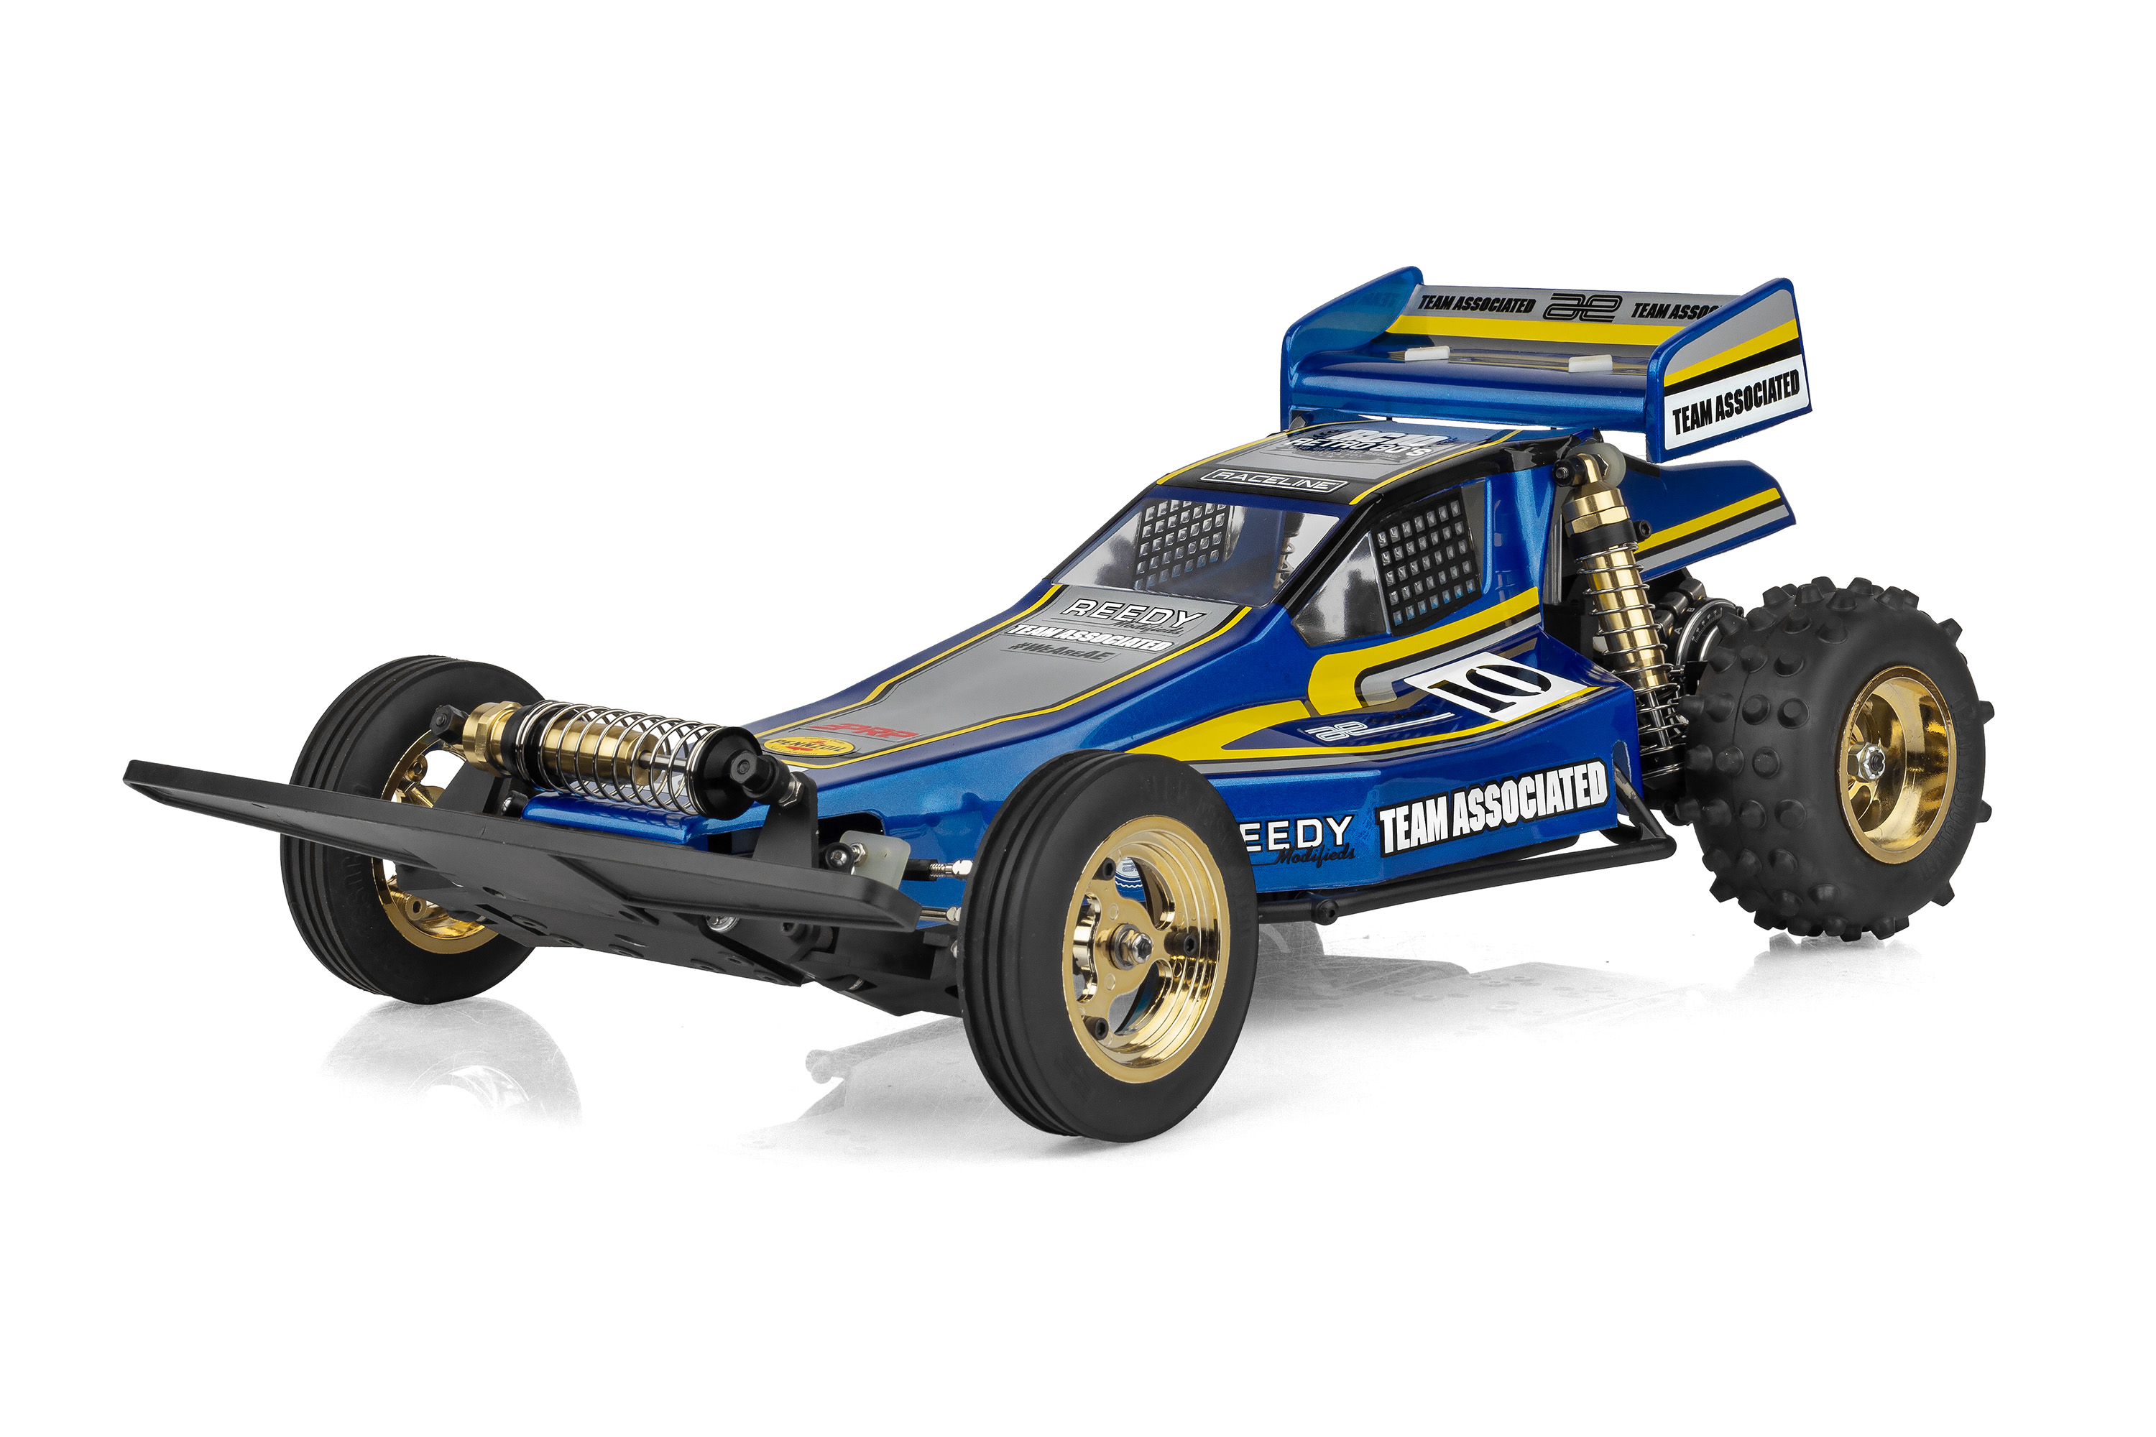

From the aggressive stance to the sleek, period-correct body lines, every inch of the Ultra Fox is designed to turn heads and stir up memories of backyard battles and local track glory.

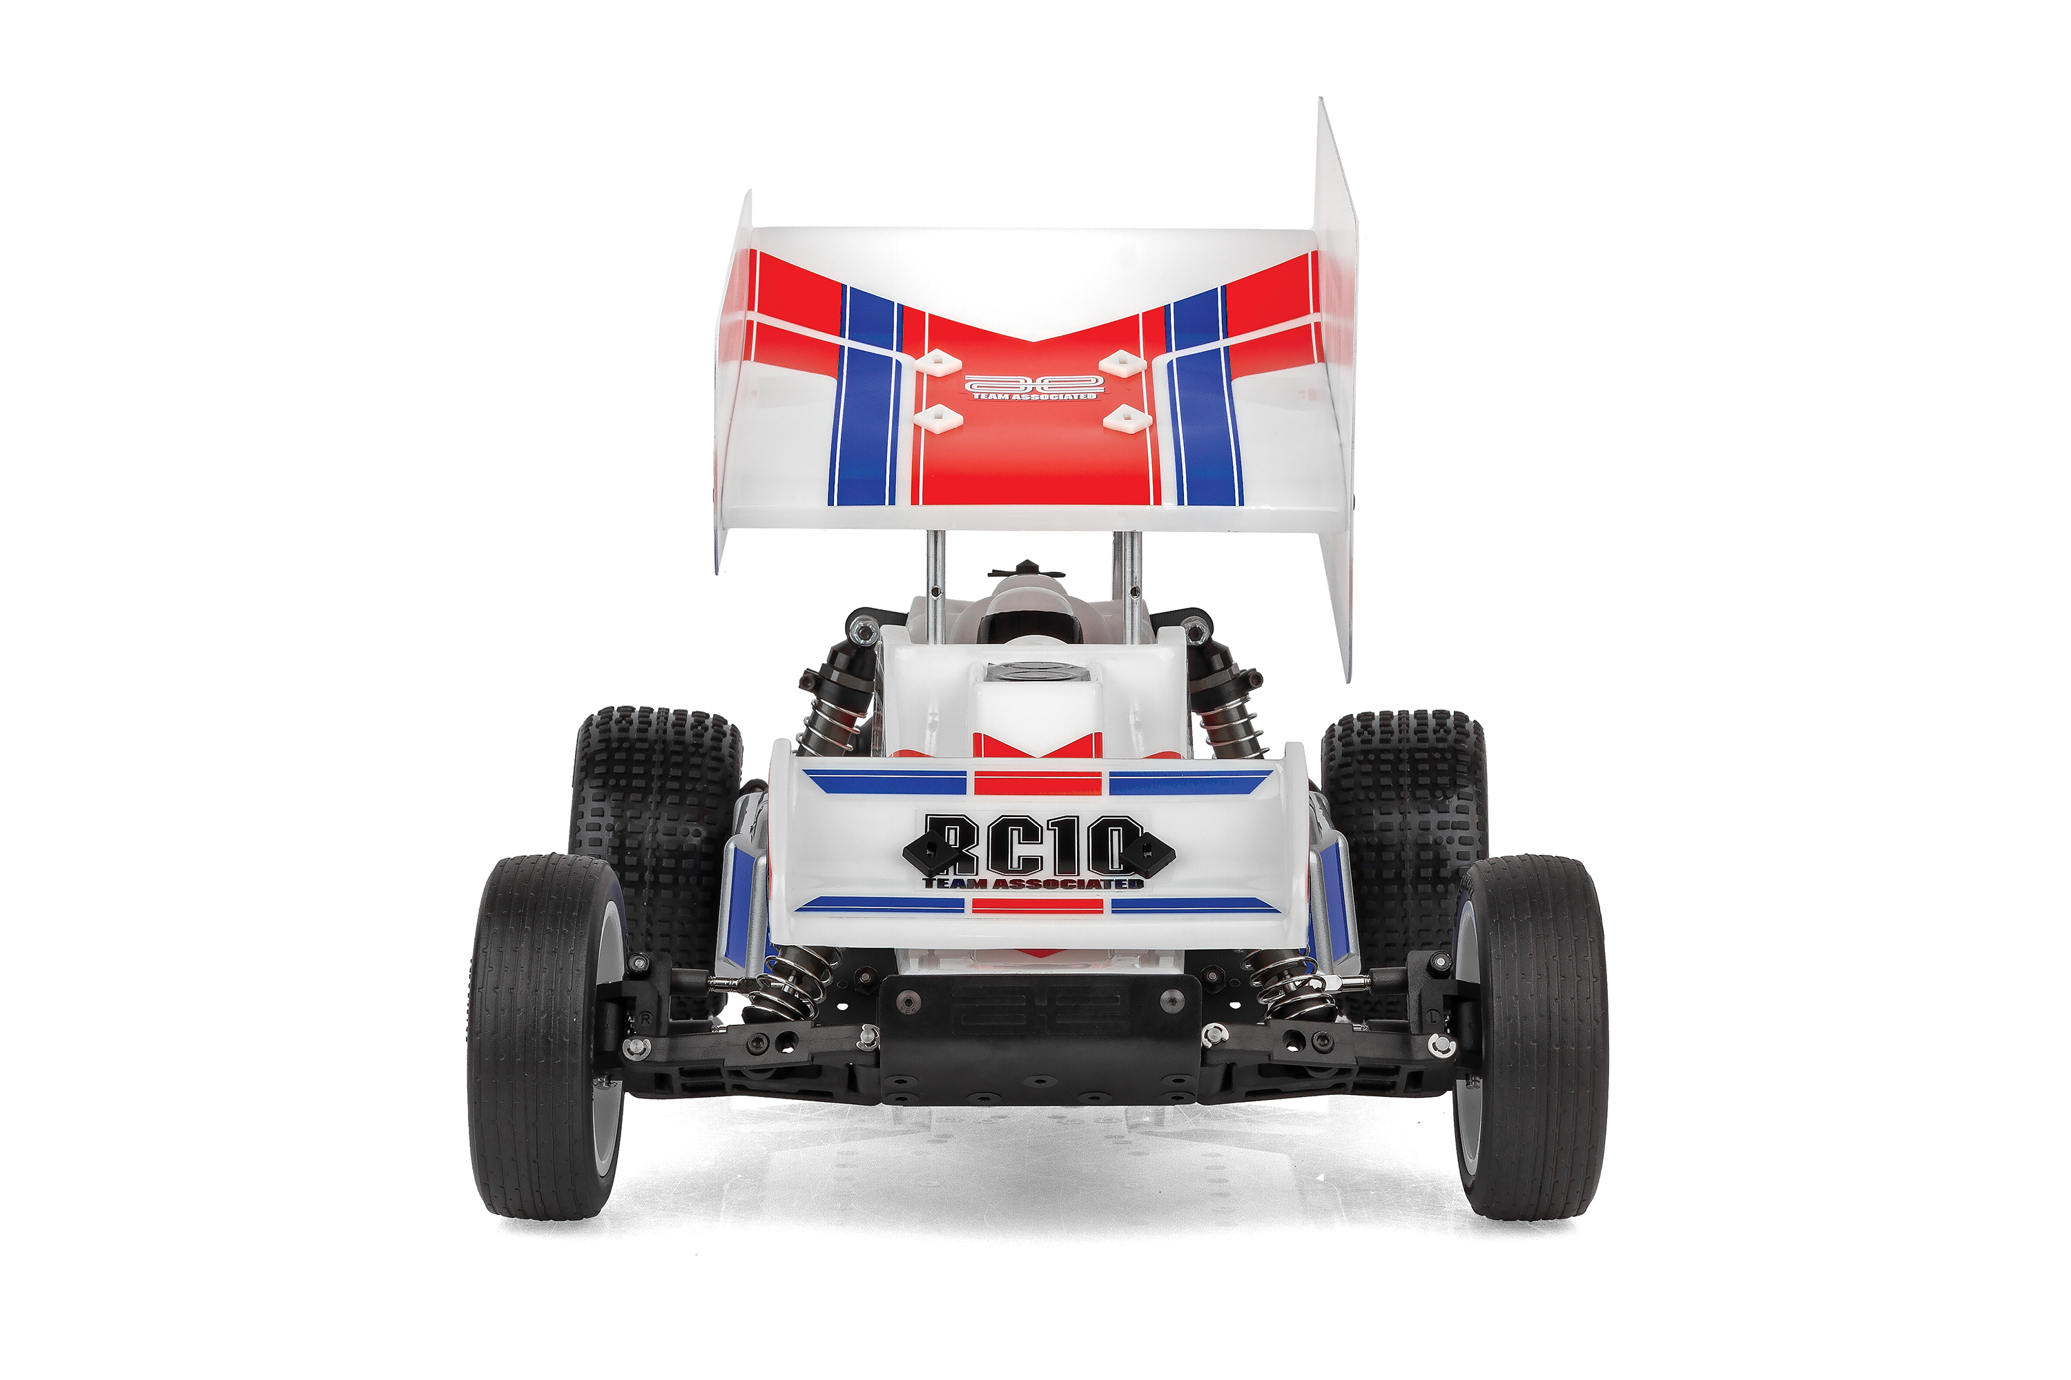
Due to ongoing R&D, photos may not match final kit. Vehicle shown on these pages equipped with items NOT included in kit: Motor, transponder, servos, receiver, wheels, tires. Assembly and painting required.
* Final width, length and weight will vary based on engine, electronics, tire configuration, wing position and vehicle setup.
FEATURES
  SPECS
Scale Size | 1:10 Scale
Terrain | Off-Road
Power | Electric
Length | 381mm (15in)
Width ​ | 226.8mm (8.93in)
Weight | Varies*
Wheelbase | 267.7mm (10.54in)
Internal Gear Ratio: | 2.25:1
Drive | 2WD
Body Style | Buggy
Assembly Level | Kit
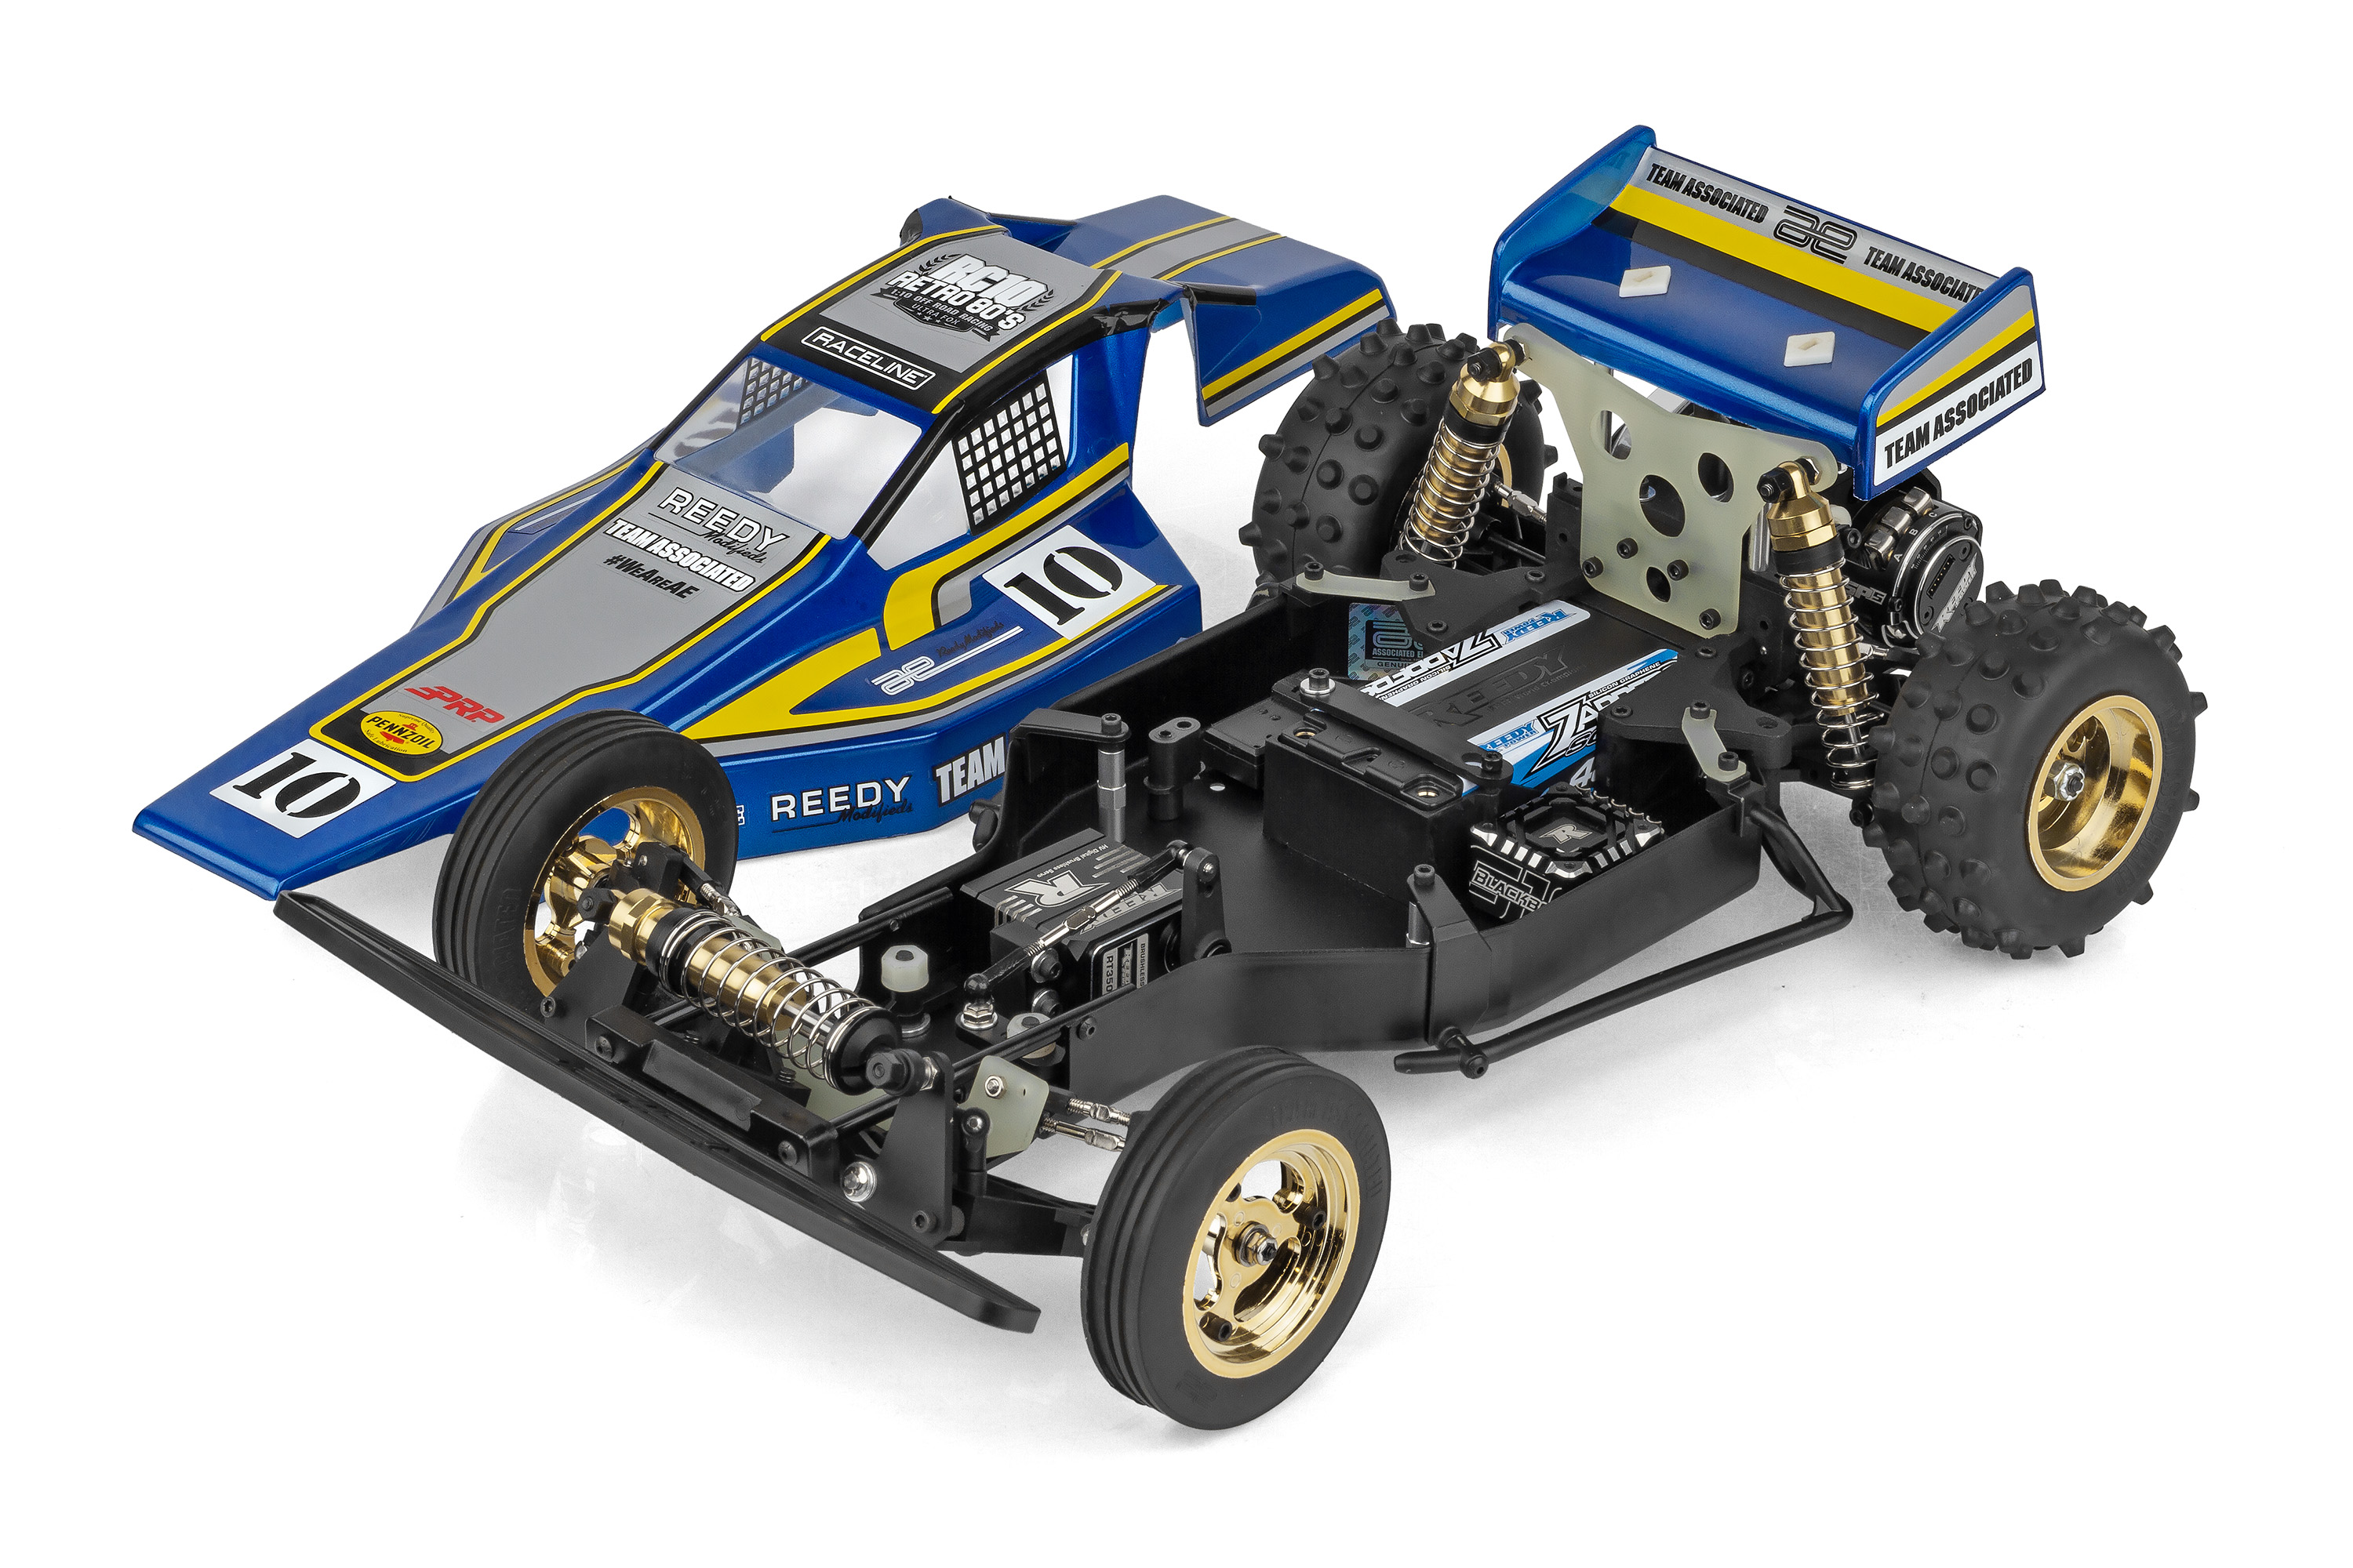

Recommended Electronics:

- New molded side guards
- New molded front bumper
- New molded rear bulkhead system
- New gold anodized front mono-shock system
- New front mono-shock tower
- 80’s Retro themed RC10 Classic
- Black anodized 6061-T6 aluminum monocoque
Tub chassis
- Black anodized nose plate and motor plate
- Hardened rear driveshafts
- Long travel, fluid-filled anodized aluminum rear coil-over shocks
- Legendary 6 gear transmission
- Exceptional ground clearance with low center of gravity
- Classic front and rear tires with metallic gold 3-piece
racing wheels
- Clear Viper body with classic wing
- Full metal ball bearings
- Fits 6-cell NiMH and 2S LiPo battery packs
- Independent rear suspension
- Front anti-roll bar set

- Battery (#27604 ZAPPERS SG6 4800mAh 135C 7.6V SHORTY)
- Motor (#27481 REEDY SONIC 540-SP5 13.5T BRUSHLESS MOTOR)
- ESC (#27016 BLACKBOX 610R COMPETITION ESC)
- Servo (#27171 REEDY RS1606HD LOW-PROFILE BRUSHLESS HI-SPEED SERVO
- Charger (#27203 REEDY 1416-C2L DUAL AC/DC COMPETITION BALANCE CHARGER)

Other Helpful Items:

- Body Scissors (AE Part # 1737)
- FT Wrench Set (AE Part #1519)
- Hobby Knife
- Needle Nose Pliers
- Wire Cutters
- Soldering Iron
- Calipers or a Precision Ruler

Items required for operation:

Motor, Servo, Receiver, Radio, Battery, and Paint. Assembly and painting required.

CATALOG INFORMATION
Motor, battery, ESC, servo, receiver, paint, tires and radio. Assembly and painting required

CATALOG INFORMATION
UPC | Part No. | Description | MSRP | MAP | Pieces Per Case | Origin | Available
784695060517 | 6051 | RC10 Ultra Fox Kit | $499.99 | $329.99 | 6 | TW | July
Download all zipped photos here: https://rc10.com/RC10UltraFoxImages/ (7.5MB) Link is active for 30 days.
Please refer to our MAP Policy here: https://img2c.associatedelectrics.com/pdf/map-policy.pdf

