For Immediate Release: April 2026

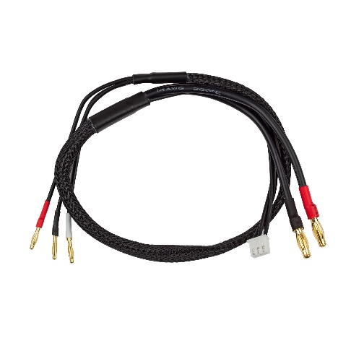
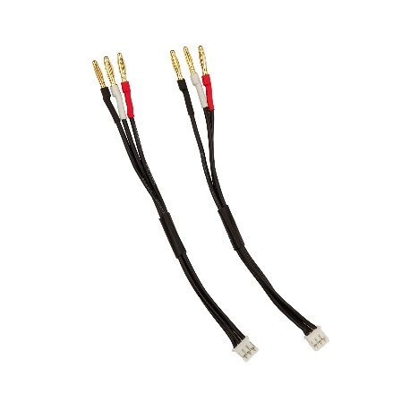
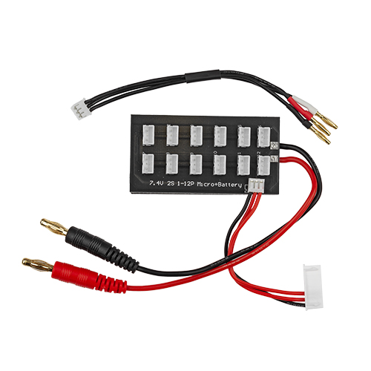
NEW! Reedy Power Micro Charge Leads

(Pictured: Left to Right - #27245, #27244 and #27246 Reedy Power Micro Charge Leads)

Reedy Power, a leader in high-performance RC electronics, proudly announces the release of new charge leads specifically designed for the growing 1:28 and 1:24 scale racing segments.

These premium charge leads deliver reliable, high-current connections for compact LiPo batteries commonly used in micro on-road and off-road racing classes, providing provide racers with flexible options to match their preferred battery configurations while ensuring safe and efficient charging.

The 2S 2mm Pro Micro Charge Lead is intended for hard case batteries with embedded 2mm sockets. The 2S Parallel Charging Board allows simultaneous charging of up to 12 batteries equipped with JST-PH 2.0 connectors and includes a convenient 2mm bullet adapter for hard case batteries with 2mm sockets. Additional 2mm Bullet Adapters are available separately.

“Micro racing continues to grow in popularity, and racers demand the same level of performance and reliability from their charging accessories as they do from their power systems,” said a Reedy Power manager Rick Hohwart. “These new charge leads complete the Reedy Mini Series ecosystem, giving drivers in 1:28 and 1:24 classes a professional-grade charging solution that matches the quality of our motors, ESCs, batteries, and chargers.”

Reedy Power micro charge leads are now available for purchase at hobby shops, online retailers, and at www.ReedyPower.com.

Key features include:
- Engineered for low-resistance, high-current flow suitable for high-C-rated micro batteries
- Compatible with standard RC chargers supporting 2S LiPo batteries

UPC | Part No. | Description | MSRP | MAP | COO | Available
784695272446 | 27244 | 2S Parallel Charging Board w/2mm Bullet Adapter | $14.99 | $12.99 | CN | 
784695272453 | 27245 | 2mm Bullet Adapter (2) | $9.99 | $8.99 | CN
784695272460 | 27246 | 2S 2mm Pro Micro Charge Lead (500mm) | $26.99 | $21.99 | CN

