For Immediate Release: May 2026

RC8B4.2e Team Kit #80955
1:8 Scale 4WD Electric Off Road Competition Buggy Kit

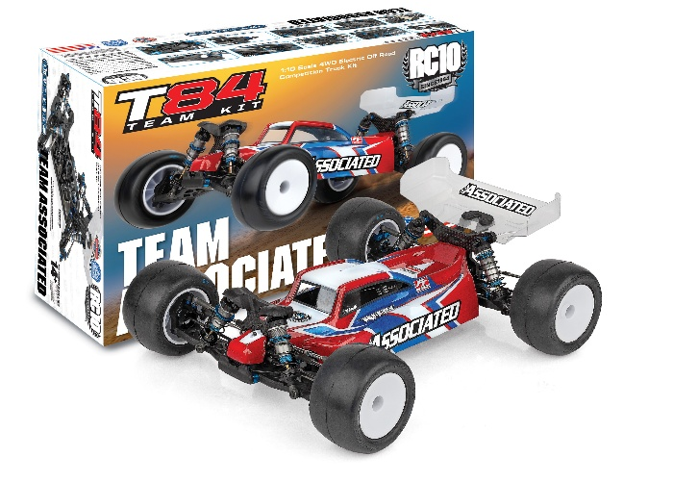
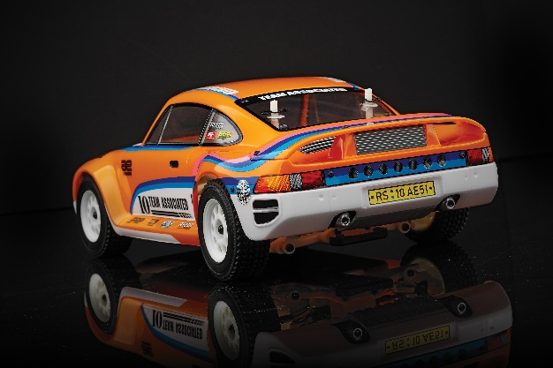
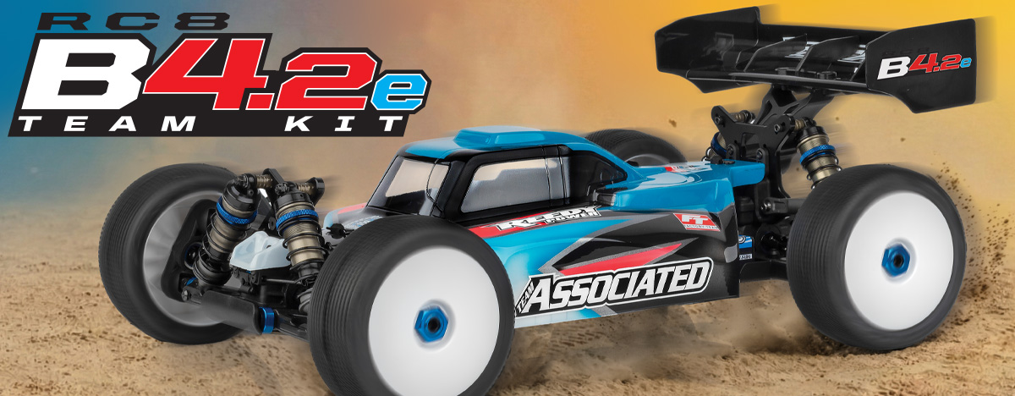

ELECTRIC ■ 1:8 SCALE ■ 4 WHEEL DRIVE ■ OFF ROAD ■ KIT
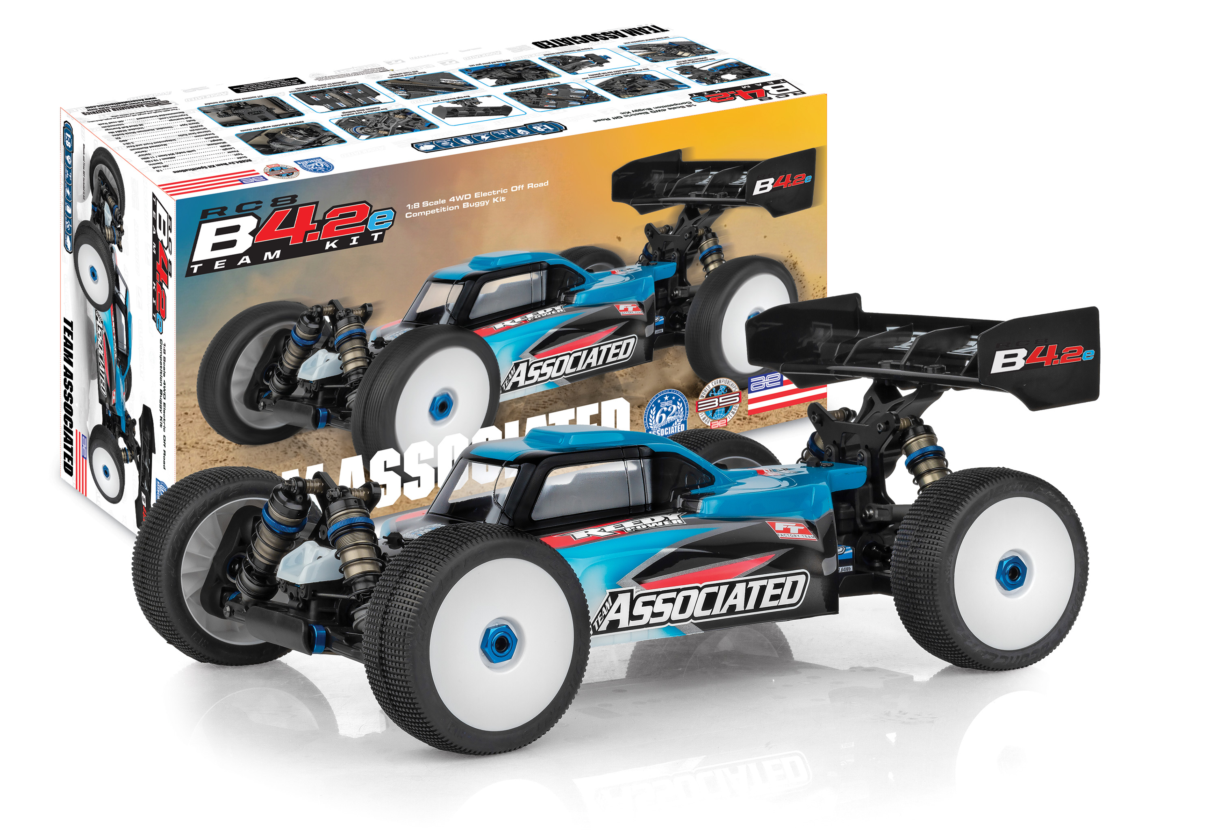
1:8 scale off road racing is one of the hobby’s most challenging disciplines; it requires a high standard and demands attention to detail.

The latest development to come from Associated Electrics’ Area 51 is designed to push boundaries of performance and build upon the number of accolades accumulated by the RC8 series.
PUSHING THE BOUNDARIES
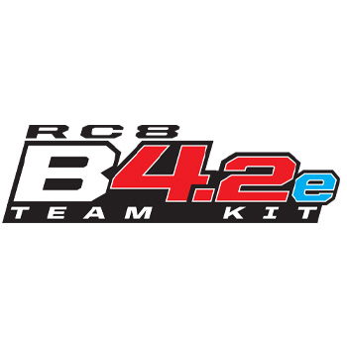

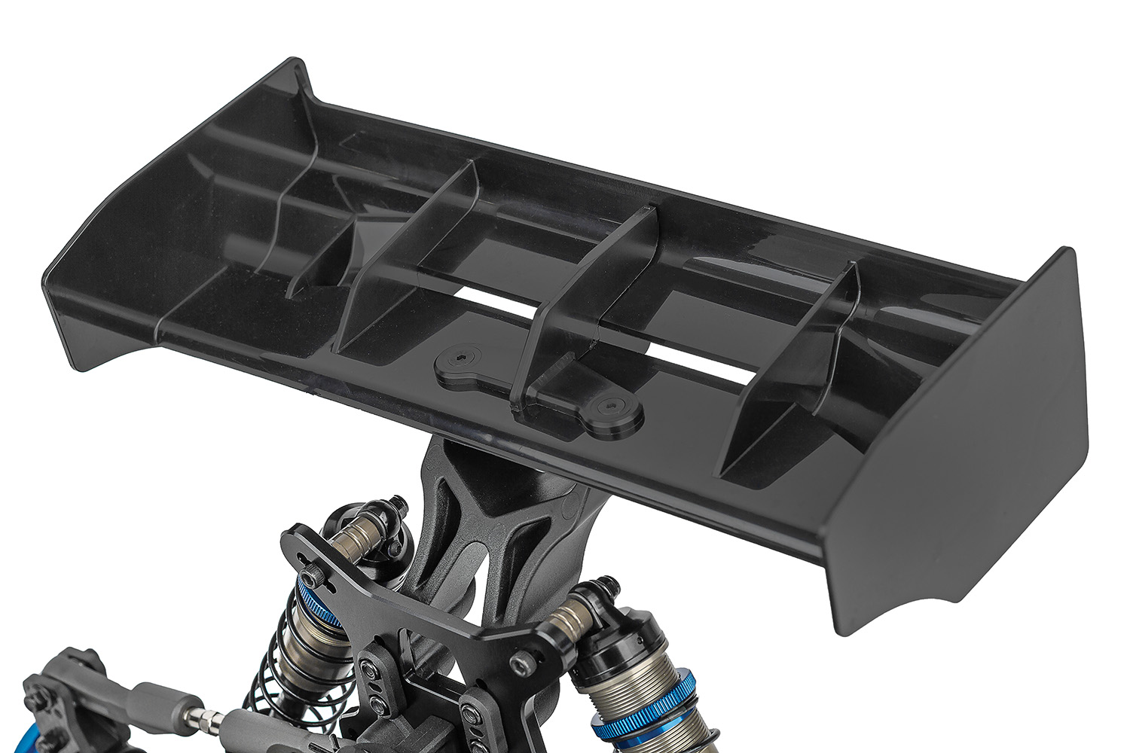
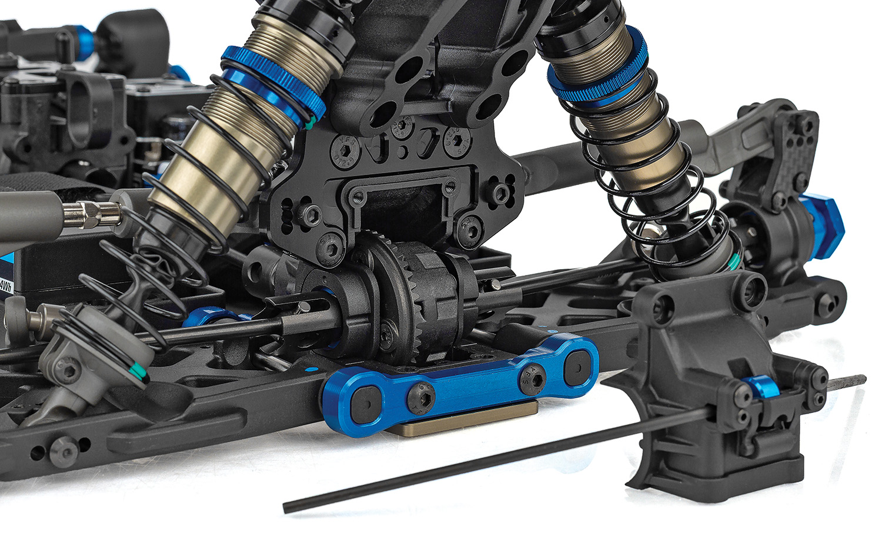

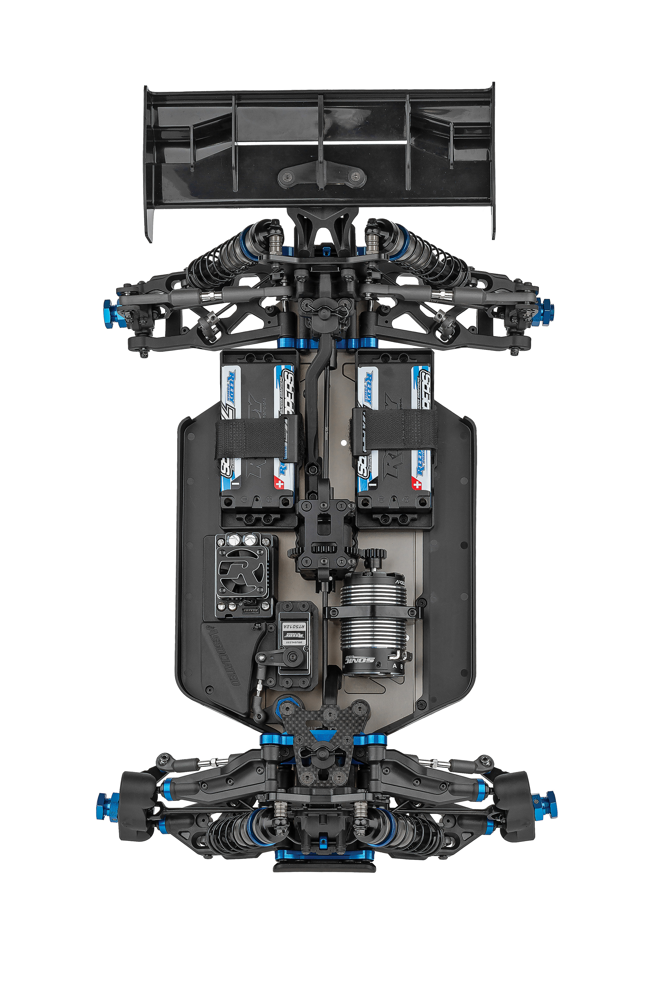

New molded height-adjustable gearboxes front and rear

New high-downforce
wing

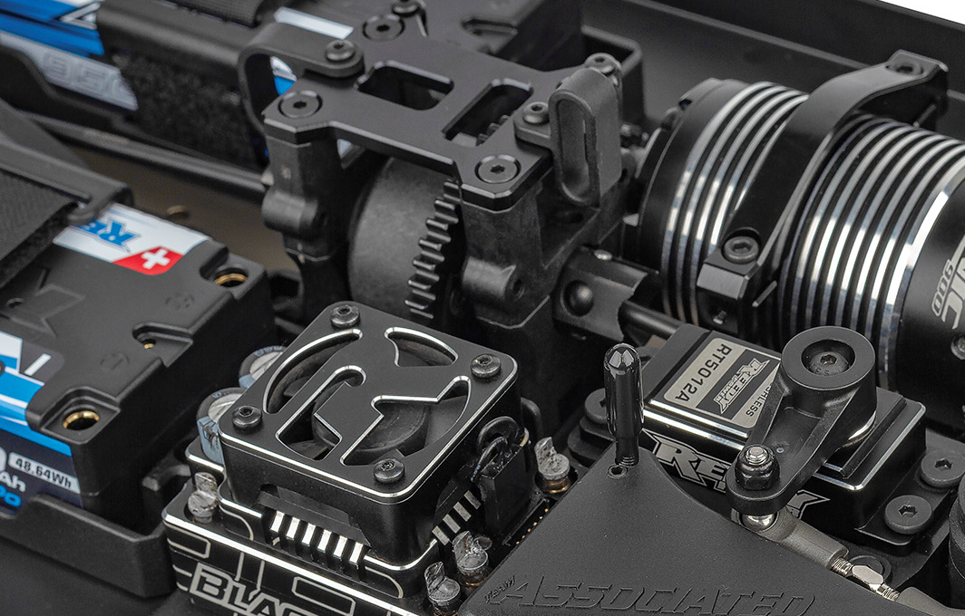
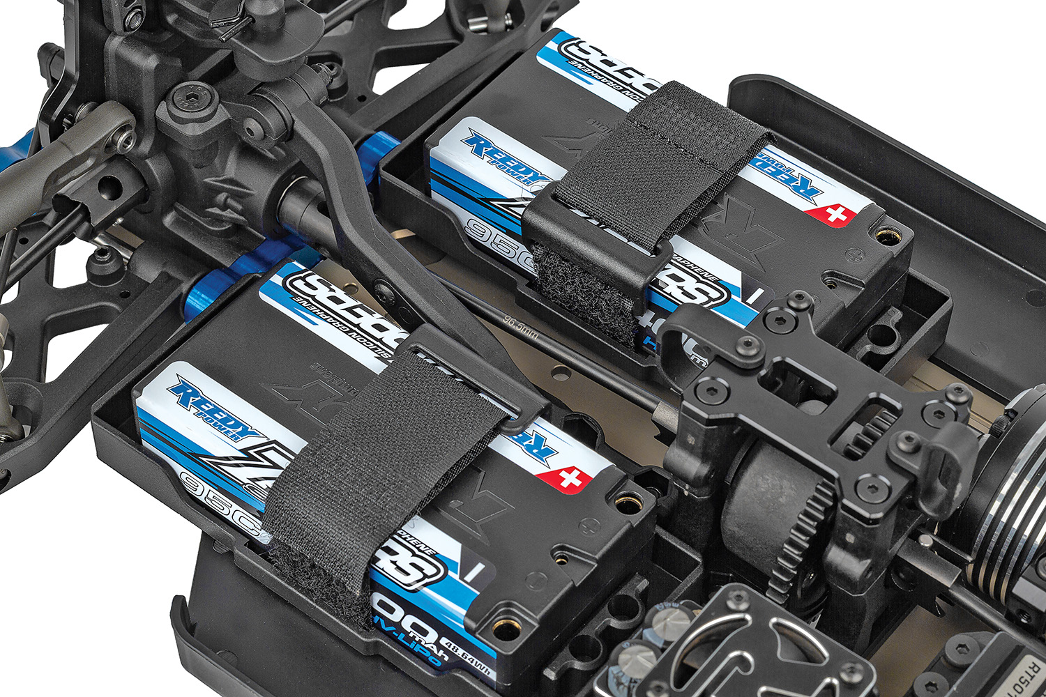

Adjustable battery tray design with hook and loop strap for retaining batteries
New high-volume center differential

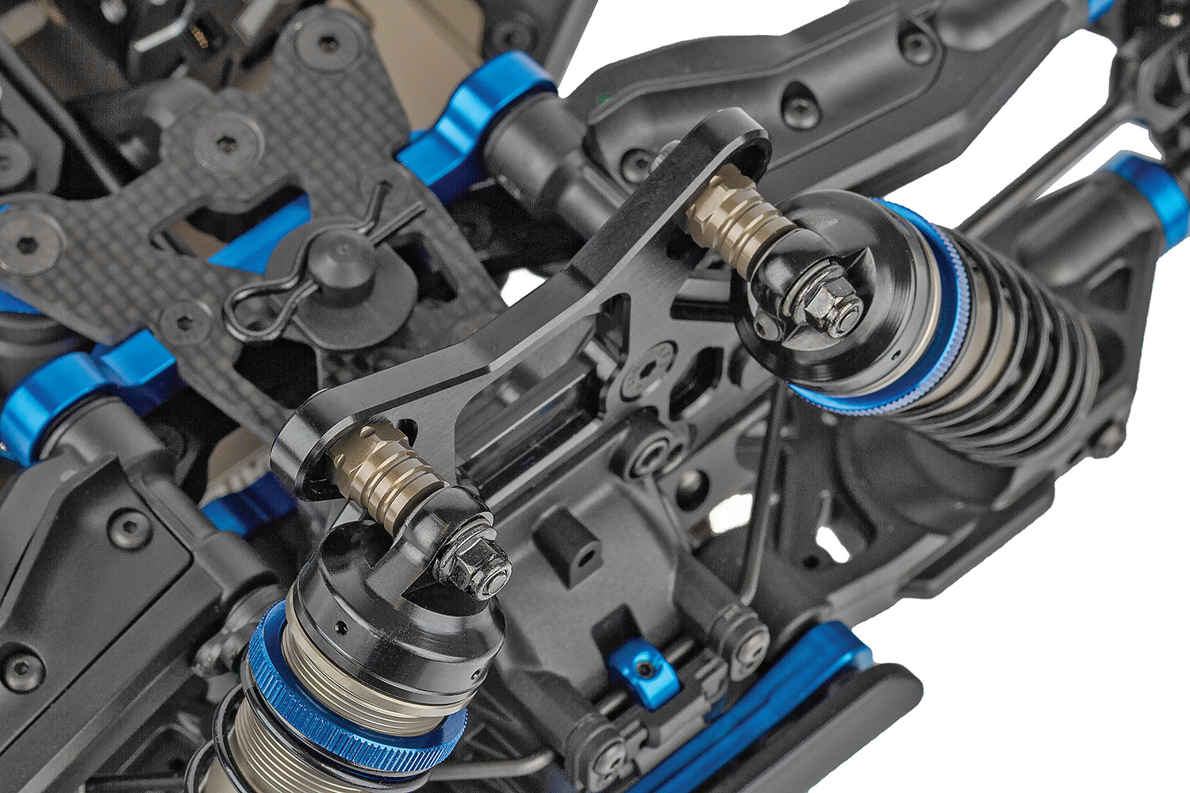
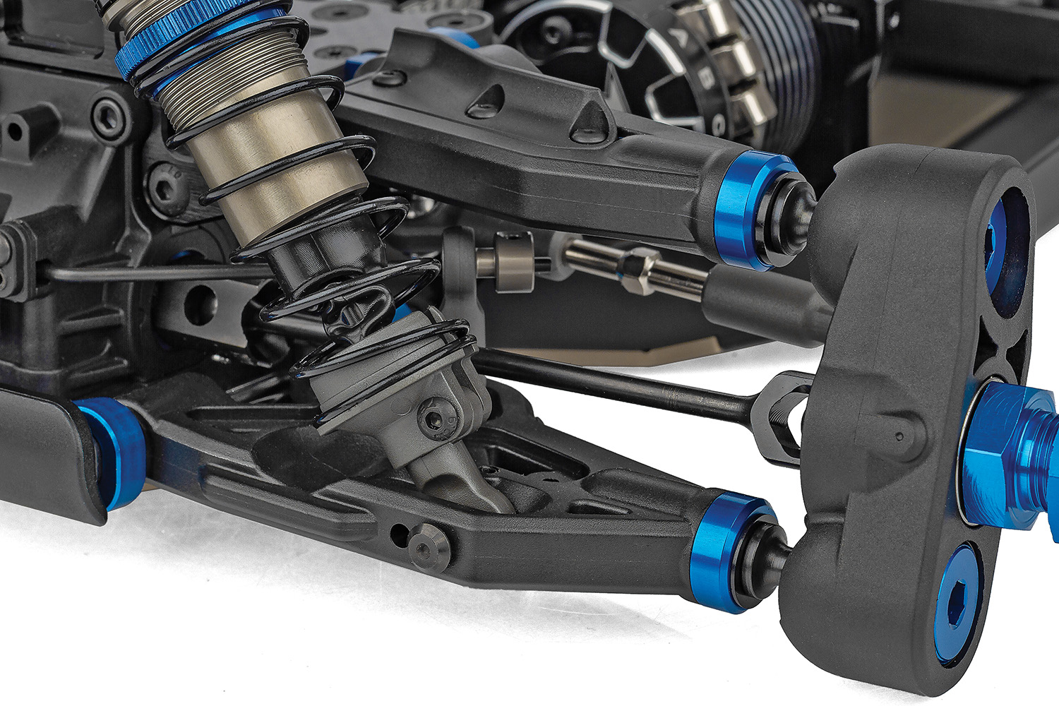

FT hard-anodized aluminum shock bushings
Soft blend material suspension arms

Due to ongoing R&D, photos may not match final kit. Vehicle shown on these pages equipped with items NOT included in kit: Electric motor, speed control, transponder, servos, receiver, wheels, and tires. Assembly and painting required.

FEATURES
  SPECS
Scale | 1:1:8
Type | Off-road
Power | Electric
Length | 486mm / 19.13in
Width | (w/body) 304.5mm / 11.99in
Weight | Varies*
Wheelbase | Varies*
Internal Gear Ratio | 3.38:1
Drivetrain: | 4WD
Chassis: | Machined Aluminum
Suspension: | Independent Front and Rear
Kit/RTR | Kit
Shock type | Threaded, Aluminum Shock Bodies
Body | Included: RC8B4 Mu
Ball bearings | 26 Oiled Ball Bearings
Experience Level | Intermediate
Recommended Environment | Off-road Track
- New molded height-adjustable gearboxes front and rear
- New offset hubs and updated rear suspension arms to accommodate new hub geometry
- New high-volume center differential
- New high-downforce wing
- Now includes FT hard-anodized aluminum shock bushings
- RWB/FWB adjustable weight bias chassis
- Soft blend material suspension arms
- 8-degree KPI steering blocks included
- 44/13 ring and pinion gear sets
- 92mm universal driveshafts with 17mm outdrives
- Both 19mm and 20mm diameter HTC internal differential gear sets included
- 47T machined steel spur gear included
- Centralized drivetrain and chassis configuration optimized for shorty-style batteries
- Adjustable battery tray design with hook and loop strap for retaining batteries

* Final width, length and weight will vary based on electronics, tire configuration, wing position and vehicle setup.


Recommended Electronics:

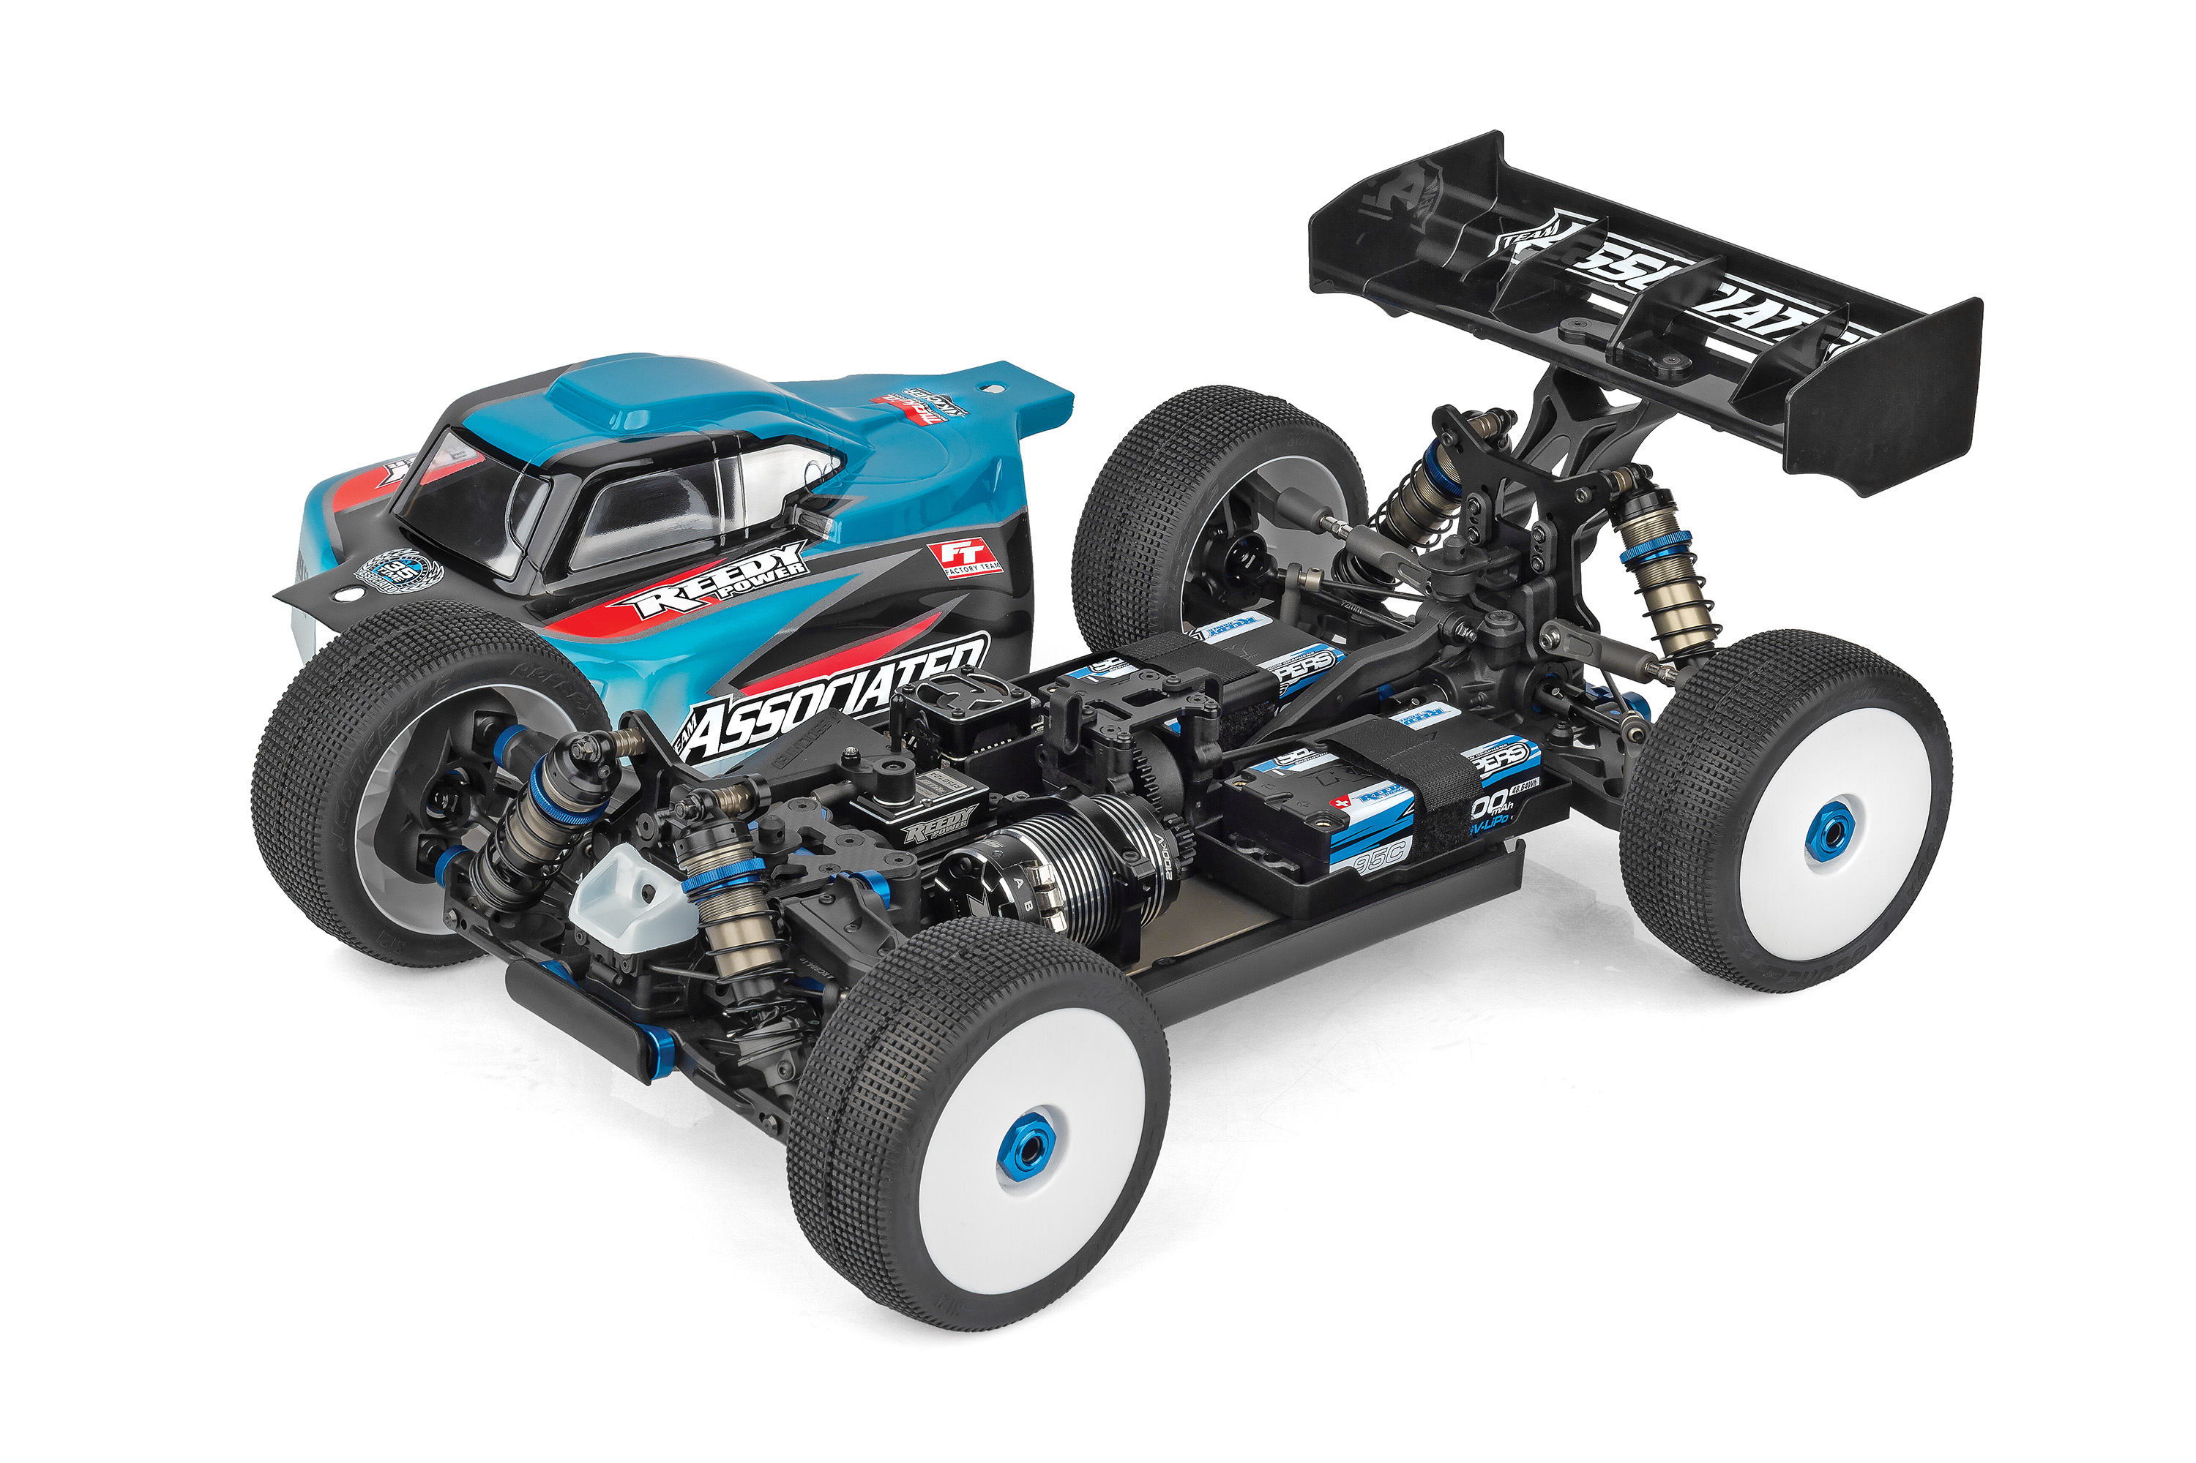
- Servo (#27168 Reedy RS4008A Hi-Speed HV Servo)
- Battery (#27619 Zappers SG7 7800mAh 140C 7.6V 1:8 Long-Shorty)
- ESC (#27043 Reedy Blackbox 880R Competition 1:8 ESC)
- Motor (#27509 SONIC 900 1900kV DE Competition
1:8 Motor)
- Charger (#27203 Reedy 1416-C2L Dual AC/DC Competition Balance Charger)
- Accessories (#27392 Grip Bullets 5mm x 14mm,
silver, qty 2)

Other Helpful Items:
- Body Scissors (AE Part # 1737)
- FT Wrench Set (AE Part #1519)
- Hobby Knife
- Needle Nose Pliers
- Wire Cutters
- Soldering Iron
- Calipers or a Precision Ruler

Items required for operation:

Motor, ESC, Batteries, Servo, Receiver, Paint, Tires and Radio. Assembly and painting required.

CATALOG INFORMATION
Motor, battery, ESC, servo, receiver, paint, tires and radio. Assembly and painting required

CATALOG INFORMATION
UPC | Part No. | Description | MSRP | MAP | Pieces Per Case | Origin | Available
784695809550 | 80955 | RC8B4.2e Team Kit | $1024.99 | $679.99 | 4 | TW | June
Download all zipped photos here: https://www.rc10.com/RC8B42eImages/ (10.12MB) Link is active for 30 days.
Please refer to our MAP Policy here: https://img2c.associatedelectrics.com/pdf/map-policy.pdf

