For Immediate Release: March 2026

New! Reedy Sonic 900 “Driver Edition” Competition 1:8 Motors
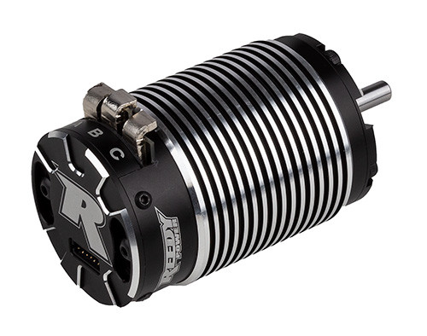

(Pictured: Sonic 900 1900kV #27509 & 2100kV #27510 DE 1/8 Competition 1:8 Motors)

Reedy Power, a leading name in high-performance RC power systems, is proud to announce the release of the new Sonic 900 Driver Edition 1:8 Competition Brushless motors.

Developed in close collaboration with the Reedy Power racing team, the Sonic 900 DE builds on Reedy’s proven Sonic platform with an updated rotor concept that delivers a smoother, more linear power band, higher top speed, and improved reliability for 1:8-scale racers and casual enthusiasts. Available in both 1900kV and 2100kV versions, each comes with a unique rotor which is interchangeable between both and sold separately to fine tune power output and delivery for specific track conditions and driver preference.

All Sonic 900 DE motors feature a precision CNC-machined can with adjustable timing. An integrated heat sink lowers operating temperatures which results in less fade over the course of a race, longer run times, and increased motor life. Sensored operation results in a smooth and controllable power band while the powerful 4-pole rotor is supported by precision ball bearings for reliability. A 200mm sensor wire is included.

“These motors are exactly what our customers have asked for,” said Rick Hohwart, Reedy Power Manager. “The new rotor produces a smooth, linear feel off the corner and predictable power delivery to negotiate rough sections and jumps. Reliability has also taken a big step forward which means one less thing to worry about in the heat of competition”

Visit www.reedypower.com for a complete list of tuning rotors and replacement/option parts.

Key features include:

- CNC machined can integrated heatsink: Designed for strength and maximum cooling for extreme performance and reliability.
- Balanced 4-pole rotor w/neodymium magnets: A high-strength balanced rotor creates a smooth and consistent powerband, run after run.
- Heavy-duty solder tabs: Thick, low resistance tabs feature a surface area capable of accepting
10-gauge wire installation.
- Adjustable timing: A convenient fine-tuning adjustment for varying track sizes and conditions, regardless of motor direction.
- Competition proven: Developed by Reedy Power’s engineering team with input from championship winning factory team drivers.
- Built to ROAR specs: Approval pending.

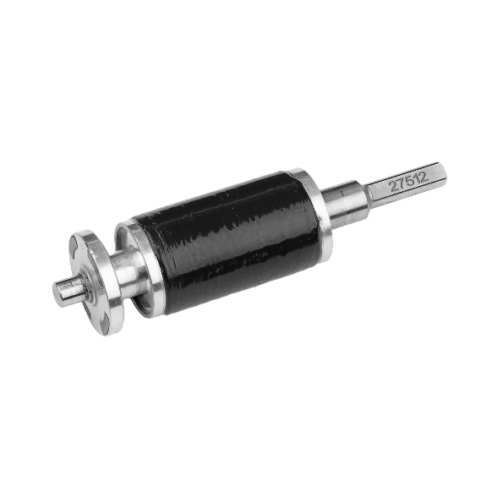

Specifications
Feature | Specification
Feature | 1900kV | 2100kV
Cells | 4-6S LiPo
Diameter (mm) | 40.0
Length (mm) | 65.0
Shaft Dia. (mm) | 5.0
Weight (g) | 325 +/-5
Rotor | 27511 | 27512
(Pictured: Sonic 900 Rotor DE – Standard)

UPC | Part No. | Description | MSRP | MAP | Origin | Available
784695 275096 | 27509 | Sonic 900 1900kV DE 1/8 Competition 1:8 Motor | $284.99 | $169.99 | CH | Now
784695 275102 | 27510 | Sonic 900 2100kV DE 1/8 Competition 1:8 Motor | $284.99 | $169.99 | CH | Now
784695 275119 | 27511 | Sonic 900 Rotor DE - Standard | $94.99 | $55.99 | CH | Now
784695 275126 | 27512 | Sonic 900 Rotor DE - Torque | $94.99 | $55.99 | CH | Now

