For Immediate Release: May 2026

TC28 Team Kit #20169
1:28 Scale 4WD Electric On-Road Competition Kit

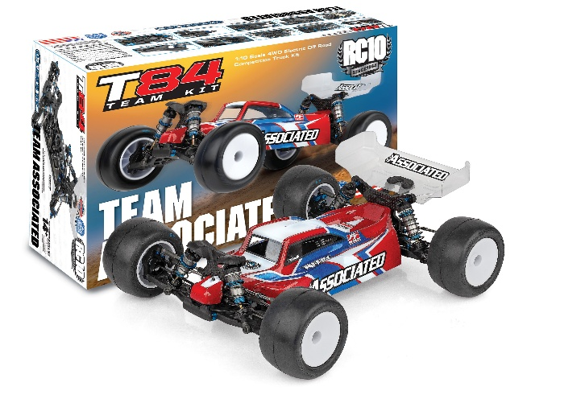
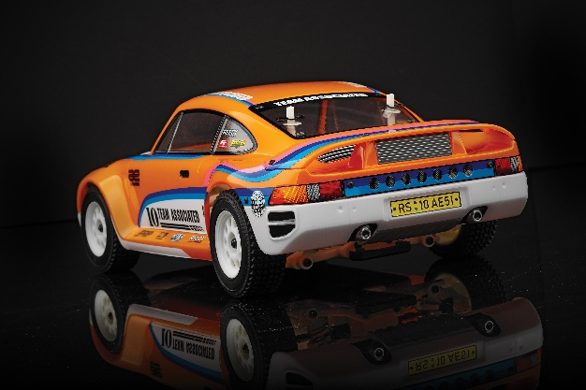
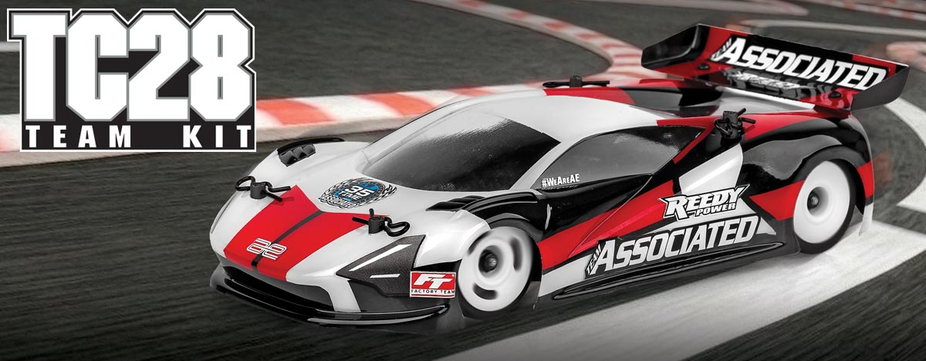

ELECTRIC ■ 1:28 SCALE ■ 4 WHEEL DRIVE ■ ON ROAD ■ KIT
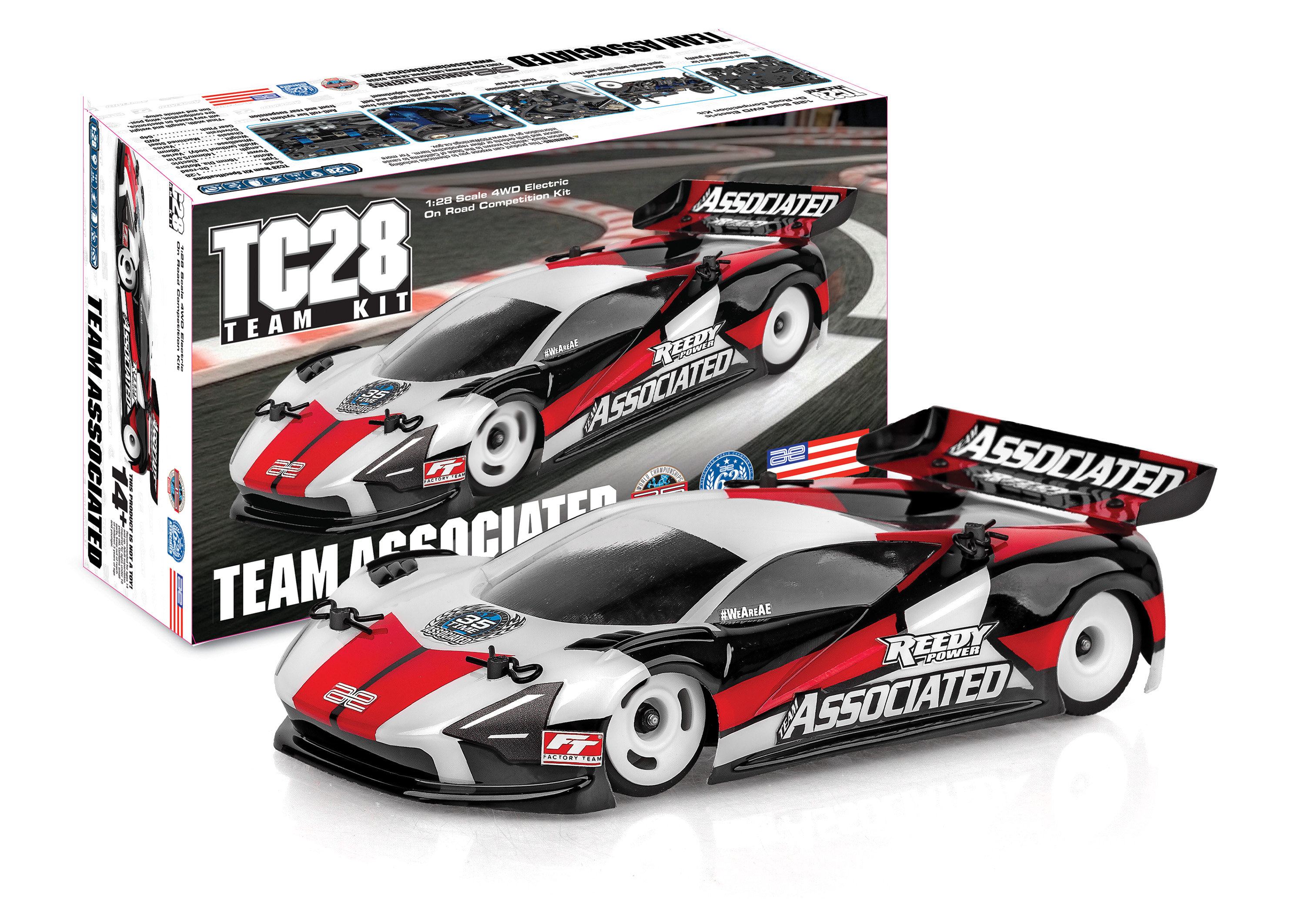
Introducing the Team Associated
TC28 Team Kit

This compact on-road race car is designed with the same engineering precision found in every AREA 51-developed product. Though small in scale, the TC28 delivers big performance in an easy to set up package. Featuring an independent front and rear suspension, constant velocity driveshafts, mid-motor configuration with equal length belts, fluid filled gear differentials with height and belt tension adjustment and a front and rear anti-roll bar.

The steel chassis plate provides a low center of gravity while the insert adjustable roll center enables chassis roll adjustment based on the grip level. White wheels and RadBody Mako X2 included. This TC28 is compatible with all 28th scale Reedy electronics. Compact, tunable, and designed to race, the TC28 is built for high performance and fun—even in tight spaces.
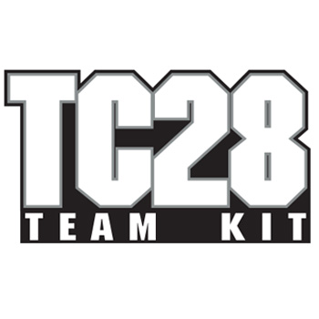

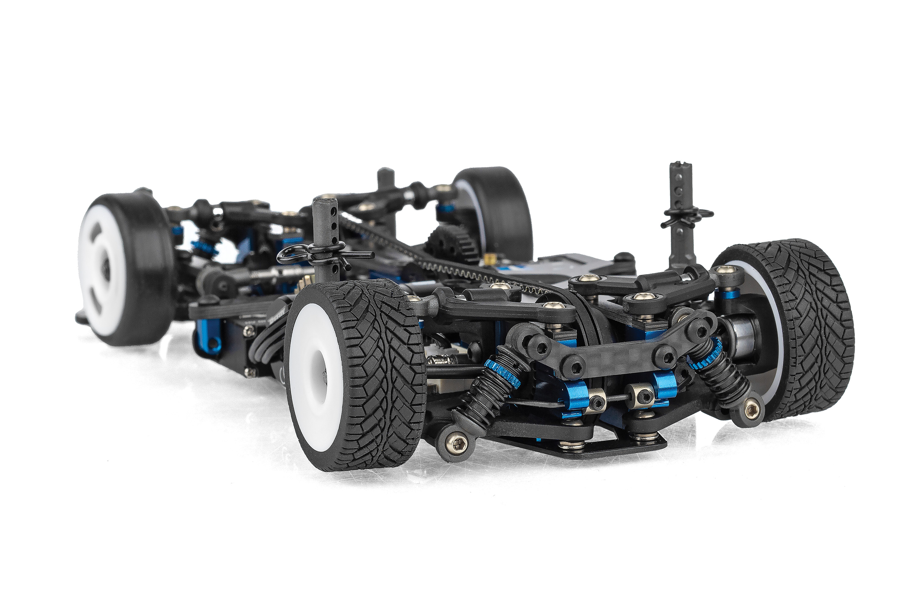

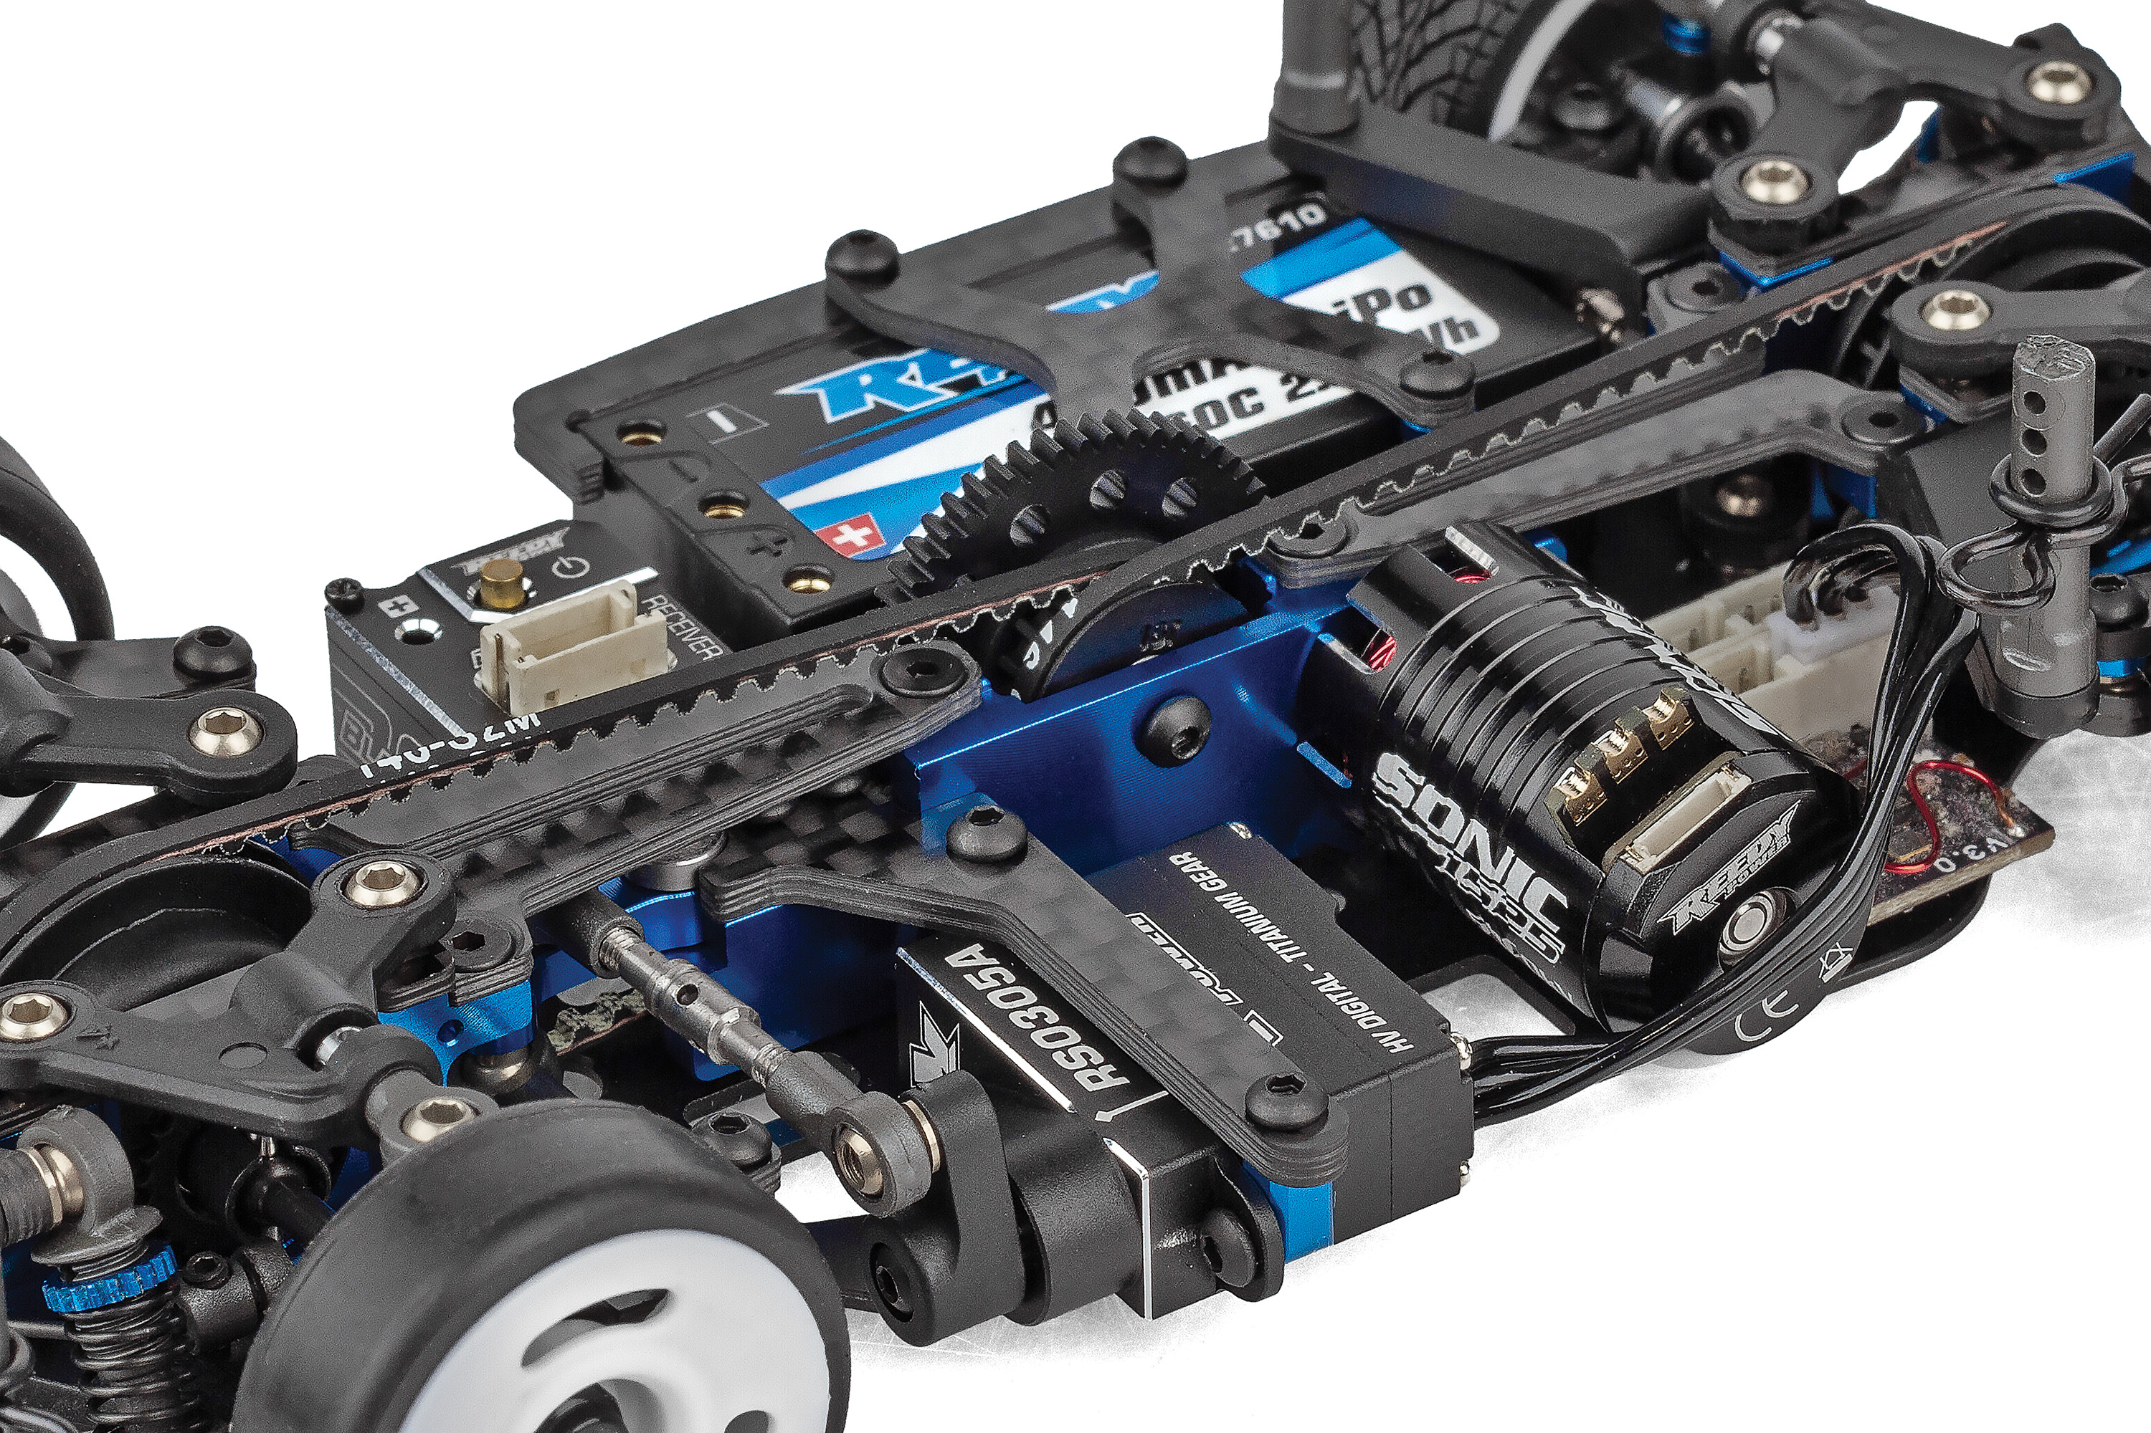

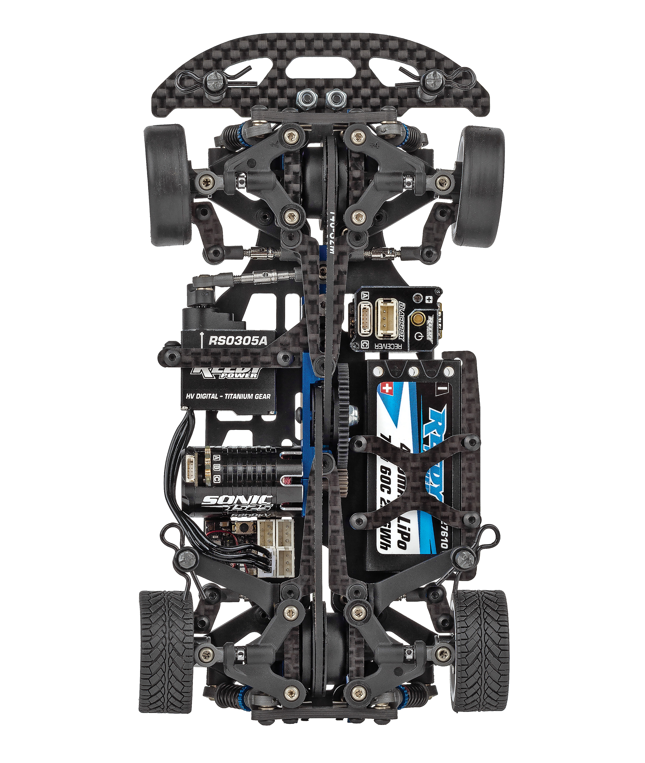

Silicone grease
lubricated shocks
Mid-motor configuration with equal length belts (front and rear)

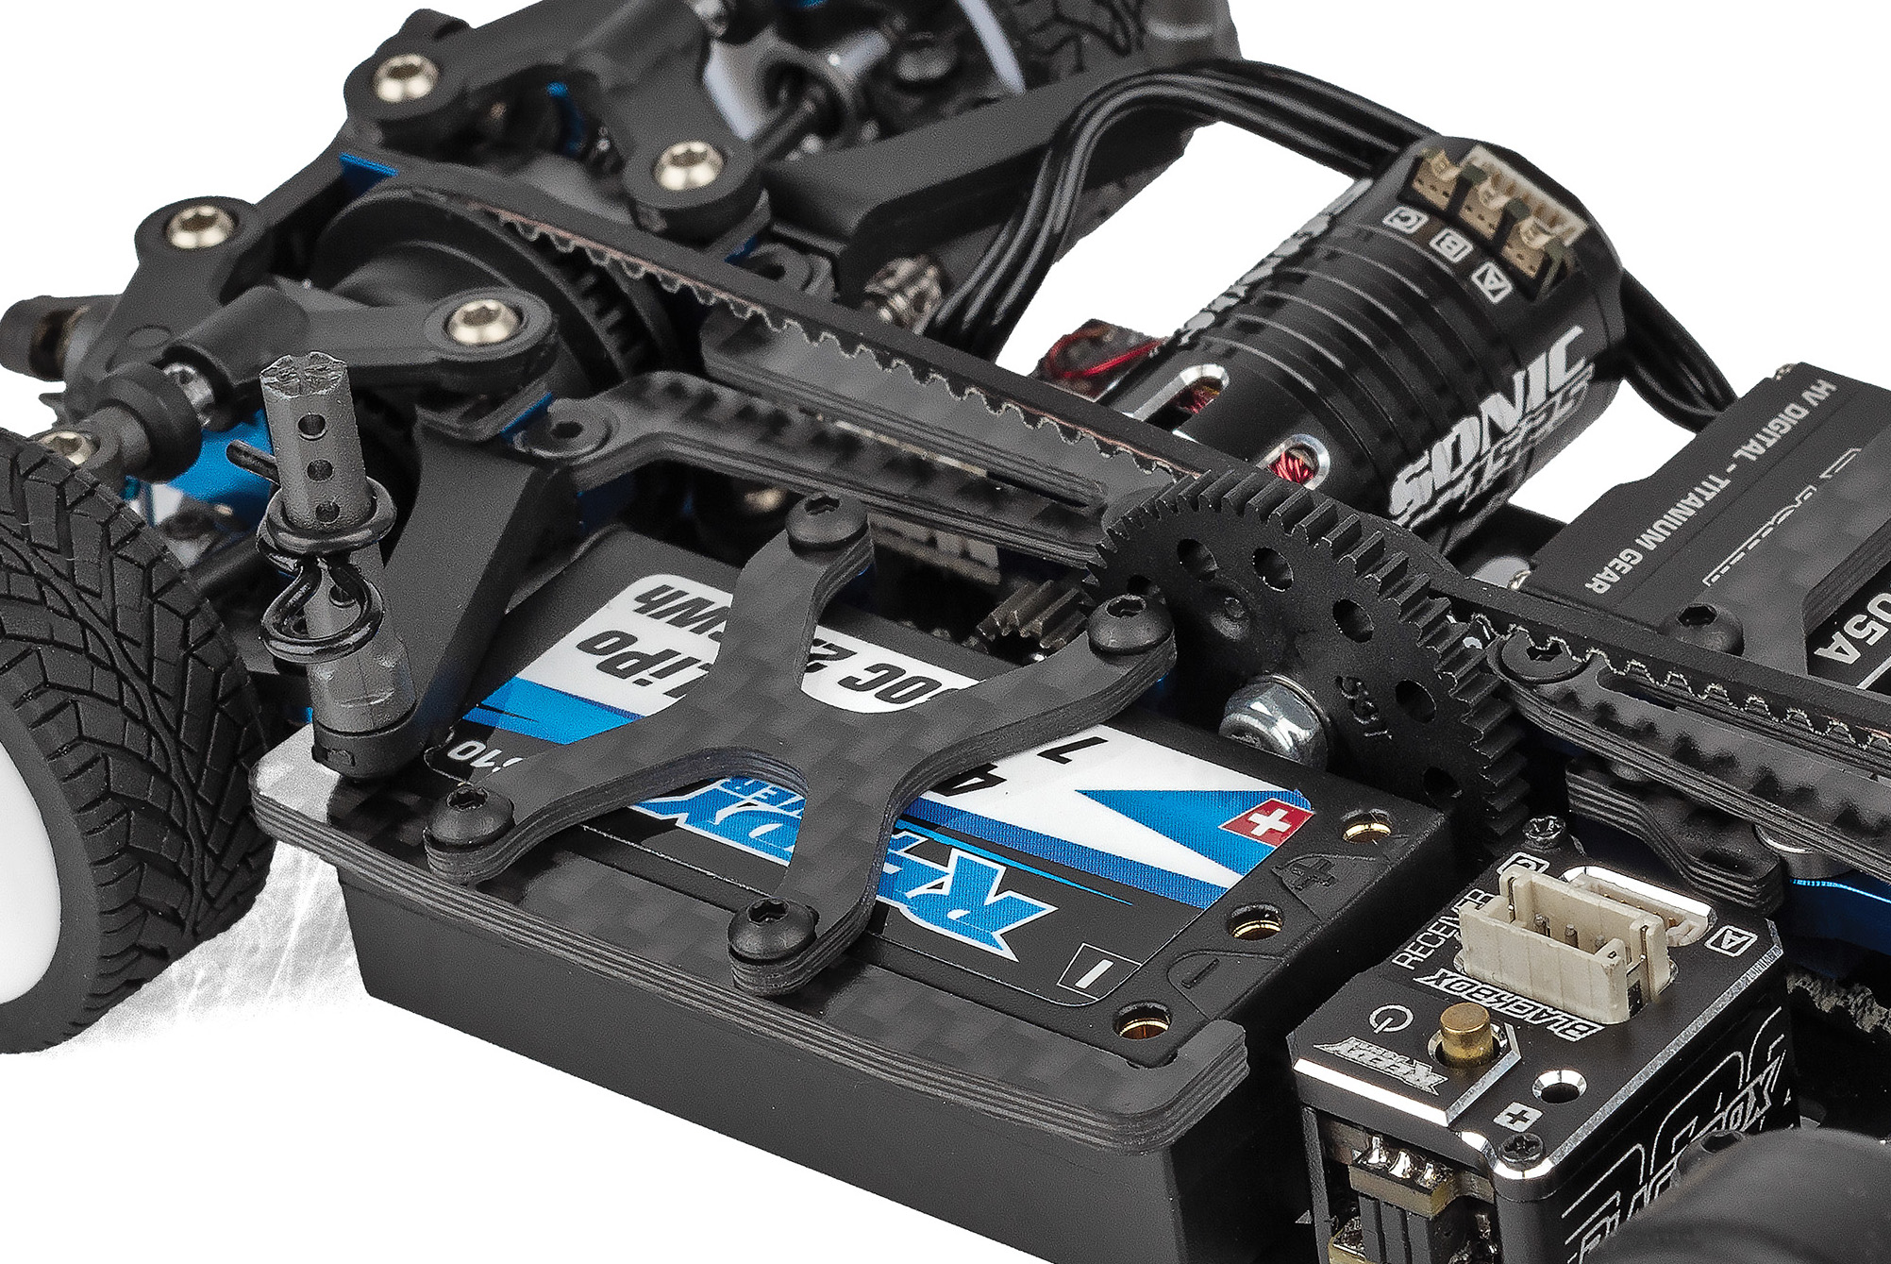
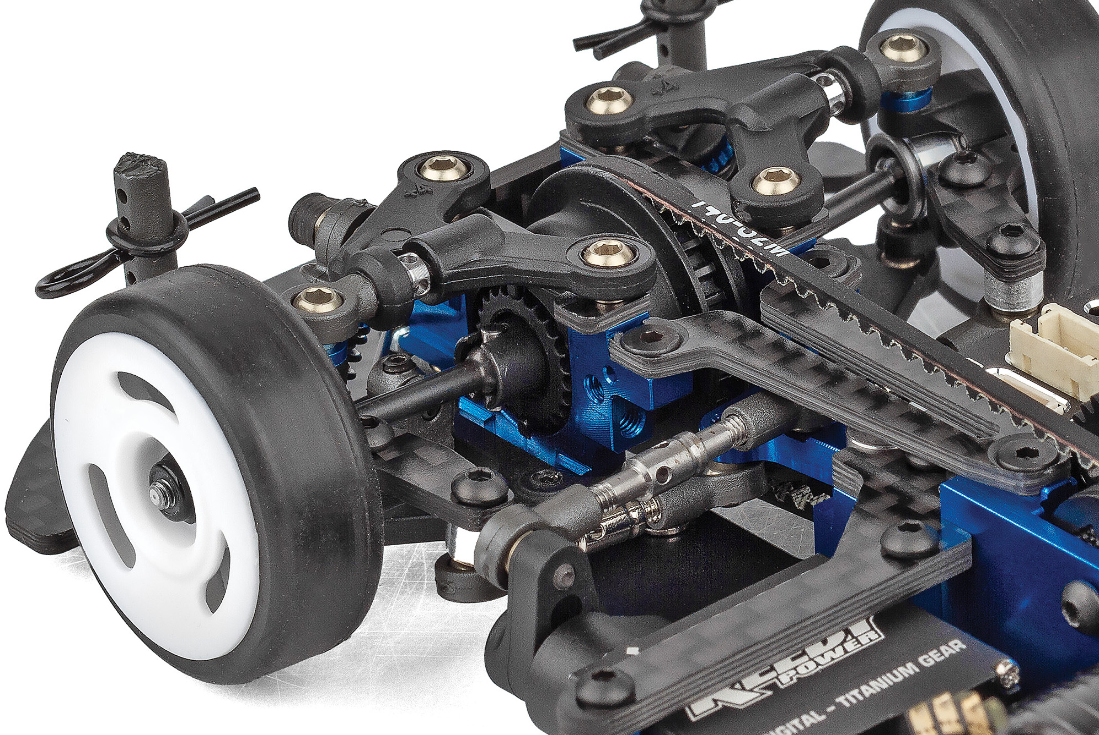

Constant
velocity driveshafts
Quick access battery holder design

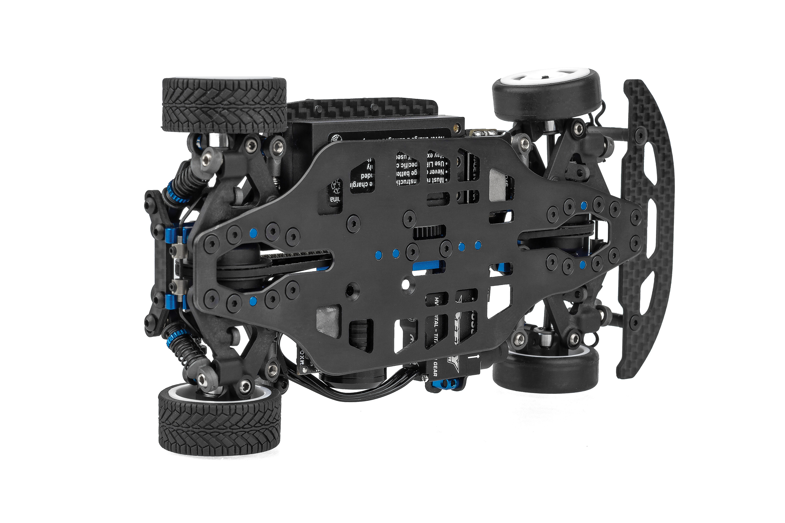

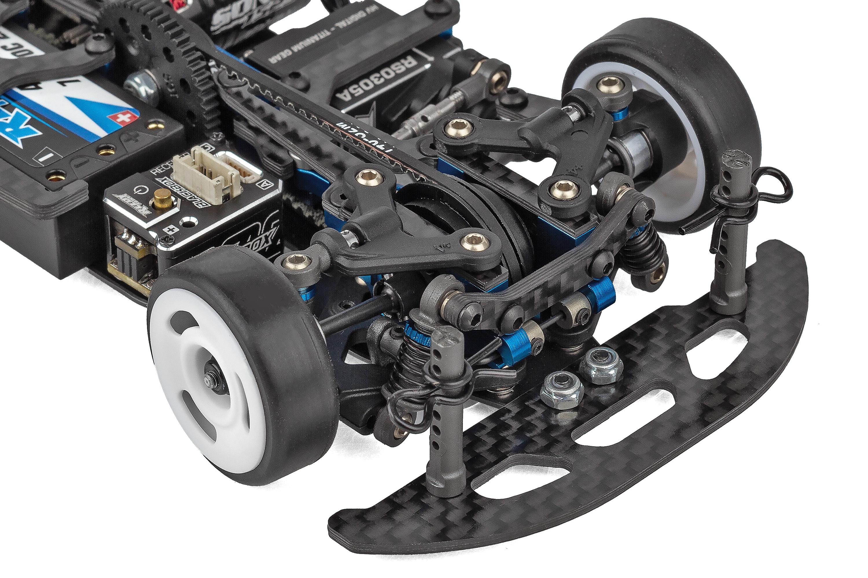

Steel chassis plate for low center of gravity
Universal
front bumper

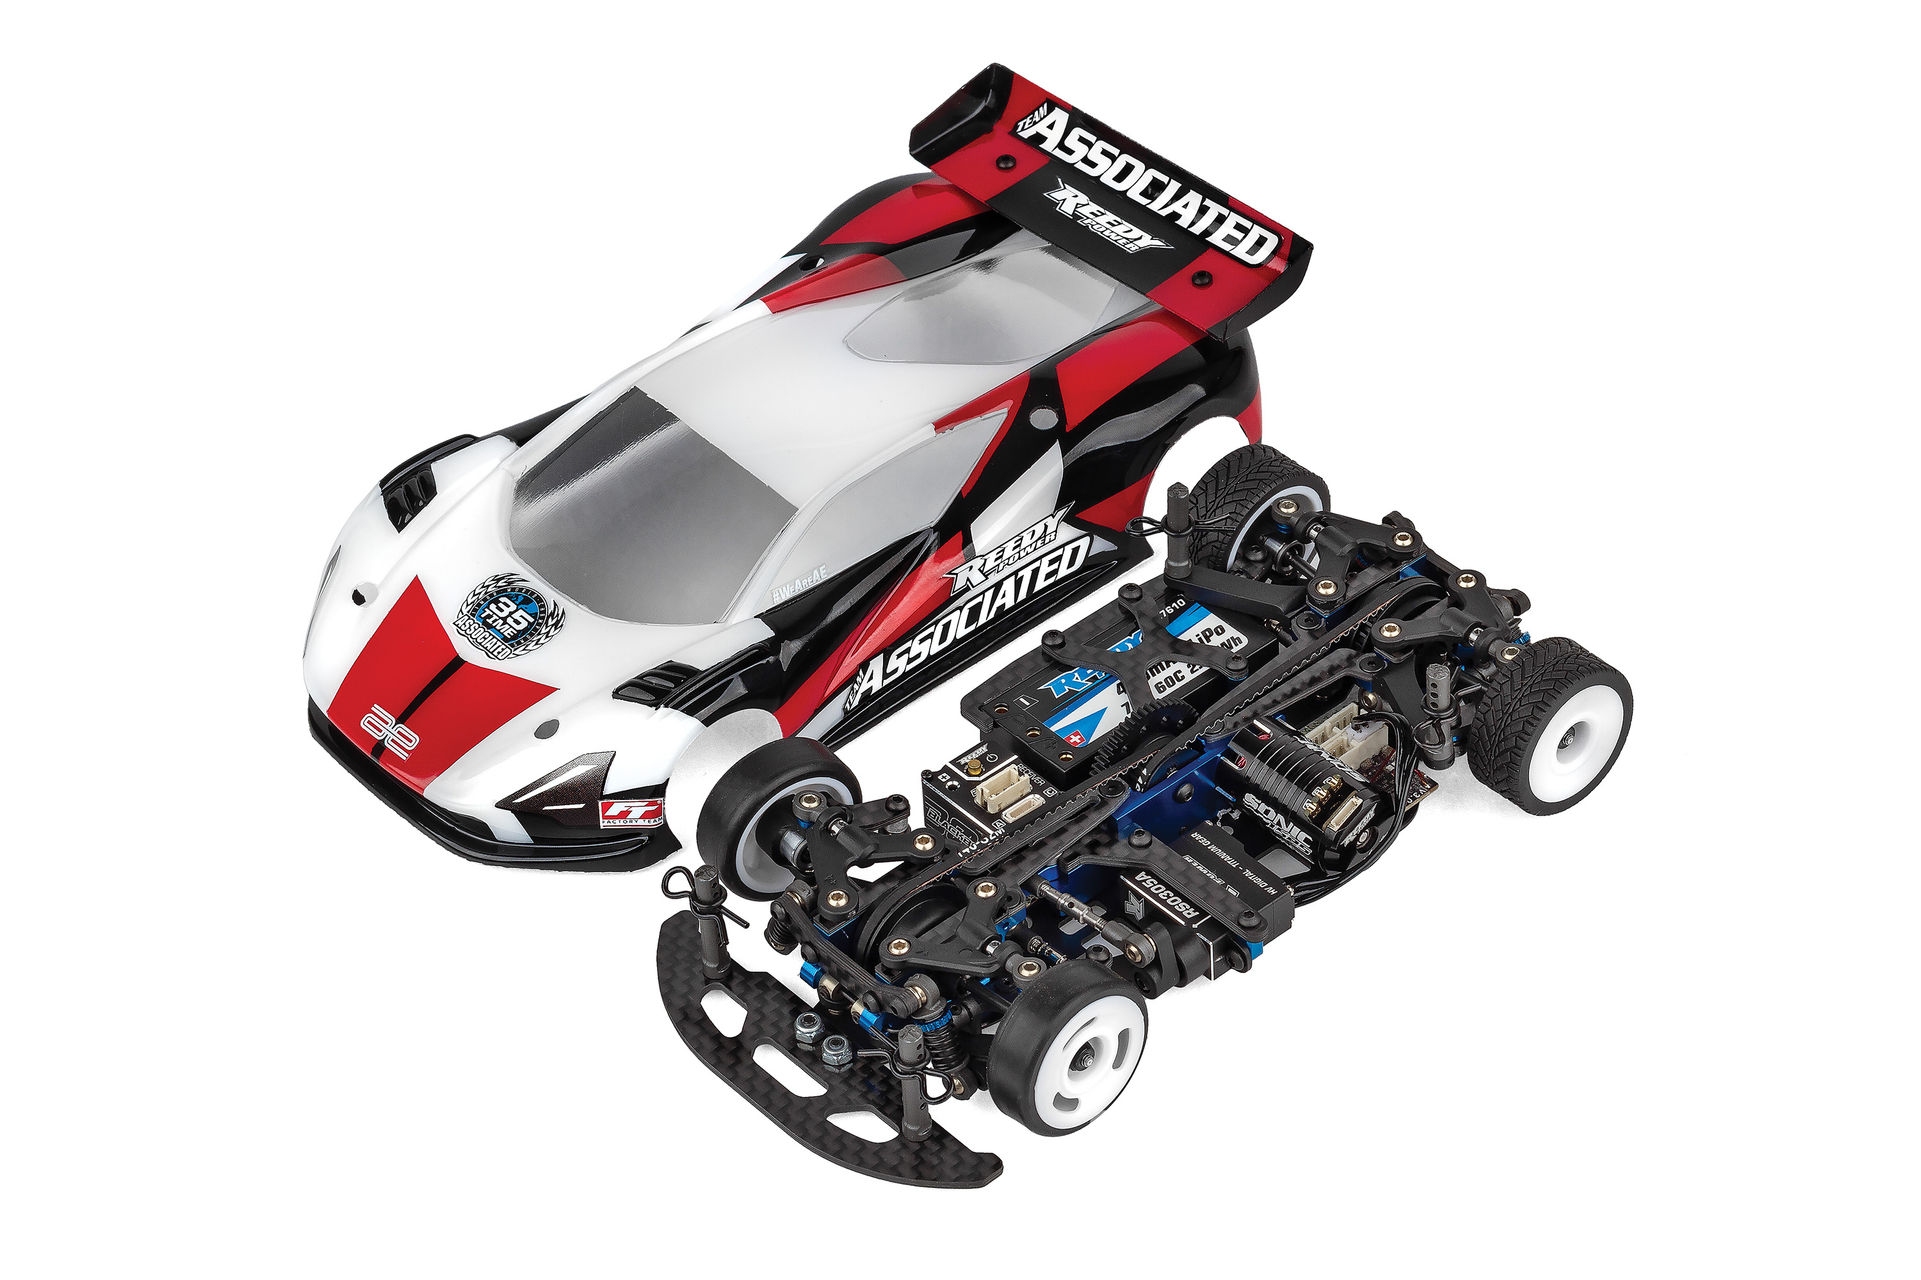

- Motors (#27506 SONIC 1525 5500kV Micro Brushless Motor) (#27507 6800kV Sonic 1525 6800kV Micro Brushless Motor)
- Battery (#27610 REEDY POWER 400mAh 60C 7.4V 1:28 Stick Battery)
- Servo (#27175 REEDY RS0305A Micro Hi-Speed Servo)
- ESC (#27045 REEDY BLACKBOX 300R Competition Micro ESC)
- Charger (#27203 Reedy 1416-C2L Dual AC/DC Competition Balance Charger)

Other Helpful Items:

- Silicone Shock Fluid (Refer to catalog for complete listings)
- Silicone Diff Fluid (Refer to catalog for complete listings)
- Body Scissors (AE Part # 1737)
- Reamer (AE Part #1499) / Hole Punch
- FT Wrench Set (AE Part #1519)
- Hobby Knife
- Needle Nose Pliers
- Wire Cutters
- Soldering Iron
- Calipers or a Precision Ruler

*Final width, length and weight will vary based on electronics, tire configuration, wing position and vehicle setup.

- Steel chassis plate for low center of gravity
- Independent suspension front and rear
- Mid-motor configuration with equal length belts (front and rear)
- Fluid filled gear differentials front and rear with height and belt tension adjustment
- Anti-roll bar system for front and rear suspension
- Silicone grease lubricated shocks
- Constant velocity driveshafts
- RadBody Mako X2 included
- Compatible with all Reedy Electronics for 28th scale
- White wheels included that fit optional front wheel flanges to tune steering feel
- Universal front bumper included

Recommended Electronics:

FEATURES
  SPECS
Scale | 1:28
Type | On-road
Motor | 16mm Dia. Motors
Power | Electric
Length | 140mm/5.51in
Width (without body) | Varies*
Weight | Varies*
Wheelbase | 98mm
Gear Pitch | 64p
Drivetrain: | 4WD
Chassis: | Machined Steel

Items required for operation:

Motor, battery, ESC, servo, receiver, paint, tires and radio. Assembly and painting required

CATALOG INFORMATION

UPC | Part No. | Description | MSRP | MAP | Pieces Per Case | Origin | Available
784695201699 | 20169 | TC28 Team Kit | $507.99 | $329.99 | 20 | TW | June
Download all zipped photos here: https://rc10.com/TC28Images/ (21.1MB) Link is active for 30 days.
Please refer to our MAP Policy here: https://img2c.associatedelectrics.com/pdf/map-policy.pdf

