For Immediate Release: November 2025

Reflex 14B Classic Kit
1:14 Scale 4WD Electric Off Road Buggy Kit

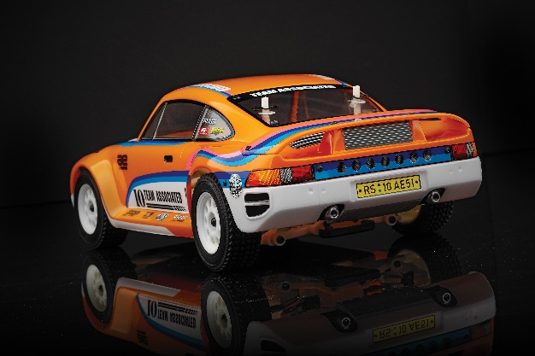
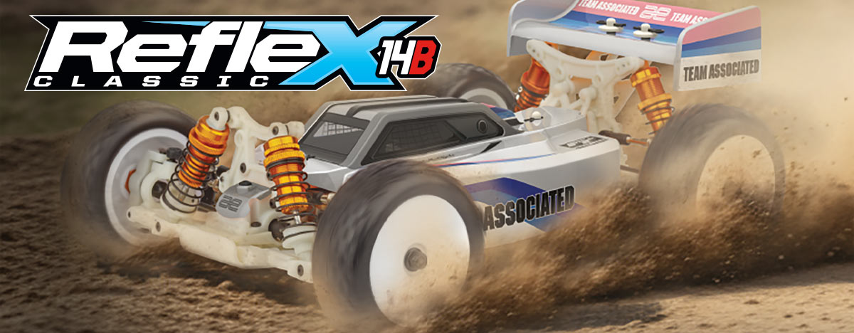

ELECTRIC ■ 1:14 SCALE ■ 4 WHEEL DRIVE ■ OFF ROAD ■ KIT
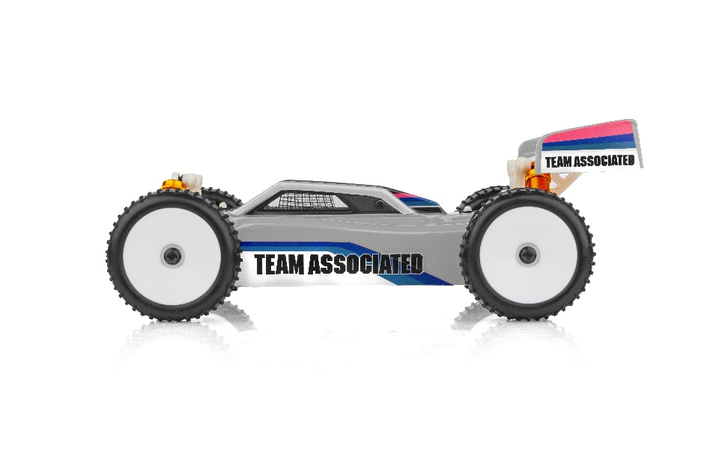
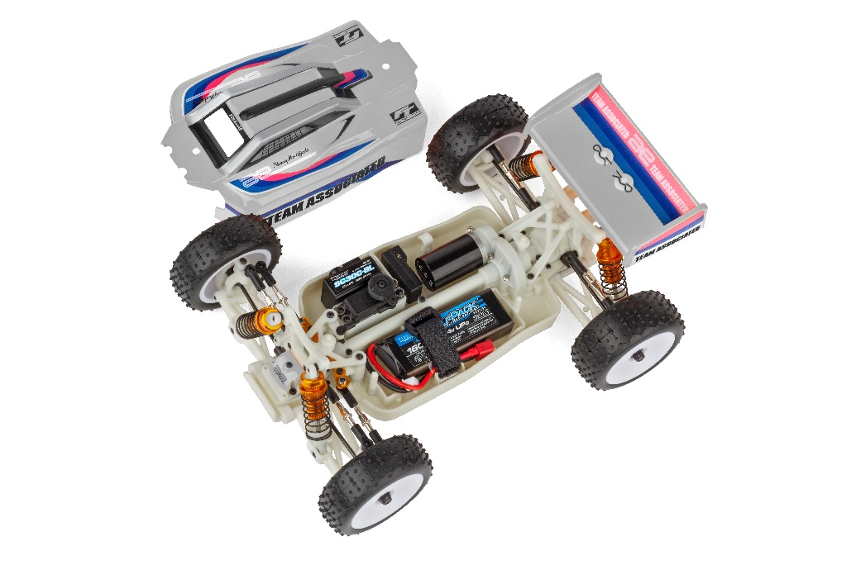
REFLEX 14B CLASSIC KIT
Team Associated has been at the leading edge of off road for over 40 years and proud to introduce the 1:14 scale Reflex 14B Classic Kit 4WD electric buggy. You know this buggy was designed with performance in mind: The adjustability offered by the turnbuckles, caster blocks and rear hubs, make the Reflex 14B Classic Kit perfect for any terrain you can throw at it. Additional features include three sealed differentials, gold aluminum steering rack and light-weight aluminum center driveshaft. These innovations have increased the potential for grip and corner speed, which leads to faster lap times and an overall thrilling-to-drive feel. With the Reflex 14B Classic you can now have big performance in a small scale package!

You can always count on durability, speed, and lineage of a champion with any Team Associated race platform.
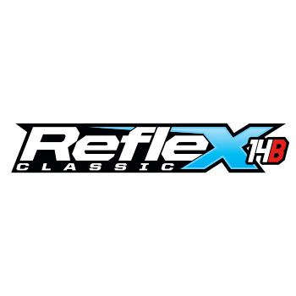

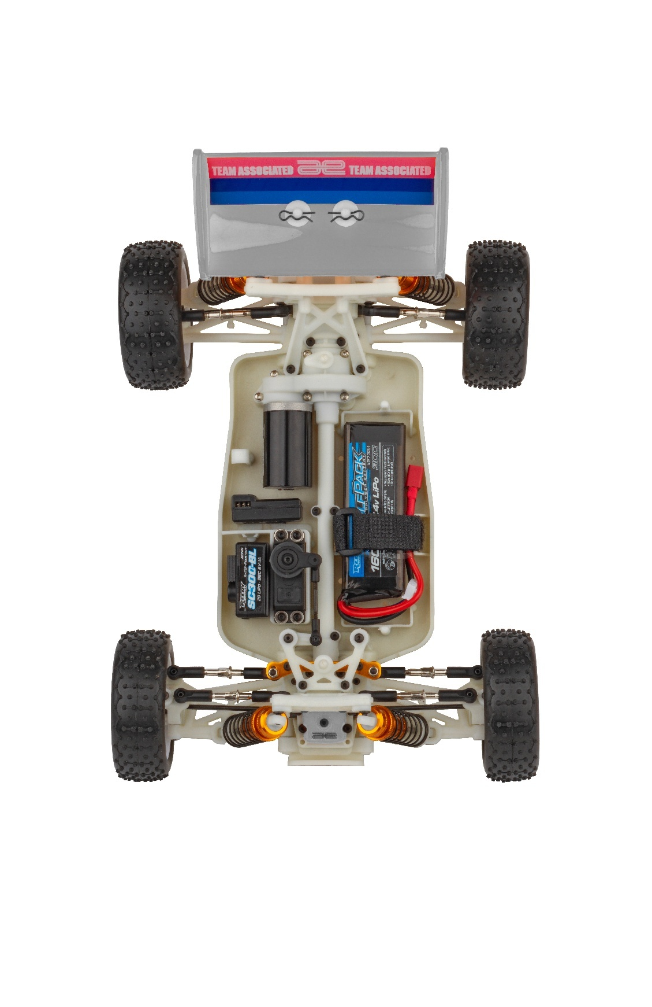

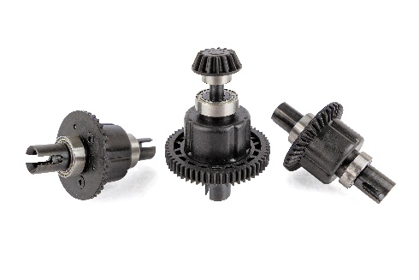

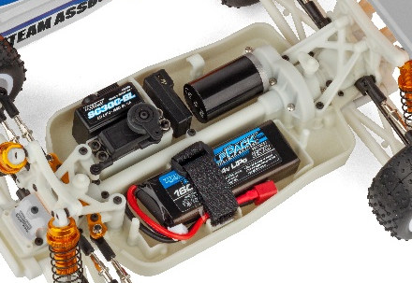

Three sealed differentials
Molded tub chassis with covered center driveshaft

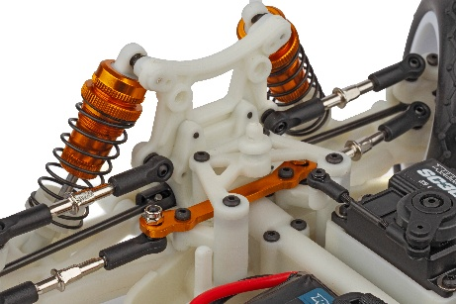
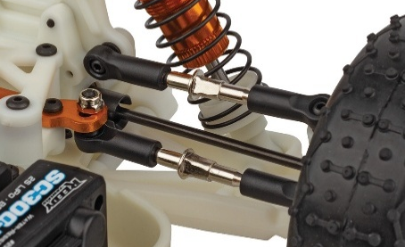

Turnbuckles to adjust camber and toe
Aluminum steering rack

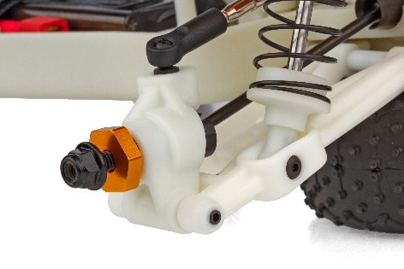
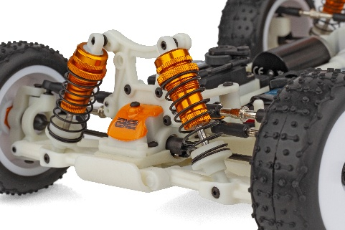

Gold aluminum wheel hexes
Gold aluminum threaded racing shocks

FEATURES
  SPECS
- Gold aluminum wheel hexes
- Gold aluminum threaded racing shocks
- Three sealed differentials
- Adjustable turnbuckles
- Adjustable inserts for caster blocks and rear hubs
- Gold aluminum steering rack
- Front universal driveshafts
- Molded tub chassis with covered center driveshaft
- Optional dust filter screen included
- New rally wheels and tires
- Gold anodized aluminum shocks
- Updated battery strap system
- Aluminum center driveshaft
- Clear Lexan® Reflex 14B Body
- RC10 Protec style rear wing

Scale | 1:14
Type | Off-road
Power | Electric
Length | 304mm (11.97in)
Width | 202mm (7.95 in)
Weight | Varies*
Wheelbase | Varies
Internal Gear Ratio | 2.46:1
Drive: | 4WD
Chassis: | Molded Plastic
Suspension: | Independent Front and Rear

*Final width, length and weight will vary based on electronics, tire configuration, wing position and vehicle setup.

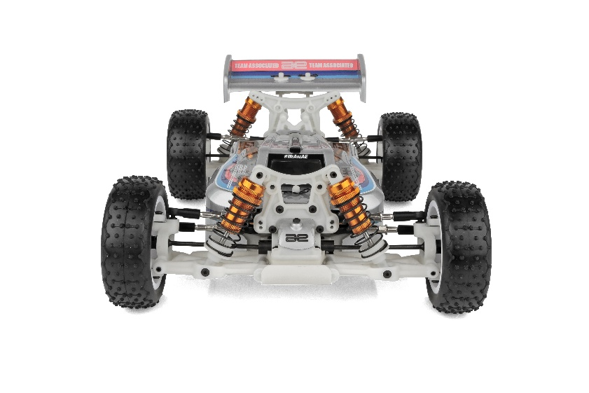

OTHER HELPFUL ITEMS

- Silicone Shock Fluid (Refer to catalog for complete listings)
- Silicone Diff Fluid (Refer to catalog for complete listings)
- Body Scissors (AE Part # 1737)
- Reamer / Hole Punch
- FT Wrench Set (AE Part #1519)
- Hobby Knife
- Needle Nose Pliers
- Wire Cutters
- Soldering Iron
- Calipers or a Precision Ruler

Items required for operation:
Motor, battery, ESC, servo, receiver, paint, tires and radio. Assembly and painting required.

UPC | Part No. | Description | MSRP | MAP | Pieces Per Case | Origin | Available
784695201934 | 20193 | Reflex 14B Classic Kit | $264.99 | $179.99 | 6 | TW | Now
CATALOG INFORMATION
Download all zipped photos here: https//www.rc10.com/RC10Reflex14BImages/ Link is active for 30 days.
Please refer to our MAP Policy here: https://img2c.associatedelectrics.com/pdf/map-policy.pdf

