

**For Immediate Release: October**

**The RC10GB Nitro Buggy Kit #6047**

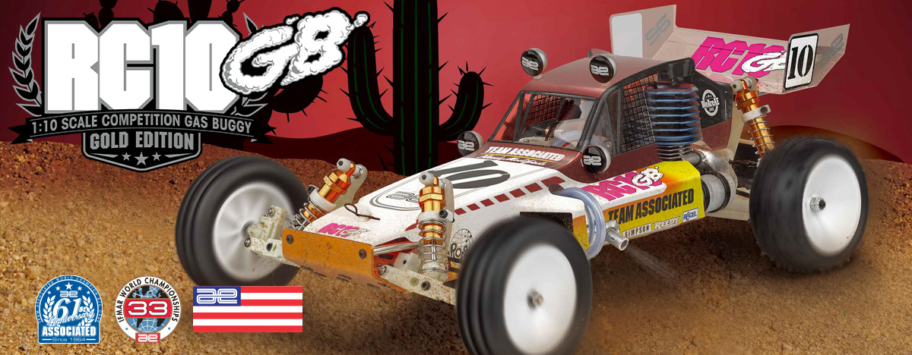

|  |
| --- |
| **GAS ■ OFF ROAD ■ 1:10 SCALE ■ 2 WHEEL DRIVE ■ KIT** |

The RC10GB is Team Associated’s all-new 2WD nitro buggy, combining the RC10GT’s gas-powered durability with the suspension and styling of the RC10 Team Car. Never released until now, it delivers vintage looks, modern performance, and true nitro excitement for collectors, racers, and off-road RC enthusiasts.

**NITRO OFF-ROAD BUGGY BORN FROM TWO LEGENDS**

**The all-new Team Associated RC10GB 2WD Off-Road Buggy is a groundbreaking release that pays tribute to two of the most iconic vehicles in RC history while blazing an entirely new trail of its own.**

For the first time ever, Team Associated has officially unveiled a nitro-powered buggy that blends the

race-proven performance of the legendary RC10GT Gas Truck with the unmistakable looks and suspension geometry of the classic RC10 Team Car. This isn’t a reissue or a replica—it’s a brand-new creation that merges decades of innovation into a single,

high-performance package.

At its core, the RC10GB is built on the durable and battle-tested foundation of the RC10GT, a gas truck that dominated ROAR Nationals and club tracks throughout the 1990s. Known for its strength, speed, and reliability, the RC10GT serves as the perfect platform for this

nitro-burning buggy. From the reinforced chassis to the tough drivetrain and stealth-inspired transmission, the RC10GB is ready to handle the rigors of high-speed

off-road racing.

What sets the RC10GB apart visually and functionally is its unmistakable buggy form. Borrowing its suspension layout, shock towers, and overall stance from the RC10 Team Car, it delivers the classic 2WD buggy feel with long-travel shocks and a low-profile design that’s perfect for loose dirt and high-traction surfaces alike. It’s a seamless blend of form and function, wrapped in a body that nods to Team Associated’s vintage golden era.

Until now, this configuration has never been available to the public. The RC10GB represents a bold and exciting “what-if” brought to life—something enthusiasts have imagined for years. Now, it’s real. Whether you’re a collector, racer, or lifelong nitro fan, the RC10GB is a one-of-a-kind machine that captures the essence of RC history while delivering the unmistakable roar and smell of nitro performance.

A 2WD OFF-ROAD BUGGY FORGED FROM TWO ICONS

The all‑new RC10GB is a nitro‑burning 2WD off‑road buggy that brilliantly combines the racing legacy of the undefeated ROAR National Champion RC10GT gas truck with the precision engineering of the RC10 Team Car electric buggy. It inherits the RC10GT’s proven .12–.15 ci nitro powertrain, quick‑fill fuel tank, and long‑travel suspension tuned for gas‑powered performance. At the same time, it integrates the Team Car’s race‑developed chassis geometry, adjustable differential, fluid‑filled shocks, and modular layout for fine‑tuned handling.

This fusion results in a hardcore competition buggy built for serious off‑road nimbleness and nitro burning power. True to Team Associated’s championship roots, the RC10GB marries the high‑traction, long‑arm RC10 Team Car with the raw sound and feel of nitro racing, delivering a unique blend of electric chassis refinement and gas‑fueled dominance.

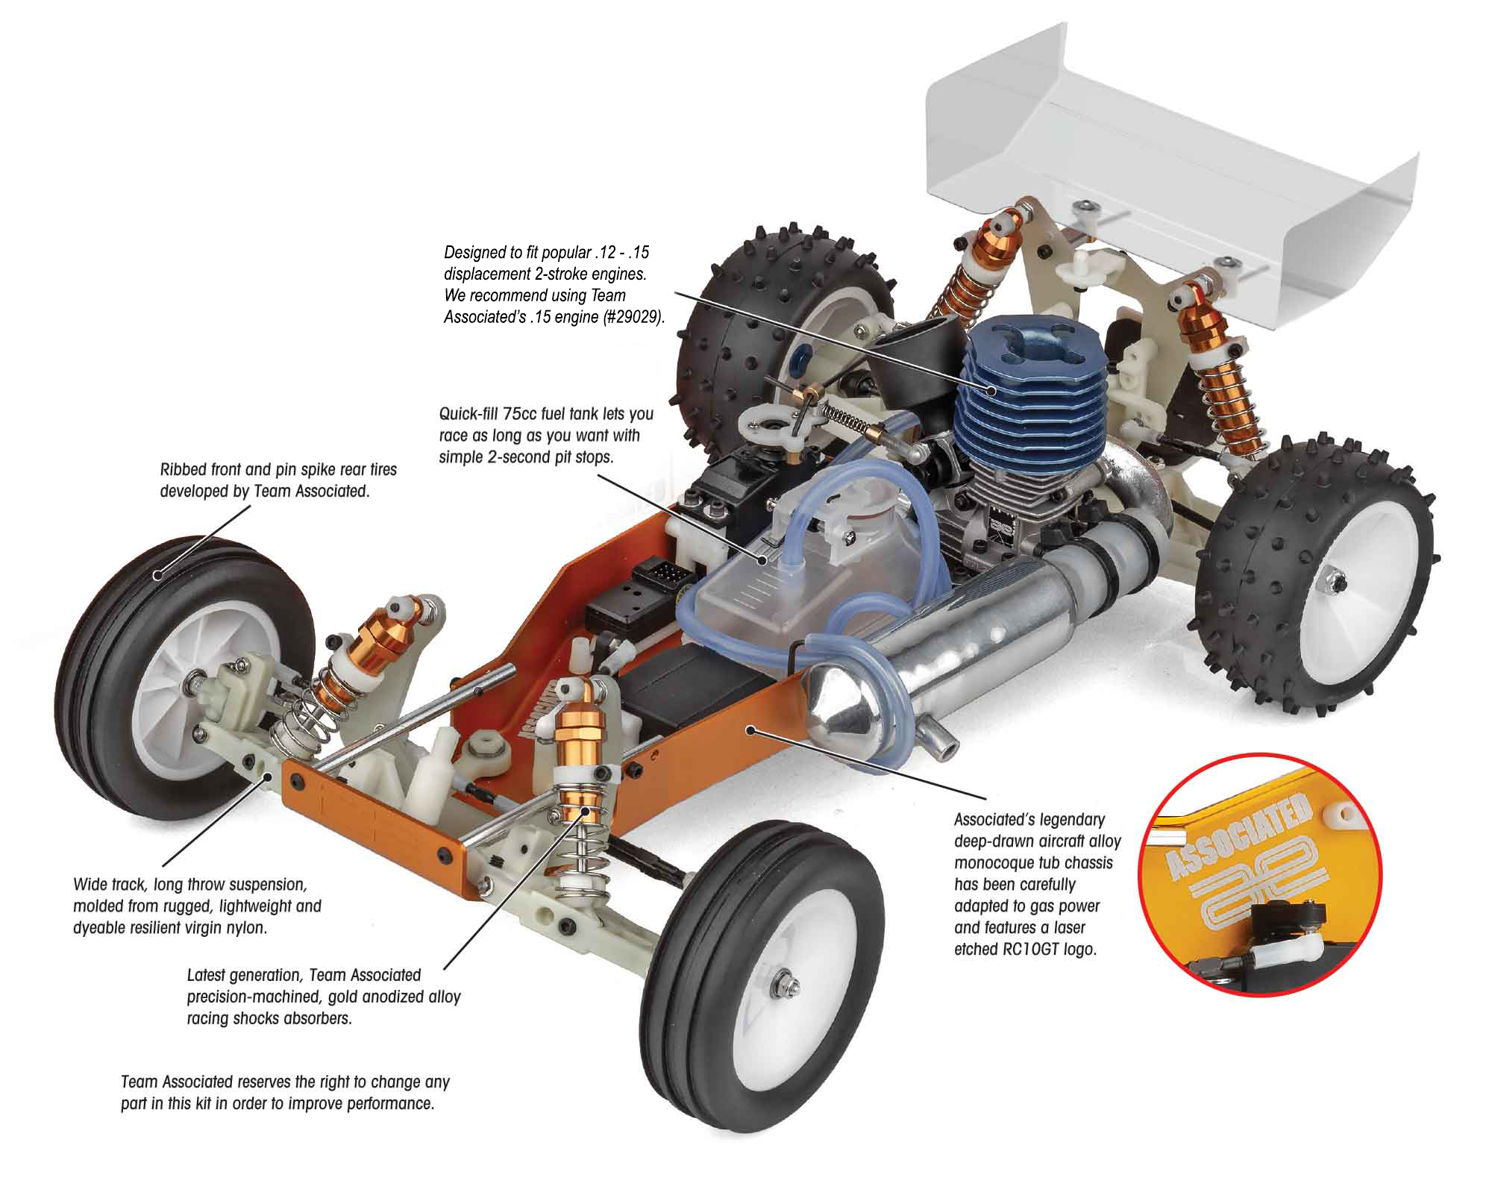

The radio control system pictured is required, but not included in this kit. PLEASE NOTE: RC10GT kit does not include an engine, but does include a manifold and exhaust pipe. It is VERY IMPORTANT that the engine and accessories are correctly matched.

|  |
| --- |
| **FEATURES** |

* 2-second, quick fill fuel tank with filter
* Heavy-duty front and rear buggy arms
* Reversible bellcrank / servo-saver steering
* Vintage ribbed front tires
* Vintage spike rear tires
* Gold anodized; oil filled shocks
* Ball differential
* Precision bearings throughout
* Original release natural white plastic parts
* Adjustable turnbuckles for camber and toe
* Aluminum engine manifold (non-pull start)
* Polished exhaust pipe (non-pull start)
* 2 shoe clutch system and flywheel (non-pull start)
* Exclusive gold aircraft aluminum tub chassis
* Updated gearing for 2wd Buggy
* Wide buggy front Arms
* Wide front axles
* Wider rear CVA axles and axle spacers
* Wider footprint for performance
* New rear shock tower
* 89 Stealth Car wing mounts
* Protech clear body with gas cutout template
* Stealth ATC transmission
* Powerful rear disk brakes
* Adjustable slipper clutch

|  |  |  |
| --- | --- | --- |
| **ITEMS NEEDED TO COMPLETE** |  | **SPECIFICATIONS** |

|  |  |
| --- | --- |
| **Scale** | 1:10 |
| **Power** | Nitro |
| **Length** | 381mm (15”) |
| **Width** | 264mm (10.39”) |
| **Weight** | Varies |
| **Wheelbase** | 267.7mm (10.54”) |
| **Internal Ratio** | 2.6:1 |

* .12 or .15 non-pull start engine (O.S. type crank)
* Radio control battery charger
* Starter box
* Nitro fuel
* 2-channel RC surface transmitter and its batteries
* 2-channel receiver
* Receiver battery pack
* Throttle and Steering servos
* Paint for body
* Glue for tires

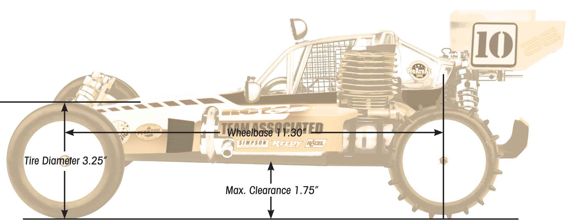

Available:

|  |
| --- |
| **CATALOG INFORMATION** |

|  |  |  |  |  |  |  |  |
| --- | --- | --- | --- | --- | --- | --- | --- |
| **UPC** | **Part No.** | **Description** | **MSRP** | **MAP** | **Pieces Per Case** | **Origin** | **Available** |
| 784695060470 | 6047 | RC10GB NITRO BUGGY KIT | $584.99 | $399.99 | 6 | TW | Oct |

Download all zipped photos here: <https://www.rc10.com/RC10GBimages/>(2MB) Link is active for 30 days.

Please refer to our MAP Policy here: <https://img2c.associatedelectrics.com/pdf/map-policy.pdf>

