For Immediate Release: October 2026

GATERUNNER 2WD KIT #40144
1:10 Scale Off-Road Truck Kit 2WD Pre-Runner Ecto
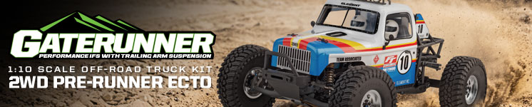

1:10 SCALE ■ OFF-ROAD ■ TRUCK ■ KIT

RACE-INSPIRED ENGINEERING.
DESERT-READY PERFORMANCE
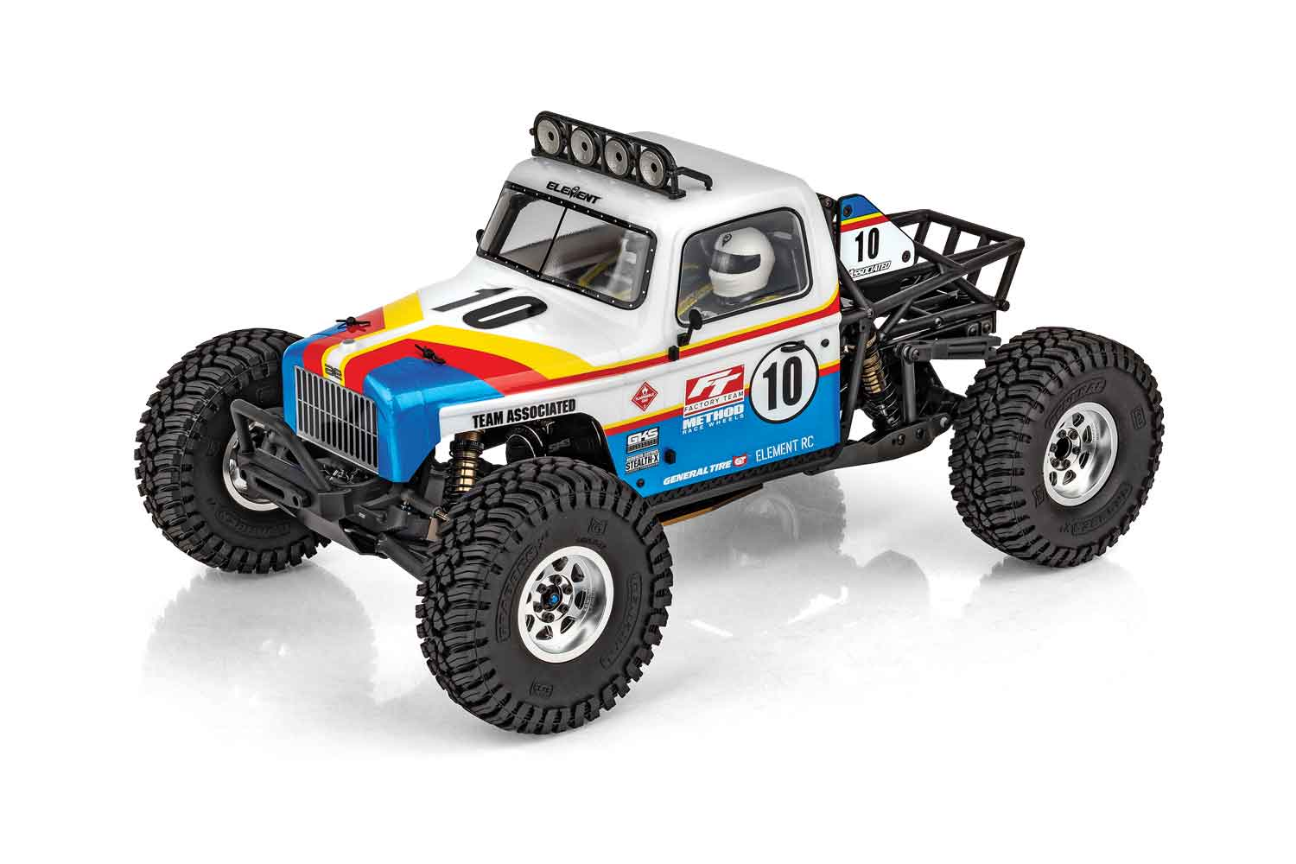
The all-new Element RC Gaterunner brings race-inspired engineering and high-performance desert truck capability to a 1:10 scale 2WD platform built for serious off-road driving. Featuring an all-new Gaterunner design, the truck is built around a hard anodized bronze chassis with a new chassis brace and support system for added strength and rigidity.

The Gaterunner’s new independent front suspension is carried over from the proven Team Associated RC10B6 race buggy, delivering precise handling and controlled performance across rough terrain. A new rear axle housing and metal-gear differential provide durability, while the CNC-machined blue anodized aluminum front arm mount and black anodized aluminum front bumper skid plate add strength and style.

An aluminum high-speed center transmission and motor mount provides a solid foundation for efficient power delivery, while the black G-10 front shock tower supports the Factory Team fluid-filled threaded shocks. Heavy-duty links and ball joints are built to handle demanding off-road conditions.

Out back, the GKS rear trailing arm suspension features an anti-roll bar for improved stability and control through high-speed corners and uneven terrain. Fully adjustable suspension allows drivers to tune the Gaterunner to suit different driving styles and terrain conditions.

Full metal ball bearings provide smooth operation and reduced friction throughout the truck. The Gaterunner is designed to accept 2S LiPo shorty battery packs, delivering a compact power solution while helping maintain balanced handling.
From rough desert terrain to high-speed runs, the all-new Element RC Gaterunner combines race-bred suspension technology, premium aluminum components, and rugged 2WD performance.

CHASSIS FEATURES:

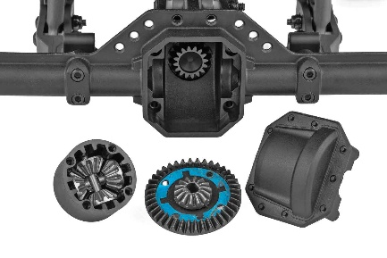
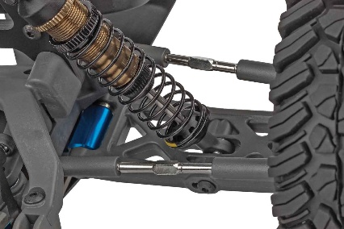


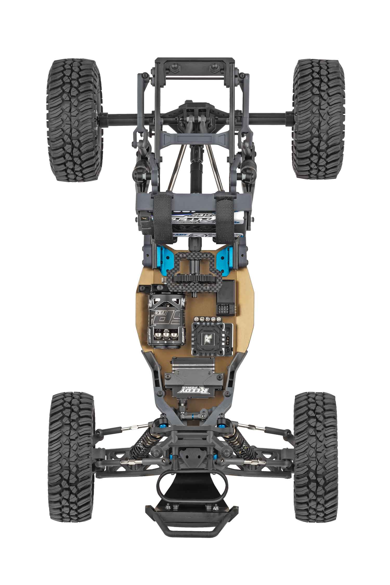

AXLE HOUSING AND DIFFERENTIAL:

To handle the higher speeds this truck was designed for, an all-new one-piece rear axle incorporates a durable open gear differential with metal ring, pinion, and planetary gears.
HIGH-PERFORMANCE IFS:

This high-performance
race-inspired independent front suspension is carried over from
our Team Associated line or racing buggies (RC10B6) and utilizes heavy-duty steel tie rods, ball cups, ball studs, and an aluminum blue anodized arm mount for increased durability.

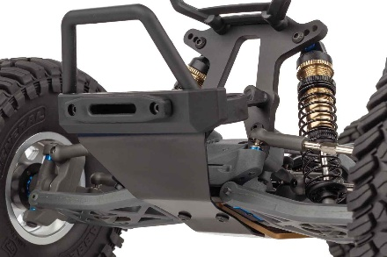
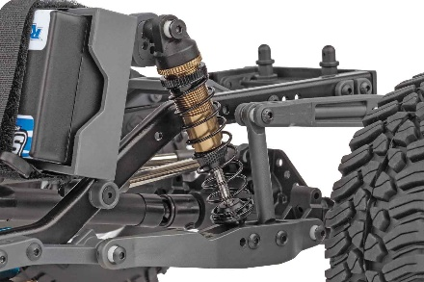

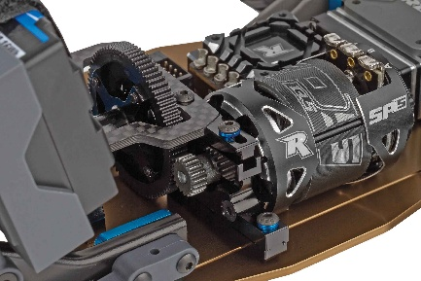
TRAILING ARM REAR SUSPENSION:

To handle bumps and jumps our classic Enduro GKS rear suspension with anti-roll bar and Factory Team aluminum threaded fluid-filled shocks is the perfect fit for the Gaterunner.

ADDITIONAL FEATURES:

- All-New Gaterunner design with hard anodized bronze chassis
- New chassis brace and support system
- Factory Team fluid-filled threaded shocks
- Fully adjustable suspension
- Full metal ball bearings
- Fits 2S LiPo shorty battery packs

*Due to ongoing R&D, photos may not match production components

ALUMINUM FRONT BUMPER SKID PLATE:

The aluminum black front bumper skid plate increases protection from impacts and incorporates a shock absorbent brace that ties into the G10 front shock tower.

DRIVE TRAIN:

The Gaterunner utilizes a high-speed and efficient center mounted transmission with an adjustable CNC aluminum motor mount, carbon fiber brace, and heavy-duty slider shafts with aluminum inserts.

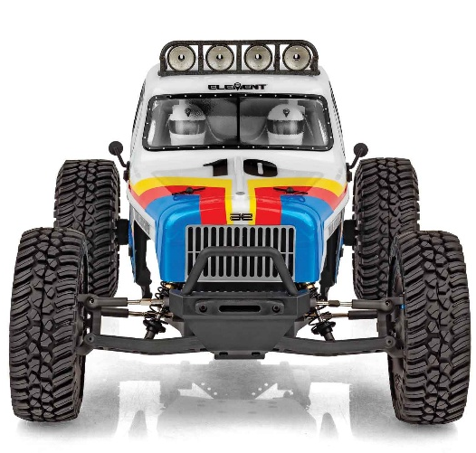
All in the details. The all-new Element RC Gaterunner 2WD combines aggressive desert styling with authentic scale detail, inspired by Dave at My Build Projects, on YouTube and Instagram, and his passion for creating unique, highly detailed off-road builds. The new clear Ecto cab and rear cage body set features an injection-molded fuel cell and radiator, bringing realistic details to the heart of the truck. A new roof-mounted lightbar accepts 3mm LEDs, allowing you to add functional lighting for an even more realistic appearance.

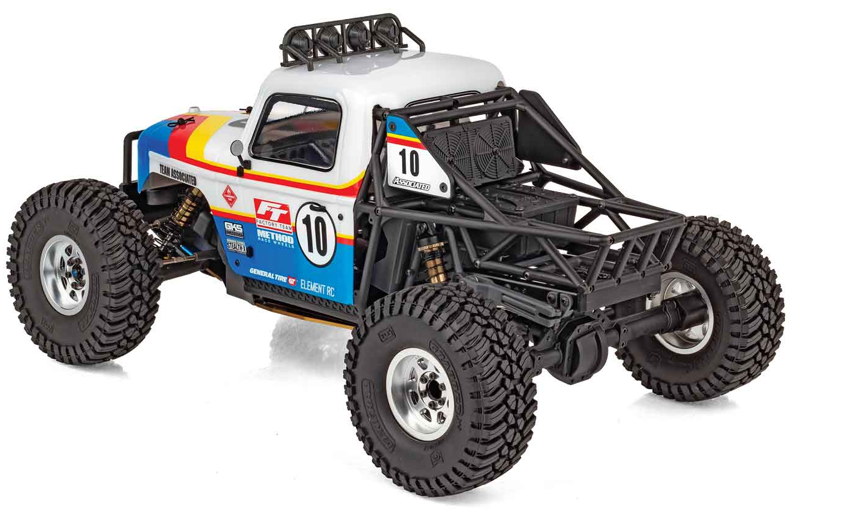

The Gaterunner rolls on officially licensed General Tire Grabber X3 tires mounted to officially licensed silver Method 701 Trail Series 3-piece beadlock wheels, delivering a premium scale look from every angle. Inside, a detailed interior includes driver and co-driver figures with molded helmets, adding another level of realism to the desert-inspired design.

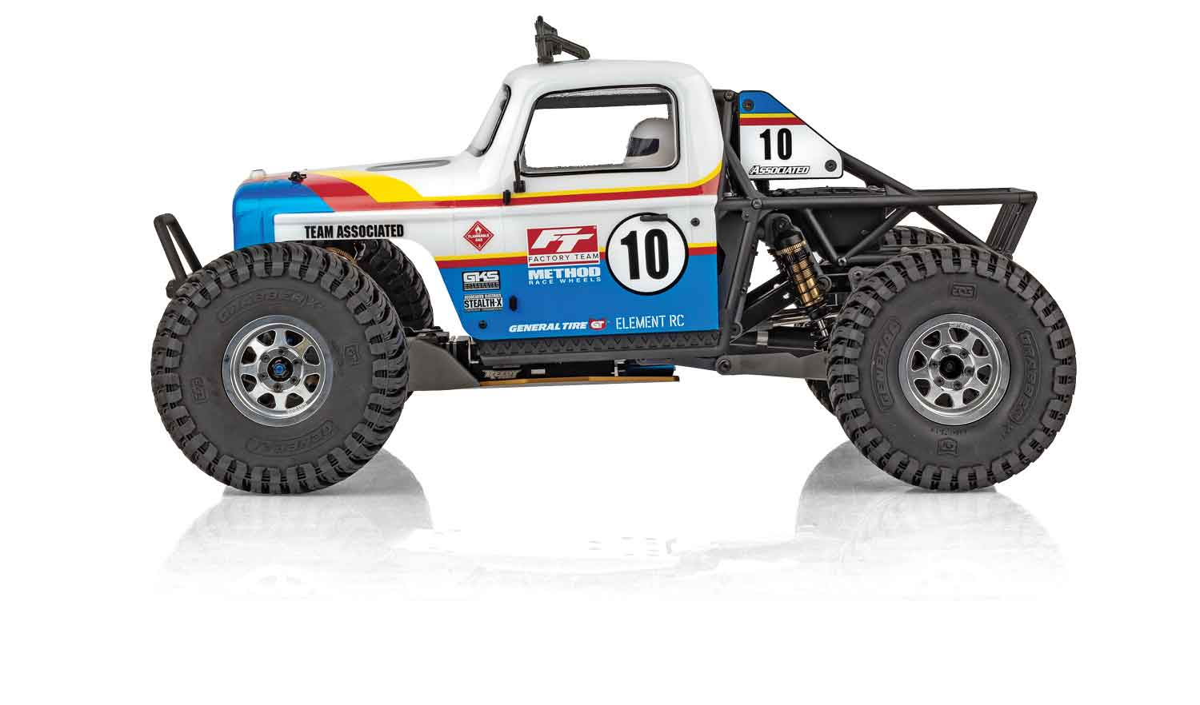
A screen-printed livery decal sheet is included to replicate the striking box-art graphics, making it easy to achieve the distinctive Gaterunner appearance right out of the box. From its detailed cage and interior to its licensed tires and wheels, the Element RC Gaterunner brings Dave’s My Build Projects-inspired vision to life in an Element RC builder’s kit platform.

OFFICIALLY LICENSED WHEELS
AND TIRES:
Gripping the desert sand is a set of officially licensed General Grabber™ X3 tires molded in a high-performance, soft compound rubber. The General Grabber™ X3 tires are mounted on officially licensed silver Method 701 Trail Series beadlock wheels. The combination of industry leading General Tires™ and Method Wheels make the Gaterunner 2WD look and perform great.

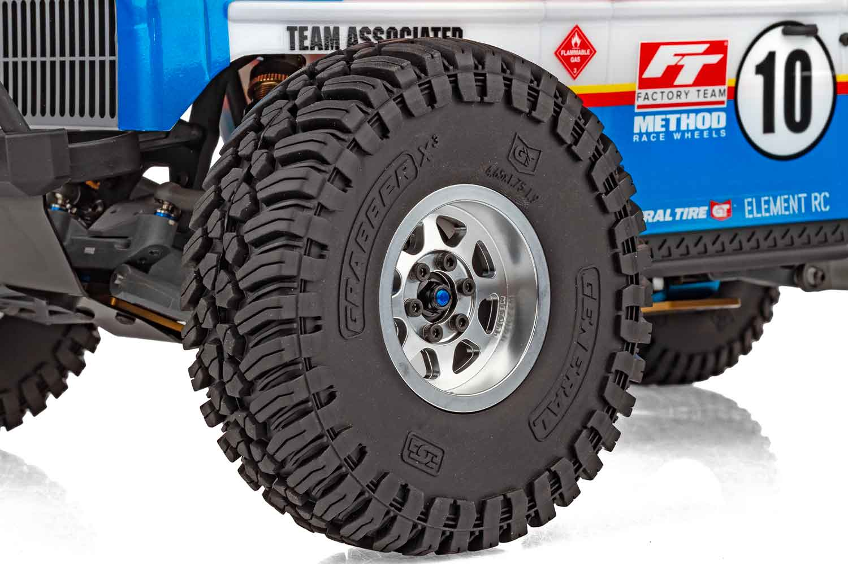

Scale | 1:10
Type | Off-Road
Length | 462mm (18.18”)
Motor or Engine | NOT INCLUDED
Power | Electric
Width | 457.2mm (18”)
Wheelbase | 279.4mm (11”)
Weight | Varies
Chassis | Stamped Steel and Aluminum
Suspension | IFS Front / 4-Link Rear
Internal Gear Ratio | Varies
Drivetrain | 2WD
Tire | 1.9” General Grabber™ A/T X
Speed Control | NOT INCLUDED
Radio | NOT INCLUDED
Servo | NOT INCLUDED
Speed | Varies
Gear Pitch | 48 Pitch
Wheel size | 1.9” Method Beadlocks
Build type | KIT
Shock type | Threaded, Aluminum Shock Bodies
Body | Ecto Cab and Cage
Ball bearings | 24 Metal Ball Bearings
Experience Level | Beginner to Advanced
Recommended Environment | Mother Earth

MORE BODY FEATURES |  | SPECIFICATIONS
- New clear Ecto cab and rear cage body set with
injection-molded fuel cell and radiator details
- New roof-mounted lightbar
- General Tire Grabber X3 tires
- Silver Method beadlock wheels
- Interior and driver figure


RECOMMENDED ELECTRONICS

- Servo: #27179 Reedy Power RT3507A, LP Brushless High-Torque HV Servo
- Battery: #758 Shorty Wolfpack Reedy WolfPack LiPo 3000mAh 30C 7.4V Shorty, with T-plug
- ESC: #27012 Blackbox 600Z-G2 Zero-Timing
Competition ESC
- Motor: #27481 (Sonic 540-SP5 13.5T Brushless Motor)

OTHER HELPFUL ITEMS

• Silicone Shock Fluid (Refer to catalog for complete listings)
• Silicone Diff Fluid (Refer to catalog for complete listings)
• Body Scissors (AE Part # 1737)
• FT Wrench Set (AE Part #1519)
• Hobby Knife
• Needle Nose Pliers
• Wire Cutters
• Soldering Iron
• Calipers or a Precision Ruler



UPC | Part No. | Description | MSRP | MAP | Pieces Per Case | Country of Origin | Available
784695401440 | 40144 | Gaterunner 2WD Kit | $584.99 | $379.99 | 2 | TW | October

Download all zipped photos here: https://rc10.com/GateRunnerImages/ (1.34MB). Link is active for 30 days. Please refer to our MAP Policy here: https://img2c.associatedelectrics.com/pdf/map-policy.pdf
General Grabber™ is a trademark of CONTINENTAL TIRE NORTH AMERICA, INC. CORPORATION

