For Immediate Release: January 2026

RC10B7.1 Kit #90046
1:10 Scale 2WD Electric Off Road Competition Buggy Kit

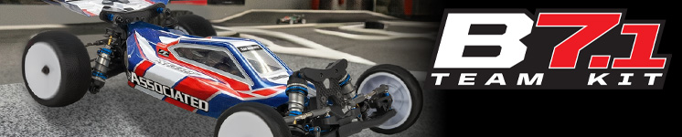

ELECTRIC ■ OFF ROAD ■ 1:10 SCALE ■ 2 WHEEL DRIVE ■ KIT
The Team Associated RC10B7.1 is Engineered for Victory!

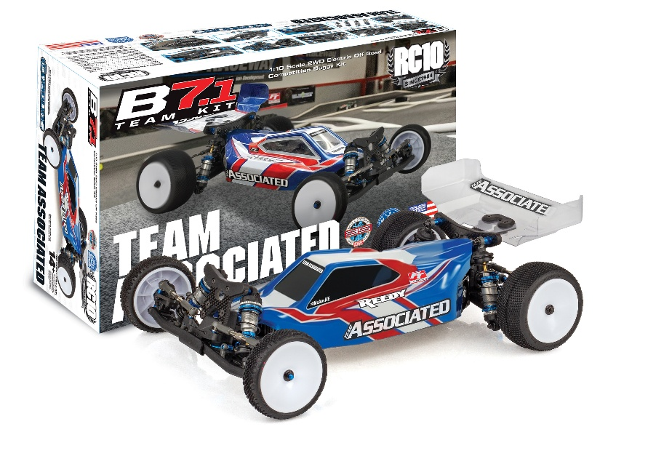

Team Associated has been at the leading edge of 1:10 scale 2WD off road for over 40 years, starting with the original RC10 and are proud to introduce the RC10B7.1. 40 years has seen a lot of development and changes with each generation being a step forward from the last. The RC10B7.1 boasts the new long-arm suspension geometry, weight-centralized electronics layout, KPI adjustable steering blocks, and increased tunability throughout the whole chassis. These innovations have increased the potential for grip and corner speed which leads to faster lap times and an overall smoother drive feel.

The RC10B7.1 is the recommended starting kit for those who plan to race on carpet, astroturf, and some high-grip sealed clay tracks. This kit comes equipped with an
all-new gear differential, front suspension arms with hinge pin brace for improved durability, and an optimized high-grip setup which includes stiffer springs and higher pack shock pistons. As with previous generations, the RC10B7.1 and RC10B7.1D feature fully interchangeable parts between the two kits which allows the user to pick and choose what configuration they want to use depending on track conditions. Both versions come with the same durability, speed, and lineage of a champion of any Team Associated race platform.

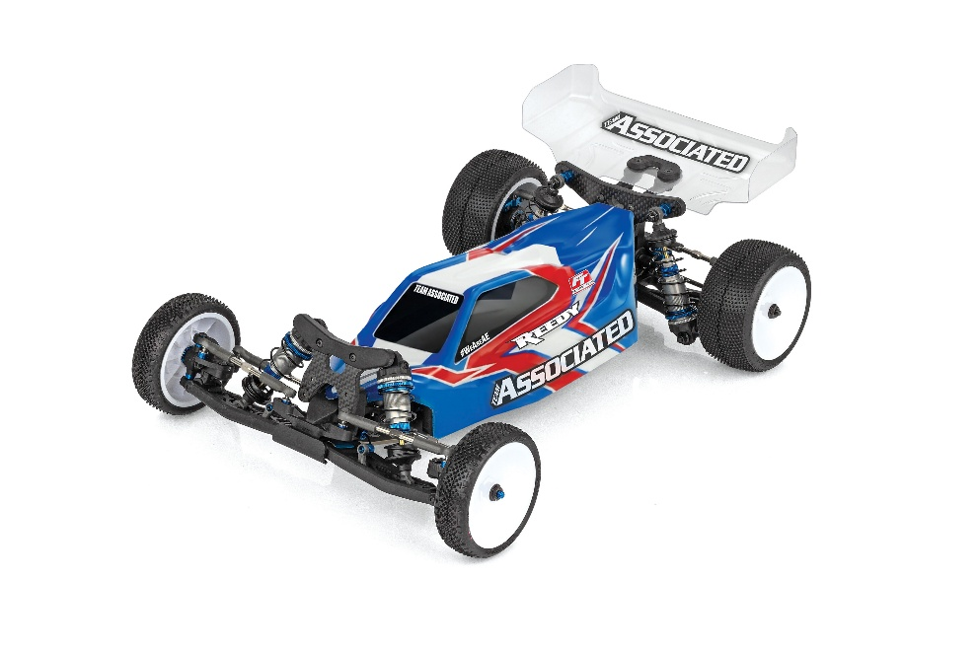

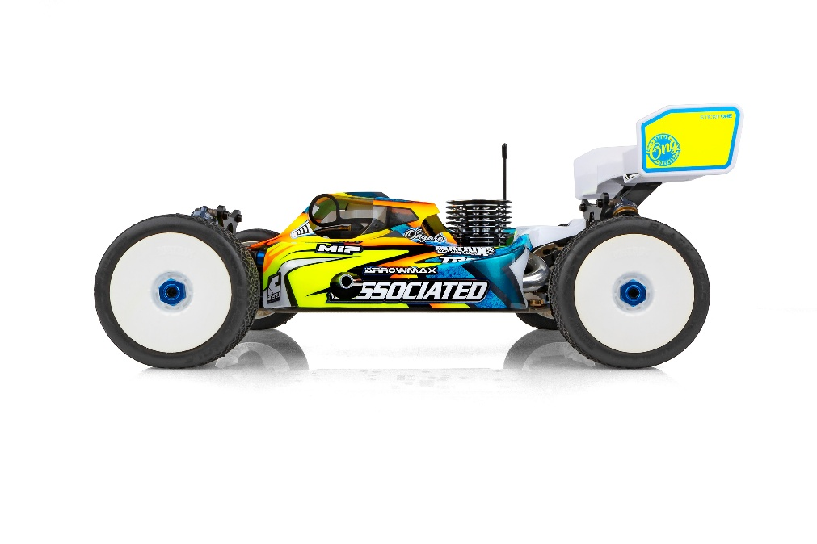

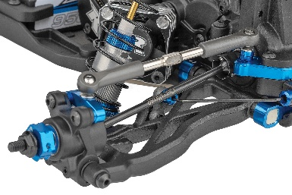
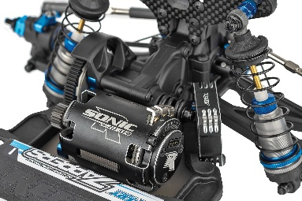
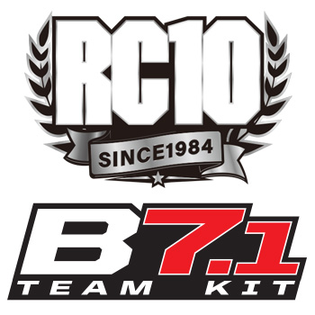

3-Gear Laydown Transmission that maintains original B7 motor position while reducing rotational weight and drag
78mm Rear Suspension Arms and 69mm CVA Bones

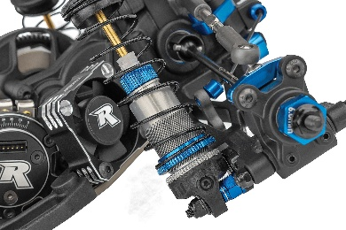
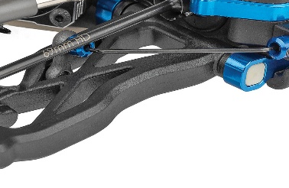
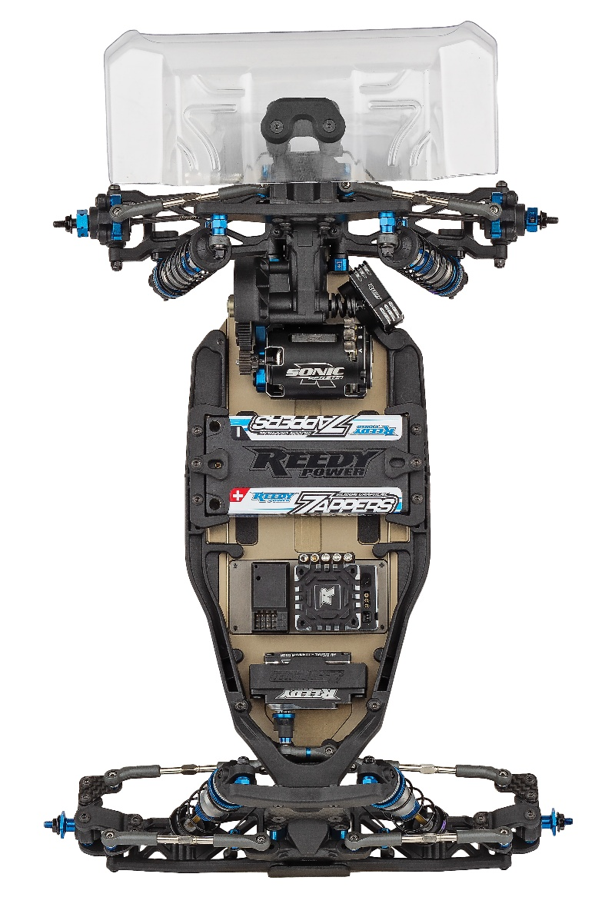

FT Inverted Rear Shock Standoff Set
Front and Rear Anti-Roll Bars and hardware

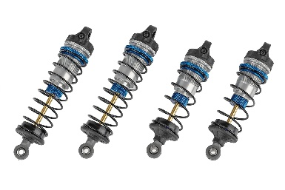
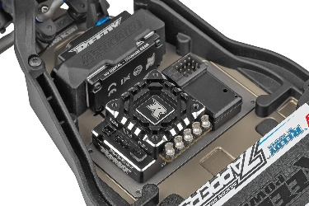
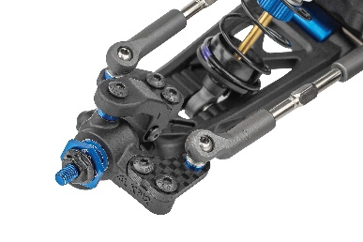

13mm Big-Bore Shocks
7075-T6 Aluminum Chassis with Optional Weight Plate Pockets (Aluminum plate included with both kits)

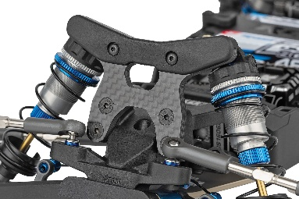

NEW Steering and Caster Block Assembly simplifies assembly and reduces weight without sacrificing tunability
NEW -2mm Front Ballstud Mount included along with updated Top Plate and Standard Ballstud Mount

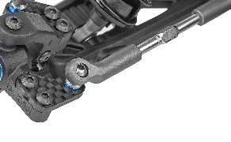
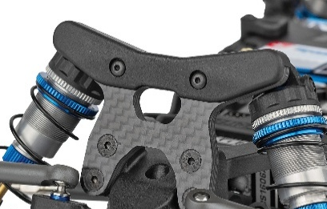

3.5mm Turnbuckles and Ballcups
Shock Tower Covers Front and Rear
Scale | 1:10
Power | Electric
Drive | 2WD
Length (w/Wing): | 390mm/15.4 in.
Width | Varies*
Weight | Varies*
Wheelbase | Varies*
Internal Gear Ratio: | 2.60:1
Type: | Off Road
Chassis: | Machined aluminum
Suspension: | Independent Front and Rear

ITEMS NEEDED TO COMPLETE

- Motor
- ESC
- Servo
- Tires
- Wheels

OTHER HELPFUL ITEMS |  |  | SPECIFICATIONS

- Silicone Shock Fluid (Refer to catalog for complete listings)
- Silicone Diff Fluid (Refer to catalog for complete listings)
- Body Scissors (AE Part # 1737)
- Reamer / Hole Punch
- FT Wrench Set (AE Part #1519)
- Hobby Knife
- Needle Nose Pliers
- Wire Cutters
- Soldering Iron
- Calipers or a Precision Ruler

- Includes 3-Gear Laydown Transmission that maintains original B7 motor position while reducing rotational weight and drag

- NEW Steering and Caster Block Assembly simplifies assembly and reduces weight without sacrificing tunability

- NEW -2mm Front Ballstud Mount included along with updated Top Plate and Standard Ballstud Mount

- NEW Front Suspension Arms with Hinge Pin Brace for improved durability

- -2mm Front Shock Tower and “Gull-Dropper” Rear Shock Tower and Suspension Arm Plates for lower center of gravity

- Includes FT Inverted Rear Shock Standoff Set

- NEW -1-degree Arm Mount “C”

- Includes 78mm Rear Suspension Arms and 69mm CVA Bones

- Includes Front and Rear Anti-Roll Bars and hardware

- Includes High-Volume Gear Differential

- Low-Profile RC10B7 Body, 7-inch Rear Wing, and
2.5-inch Front Wing

- 7075-T6 Aluminum Chassis with Optional Weight Plate Pockets (Aluminum plate included with both kits)

- Shock Tower Covers Front and Rear

- 3.5mm Turnbuckles and Ballcups

- 13mm Big-Bore Shocks

FEATURES |  | SPECIFICATIONS
UPC | Part No. | Description | MSRP | MAP | Pieces Per Case | Origin | Available
784695900462 | 90046 | RC10B7.1 Team Kit | $599.99 | $409.99 | 6 | TW | Jan

Download all zipped photos here: https://www.rc10.com/RC10B71Images/ (7.5MB). Link is active for 30 days.
Please refer to our MAP Policy here: https://img2c.associatedelectrics.com/pdf/map-policy.pdf

