For Immediate Release: August 2026

New! RC10B84 FT FRONT DCV SET, 74mm #92566
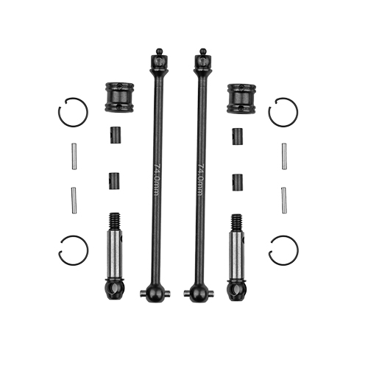
Factory Team introduces the new RC10B84 FT front DCV set, 74mm! This set comes with everything needed to assemble and install on your vehicle. Assembly is made simple by installing the two pins and using a retaining clip to hold the pins in place. The DCV system is a great tuning feature to achieve handling characteristics that cannot be easily replicated through other tuning features on your vehicle. The bones come with a black coat and visible laser etch to confirm you have the correct size. Pair this with a machine ground axle to get a great fit and finish that others will take notice of.

(Pictured left to right: 92566 RC10B84 FT FRONT DCV SET, 74mm)

Compatible with:
90050/90051/90055/90056

UPC | Part No. | Description | MAP | MSRP | Origin | Available
784695925663 | 92566 | RC10B84 FT Front DCV Set, 74mm | $59.49 | $69.99 | TW | 

