For Immediate Release: April 2025

New! Reedy Zappers SG7 Competition HV-LiPo Batteries
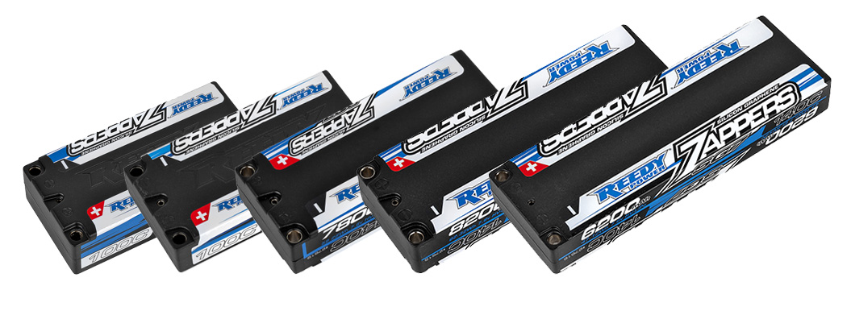

Reedy Power, a leader in high-performance RC battery technology, is thrilled to announce the launch of the all-new Zappers SG7 Competition HV-LiPo battery line. Purpose-built for the demands of hardcore competition, the SG7 delivers class-leading power, consistency, and reliability for the R/C car racing community.

An all-new formulation represents the latest evolution in Reedy’s legendary Zappers HV-LiPo platform. Heavy-duty internal construction, reduced IR, and an inherently flat discharge curve results in explosive acceleration, sustained top speed, and the reliability required to podium at club races, international competitions, and everything in between.

Zappers SG7 batteries are available in five configurations to suit variety of on-road and off-road applications. A high quality, durable hard case helps prevent damage while embedded 5mm socket connectors keep power robbing resistance to a minimum.

“The Zappers SG7 line is the direct result of engineering team pushing the limits of cell technology thanks to input from our racing team and valued customers,” said Rick Hohwart, Reedy Power manager. “We’ve refined every aspect of battery construction to give racers a measurable edge in performance, reliability, and cycle-life. The Zappers SG7 line isn’t just an incremental update; it’s a new benchmark in competition LiPo performance.”

LiPo battery technology continues to evolve and Reedy is committed to bringing improved performance to the masses.

Key features include:

- Increased Capacity with Reduced Internal Resistance: More run time, more power, more speed, more acceleration, more everything!
- Proven Reliability and Cycle-life: Compete with confidence whether racing on a smooth on-road circuit or rutted out dirt track.
- Durable Hard Case with Low-Resistance Connectors: Embedded low-resistance 5mm sockets reduce power-robbing resistance.
- Multiple Competition Specific Configurations: Five configurations are available to suit a variety of on-road and off-road applications.
- ROAR/EFRA/BRCA/IFMAR Approved: See sanctioning body websites for a list of approved models.

Specifications:

Model Number | 27615 | 27616 | 27617 | 27618 | 27619
Capacity | 8200mAh | 6200mAh | 6600mAh | 4800mAh | 7800mAh
Voltage | 7.6V (2S) | 7.6V (2S) | 7.6V (2S) | 7.6V (2S) | 7.6V (2S)
Dimensions (mm) | 139x47x25.1 | 139x47x19.5 | 95x47x25.1 | 96x47x20 | 113x47x25.1
Max. Charge Rate | 16.4A | 12.4A | 13.2A | 9.6A | 15.6A
Discharge Current | 140C | 140C | 100C | 100C | 140C
Weight (g) | 320 | 232 | 220 | 173 | 269
Socket | 5mm | 5mm | 5mm | 5mm | 5mm

UPC | Part No. | Description | MSRP | MAP | COO | Available
784695 276154 | #27615 | Zappers SG7 8200mAh 140C 7.6V Stick | $192.99 | $120.99 | CN | 
784695 276161 | #27616 | Zappers SG7 6200mAh 140C 7.6V ULP Stick | $159.99 | $99.99 | CN
784695 276178 | #27617 | Zappers SG7 6600mAh 100C 7.6V Shorty | $148.99 | $92.99 | CN
784695 276185 | #27618 | Zappers SG7 4800mAh 100C 7.6V LP Shorty | $121.99 | $75.99 | CN
784695 276192 | #27619 | Zappers SG7 7800mAh 140C 7.6V 1:8 Shorty | $187.99 | $117.99 | CN

