For Immediate Release: August 2026

RC28 ZOOM Brian Kinwald RTR #20172

1:28 Scale 2WD Electric Ready-to-Run Buggy
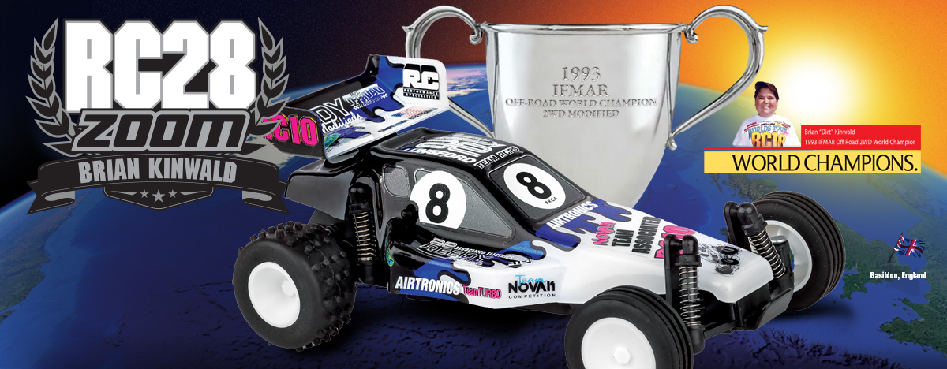
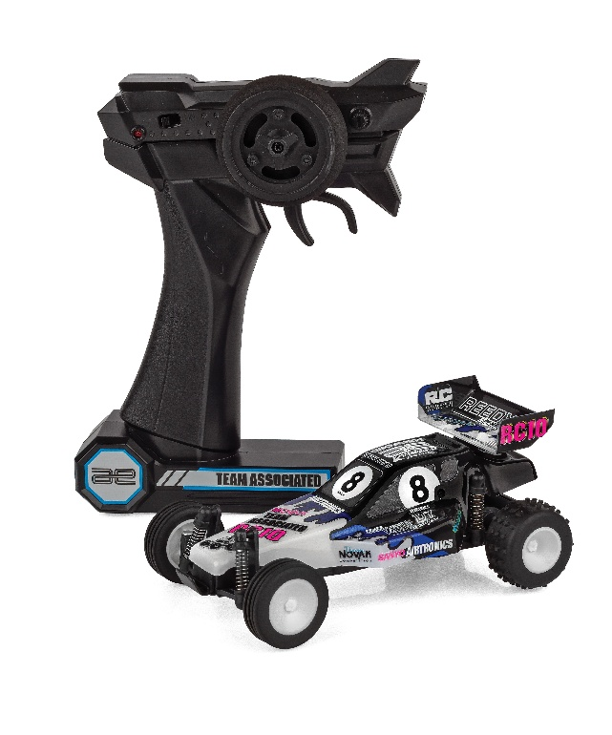
ELECTRIC ■ 1:28 SCALE ■ 2 WHEEL DRIVE ■ READY-TO-RUN
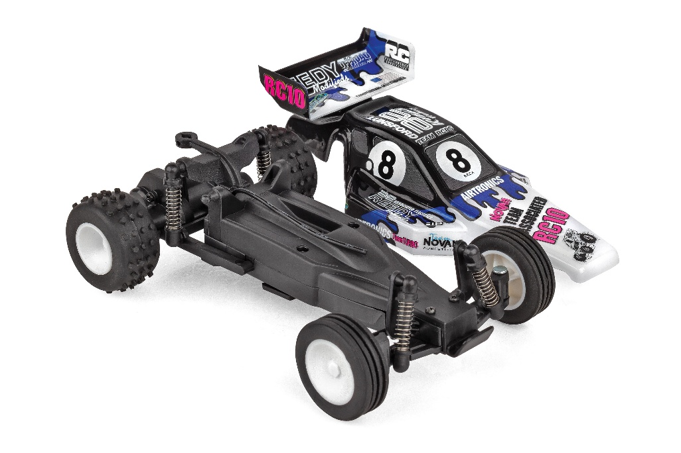
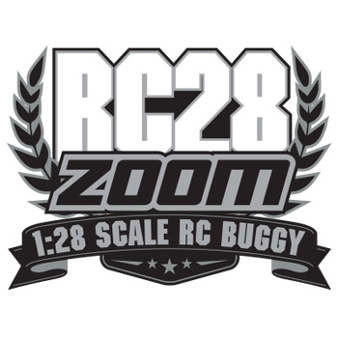
The NEW Team Associated RC28 ZOOM is a scale replica of the iconic RC10 Brian Kinwald Edition Kit! This RC28 ZOOM looks great and drives smooth thanks to a powerful electric motor and capable drivetrain.

The included 2.4 GHz transmitter allows complete control enabling you to navigate around, through and over obstacles with ease! With its off-road stance and rubber tires, the RC28 ZOOM handles like no other vehicle in its category.

The vehicle’s integrated battery is easily recharged with the included USB-C cord. So, the RC28 ZOOM is ready to go right out of the box! Just charge and drive!
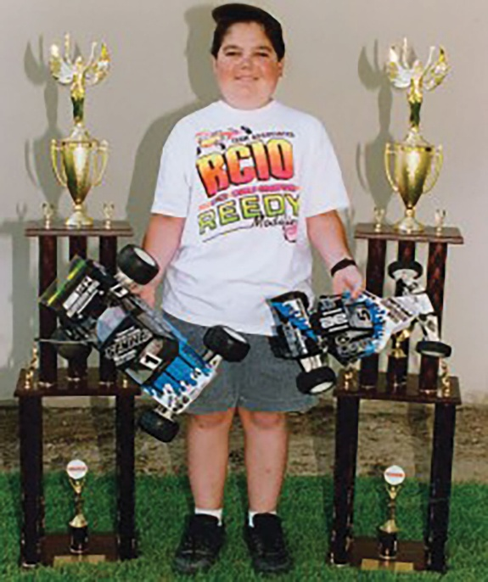
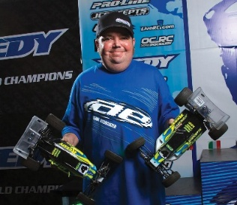
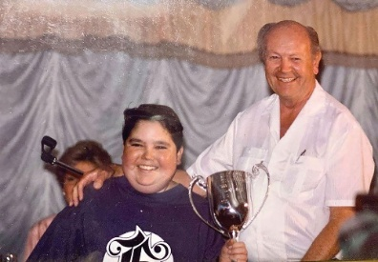
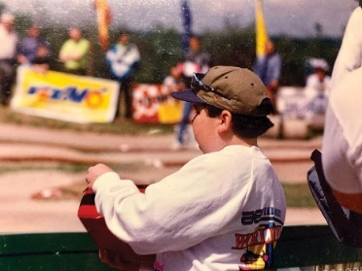
Brian Kinwald: The Racing Icon Who Transformed RC Racing On and Off
the Track
Brian Kinwald is a legendary figure in the world of RC racing, known for his incredible racing accomplishments, technical innovations, and invaluable contributions to the hobby. His career, which began in the late 1980s, saw him rise to prominence through his work with Team Associated, where he became one of the sport’s top drivers and most influential figures.

Kinwald’s racing success is highlighted by his victory at the 1993 IFMAR World Championships in 2WD off-road, which cemented his place as one of the best in the sport. His skill on the track was complemented by his deep understanding of car setup and race strategy, allowing him to excel in a variety of competitive environments. Kinwald’s consistent performances in major events, including multiple National titles, established him as a top contender for over a decade.

As a driver, Kinwald’s contributions extended beyond his success on the track. His deep knowledge of RC car setups and tuning played a significant role in the evolution of RC racing. Working with Team Associated, he helped refine car designs, suspension setups, and drivetrains, enabling better performance and handling. His influence led to advancements in car reliability, responsiveness, and overall speed, shaping the modern RC car as we know it today.

Off track, Kinwald was an active mentor and advocate for the RC racing community. His willingness to share knowledge, experiment with new technologies, and collaborate with fellow racers helped foster the growth of the hobby. Through his achievements, innovation, and passion for RC racing, Brian Kinwald left an enduring legacy that continues to inspire new generations of enthusiasts. His influence within the Team Associated family and the broader RC racing world remains immeasurable.

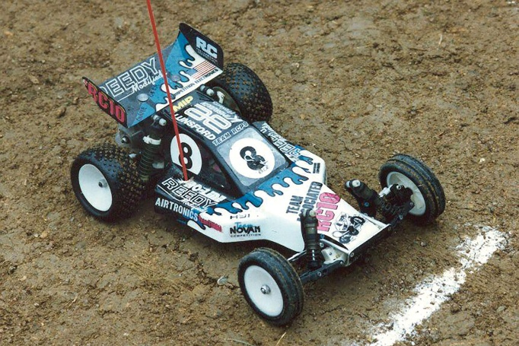
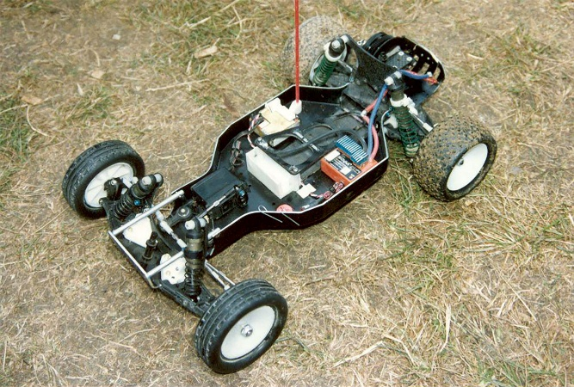

• 2.4GHz transmitter Included
• Included USB-C charging cord to charge
integrated battery
• Fully pre-printed and decaled RC10 buggy
replica body
• Realistic wheels and rubber tires
• Everything included in the box -- just charge and go!

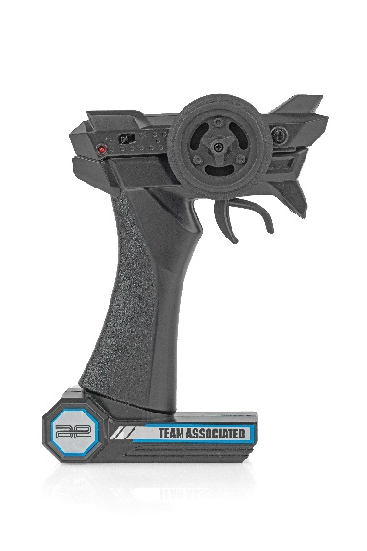

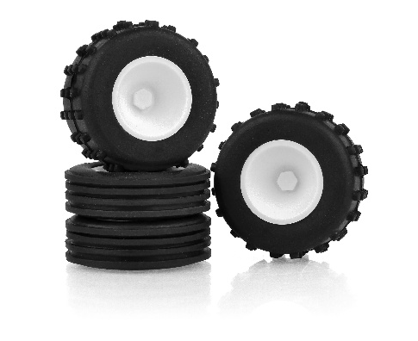

*This vehicle is fully assembled and ready to run right out of the box. Some models may require a battery and/or charger.

FEATURES
  SPECS

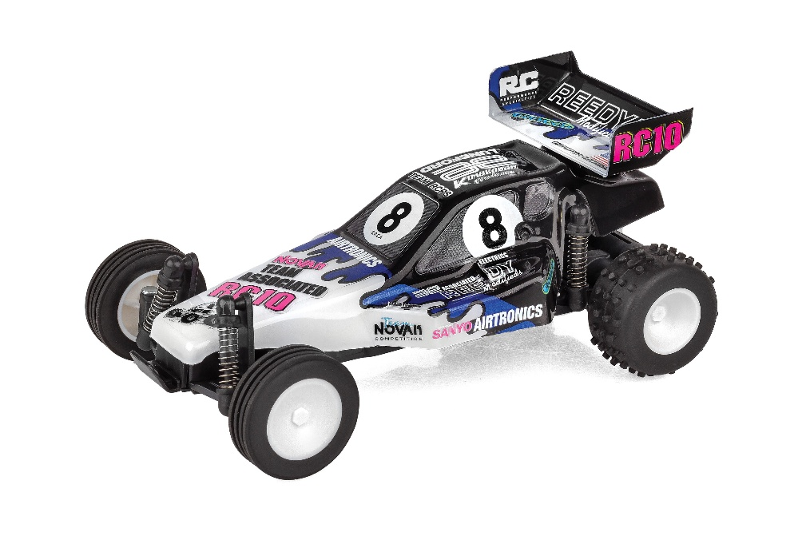

Scale | 1:28
Body Style: | Buggy
Power | Electric
Length | 143mm (5.63in)
Width | 86mm (3.39in)
Weight | 76.2g (0.17lbs)
Wheelbase | 101.5mm (4in)
Drivetrain | 2WD
Assembly Level: | Ready-To-Run*
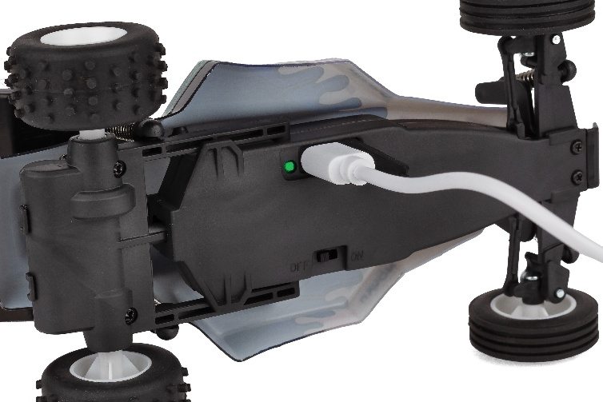

CATALOG INFORMATION

UPC | Part No. | Description | MSRP | MAP | Pieces Per Case | Origin | Available
784695201729 | 20172 | RC28 Zoom Brian Kinwald RTR | $69.99 | $44.99 | 12 | CN | September

Download all zipped photos here: https://rc10.com/RC28ZOOMBKImages/ (5.6MB). Link is active for 30 days.
Please refer to our MAP Policy here: https://img2c.associatedelectrics.com/pdf/map-policy.pdf

