For Immediate Release: June 2026

PRO2 SC10 SWB Contender Body #72125

Team Associated is proud to present the Pro2 SC10 SWB Contender Body! This body comes in clear
for you to personalize it the way you want it. This serves to better distinguish your vehicle from others when driving around. The LT10 and DK10 are also directly compatible with this body and will not require any extra hardware.
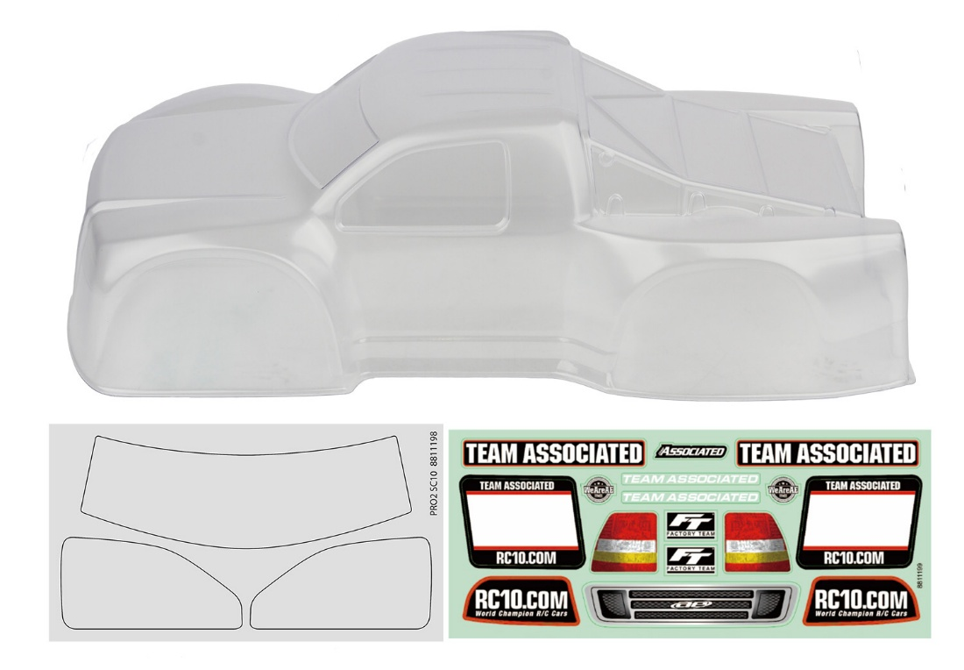

(Pictured: #72125 PRO2 SC10 SWB Contender Body)

Compatible with:
70040/70041/70023/70023C/70031/70031C/70022/70022C/90039/90039C/90038/90038C/90052
UPC | Part No. | Description | MAP | MSRP | Origin | Available
784695721258 | 72125 | PRO2 SC10 SWB Contender Body, Clear | $49.99 | $58.81 | TW | 

