For Immediate Release: February 2026

RC10T7 & RC10SC7 FT Chassis Protectors
Factory Team proudly introduces chassis protectors for the RC10T7 and RC10SC7! These protectors are precisely cut to fit your vehicle and have a nice design very similar to other Team Associated RC10 chassis protectors. These protectors ensure minimal damage going over rough terrain and also have the benefit of keeping your screw heads clean.
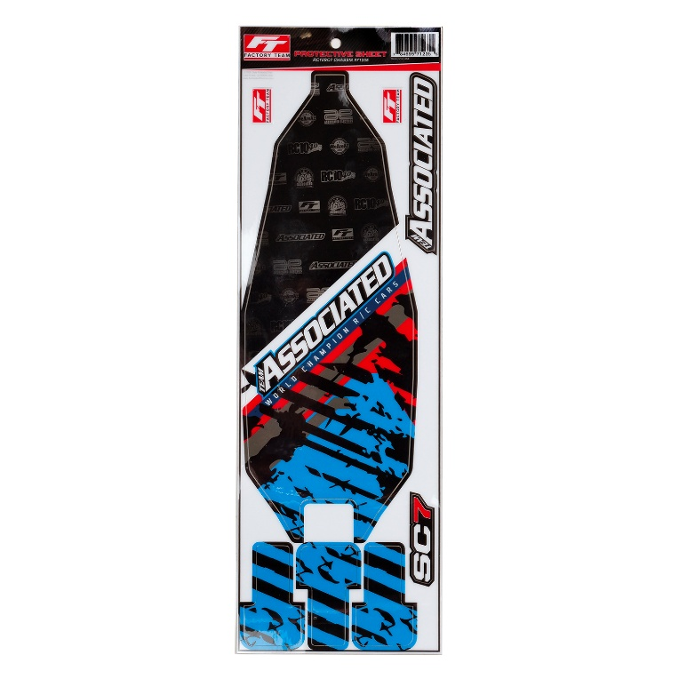
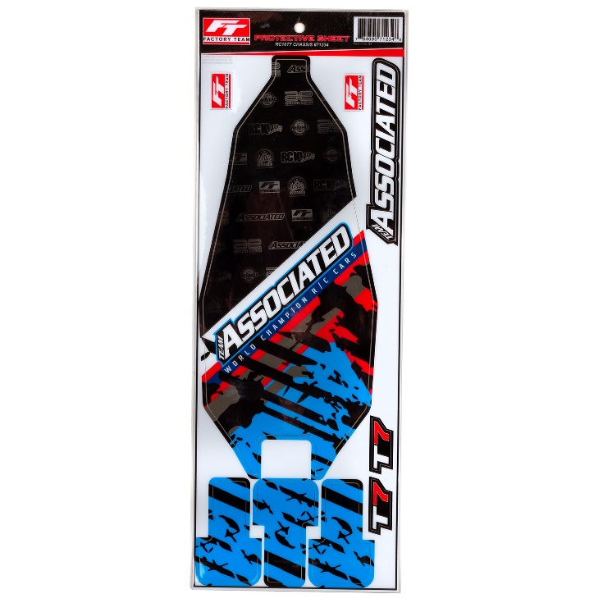

#71234 RC10T7 FT CHASSIS PROTECTOR
Compatible with:
RC10T7
#71235 RC10SC7 FT CHASSIS PROTECTOR
Compatible with:
RC10SC7

UPC | Part No. | Description | MAP | MSRP | Origin | Available
7846950712348 | 71234 | RC10T7 FT Chassis Protector | $14.44 | $16.99 | US | 
7846950712355 | 71235 | RC10SC7 FT Chassis Protector | $14.44 | $16.99 | US

