For Immediate Release: December 2025

New FT Rear Hubs for off-road
racing platforms
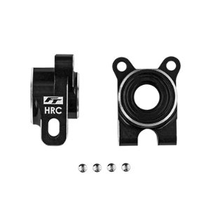
#92562, 92563, 92564, 92565
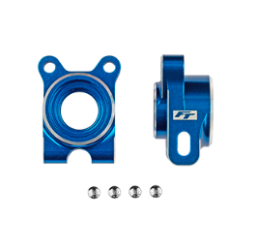
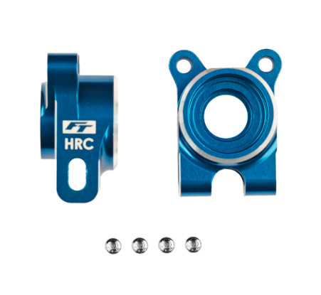
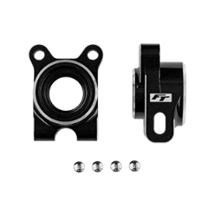

#9256592562
#9256492562
#92562
#9256392562
(Pictured: #92562, 92563, 92564, 92565 FT aluminum rear hubs, -4 offset)

Factory Team introduces the new FT aluminum rear hubs, -4 offset! These hubs serve as a direct replacement for the plastic -4 rear hubs (#92518 and #92519). For use on buggy platforms, be sure to pair these with the appropriate 81mm arms (#92516), 71mm CVA bones (#92549), and B74 CVA axle (#92207). With the trucks you can simply install them because the appropriate CVA bones and axles come in the kit. The benefits of the aluminum hubs are the added rigidity and weight difference. The weight difference is a nice tuning option for those that want to change the amount of unsprung weight. These hubs are offered in both blue or black in your choice of standard or HRC geometry.

Compatible with:
90041/90042/90050/90051/70005/70010

UPC | Part No. | Description | MAP | MSRP | Origin | Available
784695925625 | 92562 | RC10B7 FT Aluminum Rear Hubs, -4 Offset, Blue | $42.49 | $49.99 | TW | 
784695925632 | 92563 | RC10B7 FT Aluminum Rear Hubs, -4 Offset, Black | $42.49 | $49.99 | TW
784695925649 | 92564 | RC10B7 FT Aluminum Hrc Rear Hubs, -4 Offset, Blue | $42.49 | $49.99 | TW
784695925656 | 92565 | RC10B7 FT Aluminum Hrc Rear Hubs, -4 Offset, Black | $42.49 | $49.99 | TW

