**For Immediate Release:** **August 2025**

**#** **72277 DC10 FT Aluminum Steering Blocks**

**#** **72278 DC10 FT Aluminum Hubs**

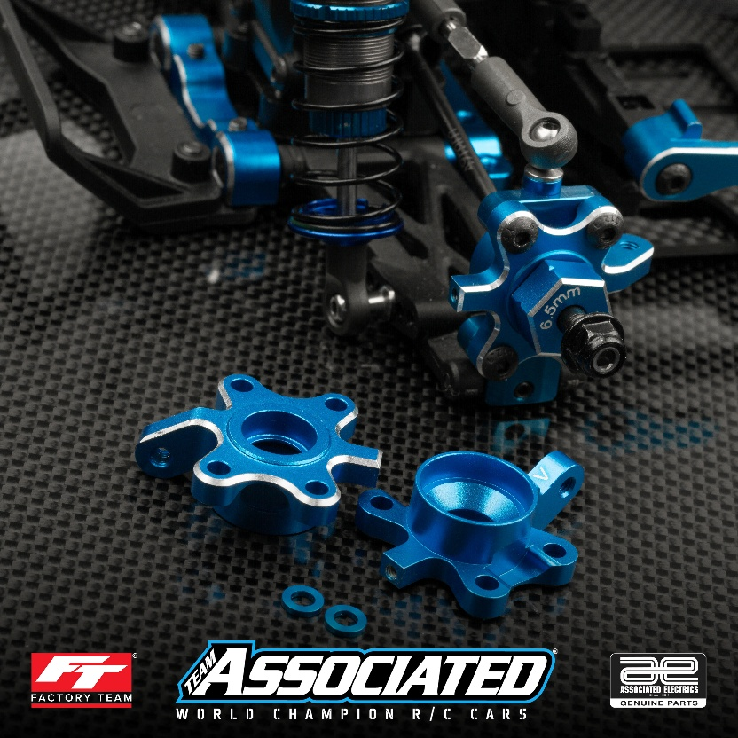

(Pictured: #72278 DC10FT Aluminum Hubs)

(Pictured: #72277 DC10 FT Aluminum Steering Blocks)

Factory Team is proud to introduce two new parts for the DC10, the FT Aluminum Steering Blocks and FT Aluminum Hubs! The FT aluminum steering blocks offer minimal amount of material inside the wheel while still allowing for many tunable features. Both parts offer a stylish look paired with thinner steering arms by one millimeter on each side. This allows for more tuning options when it comes to adjusting steering feel. Arrows are conveniently laser etched on both parts to denote whether the steering arm is in the high or low position.

**Compatible with:** DC10

|  |  |  |  |  |  |  |
| --- | --- | --- | --- | --- | --- | --- |
| **UPC** | **Part No.** | **Description** | **MAP** | **MSRP** | **Origin** | **Available** |
| 784695722774 | 72277 | DC10 FT Aluminum Steering Blocks | $33.99 | $39.99 | CH | [button-buy-now-200px](https://60years.associatedelectrics.com/dc10-ft-aluminum-steering-blocks/) |
| 784695722781 | 72278 | DC10 FT Aluminum Hubs | $34.84 | $40.99 | CH | [button-buy-now-200px](https://60years.associatedelectrics.com/dc10-ft-aluminum-hubs/) |