For Immediate Release: September 2026

NEW! Reedy Power Magnetic Power Bank
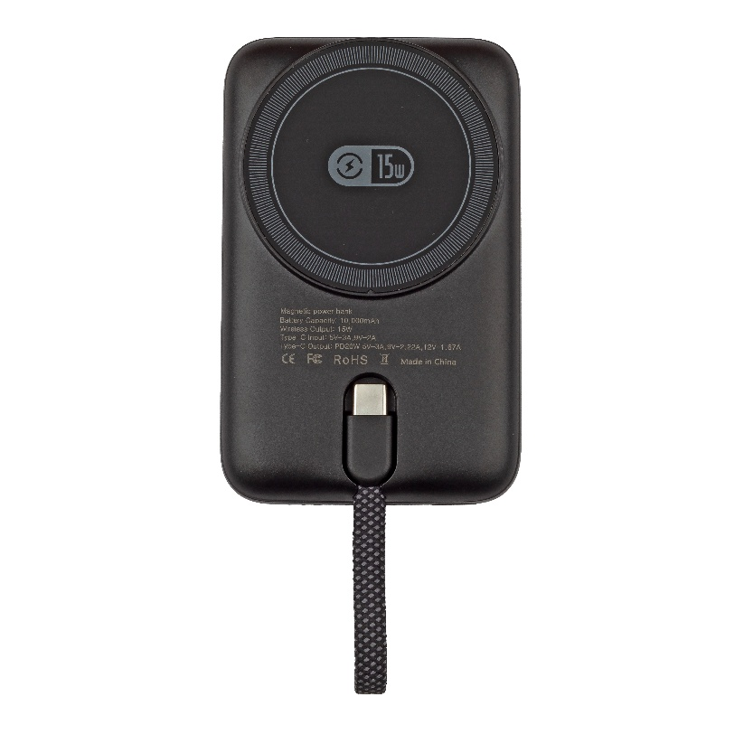
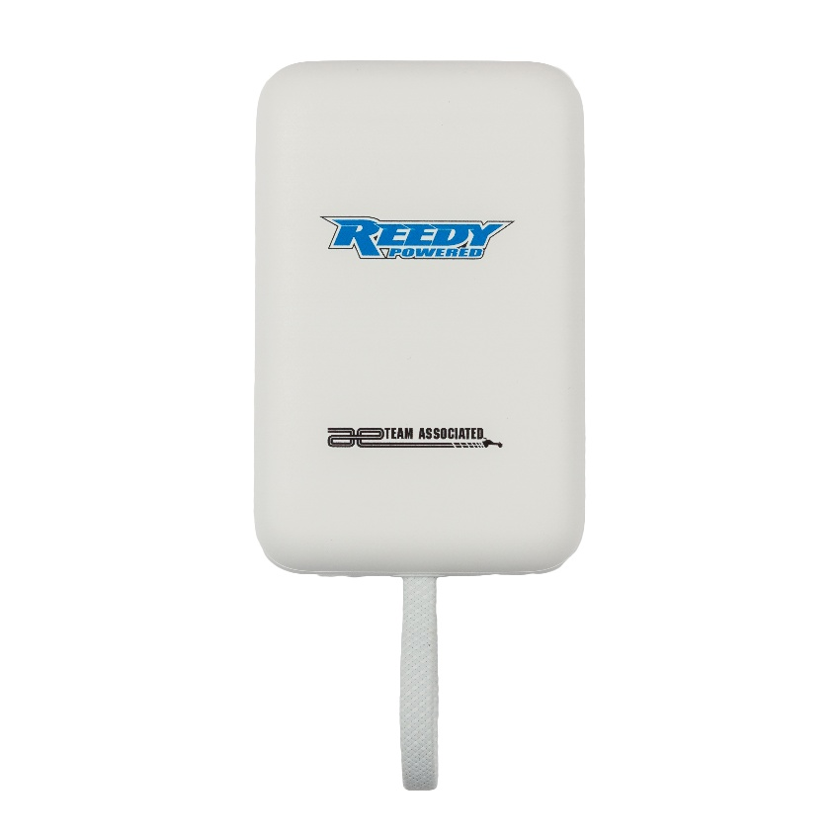

(Pictured: White (#97243) & Black (#97244) Reedy Power Magnetic Power Bank)

Reedy Power’s championship pedigree doesn’t just apply to competition level RC cars. Now, Reedy Power is here to enhance your mobile devices! Presenting the Reedy Power Magnetic Power Bank, available in White (#97243) and Black (#97244).
Offering 10,000mAh of charging capacity, you can charge your mobile device using the Power Bank’s magnetic dock or USB-C cable. You recharge the Power Bank itself via USB-C input on the side of the Power Bank (charging cable and power supply not included).
Charge your mobile device using the same brand that’s won 30 IFMAR World Championships. Reedy Power will keep your mobile device up and running, regardless of your location!

For more information, visit www.reedypower.com or contact your local hobby shop.

Specifications:
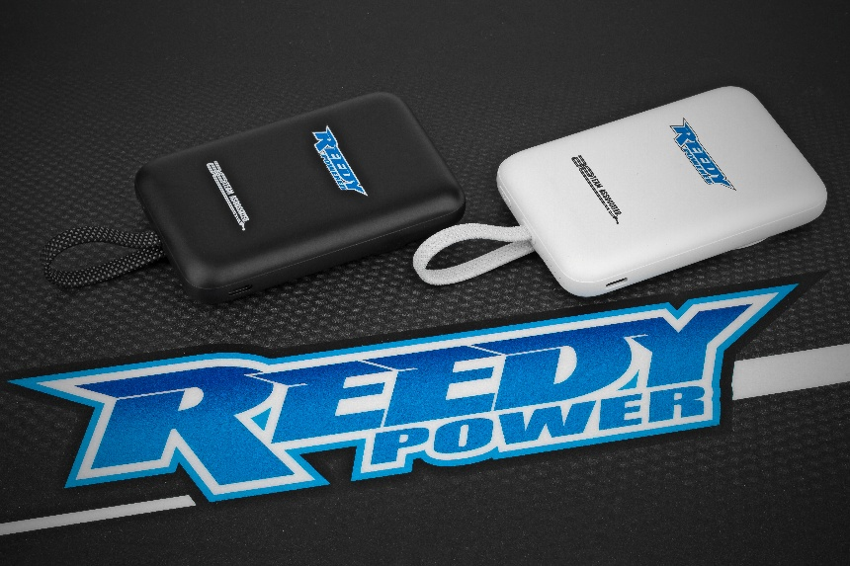
Battery Capacity: | 10,000mAh
Wireless Output: | 15W
Dimensions: | 105.2mm x 69mm x 14.8mm
Type-C Input: | 5V-3A, 9V-2A
Type-C Output | PD20W 5V-3A, 9V-2.22A, 12V-1.67Z

UPC | Part No. | Description | COO | MSRP | MAP | Available
784695972438 | 97243 | REEDY POWER Magnetic Power Bank, White | CN | $29.99 | $19.99 | 
784695271807 | 97244 | REEDY POWER Magnetic Power Bank, Black | CN | $29.99 | $19.99

