

**For Immediate Release: 2025**

**Parts for the RC10 Graphite Kit**

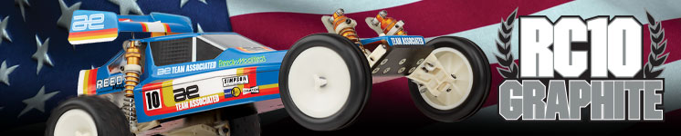

Parts for the # **6030** RC10 Graphite Kit

|  |  |  |  |  |  |  |  |
| --- | --- | --- | --- | --- | --- | --- | --- |
| UPC | Part No. | Description | Origin | MSRP | MAP | S, O, A | Available |
| 784695061736 | 6173 | RC10 Protech II Body, Clear | TW | $34.99 | $29.74 | S | Now |
| 784695061828 | 6182 | High Down-Force Wing, 5 1/2 in | TW | $10.99 | $10.99 | S | Now |
| 784695062047 | 6204 | RC10 Front Wide Suspension Arms, White | TW | $16.99 | $14.44 | S | Now |
| 784695062061 | 6206 | RC10WC Front Wide Suspension Arms, Black | TW | $16.99 | $14.44 | S | Now |
| 784695062177 | 6217 | RC10 inline steering blocks | TW | $14.99 | $14.99 | S | Now |
| 784695062184 | 6218 | RC10 Inline Front Axles | TW | $9.99 | $9.99 | S | Now |
| 784695062337 | 6233 | RC10 Graphite Kit, Front Shock Tower | TW | $11.99 | $11.99 | S | Now |
| 784695063228 | 6322 | RC10 Motor Guard, Gold | TW | $16.99 | $14.44 | S | Now |
| 784695063716 | 6371 | RC10 CVA Set, 3/16 in. Axle | TW | $46.99 | $39.94 | S | Now |
| 784695063761 | 6376 | RC10 Universals | TW | $40.99 | $34.84 | S | Now |
| 784695064164 | 6416 | FT Gold Shock Shaft, 1.32 in stroke | TW | $12.99 | $12.99 | O | Now |
| 784695064171 | 6417 | FT Gold Shock Shaft, 1.02 in stroke, front | TW | $12.99 | $12.99 | O | Now |
| 784695064188 | 6418 | FT Gold Shock Shaft, .71 in stroke | TW | $12.99 | $12.99 | O | Now |
| 784695064355 | 6435 | FT Hard Anodized Rear Shock Bodies, 1.32 in | TW | $19.99 | $16.99 | O | Now |
| 784695064362 | 6436 | FT Hard Anodized Shock Bodies, front, 1.02 in | TW | $19.99 | $16.99 | O | Now |
| 784695064379 | 6437 | FT Hard Anodized Shock Bodies, 0.71, | TW | $19.99 | $16.99 | O | Now |
| 784695064430 | 6443 | Bleeder Shock Caps, 1:10 | TW | $10.99 | $10.99 | S | Now |
| 784695065857 | 6585 | RC10 Clutch Disks | TW | $7.99 | $7.99 | S | Now |
| 784695068063 | 6806 | RC10 One-Piece Rear Wheels, 2.0"" | TW | $9.99 | $9.99 | S | Now |
| 784695068223 | 6822 | RC10 Rear Tires, 2.0"" | TW | $21.99 | $18.69 | S | Now |
|  |  |  |  |  |  |  |  |
|  |  |  |  |  |  |  |  |
|  |  |  |  |  |  |  |  |

S = Spare Part. A replacement for the same part that comes with the vehicle.

O = Optional. A part that does not come with the vehicle.

A = A tool or part to help build or set up the vehicle.

