For Immediate Release: November 2025

RC10T 4WD Kit #6048
1:10 Scale Electric 4WD Competition Off-Road Truck Kit

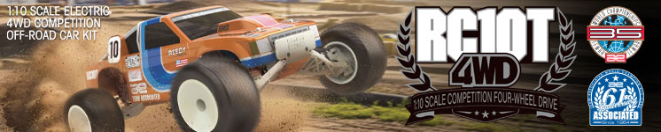

ELECTRIC ■ OFF ROAD ■ 1:10 SCALE ■ 4WD ■ KIT
IT STARTED FROM THE BEGINNING!
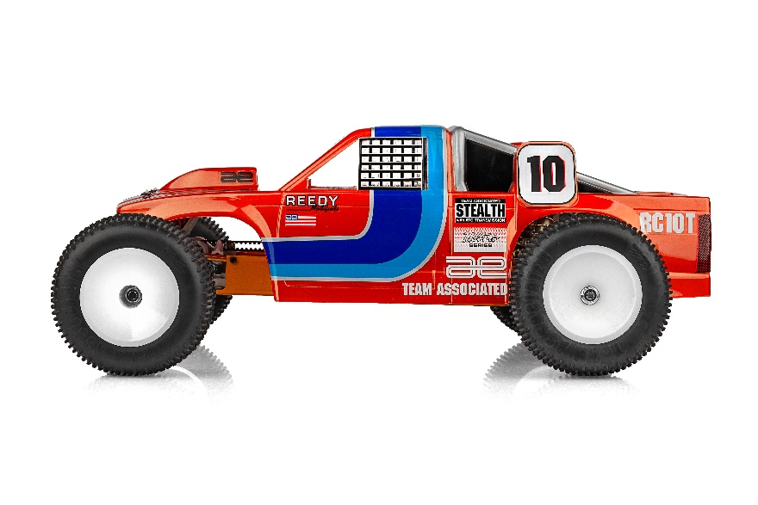

Going all the way back to 1985 at the very first IFMAR Off Road World Championships, Team Associated had always been interested in entering the 4WD buggy market. That’s why at that race, in Del Mar, California, Jay Halsey drove a prototype 4WD RC10. After taking first place in the 2WD Stock class earlier that day, Jay was poised to take first in the 4WD class as well. As fate would have it though, Jay finished a close second driving that prototype 4WD RC10 buggy. It wouldn’t be until many years later that Team Associated would finally produce a 4WD off road kit, the B44. To fill in the gap between that first IFMAR Off Road Worlds and the release of the B44, many aftermarket companies designed and produced their own RC10 4WD conversion kits. With the release of the Team Associated RC10 4WD kit you no longer have to piece a 4WD buggy together and hope everything fits. With our genuine Team Associated parts, everything you need comes in one box!

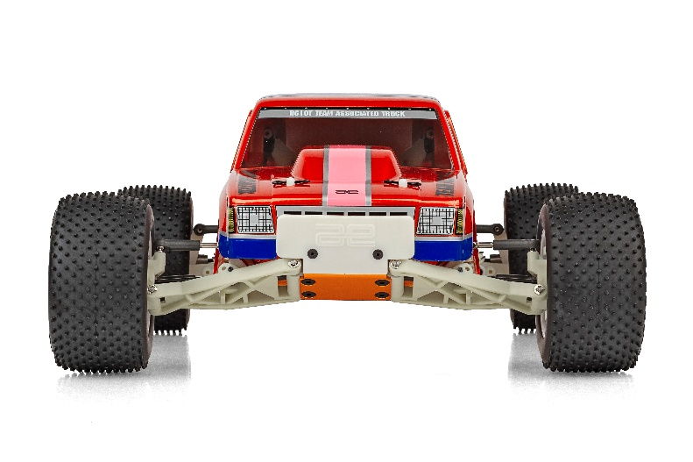

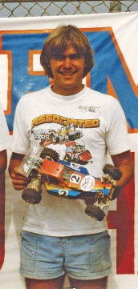
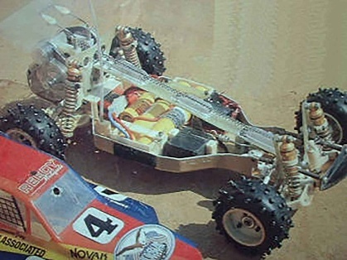

Building on the success and innovation of the RC10 4WD, Team Associated took things a step further with the introduction of the RC10T 4WD. This all-new truck evolved directly from the proven RC10 4WD platform, sharing its advanced drivetrain, suspension geometry, and durable construction while expanding into the stadium truck class. The RC10T 4WD combines the classic styling and rugged spirit of the original 1991 RC10T with the cutting-edge performance and engineering of the RC10 4WD, creating a versatile, race-ready machine designed for today’s off-road tracks.

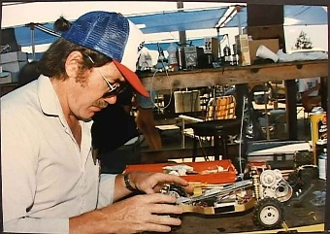

Iconic Stadium Truck Heritage Meets Innovation

This new truck combines the tough, race-proven DNA of the original RC10 buggy and RC10 4WD with design cues and handling characteristics that pay tribute to the original RC10T. The result is a 1:10-scale 4WD stadium truck that delivers maximum traction, speed, and control—ready to dominate dirt, clay, and turf tracks alike. Featuring advanced suspension geometry, optimized weight balance, and rugged drivetrain components, the RC10T 4WD is built for serious racers and vintage enthusiasts alike.
The all-new Team Associated RC10T 4WD marks the exciting return of one of the most legendary names in off-road RC history. Originally debuting in 1991, the RC10T was Team Associated’s first stadium truck—setting new performance standards and helping define what competitive RC truck racing would become. Now, more than three decades later, the RC10T 4WD revives that iconic legacy with a modern twist, blending the soul of the original with cutting-edge engineering from the RC10 4WD platform.
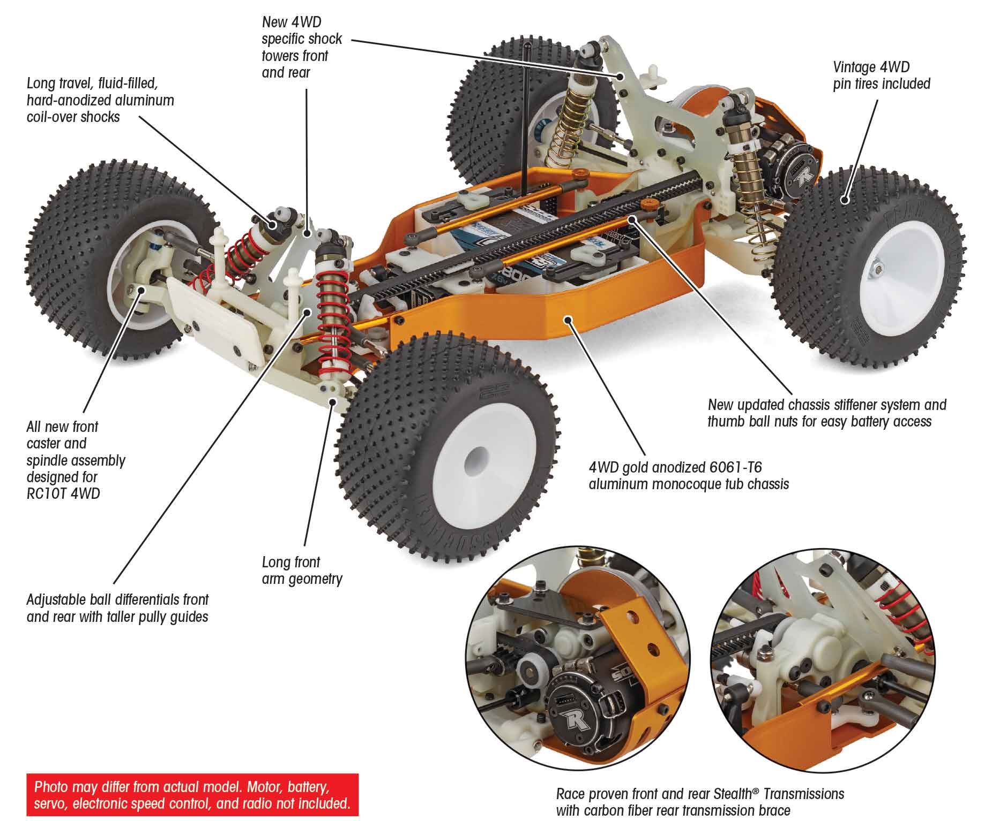

A fully adjustable four-wheel independent suspension system, featuring an all-new front caster and spindle assembly designed specifically for the vintage 4WD platform, 3.5mm turnbuckles, heavy-duty metric ball studs, and long-travel, fluid-filled, hard-anodized aluminum coil-over shocks, provides superior handling and control on any surface.
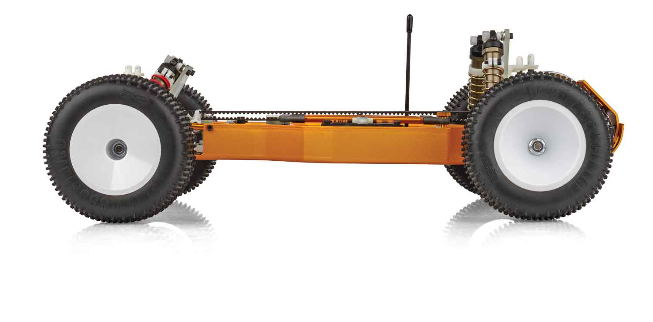
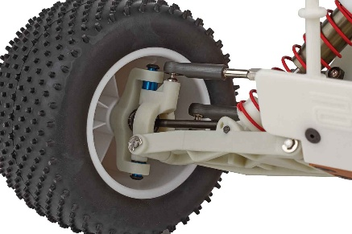

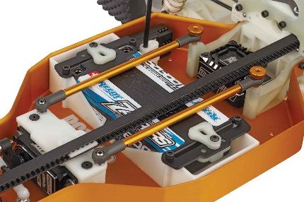
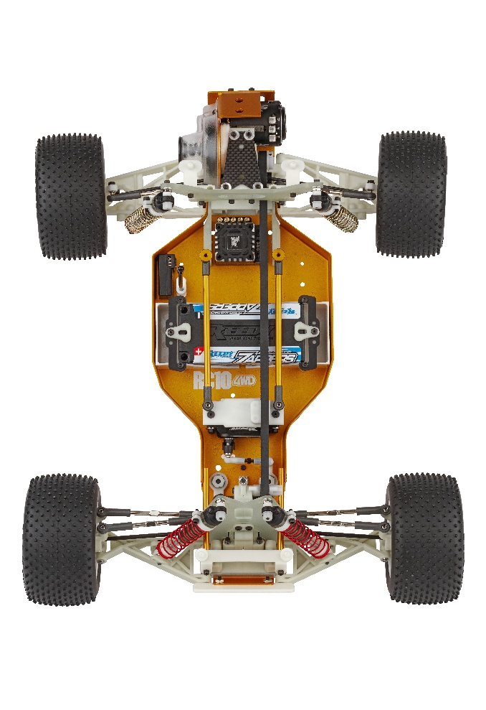
THE LEGEND JUST GOT BETTER
A COMPLETE 4WD RC10T KIT

The iconic RC10T is now available as a 4WD race truck with everything included in one box. No need for a conversion kit or sourcing rare parts. Build a high-performance race truck from the 90s that is meant to be raced, using the latest electronics of your choice (electronics not included; fits 6-cell NiMh and 2S LiPo batteries).

This kit includes clear polycarbonate RC10T stadium truck body, full ball bearings, CVA driveshafts, vintage front and rear 4WD pin tires, all on a gold anodized 6061-T6 monocoque tub chassis.

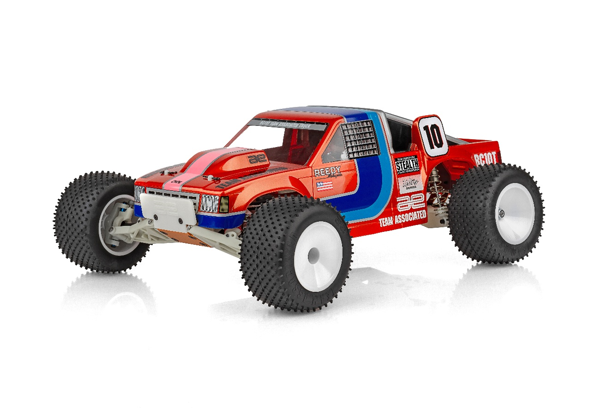

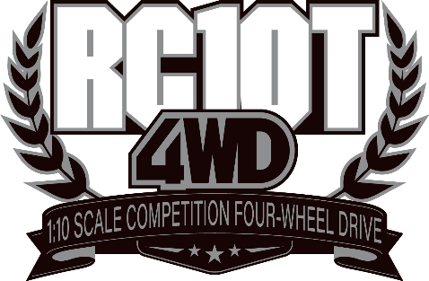

FEATURES
- Gold anodized 6061-T6 aluminum monocoque 4wd tub chassis
- Gold anodized nose plate and motor plate
- Exclusive Gold anodized nose tubes
- New Gold anodized aluminum chassis stiffeners
- New designed gold anodized thumb nuts
- New larger diameter pulley flanges (front)
- New servo mount and belt guide system
- New red front shock springs
- Fully adjustable four-wheel independent suspension
- Long travel, fluid-filled, hard-anodized aluminum coil-over shocks
- Race proven front and rear Stealth transmissions
- Adjustable ball differentials front and rear
- Exceptional ground clearance with low center of gravity
- Vintage stadium truck spike tires included

- Clear RC10T body included
- Precision bearings throughout
- Fits 6-cell NiMh and 2S LiPo battery packs
- Adjustable heavy duty 3.5mm turnbuckles and ball cups all around
- New Front and rear stadium truck CVA driveshafts
- Durable, longer low friction center belt and tension system for stadium truck
- Long arm stadium truck geometry
- New front caster block for stadium truck
- Updated rear bulkhead and chassis stiffener
- Carbon fiber rear transmission brace
- HD Metric Ball Studs throughout
- One piece stadium truck wheels all around
- Race Proven V2 Slipper Clutch System
- 4wd specific worlds style bell crank system

ITEMS NEEDED TO COMPLETE |  | SPECIFICATIONS
- 6-cell NiMH or 2S LiPo for radio-controlled car
- Radio control battery charger
- 1:10 scale radio control electronic speed control
- 1:10 scale 540-size electric RC car motor
- 2-channel RC surface transmitter and its batteries
- 2-channel receiver
- Pinion gear
- Steering servo
- Lexan paint for body
- Glue for tires.
- Tools

Scale | 1:10
Power | Electric
Length | 396.7mm (15.62in)
Width | 317.5mm (12.5in)
Weight | Varies
Wheelbase | 292.1mm (11.5in)
Internal Ratio | 2.25:1
Power Source | Electric
Terrain: | Off-Road
Assembly Level | Kit
Drive | 4WD
Body Style | Truck

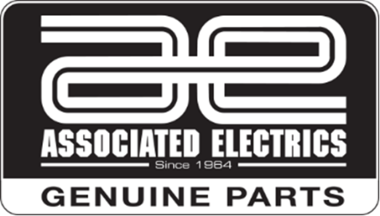

CATALOG INFORMATION

UPC | Part No. | Description | MSRP | MAP | Pieces Per Case | Origin | Available
784695060487 | 6048 | RC10T 4WD KIT | $675.99 | $459.99 | 6 | TW | December
Download all zipped photos here: https://www.rc10.com/RC10T4WDImages/ (2.8MB). Link is active for 30 days.
Please refer to our MAP Policy here: https://img2c.associatedelectrics.com/pdf/map-policy.pdf

