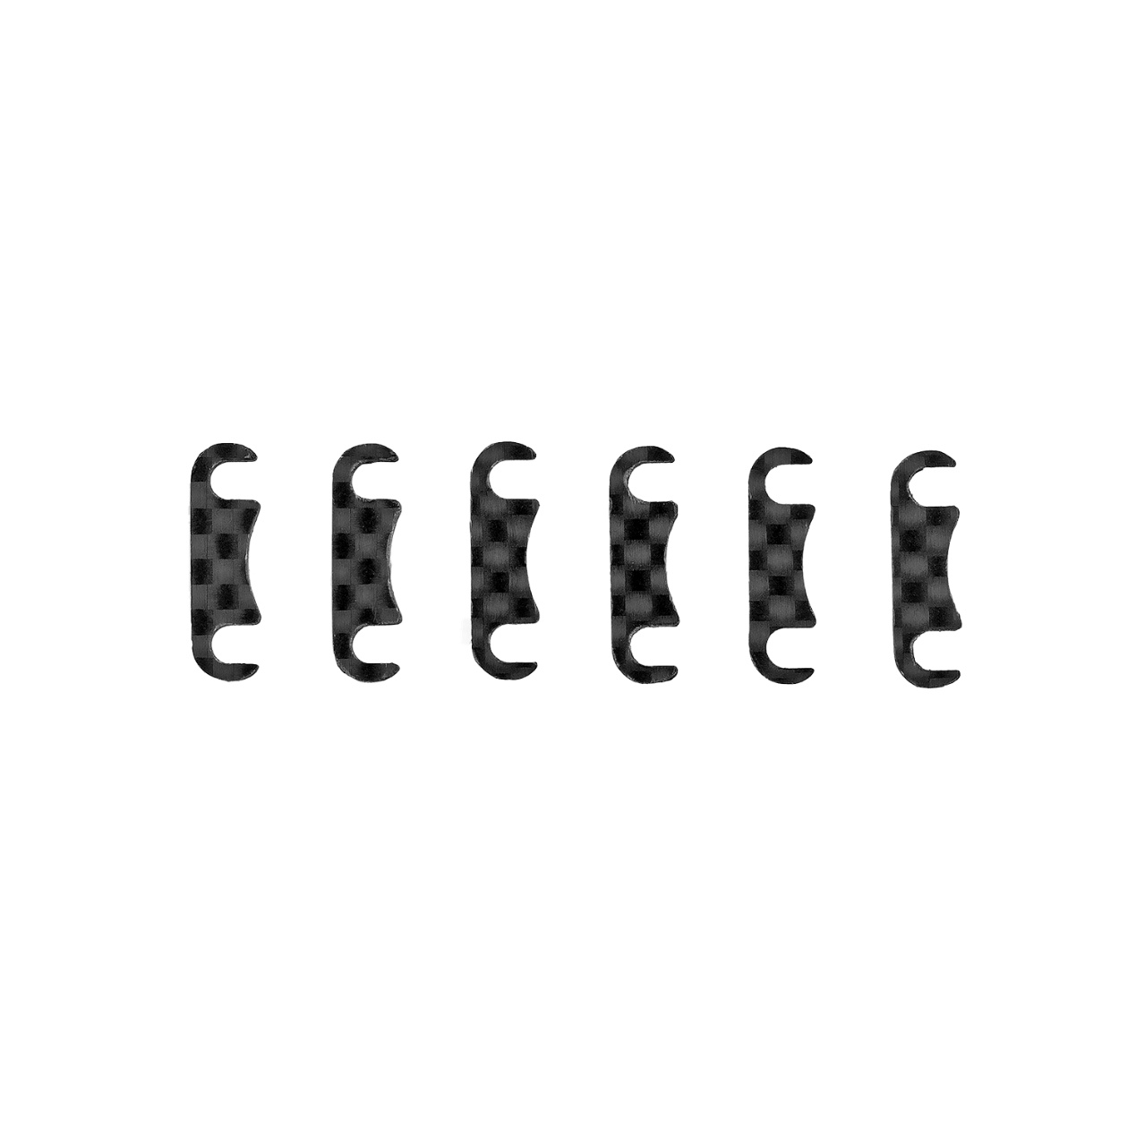
For Immediate Release: November 2025

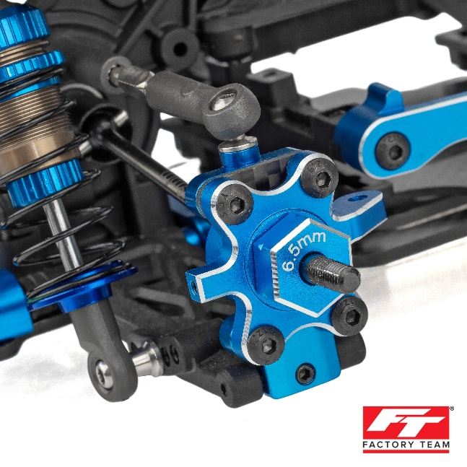
#72283 DC10 FT CARBON FIBER HUB LINK SHIM SET

(Pictured: DC10 FT CARBON FIBER HUB LINK SHIM SET)

Introducing the new DC10 FT carbon fiber hub link shim set! These shims are used to space the hub away from your hub link mounts to change roll center and provide a different feel on track. This product is conveniently slotted so that you can simply loosen the screws to put them in or take them out.

Compatible with:
30133/ 30133C/ 30134

UPC | Part No. | Description | MAP | MSRP | Origin | Available
784695722835 | 72283 | DC10 FT carbon fiber hub link shim set | $16.99 | $19.99 | CH | 

