For Immediate Release: January 2026

RC10 4x4 Pickup Truck #40015
1:12 Scale 4x4 Electric Off Road Pickup Truck Kit

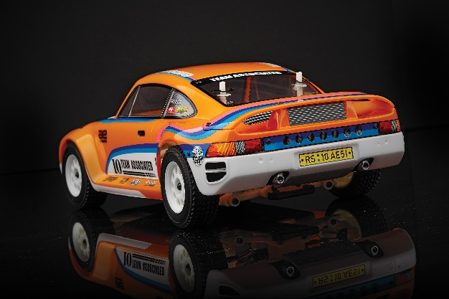
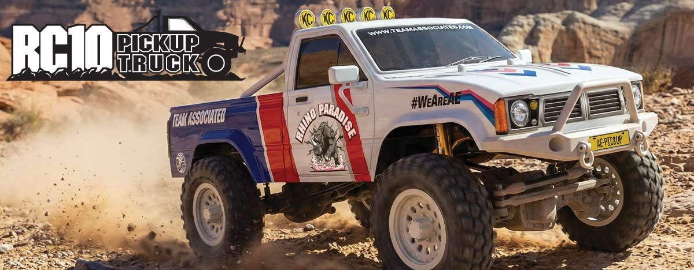

ELECTRIC ■ 1:12 SCALE ■ 4 WHEEL DRIVE ■ OFF ROAD ■ KIT

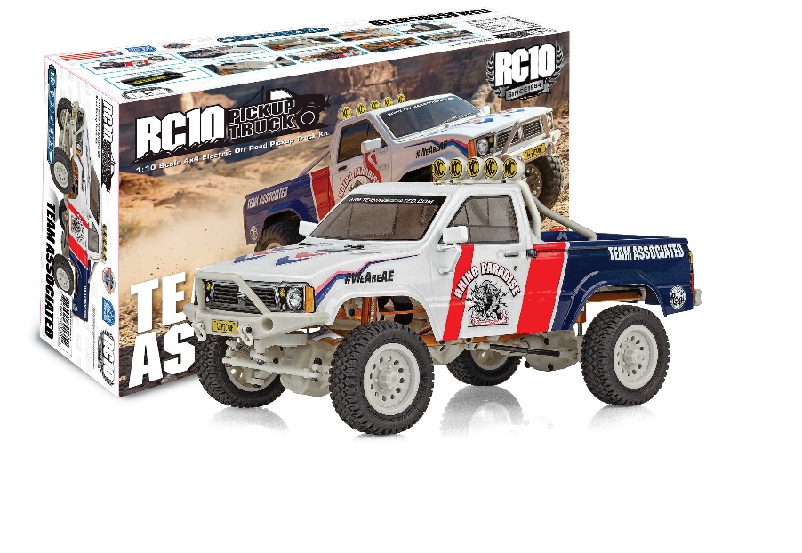
This rig is designed not only for scale looks with realistic wheels, tires and body, this truck is built for performance as well. The steel ladder frame chassis provides the perfect backbone for this rugged little rig. The 4-link suspension, scale shocks, and soft rubber tires give the grip and performance needed to climb over the roughest terrain. Transferring power to the rocks is a compact 3-gear transmission, plastic low-friction slider-type drive shafts, front steel CVA axles, and metal shield ball bearings.

Get ready to hit the trails with the scale RC10 4x4 Pickup Truck!
The RC10 4x4 Pickup Truck may be small in size, but is packed full of features.

FEATURES
  SPECS
- Scale accurate front and rear 4x4 pickup truck bumpers
- Clear body and box art livery decals included
- New scale looking shocks all around
- Dyeable white plastics throughout
- RC10 Classic Gold anodized aluminum
- Gear differentials front and rear
- Fast Reedy 400 Brushed Motor included
- Low center of gravity
- Updated gearing for faster speeds
- Metal 4-link front and rear suspension

Scale | 1:12
Type | Off Road
Power | Electric
Length | 398mm (15.6 in.)
Width | 178mm (7 in.)
Weight | Varies*
Wheelbase | 228mm (9 in.)
Drive: | 4WD
Chassis: | Gold c-channel frame
Suspension: | Solid front and rear axles

*Final width, length and weight will vary based on electronics, tire configuration, wing position and vehicle setup.

Items required for operation:
OTHER HELPFUL ITEMS
ESC, Servo, Battery, Radio, Receiver

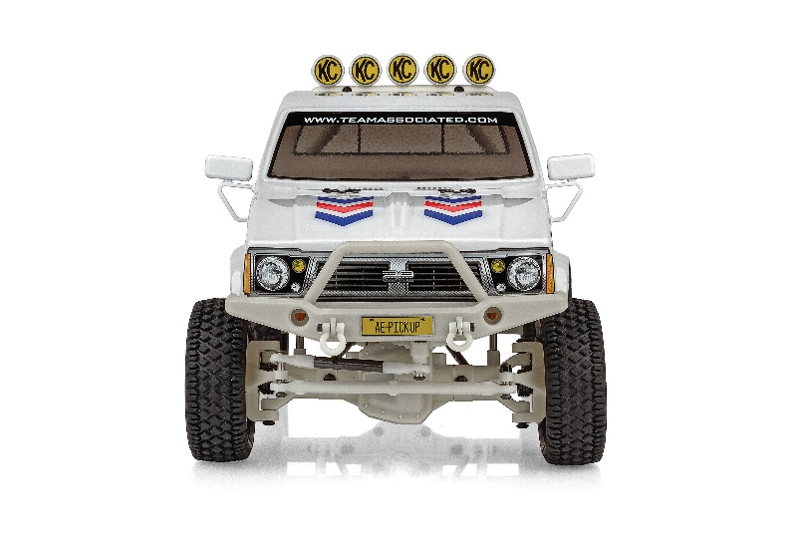
- Silicone Shock Fluid (Refer to catalog for complete listings)
- Silicone Diff Fluid (Refer to catalog for complete listings)
- Body Scissors (AE Part # 1737)
- Reamer / Hole Punch
- FT Wrench Set (AE Part #1519)
- Hobby Knife
- Needle Nose Pliers
- Wire Cutters
- Soldering Iron
- Calipers or a Precision Ruler

UPC | Part No. | Description | MSRP | MAP | Pieces Per Case | Origin | Available
784695400153 | 40015 | RC10 Pickup Truck Kit | $289.99 | $159.99 | 6 | TW | Jan
CATALOG INFORMATION
Download all zipped photos here: https://rc10.com/RC10PickupTruckImages/ Link is active for 30 days.
Please refer to our MAP Policy here: https://img2c.associatedelectrics.com/pdf/map-policy.pdf

